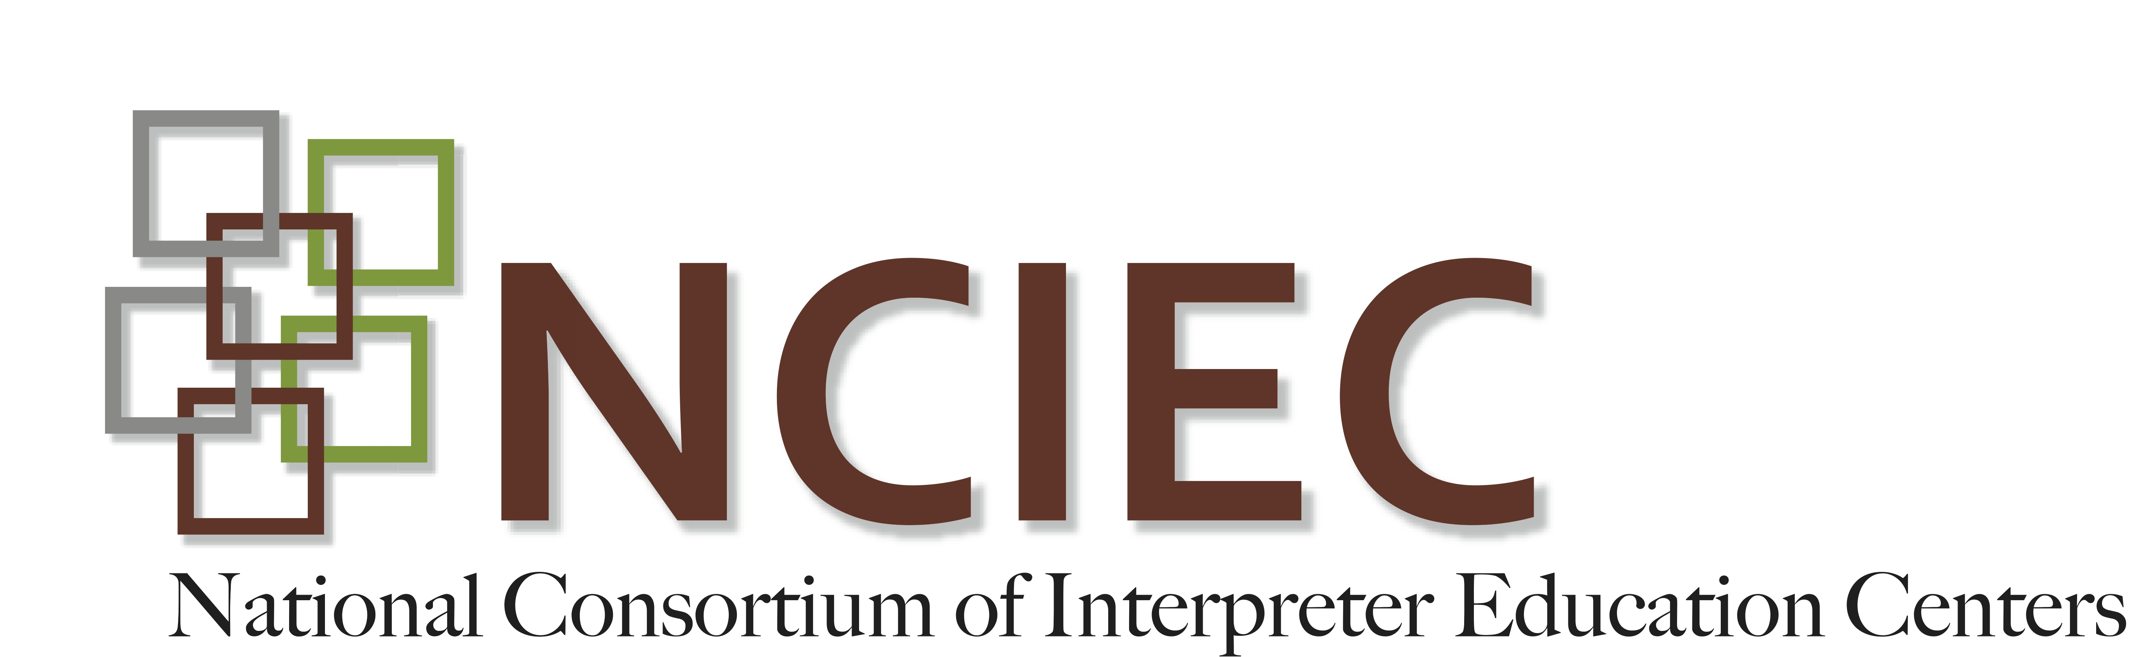

**DeafBlind Interpreting Module**

**Modifications to Interpreting Mode**

**ANSWER KEY**

Directions: Write the name of the interpreting mode next to its definition. You will use some modes more than once.

Tracking Two-Handed Tactile One-Handed Tactile Print-on-Palm Close Vision

1. Print on Palm Used briefly to clarify a word, number, symbol or detail
2. One-Handed Tactile Used by consumers who are very skilled at tactile communication
3. Close Vision Involves greatly reducing your signing space
4. Two-Handed Tactile Used when seeking fuller tactile picture of a signed message
5. Close Vision and Tracking Used by persons with usable residual vision
6. Two-Handed Tactile Used by persons just learning tactile sign
7. Print-on-Palm Used in combination with both tactile modes
8. Close Vision Involves reducing your rate of interpreting, particularly the speed of fingerspelling
9. Tracking Often used as a transitional mode from visual to tactile communication
10. Close Vision Only method that might be used while seated at a distance from the consumer.

Adapted by J. Hecker-Cain. Morgan, S. (n.d.). *Interpreting strategies for deaf-blind students: An interactive training tool for educational interpreters*. Dayton, OH: Ohio Center for Deaf-Blind Education. (T200.0001.01) Retrieved from the [NCRTM website](https://ncrtm.ed.gov/Default.aspx).