**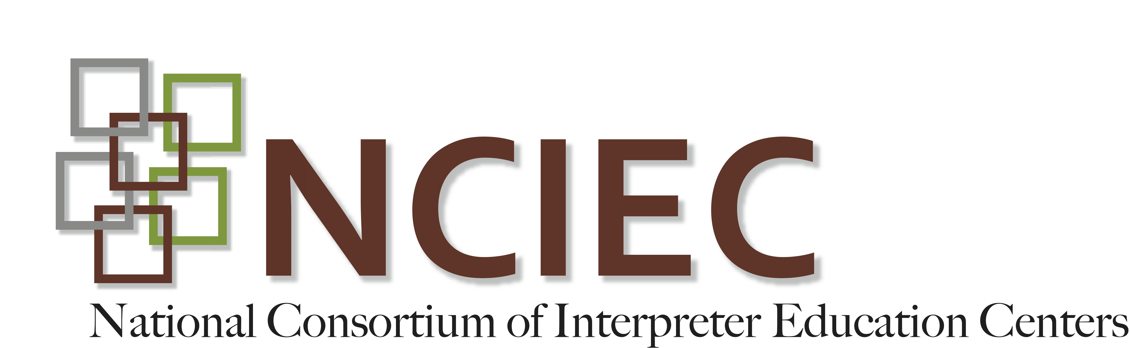**

**DeafBlind Module**

*What’s Wrong With This Picture?*

Fill in the chart below with examples of what is not being done correctly and how these errors can be corrected. Include as many examples as you can find.

**Note:** You will notice that this interpreter is not making continuous eye contact with her consumer. This is because the interpreter depicted in this video is a Deaf interpreter. She is copy signing from either a hearing interpreter working from spoken English or a Deaf presenter using sign.

[http://vimeo.com/user5994566/whats-wrong-with-this-picture](http://vimeo.com/user5994566/whats-wrong-with-this-picture" \t "_blank)

|  |  |  |
| --- | --- | --- |
|  | ***What’s Wrong***  ***With This Picture?*** | ***How Can This Be***  ***Corrected?*** |
| **Lighting** |  |  |
| **Background** |  |  |
| **Interpreter’s Clothing** |  |  |
| **Interpreter’s Sign Production** |  |  |
| **Interpreter’s Deference to Consumer’s Preferences** |  |  |

Adapted by J. Hecker-Cain. Morgan, S. US Department of Education, Ohio Center for Deaf-Blind Education. (n.d.). Interpreting strategies for deaf-blind students: an interactive training tool for educational interpreters (Project Award “H326C080020). Dayton, OH (T200.0001.01). [Retrieved NCRTM website](https://ncrtm.ed.gov/).