The region to be managed (the western North Pacific) is divided into 22 sub-areas (see Fig. 1). Future surveys are unlikely to cover sub-areas 1, 2, 3, 4 and 13 (see Table 3) so these sub-areas are taken to be Residual Areas in the current trials (although allowance is made for future bycatches from some of these sub-areas – see section D). The term ‘stock’ refers to a group of whales from the same breeding ground.
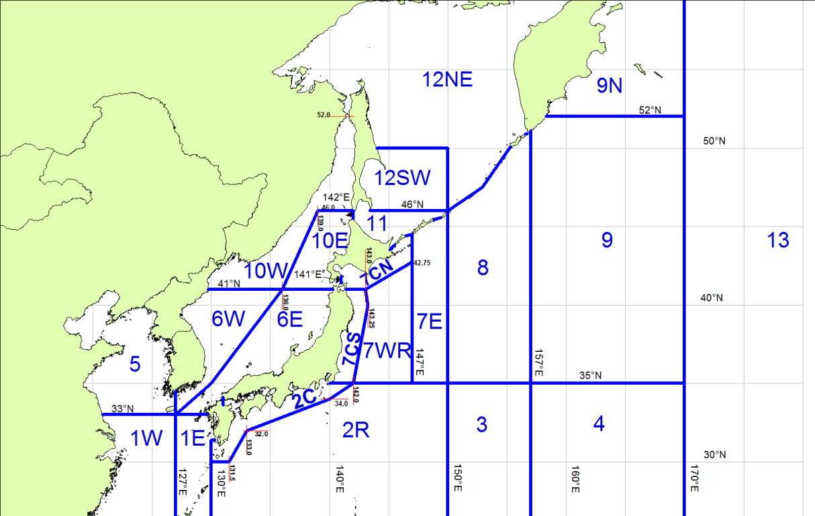
Fig. 1. The 22 sub-areas used for the Implementation Simulation Trials for North Pacific minke whales Three fundamental hypotheses are considered to account for patterns observed in the results from the genetic analyses:
  - there is a single J-stock distributed in the Yellow Sea, Sea of Japan, and Pacific coast of Japan, and a single O-stock in sub-areas 7, 8, and 9 (referred to as hypothesis A);
  - as for hypothesis (A), but there is a third stock (Y-stock) which resides in the Yellow Sea and overlaps with J-stock in the southern part of sub-area 6W (referred to as hypothesis B); and
  - there are five stocks, referred to Y, JW, JE, OW, and OE, two of which (Y and JW) occur in the Sea of Japan, and three of which (JE, OW, and OE) are found to the east of Japan (referred to as hypothesis C).

