Exploring the BRFSS data

Intzar Singh

## Setup

### Load packages

library(ggplot2)  
library(dplyr)

### Load data

load("/Users/Intzar/Downloads/brffs2013.rd")

## Part 1: Data

The data collected in this survey used a random sampling technique. This allows us to see that the results and valid interpretations of this data can be generalized to a larger population. However, we need to note that these results should only be generalized to the populations that this sample is representative of.

Furthermore, we can also rule out any causal factors in this study because there is no control group to compare to. In addition to this, observational studies, which this survey can be categorized as, can not determine causal relationships.

However, we may be able to get information in this data that may help us determine weather certain factors deserved to be looked at in more detail. These topics of further study could greatly aide the CDC in its efforts to predict upcoming health trends for communities.

For more Information on the data collection process as provided by the CDC: <https://www.cdc.gov/brfss/annual_data/2019/pdf/overview-2019-508.pdf>

## Part 2: Research questions

**Research quesion 1:** The first question that is of interest is to determine whether there is any relationship between the marital status of a respondent, the number of children in their home, and the number of days in a month that they felt they were bad mentally.

This question could help us determine if respondents that were married with children felt more positive about their mental health when compared to married respondents without children. On the opposite end of this question, we will also be able to see if any relationships may exist between unmarried respondents with kids, and their mental health.

More formally :

Do respondents with children feel differently about their mental health based on their Marital Status? Furthermore, can we determine a trend for married and unmarried respondents mental health and the number of children they have?

**Research question 2:** Next I want to evaluate the relationship between education level and likelihood of owning a home. To do this, we will use income to categorize our respondents and isolate the relationship to be between education and home ownership.I believe that income would definitely be a factor in home ownership rates, but that question is not of interest.

More formally:

When income brackets are equalized, are college graduates more likely to own homes than non college graduates? We can also do some minor analysis along the way to see the discrepancy in income between non college graduates and college graduates.

**Research question 3:** The next research question we would like to explore is the amount of times someone has gone to the doctor in the past year, based on whether they wear their seat belt and have gotten their flu shot.

What I am interested in testing here, is a parallel in being responsible about your health and safety across different fields. Although we may get things that are nonsensical or completely unrelated, I am interested in seeing whether someone who wears their seat belt and gets their flu shot, is also more likely to visit the doctor.

More formally:

Do respondents that wear their seat belt and have gotten a flu shot visit the doctor more than respondents that do not fit that criteria? * * *

## Part 3: Exploratory data analysis

**Research question 1:** We are going to first filter the data we need out of the bigger set of data, and clean it up to get rid of any NA values if they exist.

q1_data <- brfss2013 %>%  
 select(marital, children, menthlth)  
  
q1_data <- q1_data %>%  
 filter_at(vars(marital,children,menthlth), all_vars(!is.na(.)))

This is all the data that we really want to clean, so we can now move over into looking at some statistics about the data, based on wether the participant is married or not.

q1_data %>%  
 group_by(marital) %>%  
 summarise(ment_med = median(menthlth), ment_mean= mean(menthlth))

## `summarise()` ungrouping output (override with `.groups` argument)

## # A tibble: 6 x 3  
## marital ment_med ment_mean  
## <fct> <dbl> <dbl>  
## 1 Married 0 2.59  
## 2 Divorced 0 4.81  
## 3 Widowed 0 3.04  
## 4 Separated 0 7.19  
## 5 Never married 0 4.25  
## 6 A member of an unmarried couple 0 4.49

From this table we can see that although the data for all members of the marital group has a median of 0, their means have quite a bit of variation between them. We can see that people who are married have a lower average number of days they felt poorly about their mental health for their group. Furthermore, we can see that separated individuals post the highest average.

I now want to look at the distribution of the mental health variable for each of these groups and see if we can find something that is of interest to us.

ggplot(data = q1_data) +  
 geom_bar(aes(x = menthlth), colour = "black", fill = "blue") +  
 xlab("Days of Poor Mental Health")+  
 facet_wrap(~ marital)

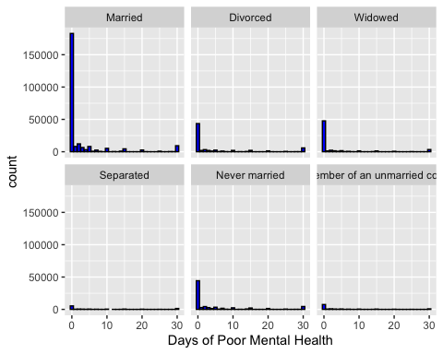

We can see from the above frequency plot that all of the various distributions for each type of data are right skewed. Furthermore, the median of all our distributions seems to be 0, from the graph as well, which can be verified by looking at the summary table above.

ggplot(data = q1_data, aes(x= marital, y= menthlth)) +  
 xlab("Marital Status")+  
 ylab("Days of Poor Mental health")+  
 theme(axis.text.x = element_text(angle = 90, vjust = 0.2))+  
 geom_boxplot(color = "steelblue")

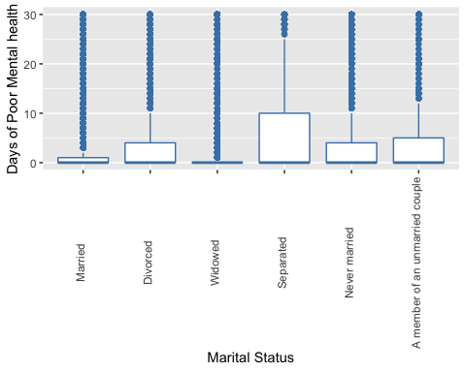

Insights:From the Frequency Plot, and the Box Plot we can see that some variables might require some further studying. One case of this can be seen in the Separated and Divorced cases. The wide range of the mental health variable for Separated couples when compared to those that are divorced, or married, may suggest that there are some factors that may be leading to more stress. Furthermore, When we compare the means of the data, we can further see that there is definitely some discrepancy between Divorced participants and their feelings on their mental Health, and those of Married Participants. One Key thing to note however, is that the median for all of these categorical variables was the same. What this suggests to me is that those participants who are Separated or Divorced and express poor mental health for at least 1 day of the month, will express a greater number on average for participants of the same type who are married.

We can now turn over into evaluating how the number of children that a participant may have affects the number of days they express poor mental health. Ideally, we will get a working version of a visualization that will allow us to establish some type of relationship between these variables.

q1_data <- q1_data %>%  
 mutate(cat_child = ifelse(children<1,"No Childen",ifelse(children<=3, "1-3 Children","More than 3 Children")))

ggplot(data = q1_data, aes( x= marital, y= menthlth, fill = cat_child))+  
 geom_boxplot()+  
 xlab("Marital Status")+  
 ylab("Days of Poor Mental Health")+  
 guides(fill = guide_legend("Children"))+  
 theme(axis.text.x = element_text(angle = 90, vjust = 0.2))

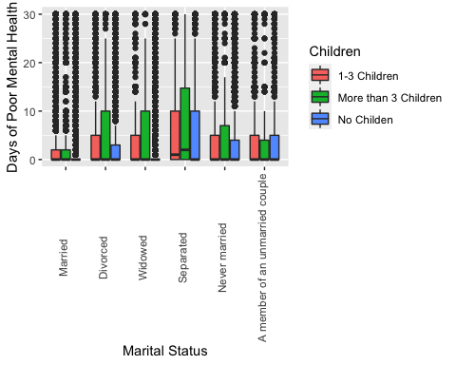

We can see from this graph that when we look at the Marital Status categories that we have decided are of importance to us, we can see that Seperated participants that had children had a higher median for the amount of days that they felt poor mental health. Furthermore, Separated participants with more than 3 children had not only the highest median, but also the largest middle 50th percentile.

q1_data %>%  
 group_by(cat_child,marital) %>%  
 summarise(ment_med = median(menthlth), ment_mean= mean(menthlth), count = n())

## `summarise()` regrouping output by 'cat_child' (override with `.groups` argument)

## # A tibble: 18 x 5  
## # Groups: cat_child [3]  
## cat_child marital ment_med ment_mean count  
## <chr> <fct> <dbl> <dbl> <int>  
## 1 1-3 Children Married 0 2.87 76681  
## 2 1-3 Children Divorced 0 5.56 13139  
## 3 1-3 Children Widowed 0 5.17 3234  
## 4 1-3 Children Separated 1 7.25 3695  
## 5 1-3 Children Never married 0 4.84 16479  
## 6 1-3 Children A member of an unmarried coup… 0 4.70 4707  
## 7 More than 3 Children Married 0 3.06 7096  
## 8 More than 3 Children Divorced 0 6.60 762  
## 9 More than 3 Children Widowed 0 6.20 201  
## 10 More than 3 Children Separated 2 7.69 398  
## 11 More than 3 Children Never married 0 5.44 1245  
## 12 More than 3 Children A member of an unmarried coup… 0 4.42 431  
## 13 No Childen Married 0 2.43 165804  
## 14 No Childen Divorced 0 4.60 54883  
## 15 No Childen Widowed 0 2.92 60055  
## 16 No Childen Separated 0 7.13 6265  
## 17 No Childen Never married 0 4.05 55887  
## 18 No Childen A member of an unmarried coup… 0 4.37 7851

This table further shows us the discrepancies in how children affect the mean and median mental health variable for various individuals.

Lastly I want to see the distribution of the Mental Health Variable grouped by how many children a person has. This will allow me to see whether we have a substantial amount of respondents to make a judgment on if these factors require further studying.

ggplot(q1_data)+  
 geom_bar(aes(x=menthlth), fill = "steelblue")+  
 facet_wrap( ~ cat_child, ncol=1)+  
 xlab("Days of Poor Mental Health")

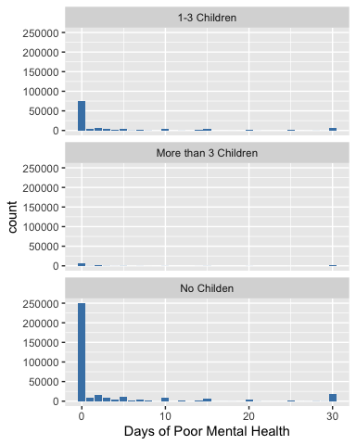

From the graph above, we can see that the distributions themselves look very similar, the only major difference between them being the total number of respondents that fit into these categories. Because these distributions are similar, I believe that as we explored earlier, the marital status of a person is having an effect on the respondents mental health.

As a whole, I do believe that looking at the data in this perspective has helped us look into how the different Marital Status variables interact with the other two variables of our analysis. If I were to take this past the EDA phase, I would focus in on the Separated, Married, and Divorced Categories and see if there can be any inferences drawn based on further study.

**Research question 2:** We are going to first filter the data we need out of the bigger set of data, and clean it up to get rid of any NA values if they exist.

When income brackets are taken into consideration, are college graduates more likely to own homes than non college graduates? We can also do some minor analysis along the way to see the discrepancy in income between non college graduates and college graduates.

q2_data <- brfss2013 %>%  
 select(X_incomg,renthom1,X_educag) %>%  
 filter_at(vars(X_incomg,renthom1,X_educag),all_vars(!is.na(.)))  
   
q2_data %>%   
 group_by(X_incomg) %>%  
 summarise( count = n())

## `summarise()` ungrouping output (override with `.groups` argument)

## # A tibble: 5 x 2  
## X_incomg count  
## <fct> <int>  
## 1 Less than $15,000 51602  
## 2 $15,000 to less than $25,000 75683  
## 3 $25,000 to less than $35,000 48412  
## 4 $35,000 to less than $50,000 61029  
## 5 $50,000 or more 179887

q2_data %>%   
 group_by(X_educag) %>%  
 summarise( count = n())

## `summarise()` ungrouping output (override with `.groups` argument)

## # A tibble: 4 x 2  
## X_educag count  
## <fct> <int>  
## 1 Did not graduate high school 32873  
## 2 Graduated high school 117645  
## 3 Attended college or technical school 115199  
## 4 Graduated from college or technical school 150896

q2_data %>%   
 group_by(renthom1) %>%  
 summarise( count = n())

## `summarise()` ungrouping output (override with `.groups` argument)

## # A tibble: 3 x 2  
## renthom1 count  
## <fct> <int>  
## 1 Own 303769  
## 2 Rent 97088  
## 3 Other arrangement 15756

The above table summaries give us a good idea of the way the variables are laid out across the data set. To get a better visualization of this, we will now create a bar graph.

There are some things to note about this question that make our analysis different: - Categorical Data was already provided in the form we need, so no code was needed - All 3 variables being compared are categorical - We cant do our normal Numeric operations and Descriptions because these data tables are all categorical.

Now I want to first plot the distributions of all of these variables. This will be similar to the data tables above, but more visually appealing.

ggplot(data = q2_data, aes(x= X_incomg))+  
 geom_bar(fill = "steelblue")+  
 xlab("Income Bracket")+  
 theme(axis.text.x = element_text(angle = 90, vjust = 0.2))

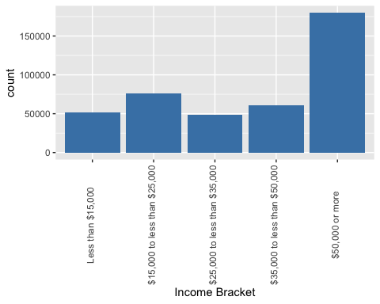

ggplot(data = q2_data, aes(x= renthom1))+  
 geom_bar(fill = "steelblue")+  
 xlab("Home Owwnership")+  
 theme(axis.text.x = element_text(angle = 90, vjust = 0.2))

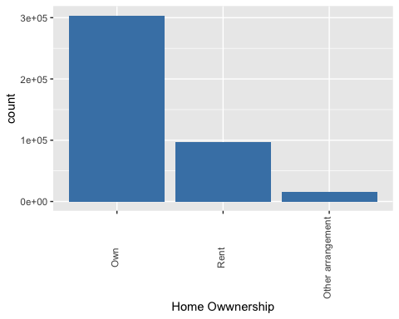

ggplot(data = q2_data, aes(x= X_educag))+  
 geom_bar(fill = "steelblue")+  
 xlab("Education Level")+  
 theme(axis.text.x = element_text(angle = 90, vjust = 0.2))

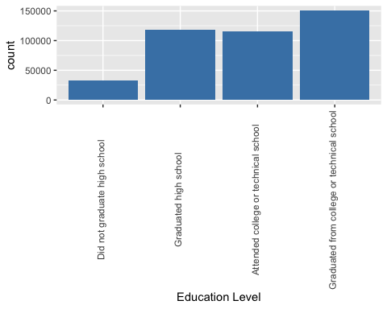

The above bar graphs give us a better visual understanding of the dstribution of our data, but we are still missing some comparative visualizations that can help us with our question.

Since we are dealing with only categorical variables, I will start by showing a contingency table. We will then evaluate the distrubution based on these contigencies with a layered bar graph.

q2_data %>%  
 group_by(X_educag, X_incomg) %>%  
 summarise(count = n())

## `summarise()` regrouping output by 'X_educag' (override with `.groups` argument)

## # A tibble: 20 x 3  
## # Groups: X_educag [4]  
## X_educag X_incomg count  
## <fct> <fct> <int>  
## 1 Did not graduate high school Less than $15,000 12641  
## 2 Did not graduate high school $15,000 to less than $25,0… 11073  
## 3 Did not graduate high school $25,000 to less than $35,0… 4007  
## 4 Did not graduate high school $35,000 to less than $50,0… 2529  
## 5 Did not graduate high school $50,000 or more 2623  
## 6 Graduated high school Less than $15,000 20045  
## 7 Graduated high school $15,000 to less than $25,0… 31190  
## 8 Graduated high school $25,000 to less than $35,0… 18003  
## 9 Graduated high school $35,000 to less than $50,0… 18722  
## 10 Graduated high school $50,000 or more 29685  
## 11 Attended college or technical school Less than $15,000 13068  
## 12 Attended college or technical school $15,000 to less than $25,0… 21922  
## 13 Attended college or technical school $25,000 to less than $35,0… 15298  
## 14 Attended college or technical school $35,000 to less than $50,0… 19671  
## 15 Attended college or technical school $50,000 or more 45240  
## 16 Graduated from college or technical school Less than $15,000 5848  
## 17 Graduated from college or technical school $15,000 to less than $25,0… 11498  
## 18 Graduated from college or technical school $25,000 to less than $35,0… 11104  
## 19 Graduated from college or technical school $35,000 to less than $50,0… 20107  
## 20 Graduated from college or technical school $50,000 or more 102339

The above data is rather messy, the key question we are trying to see, is based on education level, is the proportion of total respondents income higher with more education. We can try a bar graph next.

ggplot(data=q2_data)+  
 geom_bar(aes(x= X_incomg), fill ="steelblue")+  
 facet_wrap(~ X_educag, ncol = 1)+  
 xlab("Income Level")+  
 theme(axis.text.x = element_text(angle = 90, vjust = 0.2))

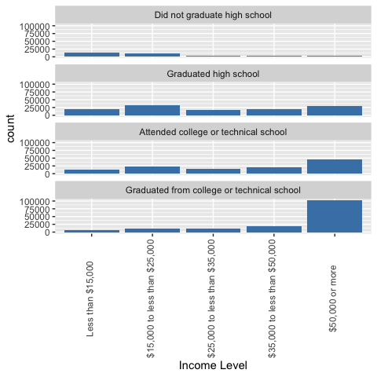

From the above data, it becomes quite clear that as you increase your education level the more likely you are to fall into a higher income category.

Finally, lets look at the way homeownership is related to these two variables, and then lets determine if there is a way to see all three of these variables together.

ggplot(data=q2_data)+  
 geom_bar(aes(x= renthom1), fill ="steelblue")+  
 facet_wrap(~ X_incomg, ncol =1)+  
 xlab("Income Level")+  
 theme(axis.text.x = element_text(angle = 90, vjust = 0.2))

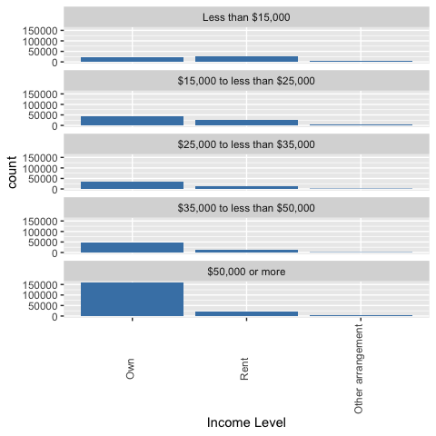

ggplot(data=q2_data)+  
 geom_bar(aes(x= renthom1), fill ="steelblue")+  
 facet_wrap(~ X_educag, ncol = 1)+  
 xlab("Income Level")+  
 theme(axis.text.x = element_text(angle = 90, vjust = 0.2))

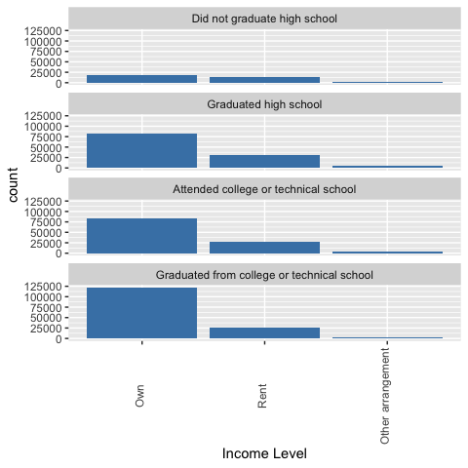

In data table above graphs would look like the following, click through to see the various differences

q2_data %>%  
 group_by(X_educag,renthom1) %>%  
 summarise(count = n())

## `summarise()` regrouping output by 'X_educag' (override with `.groups` argument)

## # A tibble: 12 x 3  
## # Groups: X_educag [4]  
## X_educag renthom1 count  
## <fct> <fct> <int>  
## 1 Did not graduate high school Own 17446  
## 2 Did not graduate high school Rent 13256  
## 3 Did not graduate high school Other arrangement 2171  
## 4 Graduated high school Own 81787  
## 5 Graduated high school Rent 30599  
## 6 Graduated high school Other arrangement 5259  
## 7 Attended college or technical school Own 82270  
## 8 Attended college or technical school Rent 28074  
## 9 Attended college or technical school Other arrangement 4855  
## 10 Graduated from college or technical school Own 122266  
## 11 Graduated from college or technical school Rent 25159  
## 12 Graduated from college or technical school Other arrangement 3471

q2_data %>%  
 group_by(X_incomg,renthom1) %>%  
 summarise(count = n())

## `summarise()` regrouping output by 'X_incomg' (override with `.groups` argument)

## # A tibble: 15 x 3  
## # Groups: X_incomg [5]  
## X_incomg renthom1 count  
## <fct> <fct> <int>  
## 1 Less than $15,000 Own 21485  
## 2 Less than $15,000 Rent 25166  
## 3 Less than $15,000 Other arrangement 4951  
## 4 $15,000 to less than $25,000 Own 44378  
## 5 $15,000 to less than $25,000 Rent 27306  
## 6 $15,000 to less than $25,000 Other arrangement 3999  
## 7 $25,000 to less than $35,000 Own 33322  
## 8 $25,000 to less than $35,000 Rent 13224  
## 9 $25,000 to less than $35,000 Other arrangement 1866  
## 10 $35,000 to less than $50,000 Own 47081  
## 11 $35,000 to less than $50,000 Rent 12228  
## 12 $35,000 to less than $50,000 Other arrangement 1720  
## 13 $50,000 or more Own 157503  
## 14 $50,000 or more Rent 19164  
## 15 $50,000 or more Other arrangement 3220

ggplot(data=q2_data)+  
 geom_bar(aes(x= renthom1, fill = X_incomg))+  
 facet_wrap(~ X_educag ,ncol = 1)+  
 xlab("Income Level")+  
 guides(fill = guide_legend("Income Level"))+  
 theme(axis.text.x = element_text(angle = 90, vjust = 0.2))

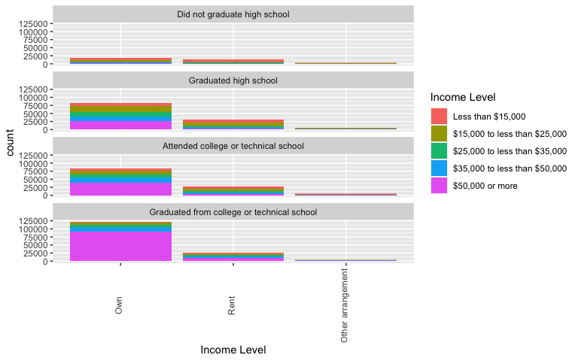

Insights: The above data shows that there is clearly a relationship between Education Level, Income, and Home Ownership. Although the relationship between Education Level, and Income may be expected, I was more surprised about the Education Level and Home Ownership relationship. From our last graph, we can see that Home Ownership Proportions are higher for those that have completed college than those who have not. This leads me to believe there may be a third variable, such as loan acceptance rates that may be confounding this relationship.

This would be a great topic of study to possible gather more data in and try to generalize this relationship.

**Research question 3:** Restating the Question from Above:

Do respondents that wear their seat belt and have gotten a flu shot visit the doctor more than respondents that do not fit that criteria?

First lets discuss the variables that we will be using for this question. The seat belt use is a ordinal categorical variable, flu shot variable tells us if the respondent has gotten a flu shot in the last 12 months, and the doctor visits variable tells us how many visits a person has made to the doctor over the past 12 months.

Lets extract and clean our data. The good thing for us here is that in our entire data set, as we have seen above, all we have had to do is remove NA values. We haven’t had the need to fill in missing values or anything else of the sort. However, this time, we want to get rid of some extra variable values that we would not like to consider.

q3_data <- brfss2013 %>%  
 select(seatbelt,drvisits,flushot6) %>%  
 filter_at(vars(seatbelt,drvisits,flushot6),all_vars(!is.na(.)))  
q3_data <- q3_data %>%  
 filter(seatbelt != "Never drive or ride in a car")

I want to start by looking at the distributions of all of the variables in question.

ggplot(data = q3_data)+  
 geom_bar(aes(x= seatbelt), fill = "steelblue")+  
 xlab("Seatbelt worn while Driving")

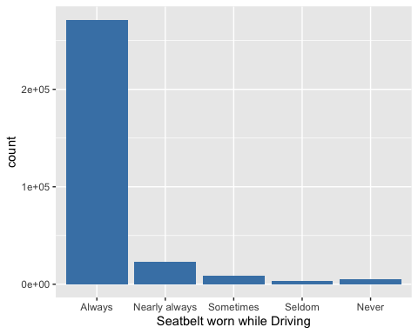

ggplot(data = q3_data)+  
 geom_bar(aes(x= flushot6), fill = "coral")+  
 xlab("Recieved Flushot")

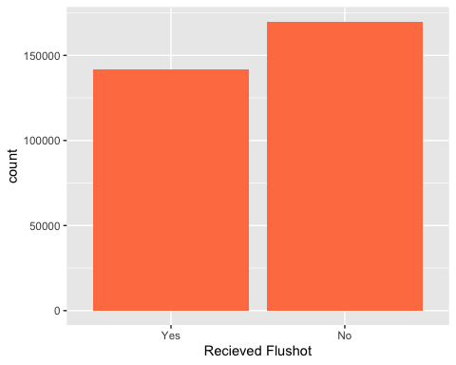

ggplot(data = q3_data)+  
 geom_bar(aes(x= drvisits), fill = "seagreen")+  
 xlab("# of Doctor Visits")

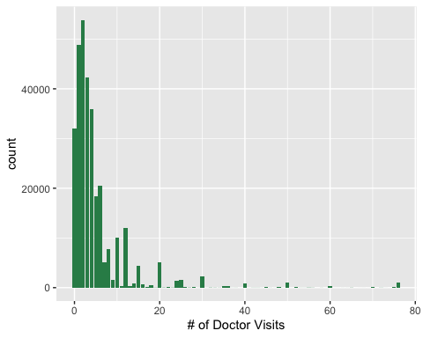

We can see from the above that, that overwhelmingly people say that they Always wear their seatbelts, More people have not gotten their flu shot than those who have, and the fistribution for doctor visits is right skewed with a peak about 3 visits.

Lets dive more into the relationships between these variables.

ggplot(data = q3_data)+  
 geom_bar(aes(x= seatbelt), fill = "coral2")+  
 facet_wrap(~ flushot6, ncol = 1)+  
 theme(axis.text.x = element_text(angle = 90, vjust = 0.2))+  
 xlab("Seatbelt worn while Driving")

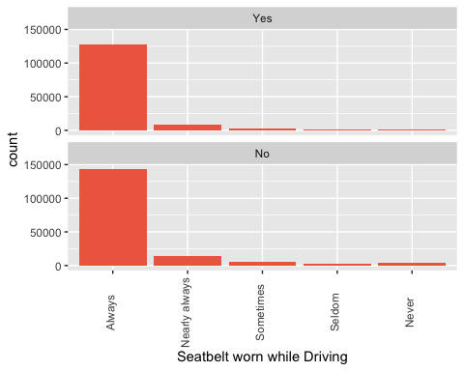

These distributions are similar, so it seems that having gotten your flushot does not relate to the frequency of wearing your seat belt.

ggplot(data = q3_data)+  
 geom_bar(aes(x= drvisits), fill = "coral2")+  
 facet_wrap(~ flushot6, ncol = 1)+  
 xlab("# of Doctor Visits")

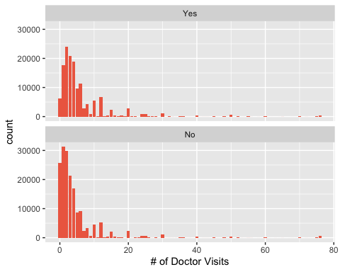

Again, there doesn’t seem to be a difference between the data set distribution based on the flu shot variable alone. But there does seem to be a shift towards the right in terms of its peak value for the group that have gotten their flu shot. We can look at a table to have a clearer view.

q3_data%>%  
 group_by(flushot6) %>%  
 summarise( meanDR= mean(drvisits), medDR = median(drvisits))

## `summarise()` ungrouping output (override with `.groups` argument)

## # A tibble: 2 x 3  
## flushot6 meanDR medDR  
## <fct> <dbl> <dbl>  
## 1 Yes 6.10 4  
## 2 No 4.59 2

Here we can see that the Mean and Median are both higher for the Doctor Visits variable, for the group that has gotten their flu shot.

We can now try and see if these three variables combined have a relationship that may be of interest to us. We will be generating a box plot

ggplot(data = q3_data, aes(x= seatbelt, y= drvisits, fill = flushot6)) +   
 geom_boxplot()+  
 xlab("Seatbelt worn while Driving")+  
 ylab("Doctor Visits")+  
 guides(fill = guide_legend("Flushot Recieved"))

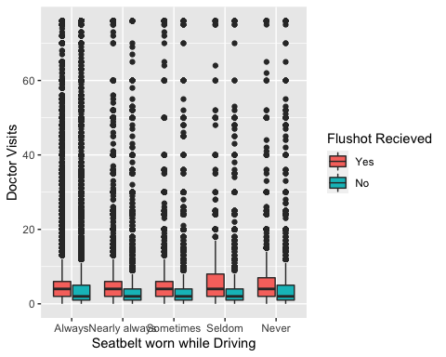

Insights:

From all of the data visualizations and analysis above, I think one of the more interesting questions to study would be if health consciousness can be predicted by using variables like Flu Shot. If that is the case we might be able to draw a relationship between many more interesting things such as health conditions and likelihood of recieving preventative medicine.