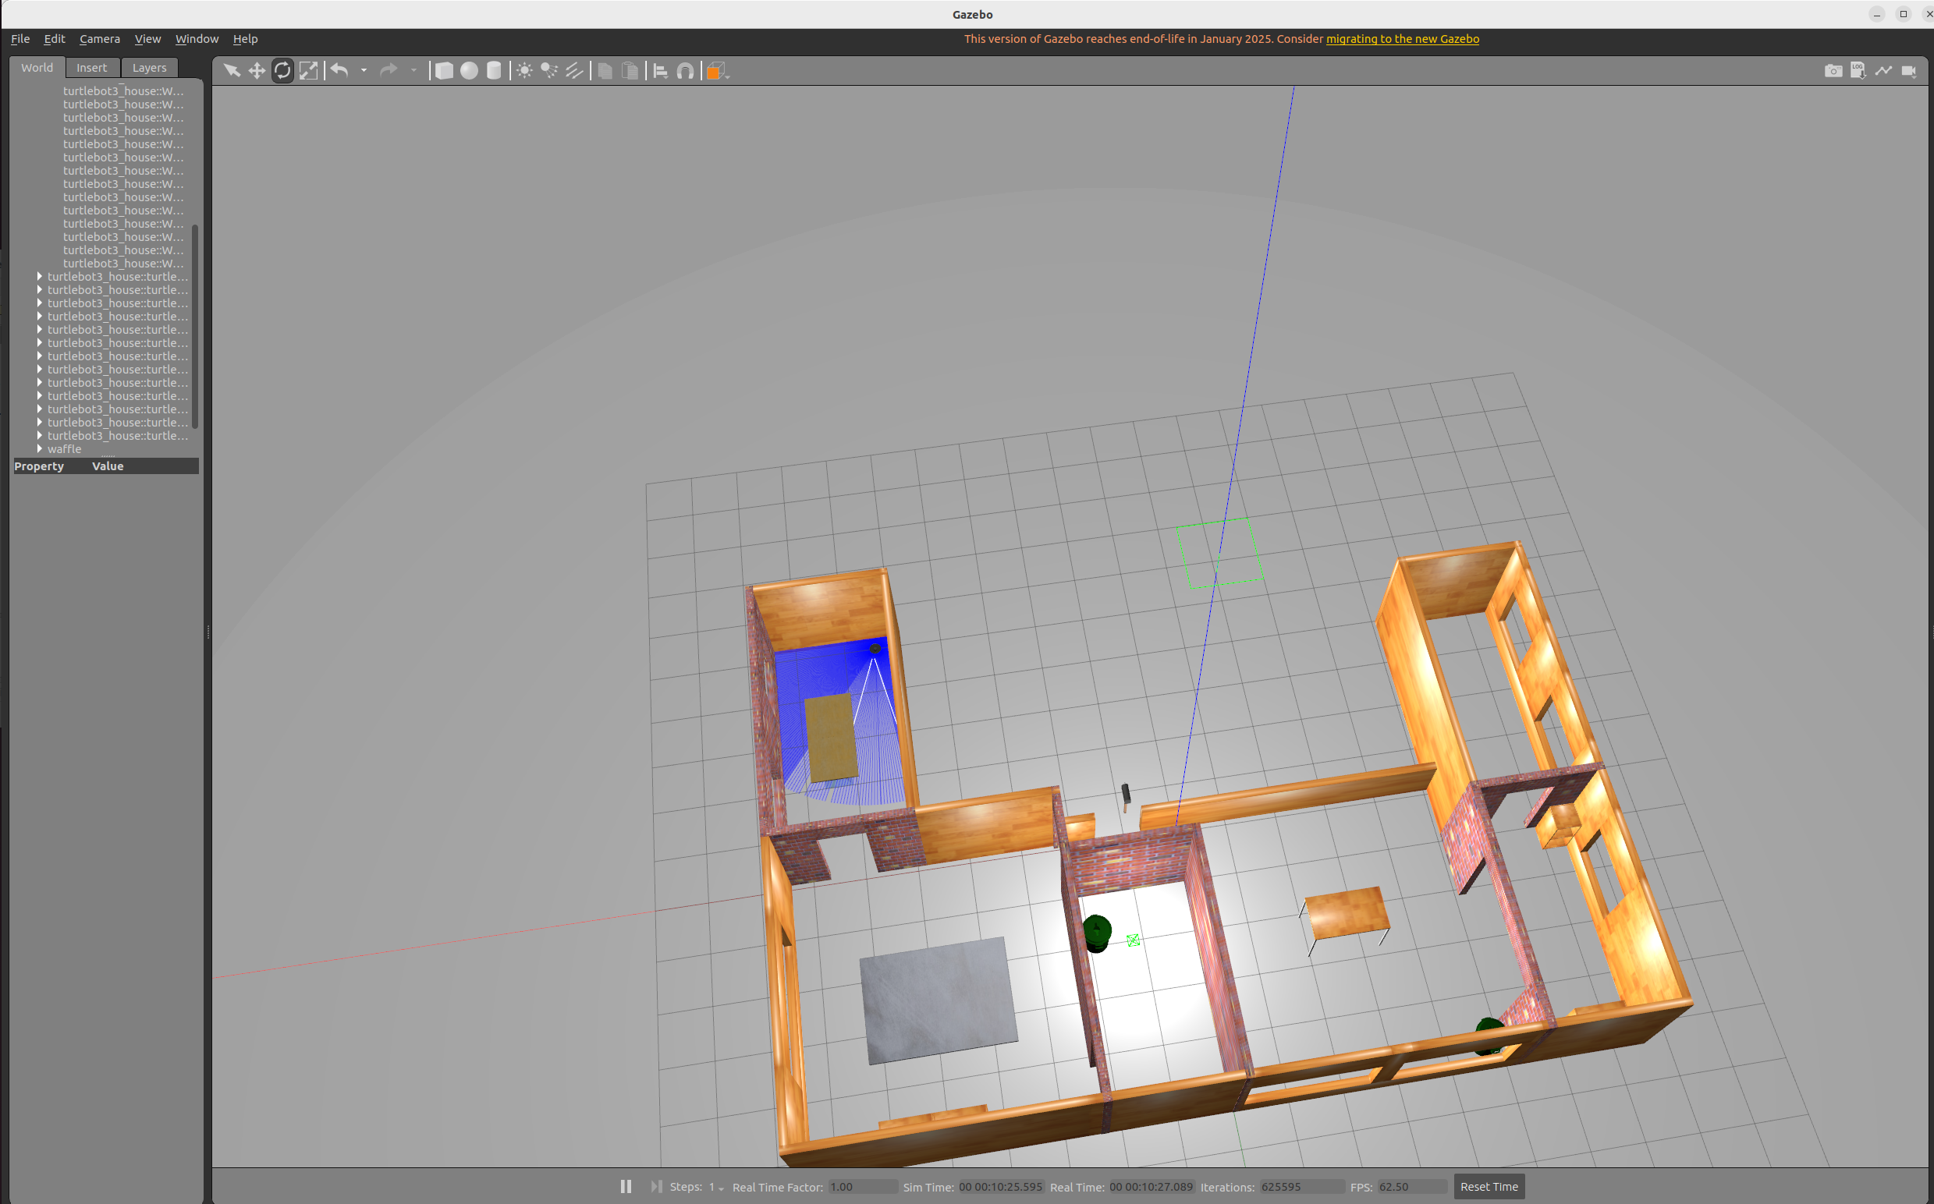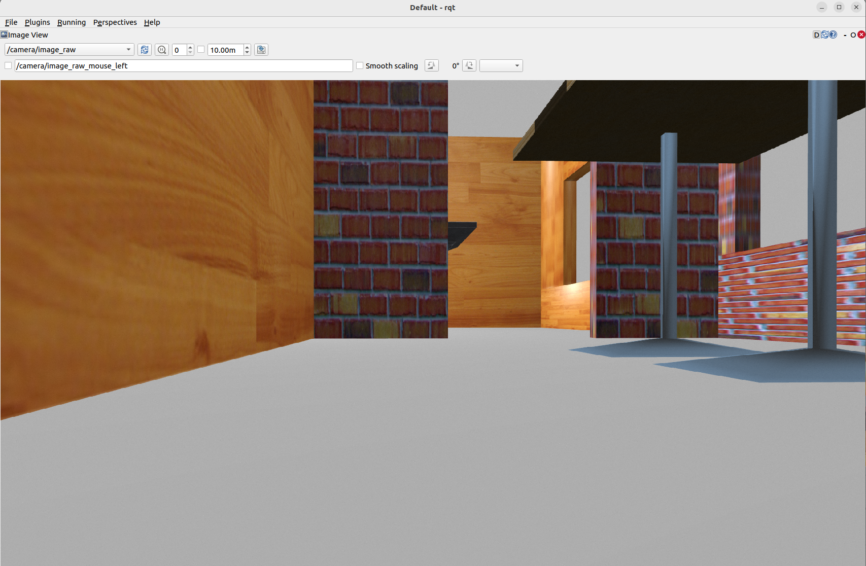

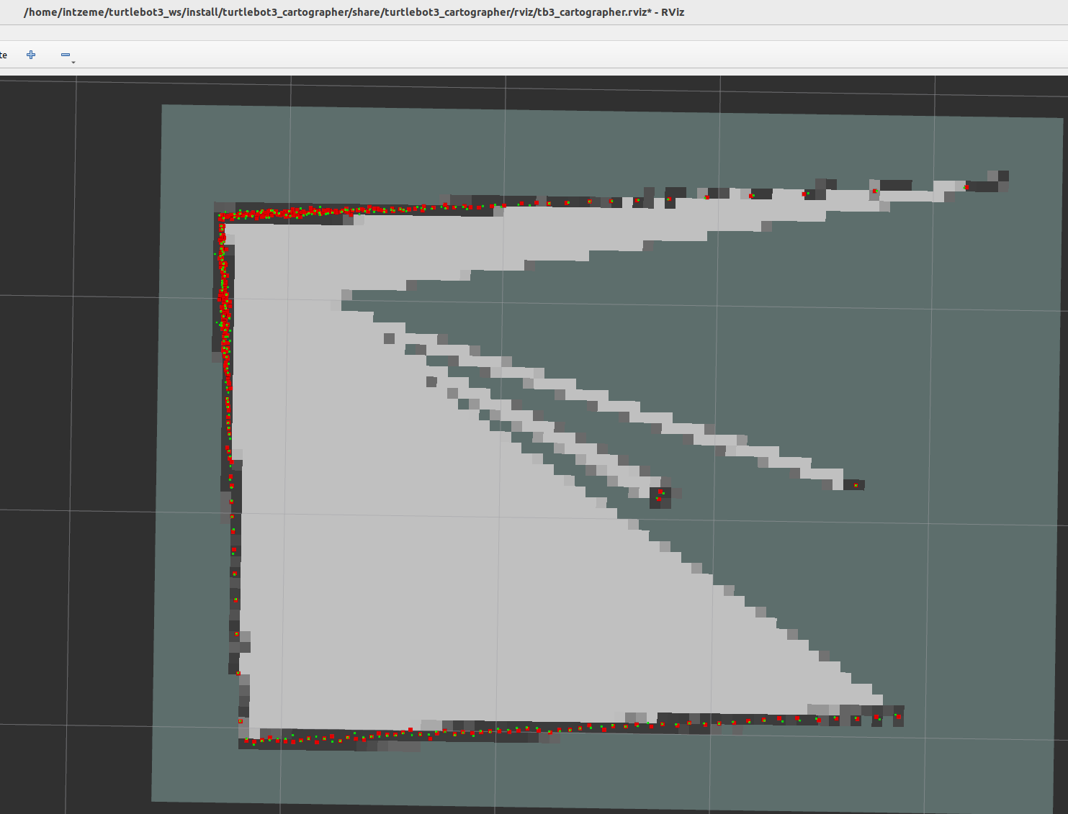

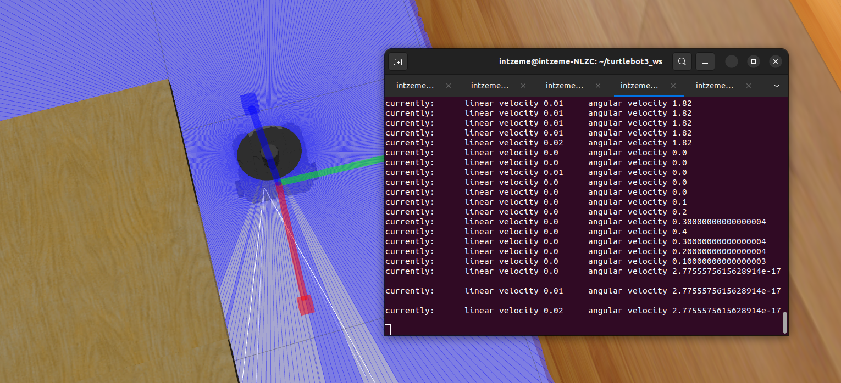

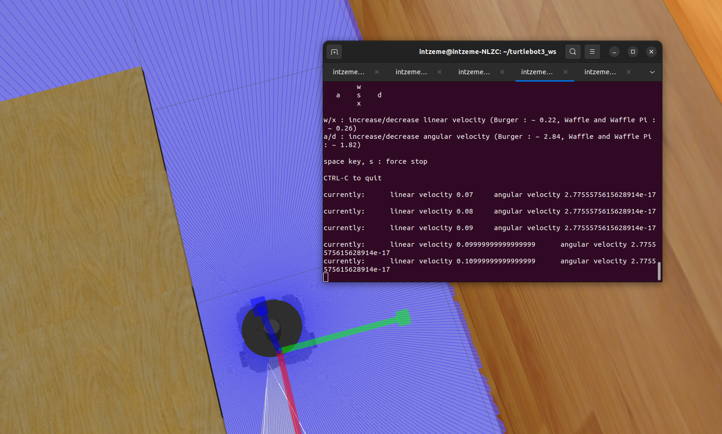

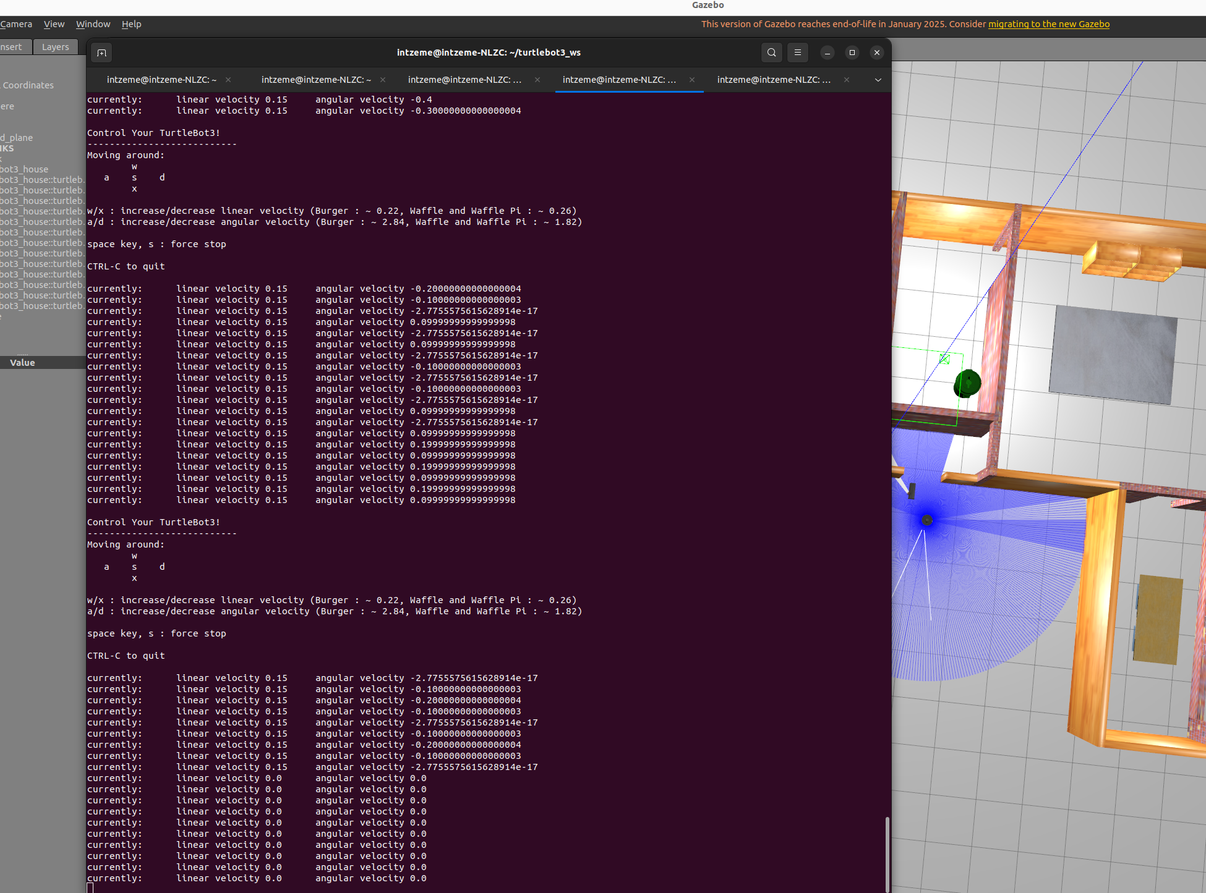

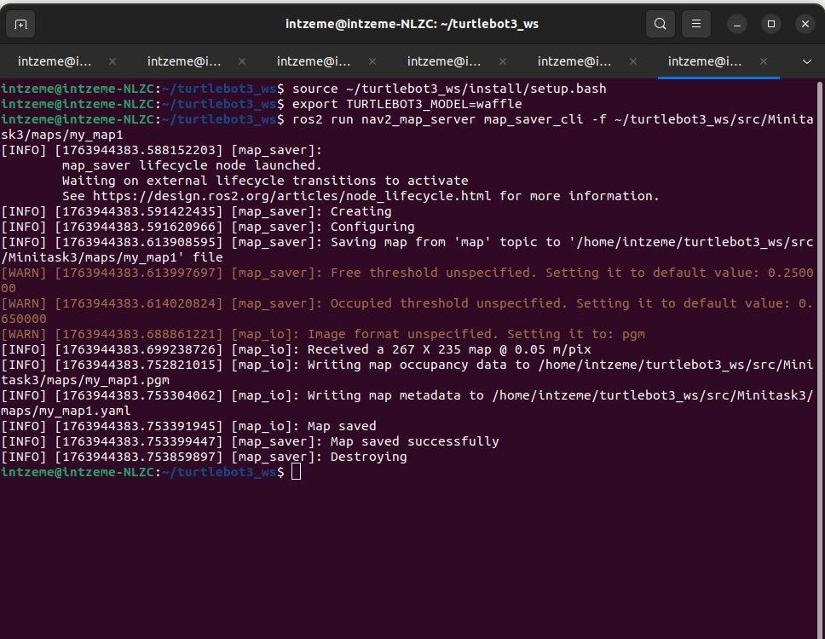
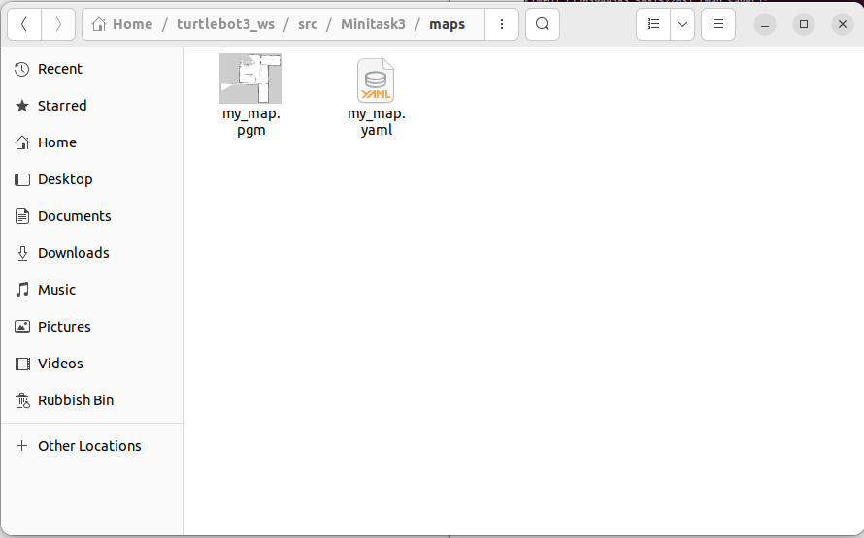
I mapped it again to see if I missed any steps (which is why the file name is my_map.yaml on the image). I firstly saved it as my_map1.yaml (which I thought was the issue), but turns out there’s something preventing my map to appear.

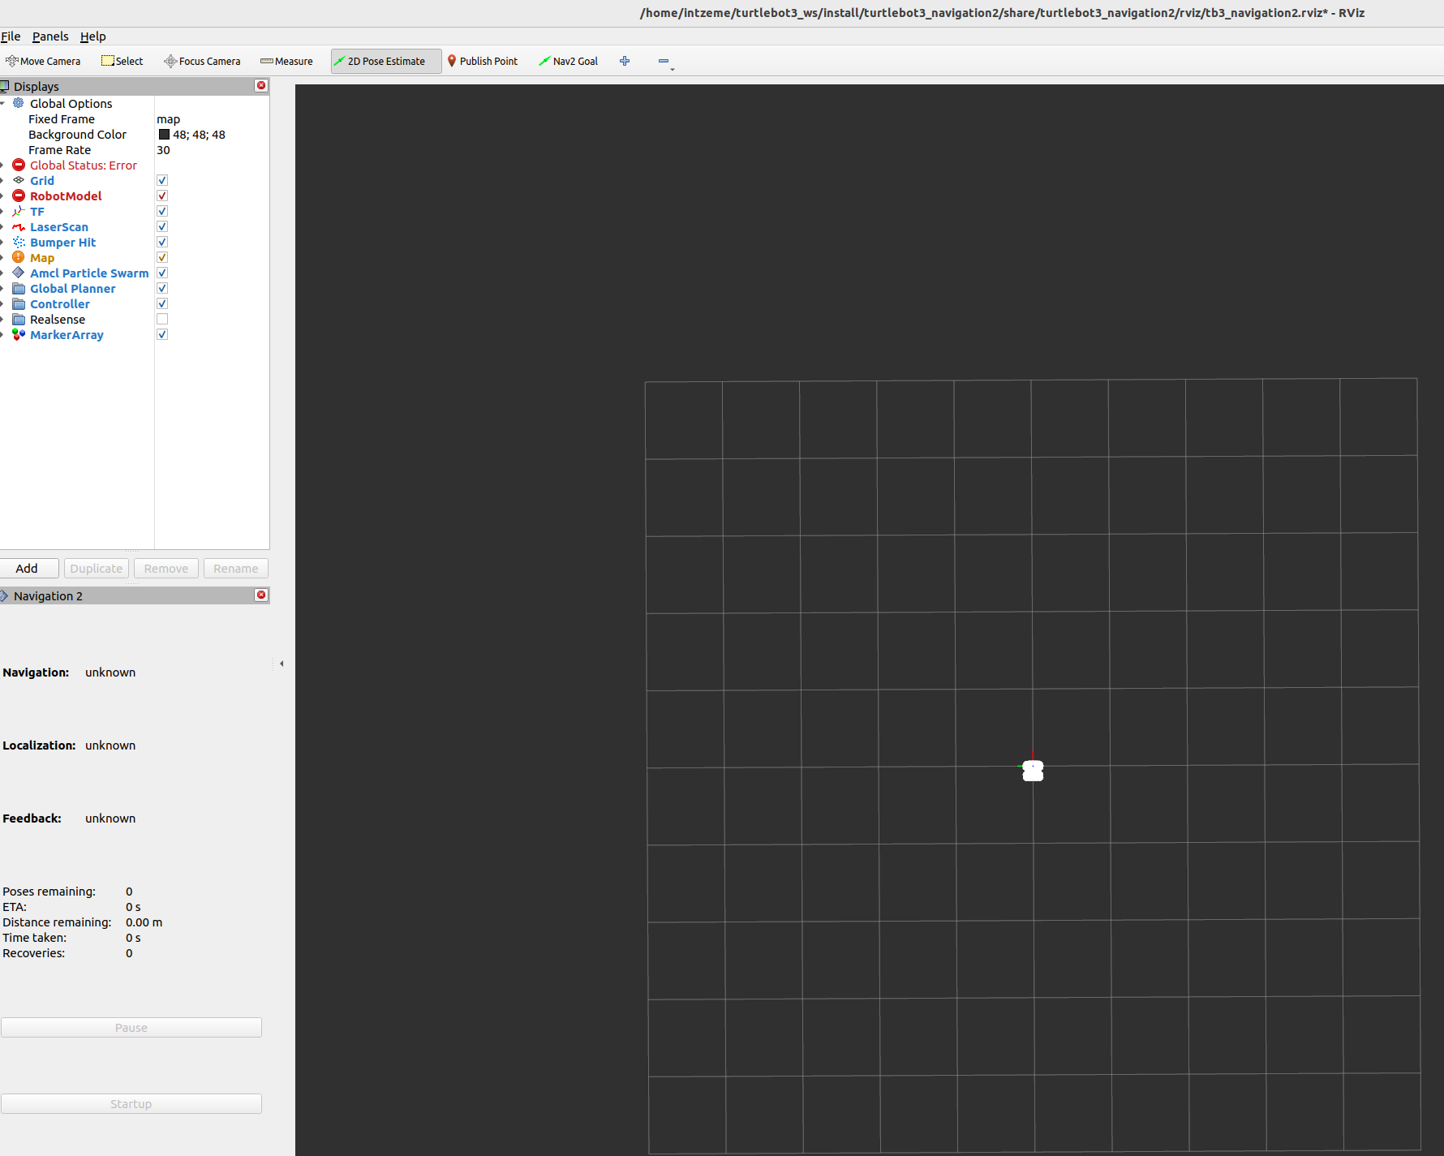

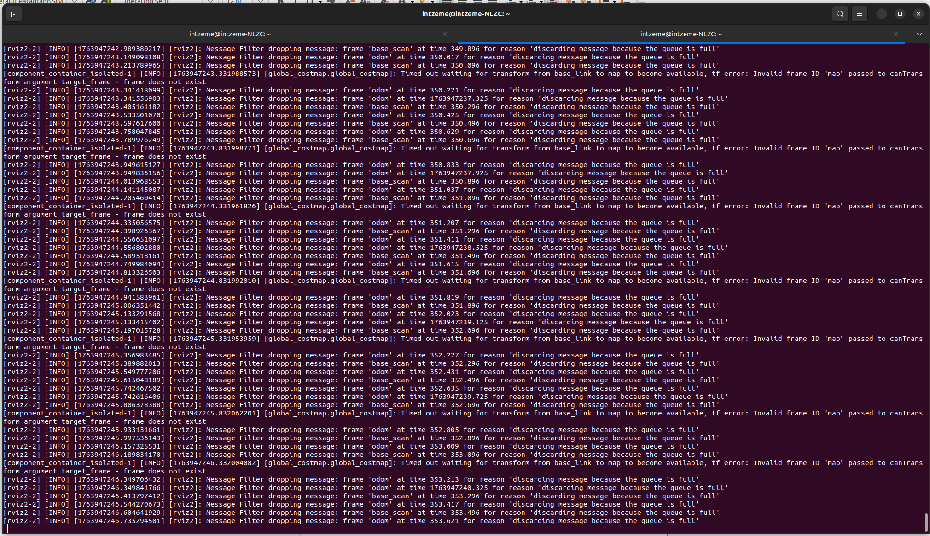

While going through Minitask3 – I was not able to complete Part 1.5 since Rviz was failing to open my map, even though I clearly saved it as specified in the instructions and managed to successfully map it.

Please see folder turtlebot3_ws/src/Minitask3/maps/ to find my mapping which wasn’t loading on Rviz despite trying plenty of times.

Since I wasn’t able to load my map, I didn’t get the chance to complete Part 2 as it required the Rviz windows to be working with the loaded map.

However, I did manage to add package.xml and setup.py (the repository with all the features), then edit them to match my details, but just couldn’t proceed with part 1.5 and 2.

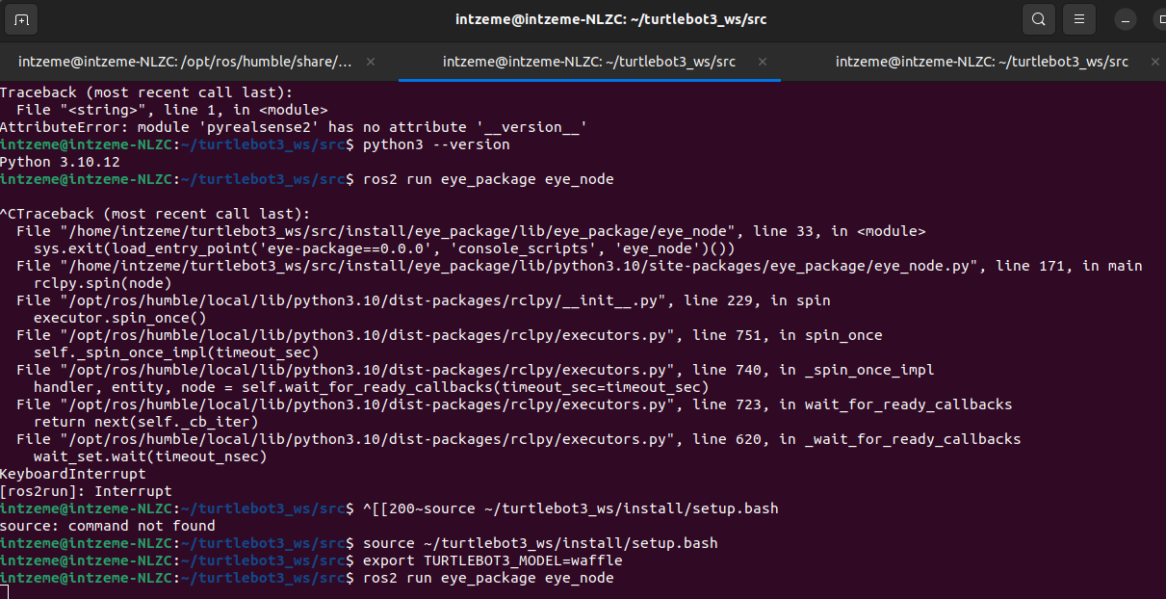
running eye_node

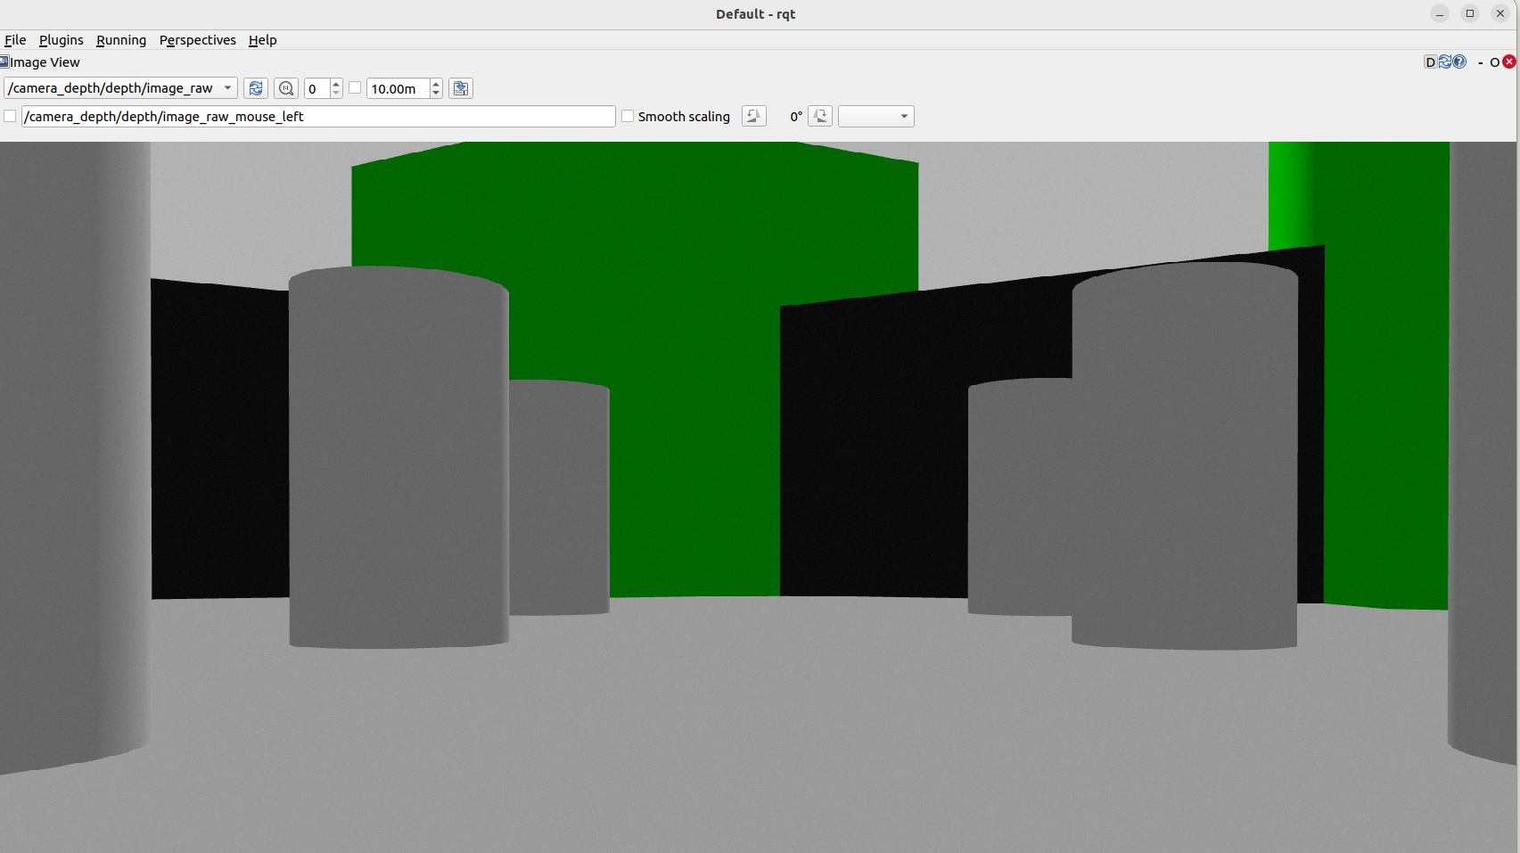
loaded /camera_depth/depth/image_raw

