**OVERVIEW**

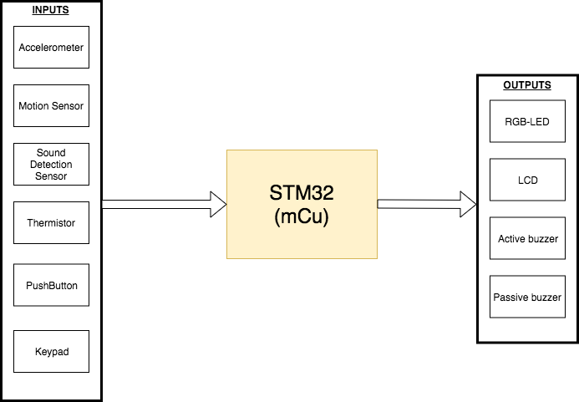

**COMPONENTS**

* STM32F401RE NUCLEO-64
* LCD 20X4
* Keypad 4X4
* PIR motion sensor
* RGB LED
* ADXL345
* Sound detection sensor
* Pushbutton
* 2x breadboards
* YWROBOT POWER MB
* 6.5-12v PSU/ BATTERY
* 2x Buzzers
* Wires
* Thermistor
* Resistors

**STATE MACHINE**

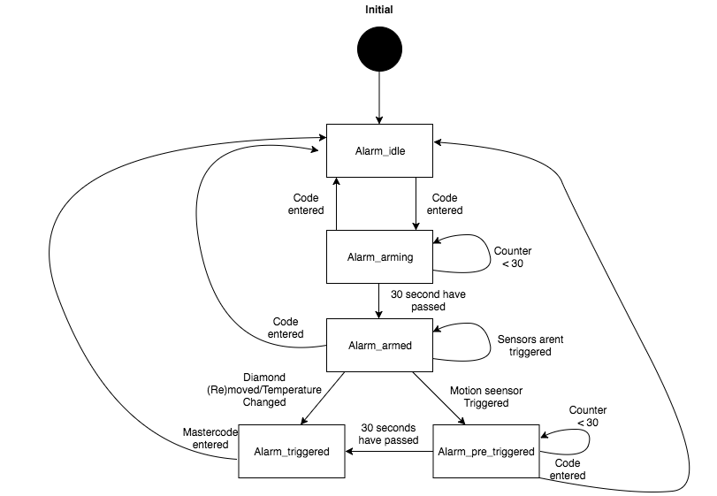

**FULFILLED REQUIREMENTS**

* An alarm system with an access panel consisting of a display and a keypad. A user interface is shown on the display presenting the status of the alarm and the possibility to deactivate/active the alarm with a 4 digits long code.
* LEDS indicating the current state.
* A PIR motion sensor to detect any thermal activities.
* A mechanical switch integrated beneath the diamond.
* Two buzzers
* Temperature sensor is added to measure any temperature changes and will then compare it to the set temperature.
* The set temperature is programmable via the keypad in the idle state by pressing the ‘A’ key on the keypad.
* An accelerometer is added and used in the activity interrupt mode. The accelerometer will generate an interrupt indicating that an intruder is detected.
* The threshold level for the accelerometer can be programmed by pressing the ‘B’ key on the keypad.

**ADDITIONAL FEATURES**

* Sound detection sensor
* The ‘D’ key works as a delete button when entering the code.
* The user code can be changed in idle state.
* A single RGB-LED instead of three LEDS.
* A bigger LCD-screen
* A cross-platform application displaying the actual state of the alarm and the temperature.

**PINOUT & SCHEMATICS**

|  |  |  |  |
| --- | --- | --- | --- |
| PIN LABEL | PIN NUMBER | PIN DESCRIPTION | GPIO MODE |
| LCD_D0 | PC0 | LCD DATA PIN 0 | OUTPUT |
| LCD_D1 | PC1 | LCD DATA PIN 1 | OUTPUT |
| LCD_D2 | PC2 | LCD DATA PIN 2 | OUTPUT |
| LCD_D3 | PC3 | LCD DATA PIN 3 | OUTPUT |
| LCD_D4 | PC4 | LCD DATA PIN 4 | OUTPUT |
| LCD_D5 | PC5 | LCD DATA PIN 5 | OUTPUT |
| LCD_D6 | PC6 | LCD DATA PIN 6 | OUTPUT |
| LCD_D7 | PC7 | LCD DATA PIN7 | OUTPUT |
| LCD_RS | PB0 | LCD RS PIN | OUTPUT |
| LCD_RW | PB1 | LCD RW PIN | OUTPUT |
| LCD_E | PB2 | LCD ENABLE PIN | OUTPUT |
| PAD_COLUMN_1 | PA6 | KEYPAD COLUMN 1 | OUTPUT |
| PAD_COLUMN_2 | PA7 | KEYPAD COLUMN 2 | OUTPUT |
| PAD_COLUMN_3 | PA8 | KEYPAD COLUMN 3 | OUTPUT |
| PAD_COLUMN_4 | PA9 | KEYPAD COLUMN 4 | OUTPUT |
| PAD_ROW_1 | PC9 | KEYPAD ROW 1 | INPUT |
| PAD_ROW_2 | PC10 | KEYPAD ROW 2 | INPUT |
| PAD_ROW_3 | PC11 | KEYPAD ROW 3 | INPUT |
| PAD_ROW_4 | PC12 | KEYPAD ROW 4 | INPUT |
| ADC1_IN0 | PA0 | THERMISTOR | INPUT |
| LED_BLUE | PA10 | RGB-LED BLUE PIN | OUTPUT |
| LED_RED | PA4 | RGB-LED RED PIN | OUTPUT |
| LED_GREEN | PA1 | RGB-LED GREEN PIN | OUTPUT |
| I2C1_SCL | PB8 | SCL TO ADXL345 | I2C |
| I2C_SDA | PB9 | SDA TO ADXL345 | I2C |
| GPIO_EXTI2 | PD2 | EXTERNAL INTERRUPT ADXL345 | EXTI |
| GPIO_EXTI4 | PB4 | EXTERNAL INTERRUPT PIR/SOUND | EXTI |
| GPIO_EXTI5 | PB5 | EXTERNAL INTERRUPT BUTTON | EXTI |
| TIM2_CH1 | PA15 | BUZZER | PWM |
| ACTIVE_BUZZER | PB13 | ACTIVE BUZZER | OUTPUT |

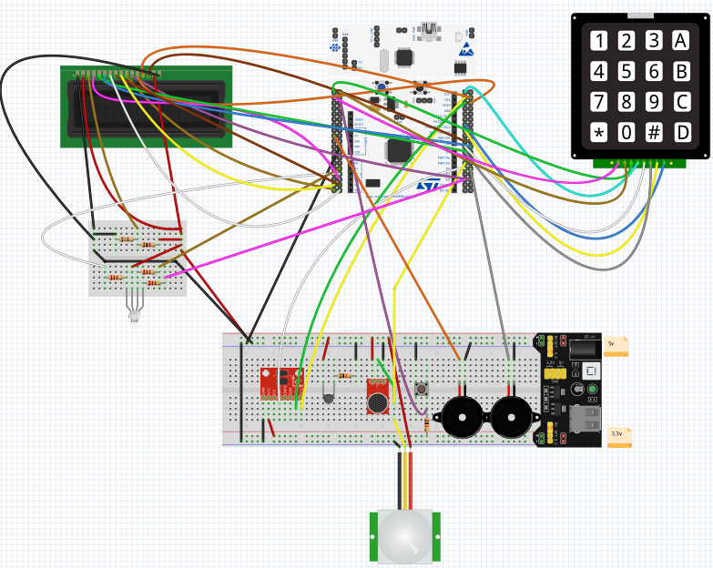

**CODE IMPLEMENTATION**

The code is divided into a couple of header/source files. The main part of the program is implemented in the alarm source file.

**Enums defined in the alarm header file**

|  |  |  |
| --- | --- | --- |
| Name | Values | Description |
| Alarm_state | Alarm_init, Alarm_idle, Alarm_arming, Alarm_armed, Alarm_PRE_Trigged, Alarm_Trigged, Alarm_SetTemp, Alarm_SetGyro, Alarm_setCode | Contains all the states for the  state machine. |
| Key_Code | Key_No_Pressed, Key_Pressed,  Key_OK,Key_Wrong, Key_A, Key_B, Key_C, Key_D | This enum is used for the  function that returns the current state of the keypad. The function does also check if the right code is entered. |
| Sensor_status | NONE, Motion_Trigged,  Sound_Trigged, Diamond_Trigged | This enum is used to indicate  the states of the sensors. A variable of this type is declared and used together with the external interrupts to indicate the states of the sensors. |
| LED_COLOR | L_OFF, L_RED, L_YELLOW,  L_GREEN | Contains all the different states the led can have in this program. |
| LCD_Status | LCD_NONE, LCD_Unlocked,  LCD_Locked, LCD_Arming, LCD_PRI_Trigged, LCD_Trigged, LCD_SetTemp, LCD_SetGyro, LCD_SetCode | This enum is like the alarm enum and is used to control the printed text on the LCD. |

**Functions defined in alarm header file**

|  |  |  |  |
| --- | --- | --- | --- |
| Function type | Function name | Function parameter list | Function description |
| void | Alarm_status | void | The alarm state machine is implemented in this function and every state calls a function. |
| Alarm_state | A_idle | TextLCDType lcd, uint8_t setTemp,  uint8_t code | This function is specifically for the idle state and relies on the function that checks the keypad status. |
| Alarm_state | A_arming | TextLCDType lcd, uint8_t code | This function is specifically for the arming state and returns a different state either if the code is entered or 30 seconds have passed |
| Alarm_state | A_armed | TextLCDType lcd, uint8_t setTemp,  uint8_t code | This function is specifically for the armed state and returns a different state if a sensor is trigged or the code is entered |
| Alarm_state | A_Pre_Trigged | TextLCDType lcd, uint8_t code | This function is for the pre_trigged state and contains a counter |
| Alarm_state | A_Trigged | TextLCDType lcd | If the user doesn’t enter code when the alarm is set of will this function run and handle the Trigged state |
| Alarm_state | A_setTemp | TextLCDType lcd, uint8_t setTemp, | This function will run when the user enters the setTemp state and handles all the setups when the user want to change Temperature |
| Alarm_state | A_setGyro | TextLCDType lcd | Works like A_setTemp but changes the threshold of the gyro instead |
| Alarm_state | A_setCode | TextLCDType lcd, uint8_t code | Works like A_setTemp and A_setGyro but changes the code instead |
| Key_code | Alarm_code_status | uint8_t code | Handles the code input |
| void | update_lcd | TextLCDType lcd, LCD_status tmpS | Used to update the text print out on the LCD |
| void | lcd_clearRow | TextLCDType lcd, uint8_t row | Clears a row on the LCD |
| uint8_t | check_sensors | uint8_t setTemp | Checks the status of the sensors and temperature |
| int16_t | Read_analog_Temp | void | Reads the Analog value of the thermistor and converts it to a temperature in Celsius |
| void | Toggle_Buzzer | void | Handles the passive buzzer |
| void | set_Led | Led_Color ld | Used to set the color of the RGB led |

**Functions defined in the keypad files**

|  |  |  |  |
| --- | --- | --- | --- |
| Function Type | Function name | Parameter list | Description |
| void | Keypad_init | void | Set all the keypad pins to high |
| Int8_t | Keypad_read | void | Checks if a button on the keypad is pressed by setting one column at a time and then checks the input from the rows. Returns 99 if a button isn’t pressed |
| void | keypad_setColumn | uint8_t column | Set all the columns outputs to high and then resets a specific one. |
| uint8_t | Keypad_Checkrow | uint8_t column | Checks the rows input value and returns the pressed keys value if a key is pressed. |

**Functions defined in ADXL345 files**

|  |  |  |  |
| --- | --- | --- | --- |
| Function type | Function name | Parameter list | Description |
| void | ADXL345_writeRegister | uint8_t regst, uint8_t value | This function is used to write a value to a specific register |
| void | ADXL345_ReadRegister | uint8_t regst, uint8_t *data | This function will read from a specific register |
| void | ADXL345_ReadRegisters | uint8_t regst, int8_t *tmpData, uint8_t dataLength | Almost same as “..readregister” but reads from multiple registers |
| void | ADXL345_init | void | Initiates the gyro in measure mode. |
| void | ADXL345_init_interrupt | void | Initiates the gyro in interrupt mode |
| void | ADXL345_clear | void | Used to clear an interrupt |
| void | ADXL345_setThreshold | uint8_t threshold | Used to set the threshold |