

**Code Complexity Measurement Tool**

**USER GUIDE**

**Software Project Management**

**Group Project**

Software Engineering Weekend Batch:**(WE-24)**

|  |  |
| --- | --- |
| **Student ID** | **Name With Initials** |
| **IT17121170** | **Ranasinghe N.K** |
| **IT17119122** | **Liyanage I.M** |
| **IT17120012** | **T. A. S. Shashiprabha** |
| **IT17092548** | **Kamburugamuwa K.L.A.P.T** |

**Table of Contents**

1. Login …………………………………………………..3
2. Register………………………………………………..4
3. File Upload ……………….…………………………..5-7
4. View Total Code complexity Of Uploaded file ……. 8-10

# 

# 

# 

# 

# 

# 

# 

# **1.0 Login**

If you already have an account, You can login to the system with your username and password.

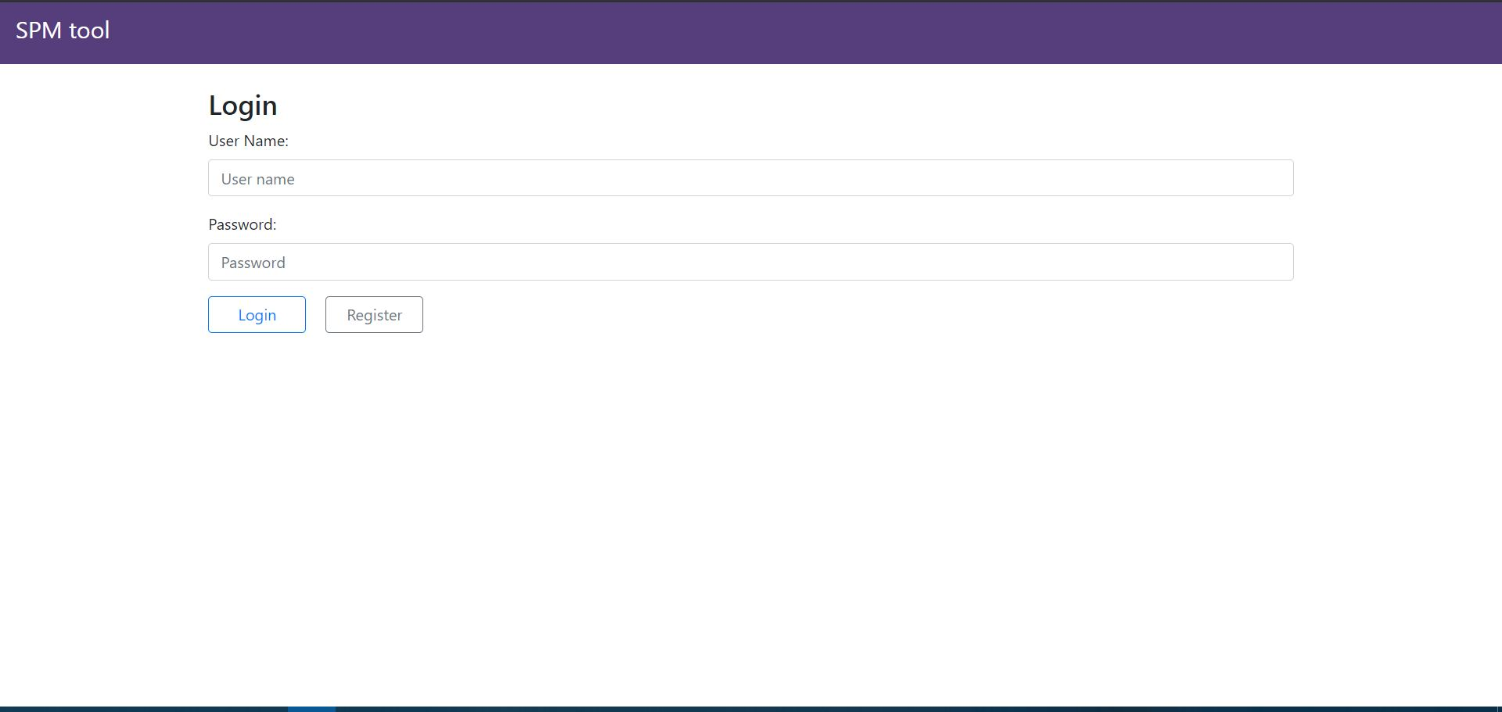

# 

# 

# **2.0 Register**

# 

If you don’t have an account ,You have to register to the system.

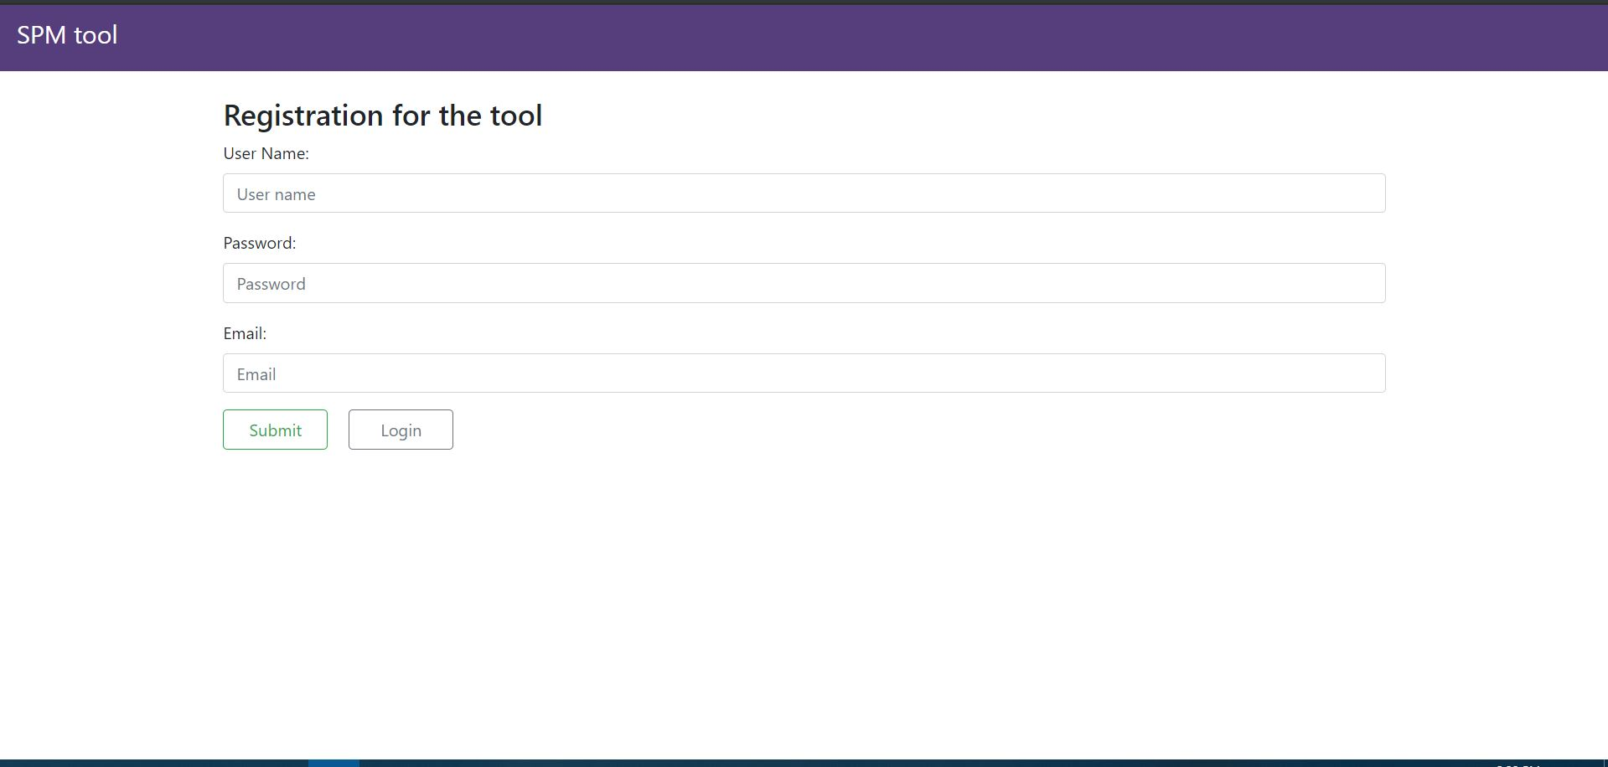

# 

# **3.0 File Upload**

Choose file from the driver and give a code key name, then upload it to the system.

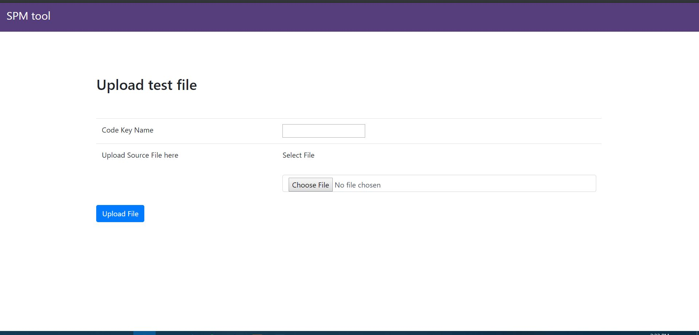

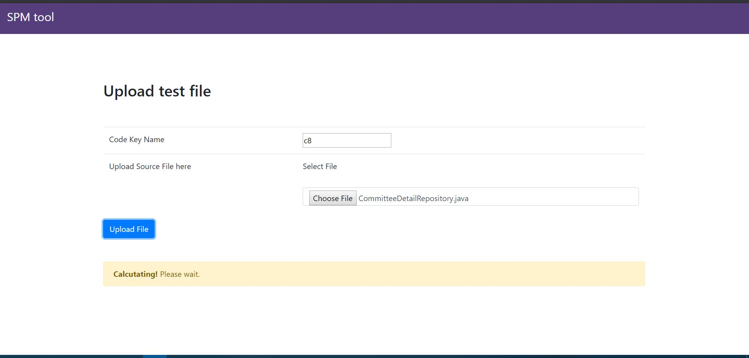

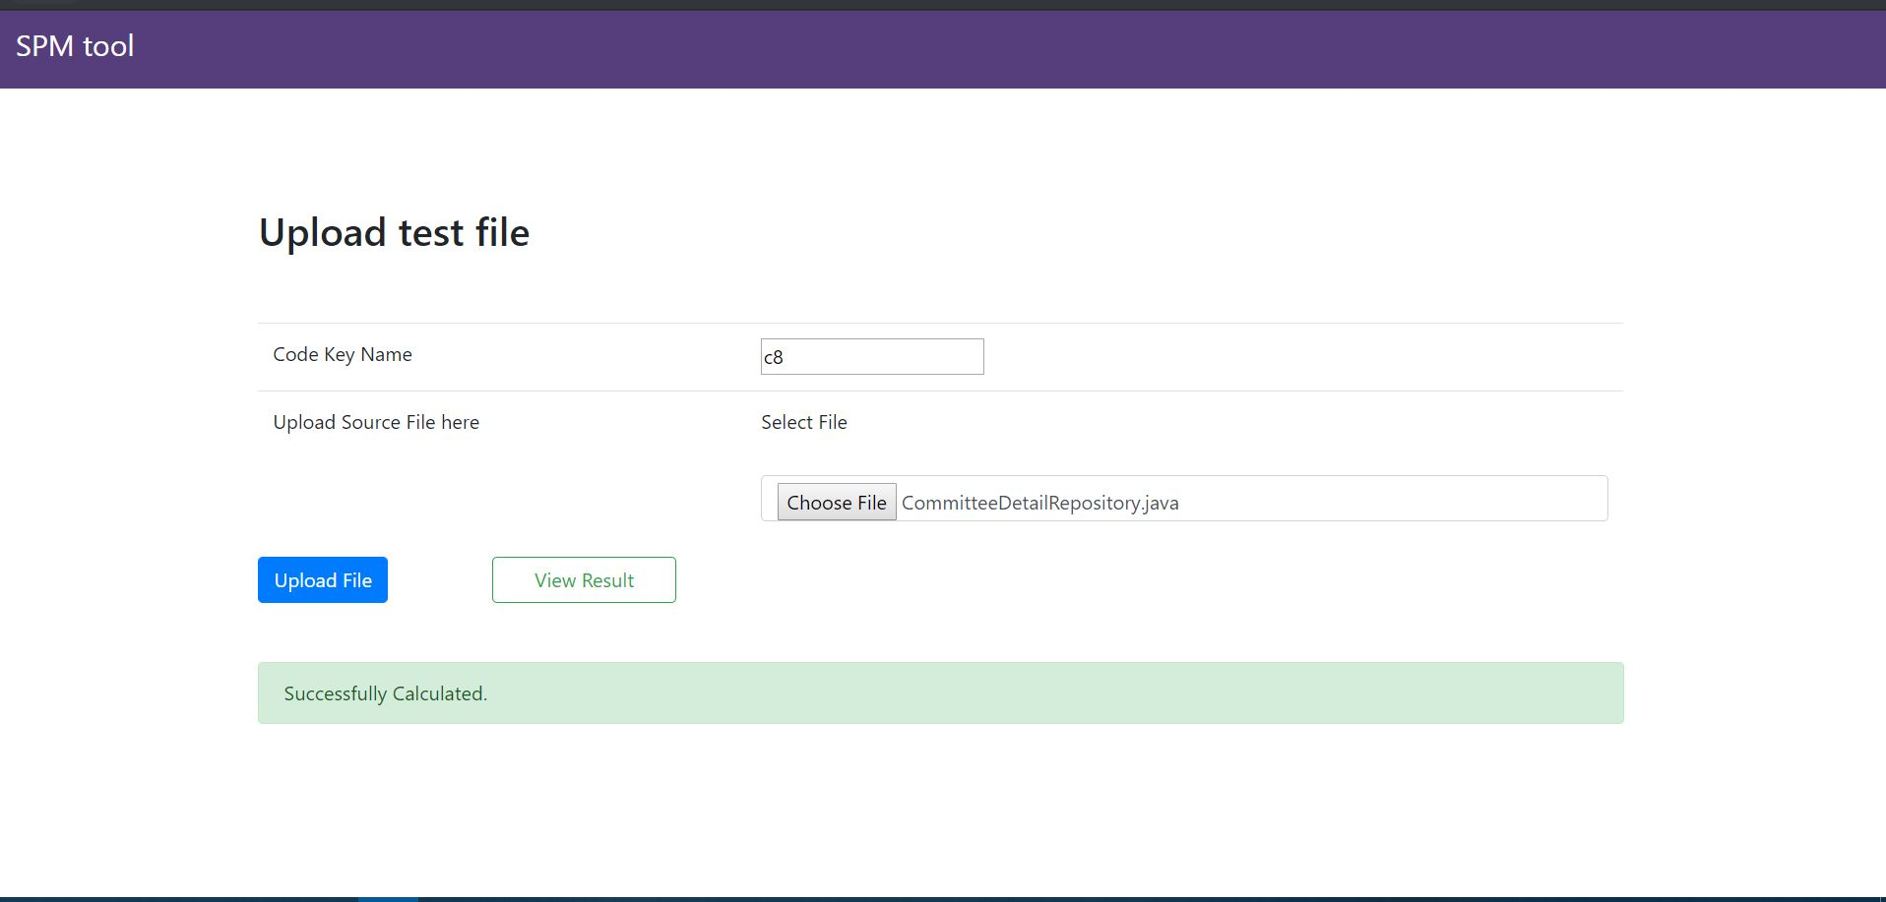

# **4.0 View Results**

# View total code complexity of uploaded code.

