最大公因數遞迴

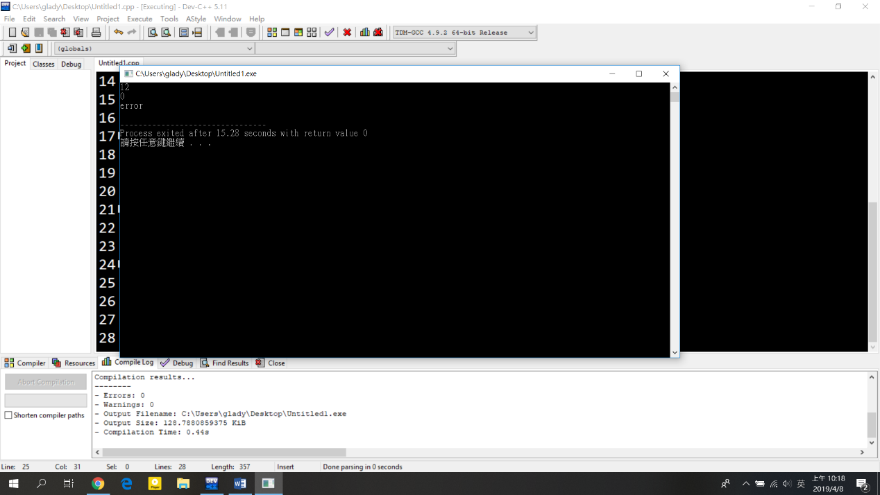#include<stdio.h>

int mcf(int x,int y){

if(x<y){

int tem = x;

x = y;

y = tem;

}

if(y==0){

return 0;

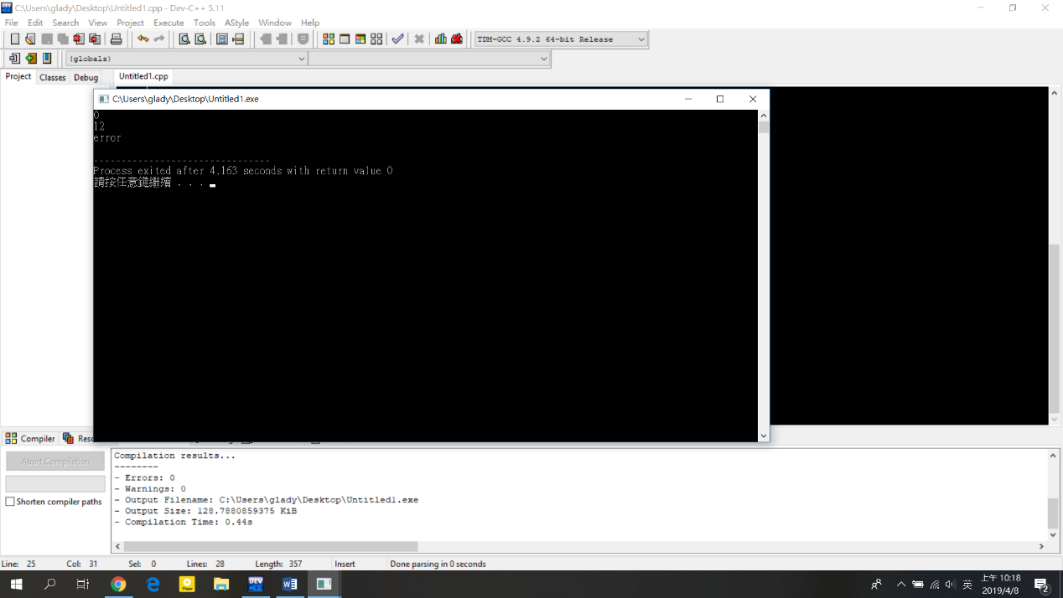 }

int m = x%y;

if(m==0){

return y;

}

return mcf(y,m);

}

int main(void){

int a,b;

scanf("%d %d",&a,&b);

int re = mcf(a,b);

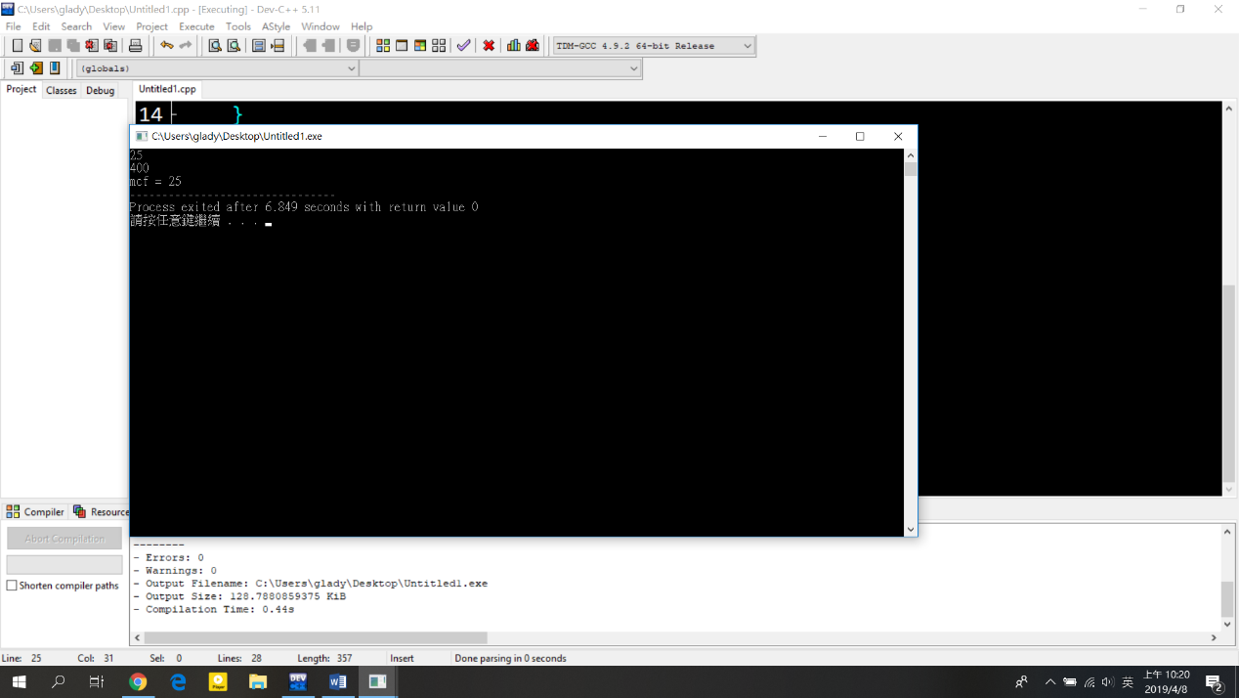 if(re == 0){

printf("error\n");

}

else{

printf("mcf = %d",re);

}

return 0;

}