Mapping the Measurement of Engineering Competencies: A Bibliometric Review of Technical and Transversal Constructs, 2014-2026
Segundo Francisco Segura Altamirano¹, Bertila Hernandez Fernandez¹
¹ Universidad Cesar Vallejo, Pimentel Km. 3.5, Chiclayo, Peru.
*Corresponding author(s). E-mail(s): sseguraal@ucvvirtual.edu.pe
Contributing authors: hfernandezb@ucvvirtual.edu.pe

Abstract
This bibliometric review examines measurement instruments for technical and transversal competencies among engineering students and the empirical evidence on their measurement properties, published between 2014 and 2026. A search across six databases (Scopus, Web of Science, IEEE Xplore, EBSCOhost, ERIC, and Dimensions), followed by two-stage screening — terminological, then semantic via a three-agent AI panel — yielded 96 articles. Bibliometric indicators (growth, co-citation, bibliographic coupling, co-authorship) were combined with LLM-assisted inductive thematic analysis, cross-checked through triangulation. The corpus shows sustained but decelerating growth (16.1% compound annual growth rate) and above-average field-normalized citation impact (mean FWCI 3.81), organized around Bandura’s self-efficacy theory alongside a comparably sized professional-competencies cluster, and validated predominantly through structural equation modeling. Collaboration is largely single-country (82.4%), engineering identity remains a narrow, still-emerging thread rather than a consolidated subtheme, and technical competencies are underrepresented relative to transversal ones. These findings describe an active but theoretically concentrated field, with opportunities for theoretical, methodological, and international-collaboration diversification.
Keywords: engineering education; competency measurement; psychometric properties; bibliometric analysis; self-efficacy; professional competencies.

Introduction
Competency-based education now occupies a central place in engineering accreditation frameworks. Initiatives such as CDIO (Conceive–Design–Implement–Operate) and criteria from bodies such as ABET have pushed institutions to redesign their curricula around measurable graduate attributes, rather than disciplinary content alone (Mahdi Al-Obaidi 2021; Salti et al. 2019). This pressure combines with that of employers, who demand evidence that graduates possess both technical competencies —design, simulation, technical problem-solving, prototyping— and transversal ones —critical thinking, communication, teamwork, self-regulation, professional ethics. Engineering programs in very different institutional contexts have responded by explicitly declaring these competencies in their curricula (Castelló et al. 2023), while early reviews had already warned about the need to specify and prioritize the set of generic competencies relevant to professional practice, given the ambiguity with which they tend to be stated in accreditation frameworks (Passow and Passow 2017). This convergence between accreditation requirements, labor-market demand, and curricular renewal has driven, over the past decade, a notable proliferation of measurement instruments designed specifically for engineering students —questionnaires, scales, rubrics, situational tests. However, this proliferation of instruments has not been accompanied by an equivalent systematization of the empirical evidence supporting their measurement properties, leaving those who must select, adapt, or develop an instrument without a clear map of what exists, for which population, and with what psychometric robustness.
Reading this literature as a coherent field is not straightforward, because at least three sources of heterogeneity coexist. The first is conceptual: seemingly related constructs —design mindset, compassion, entrepreneurial traits— have been operationalized from distinct theoretical frameworks and without shared terminology across studies (Lavrsen et al. 2024; Baquero-Sierra et al. 2025; Daud et al. 2019). The second is methodological: instrument validation draws indistinctly on exploratory and confirmatory factor analysis, structural equation modeling, or item response theory, without explicit consensus on when each approach is most appropriate; even studies that re-validate the same instrument in a national context different from the original combine several of these techniques simultaneously in order to compare their results with those of the initial validation (Direnga and Kautz 2019). The third is epistemological: recent work has questioned the over-reliance on factor analysis and latent-structure assumptions when measuring complex psychological constructs in engineering contexts, calling for more explicit reflection on what validity means in this specific domain (Fernandez and Werth 2025). This fragmentation makes it difficult to accumulate comparable evidence from one study to the next and complicates any attempt to compare instruments with one another or to decide which one is best suited to a given context.
Existing syntheses of this literature have made progress, but only partially. Some reviews focus on a single competency or mindset —for example, the curiosity, value-creation, and connections components of the entrepreneurial mindset (Jackson et al. 2026), or transversal competencies examined within a particular program (Simin and Vrgović 2025)— without offering a panoramic view of the full set of instruments available for engineering as a whole. Others are limited to a single type of tool, such as reviews focused specifically on the use of rubrics to assess entrepreneurial-minded learning (Park et al. 2020) or on instruments used to evaluate engineering laboratories (Nikolic et al. 2021), leaving questionnaires, scales, and situational tests that rely on different validation logics outside their scope. A recent review focused specifically on employability illustrates the underlying problem: by systematically examining the instruments available for this construct, it identified recurring limitations in conceptual clarity, disciplinary specificity, and the rigor of empirical validation, with no synthesis until then that integrated these observations at the scale of the field (Zhan et al. 2026). Taken together, these reviews show that attention to measurement properties —construct validity, reliability, measurement invariance— has been uneven across competencies and instruments, and that none yet offers an integrative map of the instruments used with engineering students to measure both technical and transversal competencies.
Faced with this fragmentation, bibliometric methods offer a way to visualize the field’s structure —its growth, its collaboration ties, its conceptual evolution— that narrative reviews centered on a single construct can hardly capture. Bibliometric reviews conducted in related engineering-education subfields have shown that this type of analysis can trace the thematic evolution and output of a research community over several decades (Narong and Hallinger 2024b, 2024a; Qiu and Natarajarathinam 2024), and can even combine bibliometric mapping with specific conceptual frameworks —such as CDIO itself— to situate the evolution of a subfield within a broader educational agenda (Alarcon-Pereira et al. 2023). This quantitative lens can be complemented with an inductive thematic analysis that helps interpret the patterns detected; recent developments in using large language models to support inductive thematic analysis —including discussions of their limits (De Paoli 2024), of criteria for assessing the thematic saturation reached by the model (De Paoli and Mathis 2025), and of prompt designs that make this process more replicable (Khalid and Witmer 2025)— offer a methodological avenue still little explored in reviews of engineering competency-measurement instruments. Combining both perspectives, subject to an explicit triangulation procedure, can yield an understanding of the field that neither would achieve on its own.
In this context, the objective of the present review is to identify and characterize the instruments used to measure technical and transversal competencies in undergraduate and postgraduate engineering students, and to map the empirical evidence available on their measurement properties published between 2014 and 2026. The review is organized around five guiding questions: (RQ1) how has production on the topic evolved and what temporal dynamics does it present; (RQ2) what is its intellectual structure, that is, which works and citation lineages underpin it; (RQ3) what collaboration patterns characterize those who produce it; (RQ4) what are the dominant conceptual themes and how have they evolved; and (RQ5) what gaps and emerging fronts define the current research agenda. To answer these questions, bibliometric indicators —citation, bibliographic coupling, and co-word— are integrated with an inductive thematic analysis and a triangulation procedure across approaches, so that interpretations do not rest on a single type of evidence.
The corpus is delimited to six databases (Scopus, Web of Science, IEEE Xplore, EBSCOhost, ERIC, and Dimensions), to the 2014–2026 period, and to documents centered on undergraduate or postgraduate engineering students that report original empirical evidence on at least one measurement property of a technical or transversal competency instrument; excluded are studies that use an already-validated instrument solely as an intervention outcome, non-academic reports, and instruments applied to populations outside engineering. With these delimitations, the review is expected to provide a structured map integrating the field’s growth profile, intellectual structure, collaboration networks, and conceptual axes, useful for those who must select, adapt, or develop competency-measurement instruments in engineering education. The rest of the article is organized as follows: Section 2 describes the bibliometric and inductive-thematic-analysis methodology used, including the triangulation procedure; Sections 3 through 8 present the results organized around the axes of growth, intellectual structure, collaboration, conceptual structure, emerging fronts, and normalized impact; and Section 9 discusses their implications and limitations.

Methodology

Search strategy and eligibility
The search was run across six databases (Scopus, Web of Science, IEEE Xplore, EBSCOhost, ERIC, and Dimensions), combining conceptual blocks for context (engineering education), construct (technical or transversal competency), instrument (questionnaire, scale, rubric), and psychometric evidence, under a PCC framework (Population-Concept-Context). The string applied in Scopus, adapted to the syntax of each remaining database, was:
TITLE-ABS-KEY (
( "engineering education" OR "engineering student*" OR "engineering undergraduate*" OR "engineering curriculum" OR "electronic* engineering" OR "electrical engineering" )
AND
( competenc* OR "soft skill*" OR "transversal skill*" OR "generic skill*" OR "professional skill*" OR "employability skill*" OR "self-efficacy" OR "critical thinking" )
AND
( questionnaire* OR scale* OR inventory OR rubric* OR "measurement instrument*" OR "assessment tool*" OR "assessment instrument*" )
AND
( psychometric* OR validit* OR validat* OR reliabilit* OR "internal consistency" OR "factor analys*" OR "item response theory" OR "measurement invariance" )
)
Eligibility criteria required a population of undergraduate or postgraduate engineering students (mixed samples admissible if engineering is explicitly represented), a declared technical or transversal competency construct, an identifiable instrument, and original empirical evidence on at least one measurement property, in documents published between 2014 and June 30, 2026, in English, Spanish, or Portuguese. Reviews, editorials, theses, preprints, and protocols were excluded, as were studies that administer an already-validated instrument solely as an intervention outcome.

Deduplication and PRISMA flow
Multi-database consolidation followed the approach for combining and cleaning bibliometric data across databases recommended in the methodological literature (Lim et al. 2024), with an integration logic comparable to that of tools dedicated to multi-database merging (Chansanam and Li 2025). A total of 1,193 raw records were identified (Scopus 579, IEEE 236, WoS 160, EBSCOhost 136, ERIC 55, Dimensions 27); after removing 3 records lacking a title or authorship, 1,190 records entered deduplication by DOI match (207 pairs) and fuzzy title similarity (77 pairs), yielding 906 unique records, to which candidates identified through citation snowballing via OpenAlex were added, for a total of 911 records entering screening. The flow diagram (Figure 1) follows the recommendations of PRISMA 2020 and its PRISMA-S extension for reporting sources and tracking records (Rethlefsen and Page 2022).
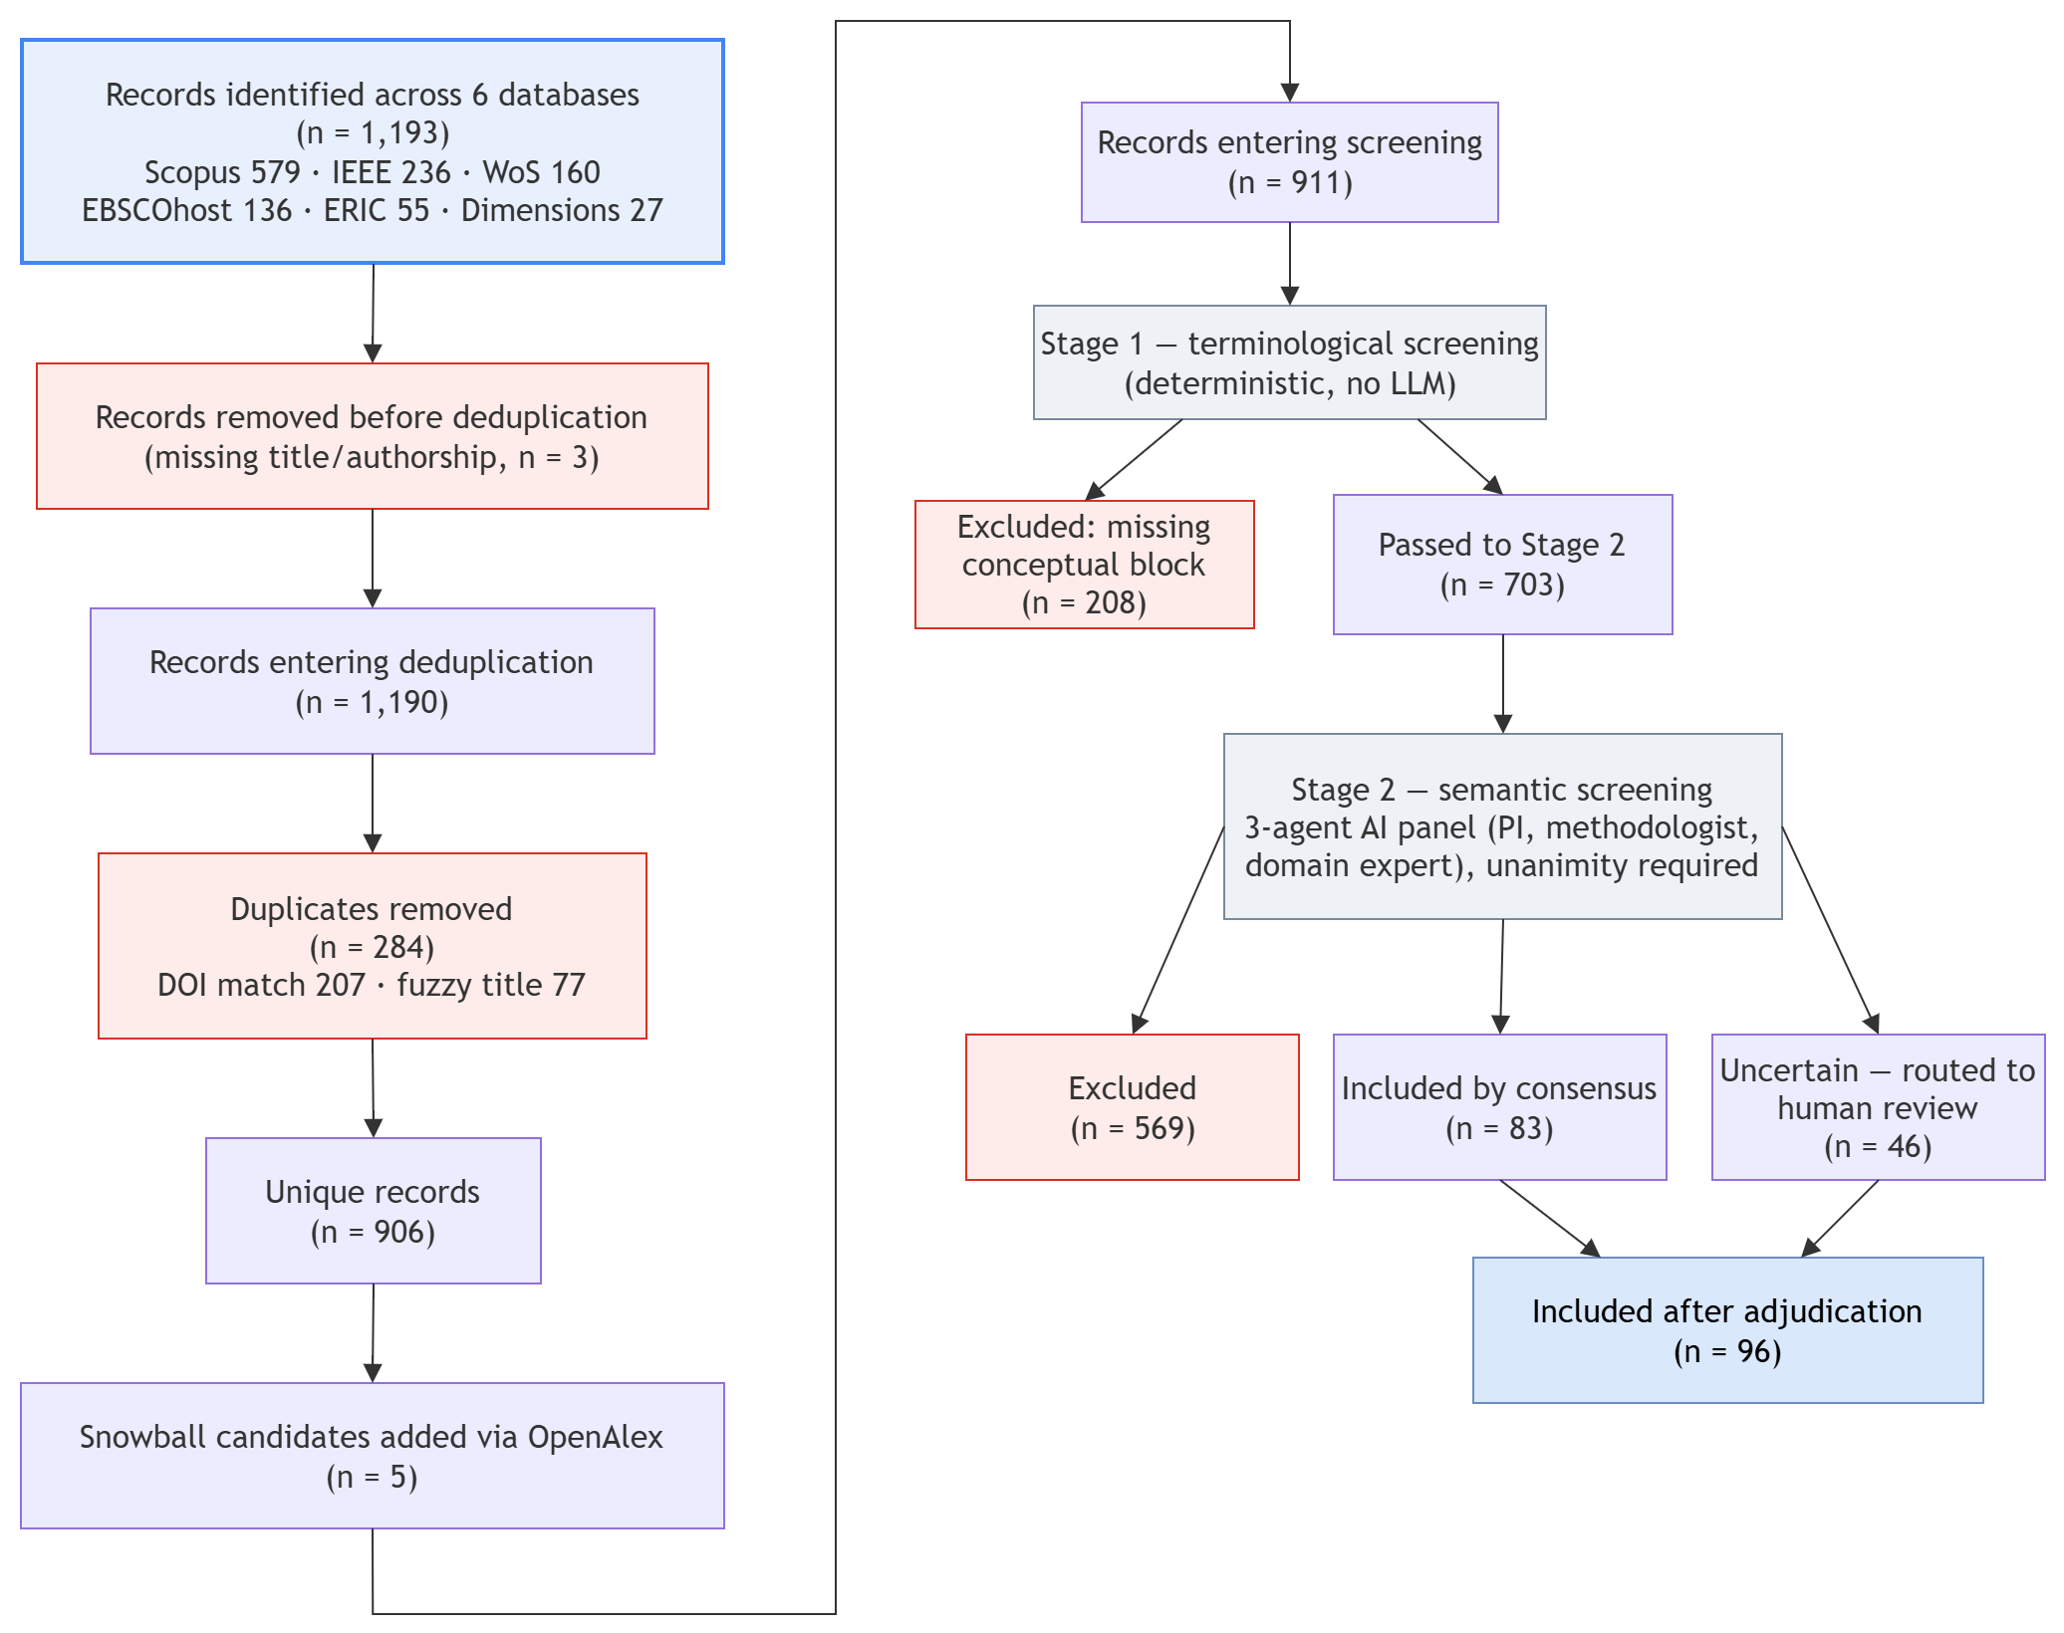
Figure 1. PRISMA-style flow diagram: records identified across six databases (n = 1,193), deduplication to 906 unique records plus 5 snowball candidates (n = 911 screened), two-stage screening, and the 96 studies included in the review.
The overall analytical pipeline, from record intake through final synthesis, is summarized in Figure 2.
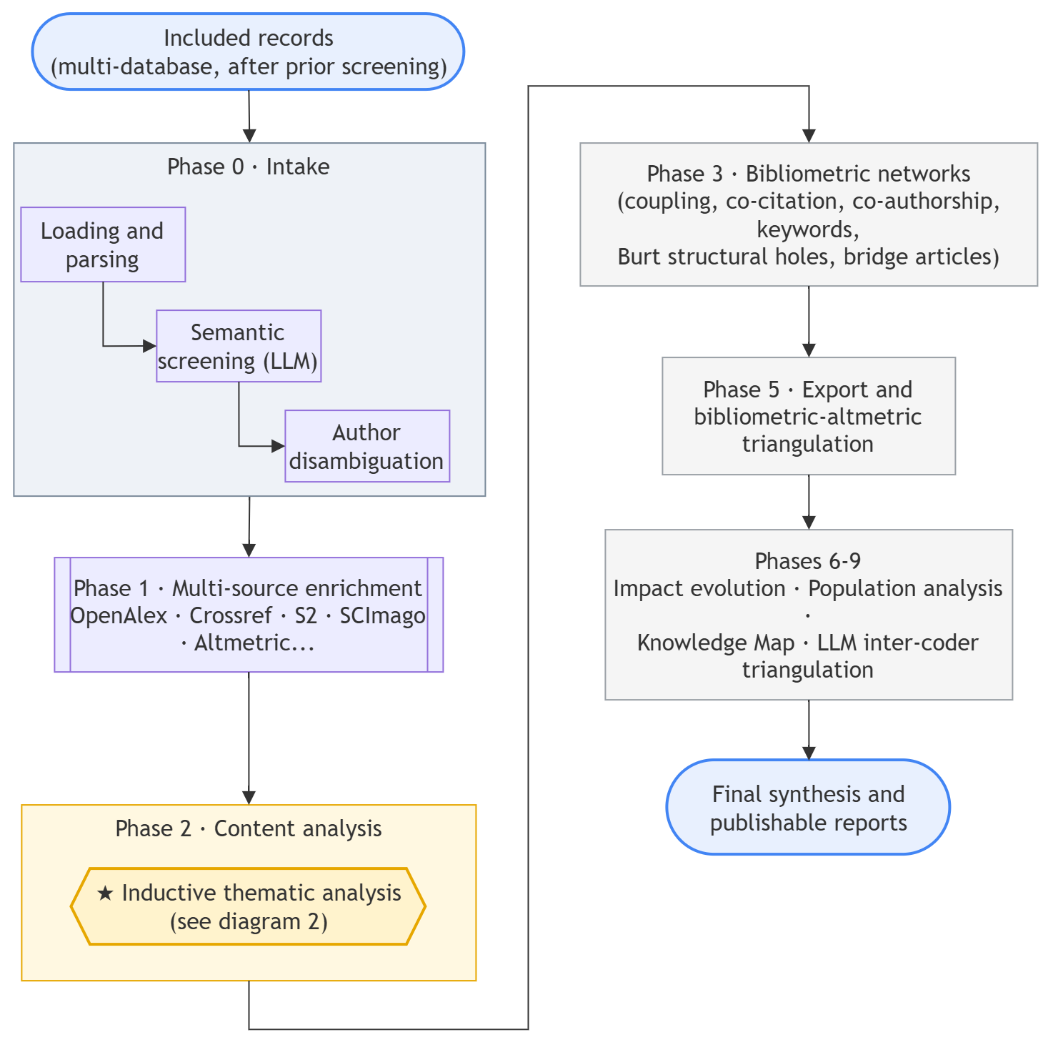
Figure 2. Overview of the nine-phase analytical pipeline, from record intake and multi-source enrichment through bibliometric networks, impact evolution, and final synthesis.

Screening
Screening was carried out in two stages, following an AI-assisted screening pillar within a broader bibliometric-analysis methodological framework (Stefanis et al. 2025). Stage 1 (terminological, deterministic, no LLM) excluded 208 records for the absence of a mandatory conceptual block, leaving 703 for Stage 2. Stage 2 (semantic) used a panel of three AI agents with complementary roles (principal investigator, methodologist, domain expert), each evaluating the full article through its own lens against the protocol’s construct, context, and evidence axes; the decision required unanimity: 569 records were excluded, 83 were included by consensus, and 46 remained uncertain for human review. After adjudication of the uncertain cases and removal of one near-duplicate record missed by automated deduplication (a title/subtitle variant indexed separately by two databases), the final corpus stood at 96 articles, consistent with the protocol’s precedence rule of never excluding under ambiguity.

Extraction and enrichment
Complete metadata (title, abstract, authorship, affiliation, keywords, citations where reported by the source) were consolidated from the six databases through identifier harmonization (DOI, ORCID where available). Additional enrichment was limited to OpenAlex, used to classify open-access status and for citation snowballing, via its application programming interface (Aria et al. 2023). Metadata completeness (DOI 76.9%, volume 59.8%, affiliations 69.6%) is reported as a precision limitation for analyses that depend on these fields.

Descriptive and network bibliometric analysis
The corpus’s growth profile was characterized using Bradford’s law (Bradford 1934) (core journals), Lotka’s fit (Lotka 1926) (author productivity), and the compound annual growth rate, using the VOSviewer, Bibliometrix/RStudio, and CiteSpace 6.3.R1 (Chen 2006) toolset in a complementary fashion (Kemeç and Altınay 2023). The intellectual structure was mapped through reference co-citation (5-year window, threshold ≥3 citations) and bibliographic coupling (threshold ≥2 shared documents); the social structure, through co-authorship with betweenness-centrality calculation, structural holes (Burt), and community detection (Louvain (Blondel et al. 2008)). The combination of these techniques —co-citation, co-word, and coupling— follows the science-mapping triangulation logic documented in related domains, where no single method alone captures a field’s complete structure (Wen et al. 2017; Kumkale Açikgoz and Arısoy 2026).

Conceptual and inductive thematic analysis
The conceptual structure was triangulated between keyword co-occurrence (threshold ≥5 occurrences) and an LLM-assisted inductive thematic analysis, detailed in Figure 3, whose unit of analysis was the title + abstract of each included record, not the full article. Thematic discovery was run in batches with a hierarchical synthesis engine, supported by Sentence-BERT embedding clustering for cross-checking against keyword clusters (Keerthi et al. 2026; Pereira et al. 2025).
The default provider was DeepSeek, with an independent triangulation run on the same corpus using Gemini and ChatGPT. Each internal phase included grounding verification of textual quotes against the source abstract, rather than an independent human coder panel; this limitation is consistent with recent warnings about the hallucination risk of generative tools applied to bibliometric analysis, which recommend complementing rather than replacing researcher judgment (Sarachuk 2025). LLM-induced themes were treated as supporting, not central, evidence, and were cross-checked against the keyword clusters before being reported.
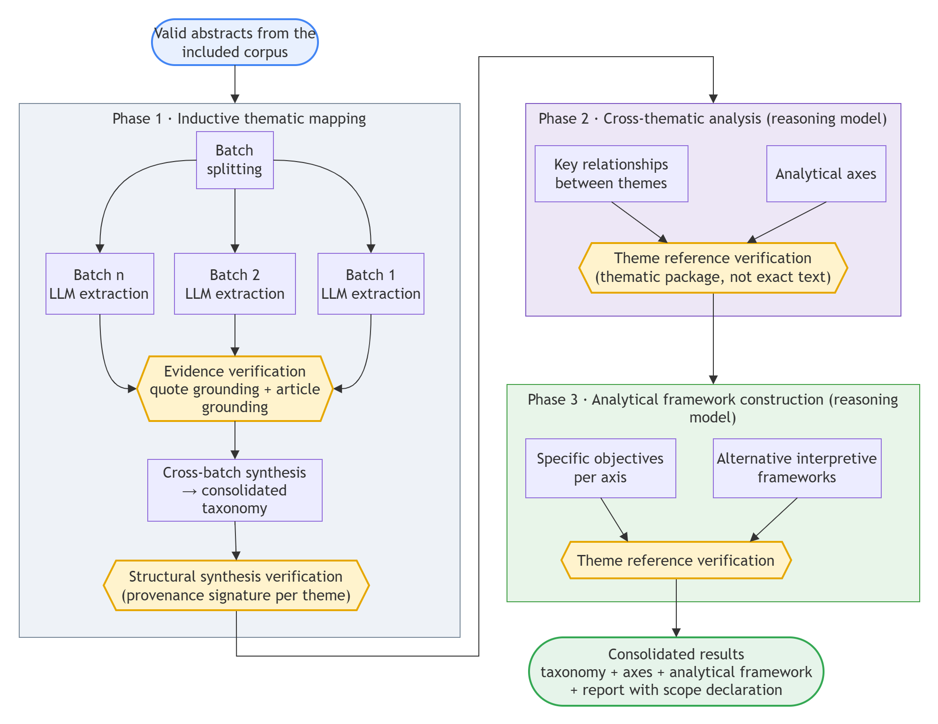
Figure 3. Three-phase inductive thematic analysis workflow, from batch-level LLM extraction with grounding verification through cross-thematic analysis and analytical framework construction.

Impact and quality indicators
Field-normalized indicators were calculated —Field-Weighted Citation Impact (FWCI) (Purkayastha et al. 2019), Mean Normalized Citation Score (MNCS), and Leiden indicators— all with bootstrap confidence intervals (95% CI) given the reduced size of the subsamples with available data (n=49 for FWCI, n=86 for the MNCS bootstrap). The comparison between articles with and without an article-processing charge (APC) was performed using the Mann-Whitney U test, with the result reported as an exploratory association rather than causal evidence.

LLM-assisted gap detection and Research Dynamics Manifold (RDM)
An additional LLM-based module extracted research gaps from the limitations and conclusions sections declared in the corpus, with the same mechanical grounding control described above and no independent human coding panel; its results feed into the discussion, not the central findings. In a complementary fashion, each article was positioned in a [0,1]³ space of Emergence (Price index, Kleinberg burst, and keyword novelty), Impact (power mean of MNCS, FWCI, citation velocity, and social attention), and Connectivity (betweenness, interdisciplinarity, collaboration, and sigma), and classified into eight archetypes based on the combination of the three axes.

Cross-phase triangulation
Findings from the quantitative (bibliometric), qualitative (inductive themes), and LLM-based (gaps) phases were systematically compared; a finding was considered triangulated when at least two independent phases supported it, and divergences were reported as nuances rather than discarded. This procedure follows the principle that triangulating distinct approaches yields a more complete picture of the field than any single method applied on its own (Jagirdar and Gupta 2026).

Results

A young field in sustained expansion
The analyzed corpus —96 articles published between 2014 and 2026— documents the emergence of a still-forming research domain: the psychometric measurement of technical and transversal competencies in engineering education. Output grows at a compound annual growth rate (CAGR) of 16.1%, peaking at 12 publications in 2025 (Figure 4). This pace shows signs of recent deceleration: the last five years (38 articles) produced 13.6% fewer articles than the preceding five-year period (44), suggesting that the field is transitioning from a take-off phase toward consolidation. The corpus draws on 320 authors —whose productivity fits Lotka’s law reasonably well— working across 120 institutions in 34 countries, with English as the dominant language (83.3%). Publications are spread across 47 distinct journals, with the top five covering 21.9% of the corpus and the International Journal of Engineering Education as the single largest venue (7 articles), a modest rather than pronounced Bradford-type core. External funding is scarce (13.5% of articles, led by the National Science Foundation) and metadata completeness averages 68.4% across eight tracked fields, two indicators that, together with the 38.5% of articles alignable with SDG 4 (Quality Education, the most frequent of the 55.2% of articles mapped to at least one Sustainable Development Goal), describe a field with still-limited funding resources. In terms of reception, the corpus accumulates 1,299 total citations (mean 13.53 per article; h-index=18), a median reference age of 10 years (Price 1970) (Price index, median 27.7%, n=73), portraying a literature of moderate rather than fleeting currency.
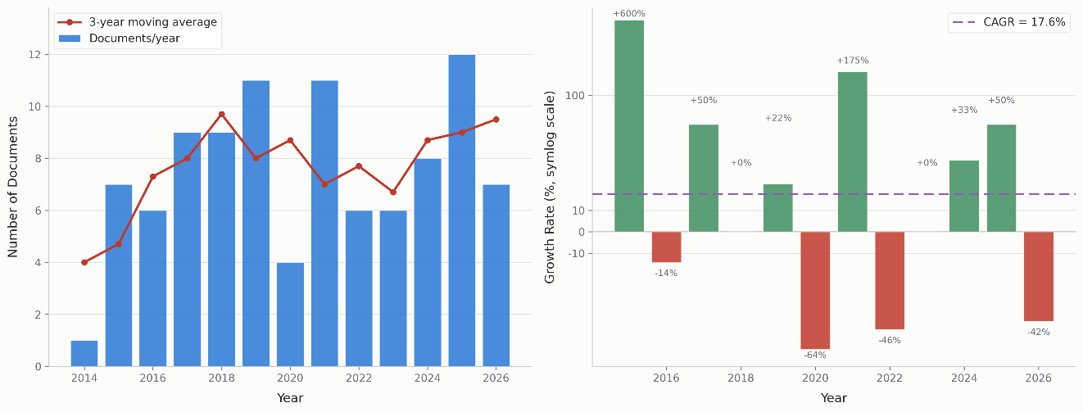
Figure 4. Annual publication growth and year-over-year growth rate of the corpus (2014–2026), with 3-year moving average and compound annual growth rate (CAGR = 16.1%).

Bandura’s self-efficacy as the dominant theoretical core
Co-citation analysis and reference spectroscopy reveal an intellectual structure strongly centered on Bandura’s social-cognitive theory: his 1977 works (Bandura 1977a, 1977b) accumulate 42,860 and 35,552 citations across two distinct records, and a 1978 work (Bandura 1978) adds a further 10,604 citations, positioning them as the field’s dominant theoretical foundation (Figure 5). The most-cited article in the corpus itself, “Measuring Undergraduate Students’ Engineering Self-Efficacy: A Validation Study” (Mamaril et al. 2016), accumulates 296 citations and exemplifies this centrality; it is also the corpus’s top-ranked article on the Research Dynamics Manifold described below. A pivot node confirms this framework’s structuring role: Self-Efficacy: The Exercise of Control (Bandura 1997) bridges three otherwise-separate clusters with a betweenness of 0.0355 and a sigma of 1.23 (high novelty combined with centrality), while a second, methodological node —Kline’s (2005) manual on structural equation modeling (SEM)— bridges four clusters (betweenness 0.041, sigma 1.38, citation burst strength of 8), evidencing that the field’s psychometric validation rests almost uniformly on SEM. The conceptual life-cycle analysis confirms this core’s relative maturity: of 25 central concepts, 22 remain in the foundational phase, 3 are active, and none is in decline, with the concept Engineering reaching its peak of 126 accumulated references in 2017. This intellectual structure’s normalized citation performance is more modest than its theoretical centrality would suggest: the corpus-wide Mean Normalized Citation Score (n=96, including uncited articles) is 0.927, with only 19 of 96 articles above the field’s world average and a top-10% proportion of 9.4% (9 articles) — indicators that place the corpus, taken as a whole, close to rather than above the citation performance expected for its discipline, a more tempered reading than the field-normalized impact reported in Section 6 below for the subsample with OpenAlex-derived indicators.
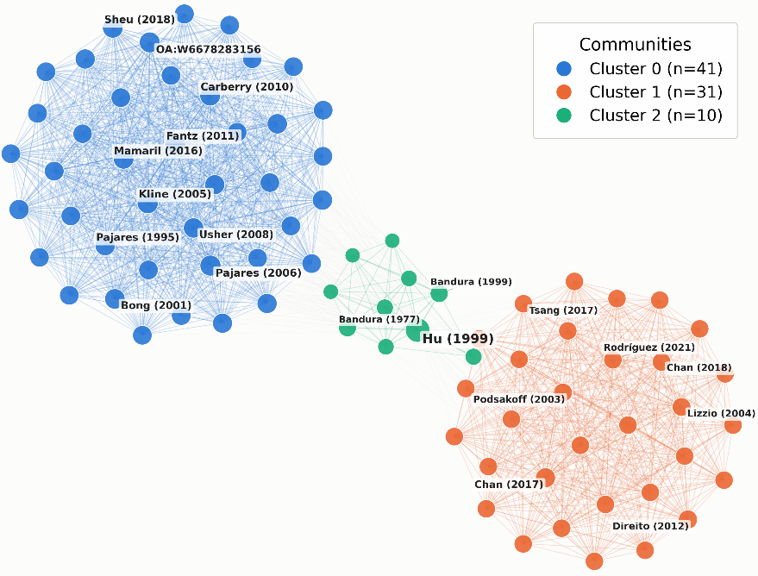
Figure 5. Co-citation network of the corpus’s most influential references, showing three thematic clusters and the bridging role of Bandura (1977, 1997) and Kline (2005).

Emerging but still incipient international collaboration
The field’s social structure is predominantly national: of the 74 articles with available country data, 82.4% correspond to single-country authorship (SCP) and only 17.6% to multinational collaboration (MCP; 95% CI 9.46–27.03%). The international ties identified in the collaboration network correspond mainly to scale-validation studies in local contexts: Khampirat (2021) developed and validated a self-regulation instrument in Thailand; Suasnavas and Rosero (2022) adapted a competency scale in Ecuador; and Lee et al. (2025) worked in a problem-based-learning context in South Korea. These cases, international in subject matter but carried out mostly within a single country, are consistent with the observed SCP predominance and suggest that current cross-border collaboration arises from the cultural adaptation of already-validated instruments (Luk and Chan 2020) rather than from joint research programs. This pattern is consistent with the context-bound nature of psychometric measurement instruments, which require local validation, and is coherent with the still-available room for growth in cross-border collaboration indicated by the width of the MCP rate’s confidence interval (Figure 6).
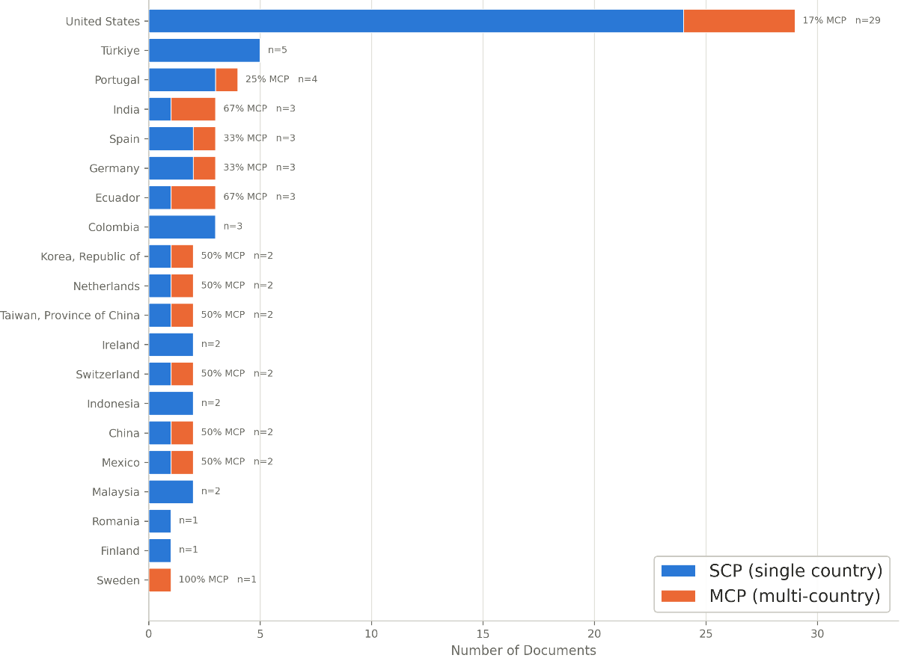
Figure 6. Distribution of single-country (SCP) and multi-country (MCP) collaboration by country of authorship.

A broadened conceptual structure anchored in self-efficacy and professional competencies
The conceptual structure, triangulated between keyword co-occurrence and inductive thematic analysis, converges on a field organized around the psychometric validation of competency-measurement instruments rather than a single narrow axis. The most consolidated inductive theme, “Self-Efficacy and Learning Experiences in Engineering Education” (approximately 30 studies, high robustness), is consistent with the centrality of self-efficacy measures documented above, as seen in instruments validated by (Mamaril et al. 2016) and (Paul et al. 2018). A second high-robustness theme, “Professional, Ethical, and Generic Competencies in Engineering Education” (approximately 22 studies), reflects sustained attention to transversal-skill assessment (Motahhari-Nejad 2021; Tormey and Laperrouza 2023). Smaller high-robustness themes complete the map: “Motivational and Career-Related Constructs” (approximately 9 studies), “Impact of Experiential Learning” (approximately 8 studies), and “Critical Thinking and Decision-Making” (approximately 6 studies). Two medium-robustness themes —“Socio-Emotional and Psychological Competencies” (approximately 3 studies) and “Sustainability and Ethics Competencies” (approximately 2 studies)— indicate emerging but still fragmentary lines of inquiry. Within the co-citation network, Allison Godwin’s (2016) identity-focused work functions as a pivot node bridging three clusters (betweenness 0.0285), a still-modest structural signal that engineering identity is beginning to connect previously dispersed communities without yet constituting a consolidated subfield on its own (Figure 7).
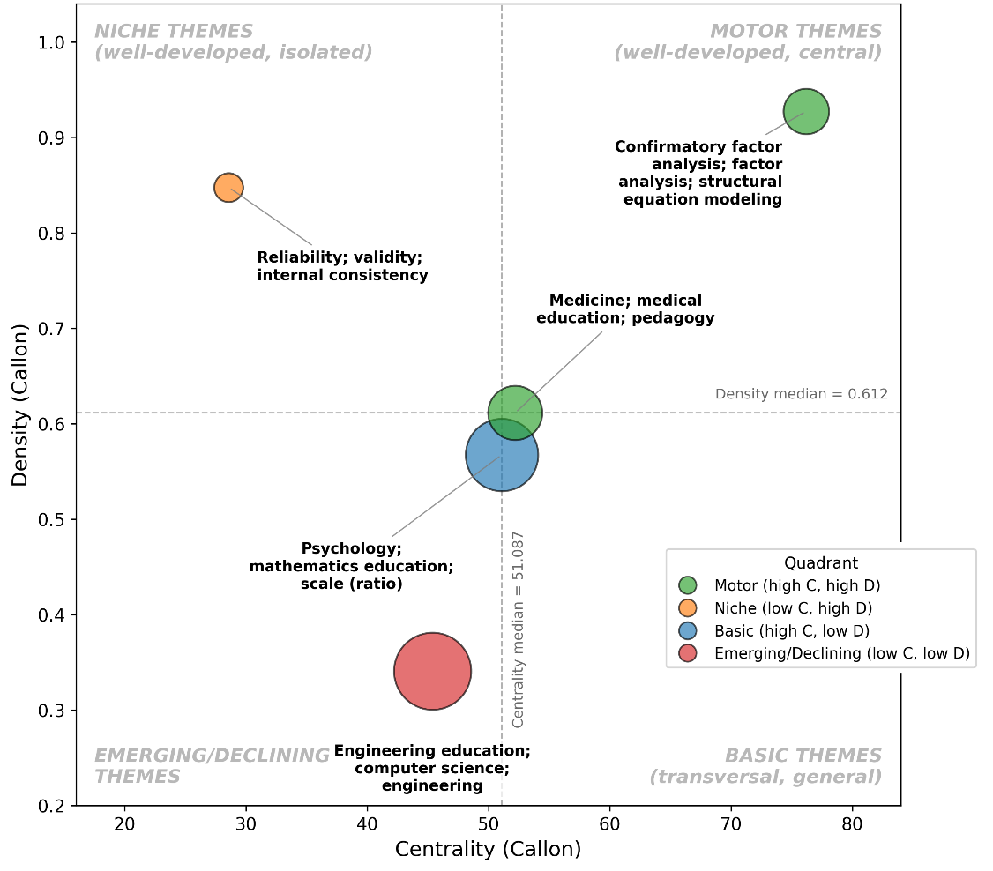
Figure 7. Thematic landscape map of the corpus’s keyword network, showing five overlapping clusters including a self-efficacy/engineering cluster.

Emerging fronts: SEM, educational physics, and methodological diversification
Burst detection analysis identifies the vectors of greatest recent dynamism. Structural equation modeling emerges as an entirely new growth front (3 recent articles), and physics shows the same pattern at a smaller scale (2 recent articles), while self-efficacy shows growth 1.65 times higher than expected (11 recent occurrences), confirming its acceleration as a central axis rather than its exhaustion. In parallel, quantitative methods show a growth ratio of 1.68× over a small but recent cluster of studies, indicating continued methodological reliance on structured, self-report instruments —consistent with survey methodology dominating the corpus’s research designs (66 of the studies with a coded method)— rather than a shift toward experimental or mixed-methods designs, which remain marginal (3 and 4 studies, respectively). Taken together, these burst patterns show theoretical consolidation around self-efficacy alongside methodological expansion in SEM, with no evidence of new theoretical frameworks emerging during the period analyzed (Figure 8).
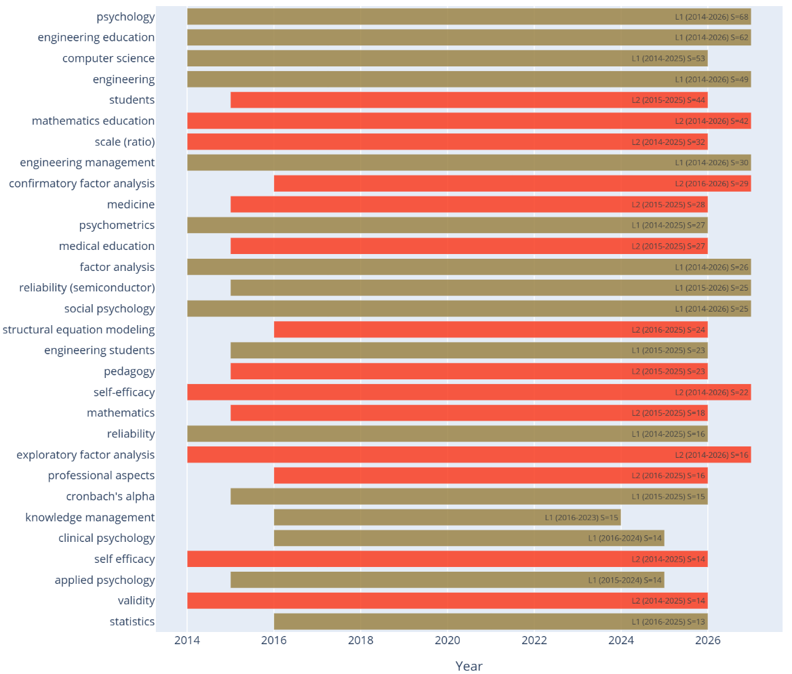
Figure 8. Burst detection: entirely new research fronts (structural equation modeling, physics) and the accelerating self-efficacy and quantitative-methods fronts.

Field-normalized impact: a high-citation tail
Restricted to the subsample of 49 articles with OpenAlex-derived indicators, normalized impact positions that subset above the disciplinary average: the mean Field-Weighted Citation Impact (FWCI) is 3.81 (95% CI 2.31–5.78), with 57.1% of articles exceeding the world average (Figure 9a). The top-decile proportion within this subsample (PP top 10%) is 10.2%, close to the value expected under a uniform distribution, indicating that the elevated impact is concentrated in a tail of highly cited works rather than uniformly distributed. Within that tail, the two most pronounced delayed-recognition (“sleeping beauty”) cases are McCormick et al.’s (2015) motivation-to-engage scale, with a beauty coefficient of 20.6 after nine dormant years and a citation peak in 2024, and (Mamaril et al. 2016), which after eight years of latency accumulates the corpus’s 296 total citations (Figure 9b). A corpus-wide bootstrap cross-check of the Mean Normalized Citation Score (0.989; 95% CI 0.62–1.48; n=90) is closer to the world average than the FWCI subsample suggests, and the Citation Success Symbol classification — applied to the full corpus of 96 articles — places the majority of the output (72 articles) in the poorly cited category, with 16 fairly cited, 7 remarkably cited, and 1 outstandingly cited, describing an asymmetric impact distribution in which a small number of works account for a disproportionate share of the corpus’s visibility.
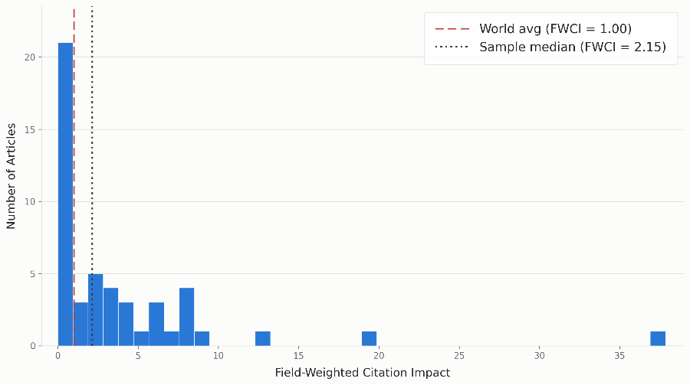
Figure 9a. Distribution of the Field-Weighted Citation Impact (FWCI) across the OpenAlex-indicator subsample (n=49).
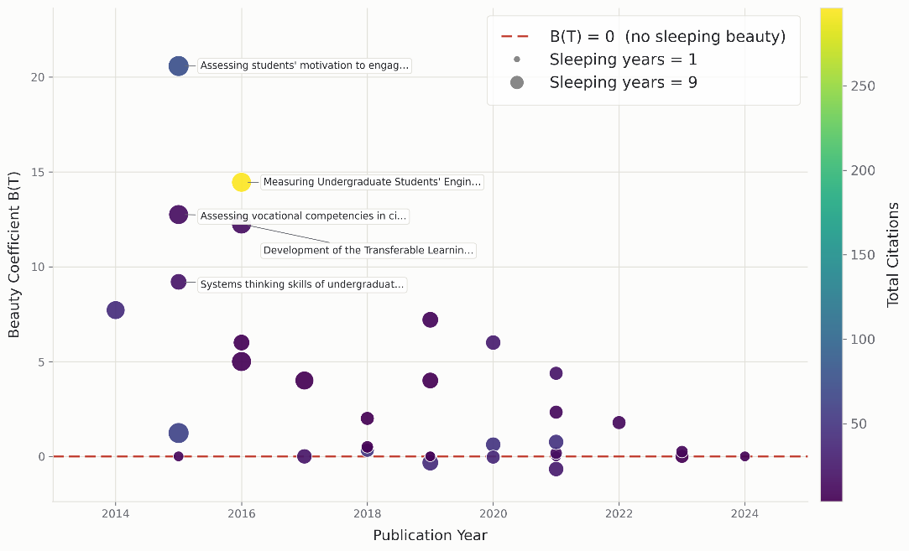
Figure 9b. Beauty coefficient of the corpus’s most pronounced “sleeping beauty” articles by publication year, sized by dormancy length and colored by total citations.
An additional exploratory analysis compared citations for 19 articles identified as carrying an article-processing charge (APC) against the remaining 77 (35.68 mean citations versus 8.07; difference +27.62; 95% CI 5.12–61.39; Mann-Whitney p=0.015). This result is not interpreted as evidence of a causal advantage of APC payment on scientific reception: a stricter identification of APC-bearing articles (n=10, mean fee USD 1,301) yields the opposite direction (5.2 versus 14.5 mean citations), showing that the association is sensitive to how APC status is coded and requires replication with a larger, consistently coded sample.

Research Dynamics Manifold: a three-dimensional reading of the corpus
The Research Dynamics Manifold (RDM) analysis positions each article along three axes —Emergence, Impact, and Connectivity— and classifies it into eight archetypes (Figure 10). The archetype with the largest number of articles is not the highest-impact one, but the Silent Connectors (21 articles, 21.9% of the corpus): works with high structural centrality but low citation visibility, which serve a conceptual-bridging function poorly captured by conventional citation metrics. The Paradigm Shifters (18 articles, 18.8%) —led by (Mamaril et al. 2016) (RDM=0.804), (McCormick et al. 2015) (RDM=0.738), and (Ro et al. 2015) (RDM=0.736)— constitute the high-impact, high-connectivity core. Two further groups of comparable size, the Emerging Bridges and the Viral Novelties (11 articles each, 11.5%), gather works that combine high novelty with, respectively, still-developing structural connections or citation impact concentrated outside the mainstream network, while 8 Isolated Seeds correspond to early or niche innovations not yet integrated into the field’s core structure. Unlike a field where new lines of inquiry would clearly outpace their consolidation, the corpus’s three axes are close to evenly balanced (Impact 34%, Connectivity 33%, Emergence 32% of articles by dominant axis), consistent with a field generating, connecting, and accumulating citation impact for its findings at a broadly comparable pace rather than one process running distinctly ahead of the others.
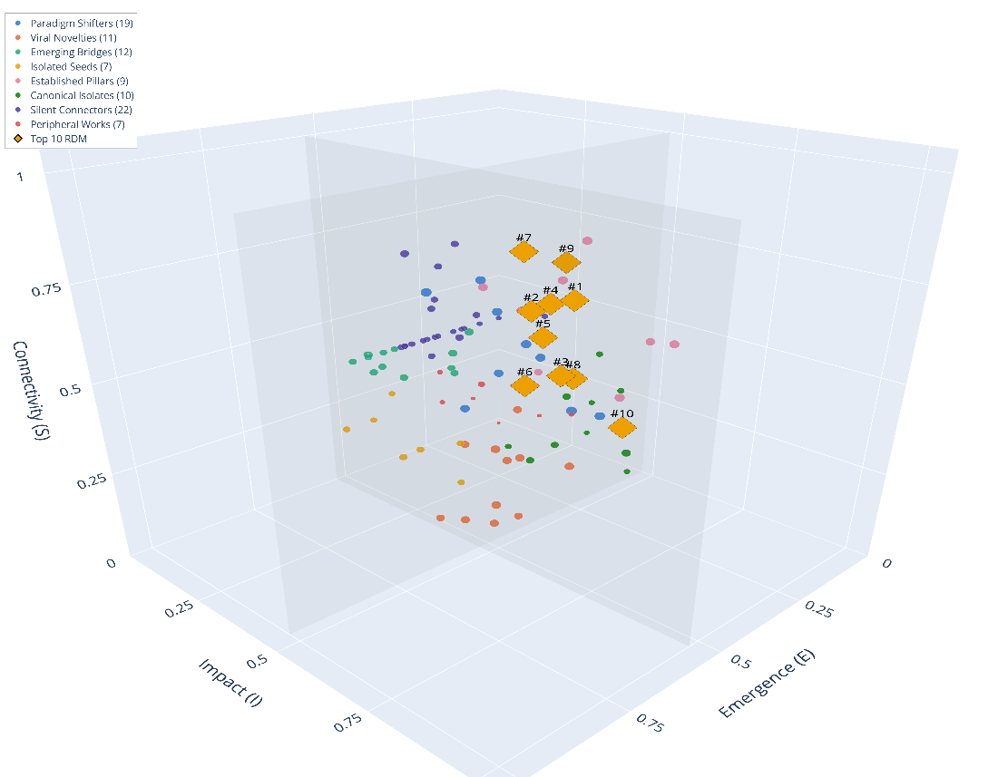
Figure 10. Research Dynamics Manifold: three-dimensional distribution of corpus articles by Emergence, Impact, and Connectivity, classified into eight archetypes.

Declared gaps and future directions
Three convergent sources —limitations declared by the studies themselves, structural methodological gaps, and sampling patterns— delimit the field’s future agenda. Researcher-identity formation has been studied predominantly outside engineering populations (Choe et al. 2017), and the impact of community-partnered projects on transversal competencies within capstone courses remains without systematic exploration of how specific instructional designs drive competency growth (Kittur et al. 2024). Methodologically, the median sample size (344 participants; n=56; mean 721.1; range 50–6,078) is a factor to consider for the precision of more demanding confirmatory factor analyses and structural equation models. The method-by-domain combination analysis did not identify studies crossing regression analysis with medical education, pedagogy, or physics, nor case-study designs applied to medicine or medical education, nor qualitative methods combined with exploratory factor analysis. These absences, within the limits of this corpus, should not be interpreted as definitive gaps in the field, but as combinations not represented in the empirical output reviewed.

Synthesis
The field exhibits a theoretical anchoring in Bandura’s self-efficacy (Mamaril et al. 2016), sustained growth with a citation-impact profile that is above the field-normalized average within the OpenAlex-indicator subsample but closer to the disciplinary average when the full corpus is considered through Leiden-style indicators, and a marked methodological dependence on SEM for instrument validation. Professional and generic-competency measurement now stands as a second, comparably sized empirical cluster alongside self-efficacy, while engineering identity remains a structurally emerging but still-narrow thread within that broader conceptual map. The language, geographic, and document-type biases flagged throughout the analysis —together with still-incipient international collaboration— should be considered when interpreting the scope of these findings.

Discussion

Synthesis and interpretation of the main patterns
The corpus shows sustained growth and a citation-impact profile that reads differently depending on the normalization lens applied — above the world average within the subsample carrying OpenAlex-derived indicators, closer to it once a Leiden-style score is computed over the full corpus — organized predominantly, though not exclusively, around self-efficacy and Bandura’s social-cognitive theory. Before reading the growth figure as a sign of the field’s vitality, it is worth qualifying: bibliometric studies of related engineering-education subfields report impact indicators and growth rates of the same order of magnitude (El-Zahr 2022; Pandey et al. 2026), so the performance observed falls within a plausible range for the area rather than an exceptional level. The theoretical concentration, by contrast, is comparatively striking: whereas research on educational technology has more often documented an absence or vagueness of explicit theoretical framing (Hew et al. 2019), this corpus displays the opposite problem —not a lack of theory, but theoretical narrowness— with self-efficacy operating even as the explanatory framework for nominally technical constructs, such as “engineering thinking” (Chen et al. 2026). That narrowness is theoretical rather than merely topical: the corpus’s second-largest empirical cluster, on professional, ethical, and generic competencies, is comparable in size to the self-efficacy cluster itself, yet it rarely mobilizes an explicit psychological framework of its own — it reads more as a practice- and rubric-driven literature than as a theoretically anchored one. Read together, the two clusters describe a field with topical breadth but a narrow theoretical repertoire: most of what does carry an explicit theory still carries the same one. This same narrowness helps explain the underrepresentation of technical competencies noted in the results: where a technical competency is clearly delimited —computer-aided design, for instance— the recent literature still lacks a dedicated validated scale, and those documenting that gap likewise reach for the language of self-efficacy to name it (Butt et al. 2024).

Convergence and divergence between analytical methods
Two methodological divergences are more instructive here than any single headline figure. The first concerns citation impact itself: the field-weighted indicator, computed only for the subsample with OpenAlex coverage, describes a corpus performing above its disciplinary average, while a Leiden-style score computed over the full 96-article corpus describes one performing close to that average. Both are legitimate readings of the same underlying data, but they answer different questions — one asks how the corpus’s more traceable, generally more visible articles compare internationally; the other asks how the corpus as a whole, uncited work included, compares once every article counts equally. Neither reading should be treated as the corpus’s single “true” impact; the gap between them says more about the fragility of subsample-dependent indicators than about a contradiction in the underlying evidence. The second divergence is between structure and visibility: the largest group of articles by research-dynamics archetype is not the most-cited one, but a set of works with high structural centrality and low citation visibility (“silent connectors”), suggesting that citation metrics do not capture conceptual bridging well — a limitation that belongs to the metrics themselves rather than to the articles in question, and one that this analysis cannot resolve with the available evidence, only flag. The field’s active fronts, for their part, are methodological before they are topical: structural equation modeling and, at a smaller scale, physics-adjacent applications emerge as genuinely new fronts, while self-efficacy and quantitative approaches accelerate rather than plateau — a pattern that reads more as technique consolidation than as conceptual renewal. Engineering identity, bridged mainly by a single recent node in the co-citation network —Godwin (2016)— rather than by a converging body of studies, illustrates the same tension noted above: a topic visibly connecting communities without yet amounting to a consolidated subfield.

Comparison with prior bibliometric reviews in the domain
Prior reviews of this literature have tended to be confined to a single competency —complex problem-solving (Azizan et al. 2025), transversal competencies in doctoral engineering education (Martins et al. 2021)— or to a specific institutional angle, such as accreditation in a civil-engineering subfield (Che Ibrahim and Ahmad Kamal 2026); few precedents combine quantitative bibliometric mapping with a content-analysis component, and those that exist tend to do so for general conference trends rather than for measurement instruments (Alves et al. 2024). The review of employability instruments in engineering (Zhan et al. 2026) —confined to a single construct, as noted in the introduction— allows for a finer comparison than simply noting its limited scope: of the 26 instruments it identifies, 23 were developed in Global South countries (India, Malaysia, Indonesia, among others) and only three in the Global North, a geographic pattern that is the inverse of this corpus, where single-country authorship of largely Anglophone tradition predominates. This suggests that the geographic concentration of production is not uniform across competencies but varies by construct measured, a nuance that neither review —this one nor the employability one— can explain on its own. That same review found that 11 of its 26 instruments rely exclusively on self-report data; since self-efficacy is, by definition, a self-perception construct, a substantial share of this corpus’s instruments likely shares that same structural limitation, although it was not systematically tallied here. Regarding growth figures, rather than presenting the corpus’s 16.1% CAGR as a noteworthy value in the abstract, it is worth anchoring it to real evidence: bibliometric reviews of related subfields report explicit growth rates ranging from 5.71% in university-industry linkages (Amarathunga et al. 2024) to a much faster expansion in education for sustainable development (Garcés Giraldo et al. 2026). This places the growth of engineering competency measurement within a broader pattern of expansion among engineering-education subfields, not as a peculiarity exclusive to this domain.

Theoretical implications
The centrality of social-cognitive theory is neither an isolated nor a recent finding: it reflects a longer-standing tendency to import psychological frameworks into engineering-education research, documented in analyses of cross-disciplinary collaborations (Borrego and Newswander 2008). It is especially telling that this narrowness had already been precisely diagnosed more than fifteen years ago: Matusovich, Streveler, and Miller (2009) showed that motivation research in engineering education tended to lack an explicit theoretical framework and, when it had one, drew almost exclusively on Bandura’s self-efficacy theory, leaving virtually unexplored two other motivational frameworks equally well established in educational psychology —self-determination theory and Eccles’ expectancy-value theory. That this corpus, spanning 2014-2026, still shows the same concentration suggests that the warning went unheeded by the field over the intervening period, rather than reflecting a recently emerged problem. A substantial share of the instruments reviewed does, in fact, operate with Bandura’s four sources of self-efficacy with virtually no theoretical modification (Carlson et al. 2024), leaving open the question of whether the field needs frameworks of its own or, at minimum, deliberately adapted versions of the ones it already uses. Engineering identity or self-concept emerges as the most visible candidate for a more discipline-specific construct, but remains anchored in the same social-cognitive theory and with still-scarce evidence (Dirisina and Shehab 2025); its theoretical implications should, for now, be framed as tentative. The professional and generic-competencies cluster identified in the results occupies the opposite corner of the same problem: it is empirically substantial but conceptually under-theorized, which raises the question of whether the field’s next contribution should be an altogether new framework or, more modestly, an explicit theoretical scaffolding for a body of applied, rubric-driven work that is currently doing without one.

Practical implications for stakeholders
Accreditation frameworks are not a passive backdrop: they directly shape which competencies end up being measured, and with what priority (Jalali et al. 2022; Willey et al. 2021). Broadening the orientation of these frameworks toward technical competencies could, through that same channel, incentivize the development of instruments that are currently scarce; the fact that well-constructed technical instruments already exist in specific cases —a competency rubric for free-body diagrams in mechanical engineering, among others (Vázquez-Sánchez and Delgado 2025)— indicates that the gap is one of proportion, not feasibility. The predominance of single-country authorship further suggests that instruments tend to be developed for a specific cultural context; deliberate adaptation to other settings, rather than direct transfer, is already practiced in concrete cases —accreditation frameworks adapted to resource-constrained contexts (Hong and Hang 2026) or local questionnaires that combine international standards with national guidelines (Bayarsaikhan et al. 2025)— and should be assumed as an expected step, not an exceptional one.

Threats to validity and limitations
Coverage across six databases does not eliminate language bias: English dominates both general indexing (Rovira et al. 2021) and, specifically, databases specialized in engineering literature (Epps and Rosenberg 2019), so the overrepresentation observed is structural rather than an incidental artifact of this particular search. Field-normalized indicators depend on reduced subsamples, with the corresponding confidence intervals already reported; the divergence between subsample-based and full-corpus impact readings noted above reinforces the case for treating any single normalized figure as approximate rather than definitive. LLM-assisted thematic coding relied on mechanical grounding verification rather than a human coder panel; recent comparisons between human and generative coding report only moderate agreement and a decline in accuracy for longer texts (Prescott et al. 2024; Han et al. 2025), confirming that this control mechanism, although necessary, does not equate to the inter-rater reliability of a human panel. Finally, the 2014-2026 window excludes, by design, earlier phases of conceptual formation; the delayed-recognition pattern detected within the corpus itself warns that relevant work predating that window may have been left out.

Future research directions
Theoretical diversification beyond self-efficacy need not start from scratch: the motivation literature in engineering itself had, some time ago, already identified two mature alternatives —self-determination and expectancy-value theory— without this corpus showing substantial adoption of either (Matusovich et al. 2009); recent studies in related educational settings confirm that self-determination theory remains a viable route, combinable with sequential qualitative-quantitative designs (Huang et al. 2026; Isaeva et al. 2026). A second, more modest direction follows from the professional-competencies cluster identified in the results: rather than importing an established framework wholesale, the field could begin by making explicit the implicit models already guiding rubric- and standards-based instruments in that space, before deciding whether a new theory is warranted. For the specific study of engineering identity, there is likewise no need to start from scratch: a qualitative, longitudinal case study from more than fifteen years ago already coded students’ self-perceptions as “future engineers” across their degree program and explicitly proposed that this work could lead to quantitative identity instruments (Matusovich et al. 2009); that this has still not been robustly realized by 2026 —engineering identity remains bridged by a single recent node in the co-citation network rather than by a converging line of studies— speaks as much to the field’s slow pace of theoretical accumulation as to the absence of methodological precedents that might have guided it. Psychometric and sample strengthening remains, in any case, a pending task that this corpus does not resolve on its own. The need for cross-cultural validation, in turn, is not a concern exclusive to this review: recent engineering-education studies explicitly flag cross-cultural validation as unresolved future work (Gupta 2025; Bhatt et al. 2025), suggesting a broader recognition across the field of that same gap.

Conclusions
Regarding the evolution of production and its temporal dynamics (RQ1), the field grew steadily over the period analyzed, but the deceleration of the most recent five-year span suggests a transition from a take-off phase toward consolidation rather than a still-exploratory expansion; editorial output, meanwhile, is spread across a comparatively wide set of journals rather than concentrated in a narrow core, a pattern more consistent with a still-diffusing field than with one already settled around a small number of flagship venues.
Regarding intellectual structure (RQ2), Bandura’s social-cognitive theory functions as the field’s dominant anchor, and instrument validation relies predominantly on structural equation modeling. This combination produces an intellectual base that is coherent but theoretically narrow: coherent because it converges on a shared framework, narrow because that framework comes almost entirely from imported psychology rather than from theorizing native to engineering education — a narrowness that persists even where the field’s topical output has broadened into a comparably sized body of work on professional and generic competencies, since that body rarely carries an explicit theoretical framework of its own.
Regarding collaboration patterns (RQ3), production is predominantly single-country, with multinational collaboration still incipient and concentrated in cases of cultural adaptation of existing instruments. This is consistent with the context-bound nature of psychometric validation, but it also points to untapped room for growth toward joint cross-country validation programs.
In the dominant conceptual themes and their evolution (RQ4), the corpus’s most consolidated evidence now spans two comparably sized empirical poles —self-efficacy and learning experiences on one hand, professional, ethical, and generic-competency assessment on the other— rather than a single motivational-identity axis; engineering identity persists as a structurally emerging thread bridging parts of this map, connected mainly through a single recent node rather than through a converging body of studies of its own, and technical competencies remain comparatively underrepresented within the whole. The resulting conceptual map is bipolar rather than strictly hierarchical: two substantial empirical cores and a thinner periphery around identity and technical measurement.
Regarding gaps and emerging fronts (RQ5), the field’s methodological momentum concentrates in structural equation modeling and, more modestly, physics-adjacent applications as genuinely new fronts, alongside an accelerating reliance on self-efficacy and on quantitative, survey-based designs; this reads as technique consolidation more than as methodological pluralism, and it is not accompanied by equivalent theoretical diversification. The method-by-domain combinations absent from the corpus delimit an agenda of gaps rather than confirming definitive shortcomings of the field.
Taken together, and in response to the question guiding this bibliometric review, the field of technical and transversal competency measurement in engineering emerges as a young domain still transitioning from expansion toward consolidation, with a citation-impact profile that reads above the normalized average within the subsample carrying comparable indicators but closer to that average once the full corpus is considered, and with a collaboration structure still predominantly national. That combination —sustained but decelerating growth, a theoretically narrow anchor despite a topically broader output, and incipient international collaboration— describes a field that is active but uneven: solid in the accumulated evidence around self-efficacy and, increasingly, around professional and generic competencies, and comparatively weak in the theoretical and methodological diversity that would let that evidence extend more evenly to technical competencies and to cultural contexts other than those that currently predominate.
Two lines of recommendation follow from these patterns. For those who develop and validate instruments, it is worth exploring theoretical frameworks complementary to self-efficacy —self-determination theory or expectancy-value theory, among others— making explicit the implicit models already guiding the field’s rubric- and standards-based competency instruments, and directing part of the validation effort toward technical competencies that are currently scarcely instrumented, using larger samples and cross-cultural invariance studies that can support comparisons across countries.
For accreditation bodies and curriculum designers, the finding of a field still concentrated on a narrow theoretical core despite its broader topical output suggests reviewing whether accreditation guidelines themselves incentivize, in practice, the measurement of technical competencies with the same emphasis as transversal ones; and for those responsible for funding research, the low level of multinational collaboration points to the value of explicitly funding joint cross-country validation studies as a way to close that gap.

Acknowledgments
This bibliometric review was developed as part of doctoral research within the Education Doctoral Program at the Graduate School (Escuela de Postgrado) of Universidad Cesar Vallejo, Pimentel campus, Peru.

Funding
The authors received no financial support for the research, authorship, and/or publication of this article.

Declaration of Interest
The authors declare no potential conflicts of interest related to the research, authorship, or publication of this article. All authors have reviewed, approved the manuscript, and assume full responsibility for its content.

CRediT Authorship Contribution Statement
Segundo Francisco Segura Altamirano: Conceptualization, Methodology, Formal analysis, Investigation, Resources, Data curation, Writing - original draft, Writing - review and editing, Visualization, Project administration.
Bertila Hernandez Fernandez: Conceptualization, Methodology, Validation, Investigation, Writing - review and editing, Supervision, Project administration.

Ethical Statement
This bibliometric review analyzes previously published literature without primary data collection or human subject involvement. Accordingly, formal Institutional Review Board approval was not required. All research activities were conducted in accordance with ethical standards governing secondary research, including methodological rigor, transparent reporting, and intellectual property protection, consistent with the Declaration of Helsinki and Peruvian research regulations.

Declaration of Generative AI Use
Generative artificial intelligence tools were used at two stages of this work. First, as part of the bibliometric methodology itself (see Methodology), large language models (DeepSeek as the default provider, with an independent triangulation run using Gemini and ChatGPT) were used to conduct the inductive thematic analysis of article abstracts, with a mechanical grounding-verification step and human review of all resulting themes before they were reported. Second, a large language model (Claude, Anthropic) was used to assist in drafting portions of the manuscript text under the authors’ direct supervision. The authors reviewed, edited, and take full responsibility for all analytical interpretations, conclusions, and the final wording of this article.

Data Availability Statement
The bibliographic dataset of the 96 articles composing the reviewed corpus, including the metadata used for the bibliometric and thematic analyses, is provided as a BibTeX file accompanying this article.

References
Alarcon-Pereira, G., I. S. Rampasso, F. J. Tapia-Ubeda, K. Rojas-Aguilar, and C. Rojas-Córdova. 2023. “The Evolution of Sustainability in Engineering Education Research: A Longitudinal Analysis Through Bibliometrics and the CDIO Initiative.” Int. J. Sustain. High. Educ. 24 (6): 1266–89. https://doi.org/10.1108/IJSHE-03-2022-0073.
Alves, A. C., S. Kumpaty, G. Shimek, D. M. Alves, and C. P. Leão. 2024. “SHAPING THE FUTURE OF ENGINEERING EDUCATION: EXPLORING TRENDS AND INSIGHTS IN ASME-IMECE ENGINEERING EDUCATION CONFERENCE PAPERS, 2012-2023.” ASME International Mechanical Engineering Congress and Exposition, Proceedings (IMECE) 7: V007T09A003. https://doi.org/10.1115/IMECE2024-140882.
Amarathunga, B., A. Khatibi, and Z. M. Talib. 2024. “University–Industry Linkages and Agendas for Future Studies: A Systematic Literature Review and Bibliometric Analysis.” Asian Educ. Dev. Stud. 13 (1): 14–30. https://doi.org/10.1108/AEDS-08-2023-0104.
Aria, M., T. Le, C. Cuccurullo, A. Belfiore, and J. Choe. 2023. “openalexR: An R-Tool for Collecting Bibliometric Data from OpenAlex.” R J. 15 (4): 167–80. https://doi.org/10.32614/RJ-2023-089.
Azizan, M. F., M. E. E. Mohd Matore, and M. Omar. 2025. “A Bibliometric Analysis of Complex Problem-Solving Approaches in Engineering Education.” J. Appl. Sci. Eng. Technol. Educ. 7 (1): 17–28. https://doi.org/10.35877/454RI.asci3846.
Bandura, A. 1977a. “Self-Efficacy: Toward a Unifying Theory of Behavioral Change.” Psychol. Rev. 84 (2): 191–215.
Bandura, A. 1977b. Social Learning Theory. Prentice-Hall.
Bandura, A. 1978. “The Self System in Reciprocal Determinism.” Am. Psychol. 33 (4): 344–58.
Bandura, A. 1997. Self-Efficacy: The Exercise of Control. W. H. Freeman / Times Books / Henry Holt & Co.
Baquero-Sierra, A., C. Vargas Ordóñez, J. Tawney, and M. Robinson. 2025. “Compassion in Engineering Education: Validation of the Compassionate Engagement and Action Scales (CEAS) and Conceptual Insights.” Educ. Sci. 15 (10): 1406. https://doi.org/10.3390/educsci15101406.
Bayarsaikhan, B., N. Baavgai, and J. Badrakh. 2025. “A Comparative Study of Graduate Competencies Assessment: A Case Study of Young Engineers.” 14th International Symposium on Computer Science and Educational Technology, ISCSET 2025 - Proceedings. https://doi.org/10.1109/ISCSET65760.2025.11540545.
Bhatt, M. W., M. R. M. Veeramanickam, J. R. Ruffner, et al. 2025. “Enhancing Engineering Student Engagement and Learning Outcomes Through WebVR and Wearable Sensor Integration with Immersive Learning.” Discov. Sustain. 6 (1): 590. https://doi.org/10.1007/s43621-025-01436-x.
Blondel, V. D., J.-L. Guillaume, R. Lambiotte, and E. Lefebvre. 2008. “Fast Unfolding of Communities in Large Networks.” J. Stat. Mech. Theory Exp. 2008 (10): P10008. https://doi.org/10.1088/1742-5468/2008/10/P10008.
Borrego, M., and L. K. Newswander. 2008. “Characteristics of Successful Cross-Disciplinary Engineering Education Collaborations.” J. Eng. Educ. 97 (2): 123–34. https://doi.org/10.1002/j.2168-9830.2008.tb00962.x.
Bradford, S. C. 1934. “Sources of Information on Specific Subjects.” Engineering 137: 85–86.
Butt, S., E. DaMaren, and A. Olechowski. 2024. “Investigating Students’ Development of Computer-Aided Design Self-Efficacy: An Analysis of Pre-Course CAD Exposure.” ASEE Annual Conference and Exposition, Conference Proceedings. https://www.scopus.com/pages/publications/85202068215?origin=resultslist.
Carlson, K., M. E. Jarvie-Eggart, and K. Richardson. 2024. “Engineering Self-Efficacy and Spatial Skills: A Systematic Literature Review.” ASEE Annual Conference and Exposition, Conference Proceedings. https://www.scopus.com/pages/publications/85202055815?origin=resultslist.
Castelló, E., C. Santiviago, J. Ferreira, et al. 2023. “Towards Competency-Based Education in the Chemical Engineering Undergraduate Program in Uruguay: Three Examples of Integrating Essential Skills.” Educ. Chem. Eng. 44: 54–62. https://doi.org/10.1016/j.ece.2023.05.004.
Chansanam, W., and C. Li. 2025. “KKU-BiblioMerge: A Novel Tool for Multi-Database Integration in Bibliometric Analysis.” Iberoam. J. Sci. Meas. Commun. 5 (1): 1–16. https://doi.org/10.47909/ijsmc.157.
Che Ibrahim, C. K. I., and N. Ahmad Kamal. 2026. “A Bibliometric Exploration of Accreditation in Civil Engineering Education: Trends and Insights.” Qual. Assur. Educ. 34 (1): 18–35. https://doi.org/10.1108/QAE-12-2024-0271.
Chen, C. 2006. “CiteSpace II: Detecting and Visualizing Emerging Trends and Transient Patterns in Scientific Literature.” J. Am. Soc. Inf. Sci. Technol. 57 (3): 359–77. https://doi.org/10.1002/asi.20317.
Chen, F., G. R. Dantes, K. R. Dantes, and D. S. Wahyuni. 2026. “From Self-Efficacy to Engineering Thinking: The Mediating Role of Student Engagement Among Undergraduate Engineering Students in China.” Front. Psychol. 17: 1761444. https://doi.org/10.3389/fpsyg.2026.1761444.
Choe, N. H., M. Borrego, L. L. Martins, A. D. Patrick, and C. C. Seepersad. 2017. “A Quantitative Pilot Study of Engineering Graduate Student Identity.” 2017-June. https://www.scopus.com/pages/publications/85030535336?origin=resultslist.
Daud, S. N., N. A. Ismail, M. Abdullah, and N. A. Hassan. 2019. “Entrepreneurship Traits Among Engineering Students: Instrument Development and Validation Procedure Using Structural Equation Modeling.” Int. J. Adv. Trends Comput. Sci. Eng. 8 (2): 235–40. https://doi.org/10.30534/ijatcse/2019/21822019.
De Paoli, S. 2024. “Performing an Inductive Thematic Analysis of Semi-Structured Interviews With a Large Language Model: An Exploration and Provocation on the Limits of the Approach.” Soc. Sci. Comput. Rev. 42 (4): 997–1019. https://doi.org/10.1177/08944393231220483.
De Paoli, S., and W. S. Mathis. 2025. “Reflections on Inductive Thematic Saturation as a Potential Metric for Measuring the Validity of an Inductive Thematic Analysis with LLMs.” Qual. Quant. 59 (1): 683–709. https://doi.org/10.1007/s11135-024-01950-6.
Direnga, J., and C. Kautz. 2019. “(Re-)validation of a Standardised Test Instrument in a Different National Context.” Proceedings of the 8th Research in Engineering Education Symposium, REES 2019 - Making Connections, 418–27. https://www.scopus.com/pages/publications/85071483236?origin=resultslist.
Dirisina, J., and R. L. Shehab. 2025. “Validating an Engineering Self-Concept Survey.” ASEE Annual Conference and Exposition, Conference Proceedings. https://doi.org/10.18260/1-2--57323.
El-Zahr, S. 2022. “Quality, Quantity and Impact in Engineering Research: Case Study of a Non-Doctoral University in the Arab World.” 2022 IEEE Integrated STEM Education Conference, ISEC 2022, 132–37. https://doi.org/10.1109/ISEC54952.2022.10025160.
Epps, A. S. van, and R. Rosenberg. 2019. “Engineering Source: How Robust Is the Coverage of the Engineering Literature?” ASEE Annual Conference and Exposition, Conference Proceedings. https://www.scopus.com/pages/publications/85078745485?origin=resultslist.
Fernandez, T. M., and A. Werth. 2025. “Factorial Measurement of Epistemological Theories of Development.” ASEE Annual Conference and Exposition, Conference Proceedings. https://doi.org/10.18260/1-2--56556.
Garcés Giraldo, L. F., R. Liza, J. A. Velásquez Ochoa, et al. 2026. “Education for Sustainable Development in Higher Education: Bibliometric Analysis of Trends, Innovations and Institutional Commitment to the SDGs (2018–2025).” Societies 16 (6): 178. https://doi.org/10.3390/soc16060178.
Gupta, M. 2025. “Integrating AI Into Online Engagement Models for Engineering Education: A Comprehensive Review.” J. Eng. Edu. Transform. 38 (Special Issue 2): 329–36. https://doi.org/10.16920/jeet/2025/v38is2/25039.
Han, Z., A. Tavasi, J. Lee, et al. 2025. “Can Large Language Models Be Used to Code Text for Thematic Analysis? An Explorative Study.” Discov. Artif. Intell. 5 (1): 171. https://doi.org/10.1007/s44163-025-00441-3.
Hew, K. F., M. Lan, Y. Tang, C. Jia, and C. K. Lo. 2019. “Where Is the "Theory" Within the Field of Educational Technology Research?” Br. J. Educ. Technol. 50 (3): 956–71. https://doi.org/10.1111/bjet.12770.
Hong, H. T., and N. T. Hang. 2026. “An Integrated STEM–CBE–ELT Framework for Engineering Education: Bridging Theory and Practice in Resource-Constrained Contexts.” J. Pedag. Res. 10 (1): 124–43. https://doi.org/10.33902/JPR.202636702.
Huang, Z., Y. Xie, G. Zhang, T. Yang, W. Zhang, and X. Liu. 2026. “Impact of Generative AI-Supported Personalized Learning on Engineering Student Engagement: Sequential Qualitative-Quantitative Evidence.” IAENG Int. J. Appl. Math. 56 (5): 1953–65. https://www.scopus.com/pages/publications/105041604557?origin=resultslist.
Isaeva, R., H. N. Caner, M. Caner, L. Giray, and E. Karadag. 2026. “Students’ Engagement with Generative AI in Academic Learning: A Self-Determination Theory and Epistemic Network Analysis Study.” Comput. Educ. Artif. Intell. 10: 100606. https://doi.org/10.1016/j.caeai.2026.100606.
Jackson, A., S. Brunhaver, C. Bodnar, S. Kavale, A. Carberry, and P. Shekhar. 2026. “Anchoring the 3Cs: A Scoping Literature Review of Curiosity, Creating Value, and Connections in Entrepreneurial Mindset Development.” J. Eng. Educ. 115 (1): e70051. https://doi.org/10.1002/jee.70051.
Jagirdar, S. S., and P. K. Gupta. 2026. “A Bibliometric Exploration of Methodological Trends, Gaps, and Future Directions in Qualitative and Quantitative Research: Navigating AI, Sustainability, and Ethical Challenges Through Methodological Innovation.” In Research Methods for Computing and Informatics. IGI Global. https://doi.org/10.4018/979-8-3693-4018-9.ch001.
Jalali, Y., H. Kovacs, S. R. Isaac, and J. Dehler Zufferey. 2022. “Bringing Visibility to Transversal Skills in Engineering Education: Towards an Organizing Framework.” SEFI 2022 - 50th Annual Conference of the European Society for Engineering Education, Proceedings, 1252–59. https://doi.org/10.5821/conference-9788412322262.1251.
Keerthi, M. S., S. Shetty, and S. Shetty. 2026. “Smart Resume Analyzer Using LLM Embeddings (Sentence-BERT) for Automated Skill Gap Detection.” ICKECS 2026 - Proceedings of 4th IEEE International Conference on Knowledge Engineering and Communication Systems. https://doi.org/10.1109/ICKECS70176.2026.11527519.
Kemeç, A., and A. T. Altınay. 2023. “Sustainable Energy Research Trend: A Bibliometric Analysis Using VOSviewer, RStudio Bibliometrix, and CiteSpace Software Tools.” Sustainability 15 (4): 3618. https://doi.org/10.3390/su15043618.
Khalid, M. T., and A.-P. Witmer. 2025. “Prompt Engineering for Large Language Model-Assisted Inductive Thematic Analysis.” Soc. Sci. Comput. Rev., ahead of print. https://doi.org/10.1177/08944393251388098.
Khampirat, B. 2021. “Validation of Motivated Strategies for Learning Questionnaire: Comparison of Three Competing Models.” Int. J. Instr. 14 (2): 609–26. https://doi.org/10.29333/iji.2021.14234a.
Kittur, J., M. Olayemi, T. Harvey, and H. Taffe. 2024. “Examining the Engineering Self-Efficacy, Design Self-Efficacy, Intentions to Persist, and Sense of Belonging of First-Year Engineering Students Through Community-Partnered Projects.” https://www.scopus.com/pages/publications/85202068219?origin=resultslist.
Kline, Rex B. 2005. Principles and Practice of Structural Equation Modeling: Methodology in the Social Sciences. 2nd ed. Guilford Publications.
Kumkale Açikgoz, E., and E. Arısoy. 2026. “Mapping Interdisciplinary Knowledge Structures Through Bibliometric Triangulation: A Case Study of Cinema–Architecture Scholarship (1975–2025).” J. Doc., 1–25. https://doi.org/10.1108/JD-02-2026-0106.
Lavrsen, J. C., C.-C. Carbon, and J. Daalhuizen. 2024. “Measuring Design Mindset: Developing the Design Mindset Inventory Through Its Relationship with Ambiguity Tolerance, Self-Efficacy and Sensation-Seeking.” Des. Sci. 10: e48. https://doi.org/10.1017/dsj.2024.36.
Lim, W. M., S. Kumar, and N. Donthu. 2024. “How to Combine and Clean Bibliometric Data and Use Bibliometric Tools Synergistically: Guidelines Using Metaverse Research.” J. Bus. Res. 182: 114760. https://doi.org/10.1016/j.jbusres.2024.114760.
Lotka, A. J. 1926. “The Frequency Distribution of Scientific Productivity.” J. Wash. Acad. Sci. 16 (12): 317–23.
Luk, Lillian Yun Yung, and Cecilia Ka Yuk Chan. 2020. “Adaptation and Validation of the Work Experience Questionnaire for Investigating Engineering Students’ Internship Experience.” J. Eng. Educ. 109 (4): 801–20. https://doi.org/10.1002/jee.20351.
Mahdi Al-Obaidi, A. Sh. 2021. “CDIO Initiative: A Guarantee for Successful Accreditation of Engineering Programmes.” Indones. J. Sci. Technol. 6 (1): 81–92. https://doi.org/10.17509/ijost.v6i1.31521.
Mamaril, Natasha A., Ellen L. Usher, Caihong R. Li, D. Ross Economy, and Marian S. Kennedy. 2016. “Measuring Undergraduate Students’ Engineering Self-Efficacy: A Validation Study.” J. Eng. Educ. 105 (2): 366–95. https://doi.org/10.1002/jee.20121.
Martins, H., A. Freitas, I. Direito, and A. Salgado. 2021. “Engineering the Future: Transversal Skills in Engineering Doctoral Education.” 2021 4th International Conference of the Portuguese Society for Engineering Education, CISPEE 2021. https://doi.org/10.1109/CISPEE47794.2021.9507210.
Matusovich, H., R. Streveler, and R. Miller. 2009. “What Does "Motivation" Really Mean? An Example from Current Engineering Education Research.” 2009 Research in Engineering Education Symposium, REES 2009. https://www.scopus.com/pages/publications/84863274619?origin=resultslist.
McCormick, Mary, Angela R. Bielefeldt, Christopher W. Swan, and Kurtis G. Paterson. 2015. “Assessing Students’ Motivation to Engage in Sustainable Engineering.” Int. J. Sustain. High. Educ. 16 (2): 136–54. https://doi.org/10.1108/ijshe-06-2013-0054.
Motahhari-Nejad, Hossein. 2021. “Professional Competencies in Engineering: Examining Validity and Measurement Invariance of a Scale.” Studies in Higher Education 46 (8): 1714–25. https://research.ebsco.com/plink/24f59451-593a-32b3-a6ce-75be6041425a.
Narong, D. K., and P. Hallinger. 2024a. “The Evolution of Service Learning in Engineering Education: A Bibliometric Review of Research (1995–2023).” Eur. J. Eng. Educ. 49 (5): 834–55. https://doi.org/10.1080/03043797.2024.2368148.
Narong, D. K., and P. Hallinger. 2024b. “Traversing the Evolution of Research on Engineering Education for Sustainability: A Bibliometric Review (1991–2022).” Sustainability 16 (2): 641. https://doi.org/10.3390/su16020641.
Nikolic, S., M. Ros, K. Jovanovic, and Z. Stanisavljevic. 2021. “Remote, Simulation or Traditional Engineering Teaching Laboratory: A Systematic Literature Review of Assessment Implementations to Measure Student Achievement or Learning.” Eur. J. Eng. Educ. 46 (6): 1141–62. https://doi.org/10.1080/03043797.2021.1990864.
Pandey, C. S., S. R. Pandey, P. Mishra, S. Pandey, and L. Lakshay. 2026. “A Bibliometric Assessment of a Decade’s Research on Educational Technologies in India, 2014-2023.” Curr. Sci. 14 (3): 805–20. https://doi.org/10.5530/JSCIRES.20251758.
Park, E., A. Leonard, J. S. Delano, X. Tang, and D. M. Grzybowski. 2020. “Rubric-Based Assessment of Entrepreneurial Minded Learning in Engineering Education: A Review.” Int. J. Eng. Educ. 36 (6): 2015–29. https://www.scopus.com/pages/publications/85096036044?origin=resultslist.
Passow, H. J., and C. H. Passow. 2017. “What Competencies Should Undergraduate Engineering Programs Emphasize? A Systematic Review.” J. Eng. Educ. 106 (3): 475–526. https://doi.org/10.1002/jee.20171.
Paul, D., B. Nepal, M. D. Johnson, and T. J. Jacobs. 2018. “Examining Validity of General Self-Efficacy Scale for Assessing Engineering Students’ Self-Efficacy.” Int. J. Eng. Educ 34 (5): 1671–86. https://www.scopus.com/pages/publications/85052677869?origin=resultslist.
Pereira, V., M. P. Basilio, and C. H. T. Santos. 2025. “PyBibX – a Python Library for Bibliometric and Scientometric Analysis Powered with Artificial Intelligence Tools.” Data Technol. Appl. 59 (2): 302–37. https://doi.org/10.1108/DTA-08-2023-0461.
Prescott, M. R., S. Yeager, L. Ham, et al. 2024. “Comparing the Efficacy and Efficiency of Human and Generative AI: Qualitative Thematic Analyses.” JMIR AI 3: e54482. https://doi.org/10.2196/54482.
Price, D. J. de Solla. 1970. “Citation Measures of Hard Science, Soft Science, Technology, and Nonscience.” In Communication Among Scientists and Engineers, edited by C. E. Nelson and D. K. Pollock. Heath Lexington Books.
Purkayastha, A., E. Palmaro, H. J. Falk-Krzesinski, and J. Baas. 2019. “Comparison of Two Article-Level, Field-Independent Citation Metrics: Field-Weighted Citation Impact (FWCI) and Relative Citation Ratio (RCR).” J. Inf. 13 (2): 635–42. https://doi.org/10.1016/j.joi.2019.03.012.
Qiu, S., and M. Natarajarathinam. 2024. “Fifty-Three Years of the Journal of Engineering Education: A Bibliometric Overview.” J. Eng. Educ. 113 (4): 767–86. https://doi.org/10.1002/jee.20547.
Rethlefsen, M. L., and M. J. Page. 2022. “PRISMA 2020 and PRISMA-S: Common Questions on Tracking Records and the Flow Diagram.” J. Med. Libr. Assoc. 110 (2): 253–57. https://doi.org/10.5195/jmla.2022.1449.
Ro, Hyun Kyoung, Dan Merson, Lisa R. Lattuca, and Patrick T. Terenzini. 2015. “Validity of the Contextual Competence Scale for Engineering Students.” J. Eng. Educ. 104 (1): 35–54. https://doi.org/10.1002/jee.20062.
Rovira, C., L. Codina, and C. Lopezosa. 2021. “Language Bias in the Google Scholar Ranking Algorithm.” Future Internet 13 (2): 1–17. https://doi.org/10.3390/fi13020031.
Salti, H., F. Alkhatib, S. Soleimani, M. Abdul-Niby, I. Zabalawi, and H. Kordahji. 2019. “ENGINEERING EDUCATION: INSTITUTIONALIZATION, INTERNATIONALIZATION, AND GRADUATE ATTRIBUTES.” Proceedings of the International CDIO Conference, 20–32. https://www.scopus.com/pages/publications/85122569078?origin=resultslist.
Sarachuk, K. 2025. “Still Not a Remedy for Academics: The Use of Generative AI-Powered Tools in Bibliometric Analysis.” Frontiers in Artificial Intelligence and Applications 415: 57–63. https://doi.org/10.3233/FAIA251515.
Simin, N., and P. Vrgović. 2025. “Transversal Competencies and Demands of Engineering Education: Literature Review and a Case Study.” Int. J. Eng. Educ. 41 (5): 1195–205. https://www.scopus.com/pages/publications/105017122114?origin=resultslist.
Stefanis, C., E. Stavropoulou, A. Stavropoulos, et al. 2025. “Innovative Methodological Pillars for Bibliometric Studies: AI Screening, Data Normalization and Dual-Tool Analysis.” Discov. Appl. Sci. 7 (9): 973. https://doi.org/10.1007/s42452-025-07653-3.
Tormey, Roland, and Marc Laperrouza. 2023. “The Development, Validation and Use of an Interprofessional Project Management Questionnaire in Engineering Education.” Eur. J. Eng. Educ. 48 (3): 502–17. https://doi.org/10.1080/03043797.2023.2171854.
Vázquez-Sánchez, A., and F. Delgado. 2025. “A Competency Assessment Model for Free-Body Diagrams Construction in Mechanical Engineering Students: A Case Study.” Eur. J. Eng. Educ. 50 (5): 1094–125. https://doi.org/10.1080/03043797.2025.2526831.
Wen, B., E. Horlings, M. van der Zouwen, and P. van den Besselaar. 2017. “Mapping Science Through Bibliometric Triangulation: An Experimental Approach Applied to Water Research.” J. Assoc. Soc. Inf. Sci. Technol. 68 (3): 724–38. https://doi.org/10.1002/asi.23696.
Willey, K., D. Lowe, E. Tilley, K. Roach, and T. Machet. 2021. “Undergraduate Student’s Perceptions of Factors That Enable and Inhibit Their Professional Skill Development.” 9th Research in Engineering Education Symposium and 32nd Australasian Association for Engineering Education Conference, REES AAEE 2021 2: 878–86. https://doi.org/10.52202/066488-0096.
Zhan, S., E. Chapman, A. Valentine, and S. Male. 2026. “Enhancing the Measurement of Employability in Engineering: Insights from a Systematic Literature Review.” Eur. J. Eng. Educ. 51 (1): 172–91. https://doi.org/10.1080/03043797.2025.2502473.

