1.Code for JavaCodeTester1:

/\*\* Application Purpose: the purpose of the class is to learn and practice Java programming. The code below is to finish assignment 2 for week2 study.

\*Step 1 Write a class declaration called JavaCodeTester1

\*Step 2 Within the class declaration write the main method.

\*Step 3 Within the main method write code to complete the tasks listed below, starting in step 4.

\*Step 4 Store a Boolean value in a variable with an appropriate name.

\*Step 5 Display the value of the variable on the computer screen.

\*Step 6 Store a character in a variable with an appropriate name.

\*Step 7 Display the value of the variable on the computer screen.

\*Step 8 Store two string values in two different variables with appropriate names.

\*Step 9 Concatenate the two strings and display the concatenated value on the computer screen.

\*Step 10 Store an integer value in a variable with an appropriate name.

\*Step 11 Display the value of the variable on the computer screen.

\*Step 12 Store a double value in a variable with an appropriate name.

\*Step 13 Display the value of the variable on the computer screen.

\* Author: Jiaqi Chen

\* Date: Janurary 30, 2021

\* Time: 1:02pm

\*/

/\*\*Challange One\*/

/\*1) Write a class declaration called JavaCodeTester1, 2) write the main method p.17-18\*/

public class JavaCodeTester1

{ public static void main (String [] args)

{

/\*Step4: Store a boolean value with a variable with an appropriate name\*/

boolean isName = false;

/\*Step5: Display the value of the variable on the computer screen\*/

System.out.println("The value of the Boolean variable on the computer screen is displayed as "+isName);

/\*Step6: Store a character variable with an appropriate name\*/

char lastInitial = 'C'; /\*Note that for Java we need to use single quotes for literal char s, double quotes for literal String s\*/

/\*Step7: Display the value of the variable on the computer screen\*/

System.out.println("The value of the character variable is displayed as "+lastInitial);

/\*Step 8: Store two string values in two different varaibles with appropriate names\*/

String firstName= "Jiaqi";

String lastName= "Chen";

/\*Step 9: Concatenate the two strings and display the concatenated value on the computer screen\*/

System.out.println("The concatenated value on the computer screen is displayed as "+(firstName+lastName)); /\*Note that for System and String command, it has to be capital letter\*/

/\*Step 10: Store an integer value in a variable with an appropriate name\*/

int birthdayDate=24;

/\*Step 11: Display the value of the variable\*/

System.out.println("The value of the integer variable is displayed as "+birthdayDate);

/\*Step 12: Store a double value in a variable\*/

double birthdayMonYear=1990.6;

/\*Step 12: display the value of the variable\*/

System.out.println("The value of the variable is displayed as "+birthdayMonYear);

}

}

2.Result for JavaCodeTester1:

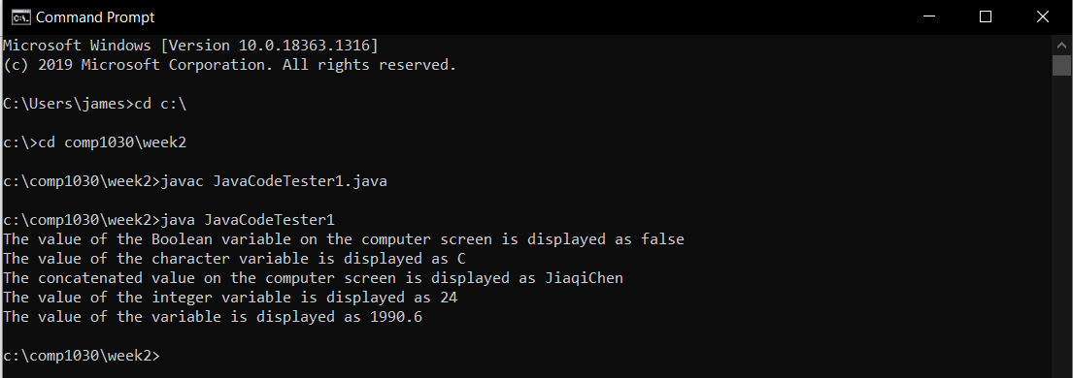

3.Code for JavaCodeTester2:

/\*\*

\* Author: Jiaqi Chen

\* Date: Janurary 30, 2021

\* Time: 1:02pmChallange 2

\*Application Purposes:

\*Challange2

\*Step 1 Write a class declaration called JavaCodeTester2

\*Step 2 Within the class declaration write the main method.

\*Step 3 Within the main method write code to complete the tasks listed below, starting in step 4.

\*Step 4 Store three String values in three different variables with appropriate names.

\*Step 5 Concatenate the three Strings and store the concatenated String in a new variable

\* with an appropriate name.

\*Step 6 Display the 3rd and 5th and 7th character of the concatenated string, on the same line and display an appropriate message telling the user the meaning of the characters that were printed.

\*Step 7 Display the Boolean value which indicates if the concatenated string from step 5 starts with test.

\*Step 8 Display the concatenated string from step 5 in all upper case letters.

\*Step 9 Store an integer value in a variable with an appropriate name.

\*Step 10 Use the increment operator to display the value of the variable. (place the increment operator before the variable name)

\*Step 11 Use the increment operator to display the value of the variable. (place the increment operator after the variable name)

\* (Do you notice something odd with the print outs?)

\*Challenge 3

\*Step 1 Within JavaCodeTester2 write code to store an integer value in a variable with an appropriate name.

\*Step 2 Determine if the integer is odd or even using the modulus operator, also use the if statement (see usage details below) to display the word odd if it is an odd number, and even if it is an even number.

\*/

public class JavaCodeTester2

{

public static void main (String [] args)

{

String greetingPart1 = "Hello"; /\*Note: Remember Semicolumn\*/

String greetingPart2 = "Our";

String greetingPart3 = "World";

String greeting=greetingPart1+greetingPart2+greetingPart3;

System.out.println(greeting);

/\*\*HelloOurWorld 3th l 5th o 7th u\*/

char thirdLetter= greeting.charAt(2);

/\*System.out.println(thirdLetter);\*/

char fifthLetter= greeting.charAt(4);

/\*System.out.println(fifthLetter);\*/

char seventhLetter=greeting.charAt(6); /\*System capital words s\*/

System.out.println("the 3rd, 5th, and 7th character of the target concatenated string HelloOurWorld are:"+thirdLetter+","+fifthLetter+","+seventhLetter+" respectively");

/\*7.Display the Boolean Value which indicates if the concatenated string from step 5 starts with the word "test". \*/

System.out.println(greeting.startsWith("test"));

/\*8 Display the concatenated string from step 5 in all upper case letters. \*/

String combLetter=""+thirdLetter+fifthLetter+seventhLetter;

System.out.println(combLetter.toUpperCase());

/\*9 Store an integer value in a variable with an approriante name\*/

int age=31;

/\*10 the increment operator before the variable name to display the value\*/

System.out.println(++age);

/\*11 the increment operator after the variable name\*/

System.out.println(age++);

/\*\*Observation: The location of the incremeter operator (either before or after the name) does not affect the result\*/

//\*Challenge 3\*/

/\*Step 1: Store integer value in a variable\*/

/\*page 13 of the deck reference https://www.edureka.co/blog/mod-method-in-java/\*/

int height=184;

int result=height%2;

/\*System.out.println(result);\*/

if (result==0)

{

System.out.println("even");

}

else

{

System.out.println("odd");

}

}

}

4.Result for JavaCodeTester2 regarding Challange2 and Challenge 3:

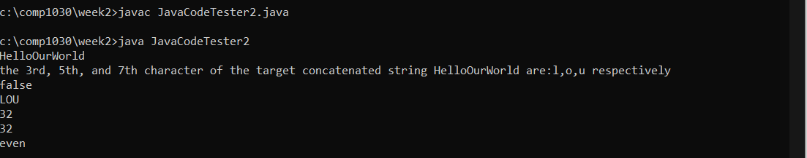

Response to step11: Based on the testing result (please see the screenshot above), the location of the incremented operator (either before or after the name) does not affect the resulting value.