Mock Exam

- The Data analyst at N&F has started an initial analysis of sales data within the firm, see Table 6 which shows the sales data over a 4-year period.

PERIOD |  | SALES DATA
1 | Spring | 1013
2 | Summer | 1025
3 | Autumn | 1002
4 | Winter | 1021
5 | Spring | 1053
6 | Summer | 1067
7 | Autumn | 1042
8 | Winter | 1060
9 | Spring | 1093
10 | Summer | 1106
11 | Autumn | 1083
12 | Winter | 1101
13 | Spring | 1134
14 | Summer | 1147
15 | Autumn | 1123
16 | Winter | 1139
Table 6: Sales data and Sales Trend Data

Use this data to compare and contrast the use of both Additive and Multiplicative models to forecast sales over the next 3 years by

- Plotting the sales data and smoothed (trend) data
- Marks)

- Calculate seasonal variations using both Additive and
Multiplicative Models for seasonal variation.
- Marks)

- Produce Sales forecasts using for next year using both
models
- Marks)

- Evaluate the results from these forecasting models and make a recommendation to the firm concerning the most appropriate model to be used to forecast future sales.
- Marks)

The seasonality does not appear to increase as the data increases. However, more data would be required to check this.
Therefore, an additive model would be sufficient, but a multiplicative model is also fine.

(Total 25 Marks)

2.
Hock-Brooke (Automobiles) the main dealer in Ceeham receives its new stock on Monday (most customers collecting their new cars on Saturday or Friday). These new cars are stored initially in an old warehouse to be prepared for display in the showroom or when the warehouse is full in a secure parking area.
The dealership is about to replace its old (large) warehouse with a modern purpose built warehouse and need to know the most suitable size for this warehouse.

The following data is available to enable them to determine the best size for this new warehouse

Number of cars delivered 7 8 9 10
Frequency (%) 10 20 50 20

Weekly Demand 6 7 8 9 10 11
Frequency (%) 5 20 30 10 20 15

The cost of providing a single warehouse space is £10, and the cost of hiring a additional parking spaces per week is £20.

Simulate the operation of this dealership with a capacity for 9 cars and hence determine the average cost of using the warehouse per week.

See Spreadsheet for simulation

(15 Marks)

Is 9 the best capacity? If not determine the best possible capacity for the warehouse.

The maximum no of cars stored in a given week will occur at the start of the week when cars are delivered.

Therefore if we work out the no of cars at the start of the week. We can then work out the storage cost as follows:

For a warehouse of capacity n, we incur a cost of n*10. If we have more cars than n then for each car we incur additional costs for them.

e.g. for m cars at the start of the week and a warehouse capacity of n we have a weekly cost of:

n*10 + max(m-n,0)*20

We can then build a simulation and take the average cost over all weeks for different values of n

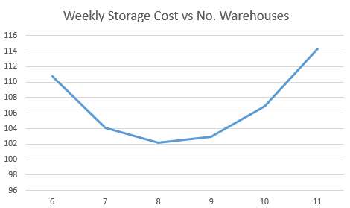

This suggests that either 8 or 9 are the best value. Note we should run many simulations and average these for a full analysis beyond the scope of this exam.
Also, you could take the average of the number of cars at the start of the week and you will get a value of between 8 and 9. Confirming the above.

(10 Marks)
Total 25 marks

3.
F.B.Knight (deliveries) distributes goods from its warehouses to the WalShop supermarkets throughout the East Midlands, and to be able to optimise their profits (for this fixed price contract) they need to be able to determine their “best” delivery schedule (warehouse to shop).

You are required to:

- Use the following data to determine FBK’s optimal distribution plan.

Warehouse A B C
Available Stock 100 100 100

Shop X Y Z
Demand 70 80 150

and the shipping costs/10 items are given in the table.

 | X | Y | Z
A | 8 | 7 | 5
B | 12 | 3 | 9
C | 10 | 11 | 7
(10 marks)
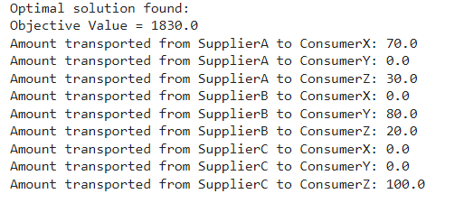
- Determine how the solution will change if the following additional restrictions are imposed.

B cannot deliver to Y, and
A must deliver at least 5 items to Z.
(5 marks)
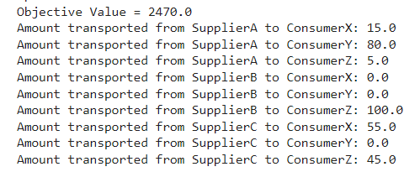

- Two new distribution locations that act as intermediary locations between the warehouse and shop become an option for use. Determine whether you should use one or both locations. Assume that if you do use the locations, you do not ship directly?

 | D1 | D2
A | 4 | 5
B | 3 | 2
C | 6 | 4

 | D1 | D2
A | 4 | 2
B | 5 | 4
C | 2 | 4

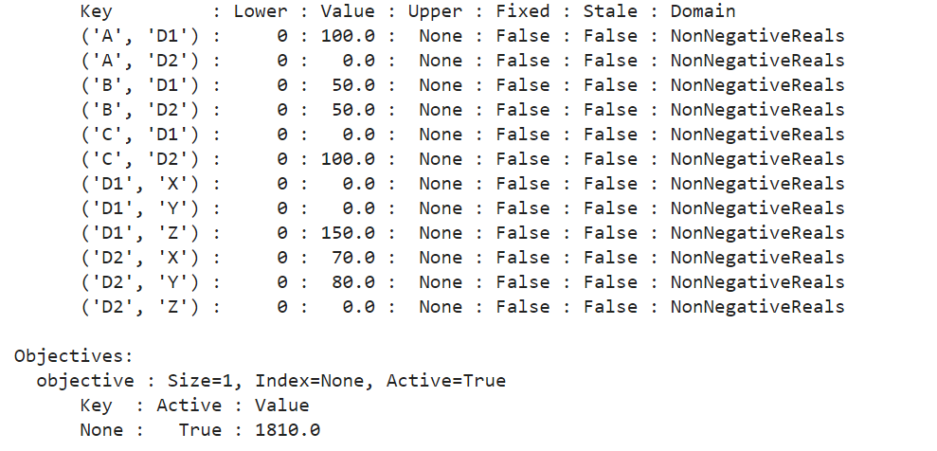
(10 Marks)

Total 25 marks

4.
- Any firm will hold stocks of many types of raw material or finished product. Discuss how a Pareto Analysis can be used to design their stock replenishment policies for their raw materials and bought-in components. (8 marks)

It can help determine which products make up most of the storage costs and thus the ones we wish to focus on with better order patterns.

- For the most important “A” lines the firm wants to determine the reorder quantity so that the associated annual cost will be minimised. Derive the Economic Order Quantity using the notation.

K Delivery cost per delivery
D Yearly demand
h Stock holding cost per item held in stock for a year
p Unit price

Listing all assumptions made to enable this analysis.

(5 marks)

See slides for the derivation

- N&F need to determine their best ordering quantity for a particular item. This item is perishable and has to be kept in a cold store, consequently the firm needs to determine the number of cold stores to build as well as to determine the order quantity (to minimise costs). Determine the order quantity and the number of cold stores given the data: -

k £100
D 10000
h 20%
p £10
a cold store can hold 300 items and costs £200 a year to operate.

(12 marks)

Total 25 marks

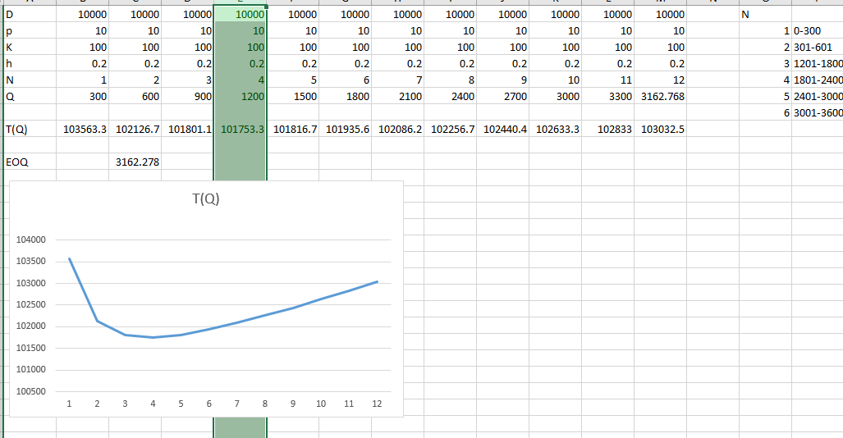

EOQ = 3162.278

4 fully utilised cold stores result in the minimum cost and therefore a minimum order quantity of Q=1200

5. A company manufactures 2 types of products, X and Y which make a profit of £36k and £34k respectively.

Each type of product requires use of two raw materials, raw material A and raw material B. Product X requires 4 units of raw material A and 0.2 units of raw material B, product Y requires 3 units of raw material A and 0.3 units of raw material B. The company has a maximum of 40 units of raw material A and 3 units of raw material B to use a week. What is the optimal amount of product X and product Y that the company should make a week?

- Formulate a linear programming model.
(8 marks)

Max 36x +34y

Subject to

4x+3y<=40
0.2x+0.3y<=3

x,y >= 0

x and y integers

- Solve the linear programming model to determine how many of each product should be made per week so that the largest profit is made?
(7 marks)

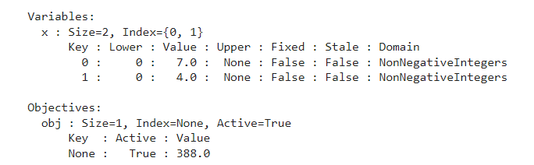

- Interpret your results from b), what is the unused material (if any) on machine A and machine B.
(5 marks)

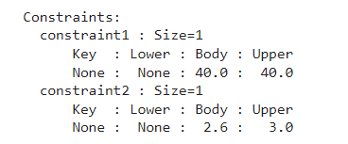

Unused material for raw material B is 0.4

- Extend your model so that for every Product X that is made, 3 of Product Y is made and solve

Add the equality constraint y=3x
(5 marks)

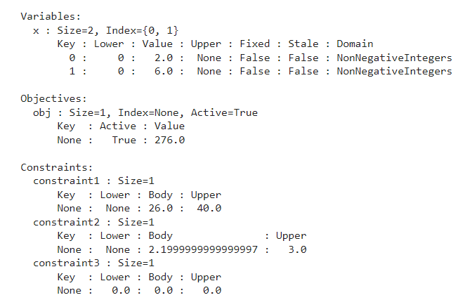
Total 25 marks

