Revision – Sample Questions

  - Form a linear program as follows

$x$ – Product X
$y$ – Product Y

maximise
$$24x+23y-\left(3⋅1+3⋅4+4⋅1\right)x-\left(2⋅3+6⋅1+4⋅1\right)y=5x+7y$$

subject to:

$x+3y≤60$ (Hours for A)$4x+y≤75$ (Hours for B)$x+y≤27$ (Hours for C)
and
$$x,y≥0$$

Solutions via Pyomo
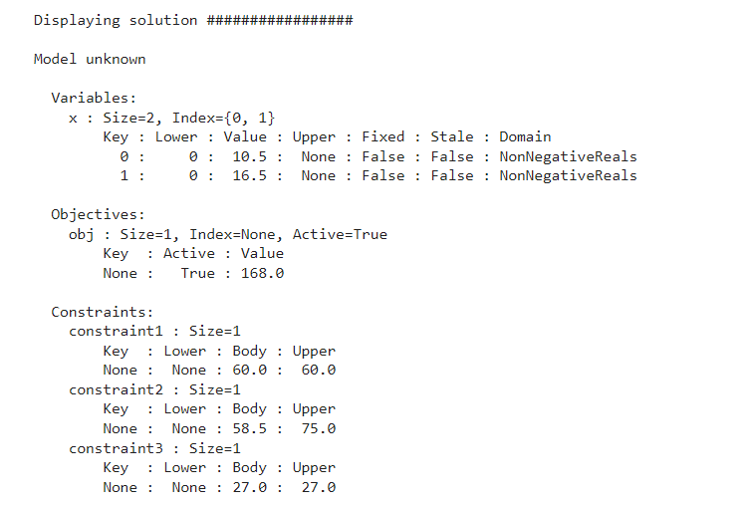

Solution via Desmos

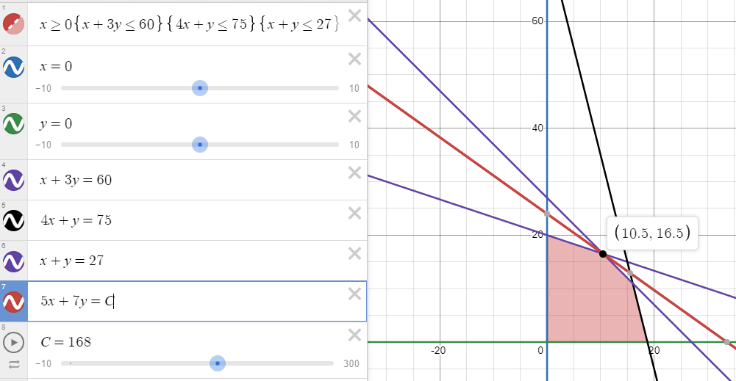

  - Add the additional constraint
$$x≥\frac{3}{2}y$$
e.g. if $y=4$ then $x≥6$. Hence the percentage of produce $x$ is $\frac{6}{10}*100=60\%$
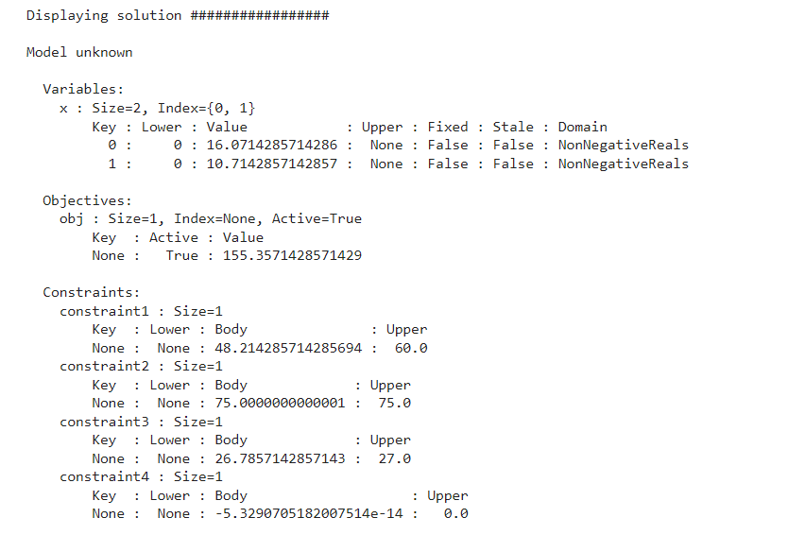
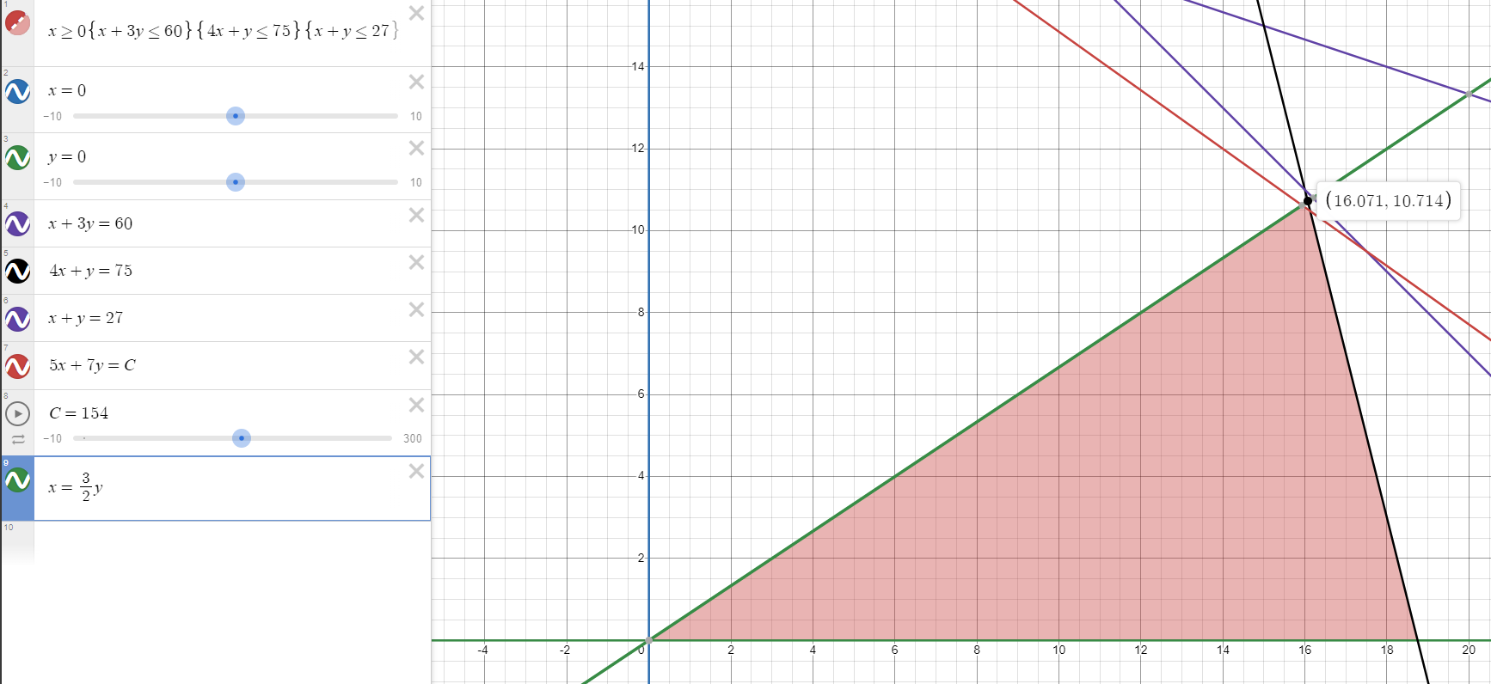

  - Add a constraint

$\left(3⋅1+3⋅4+4⋅1\right)x+\left(2⋅3+6⋅1+4⋅1\right)y≤400$ (Total hours cost for A, B and C)

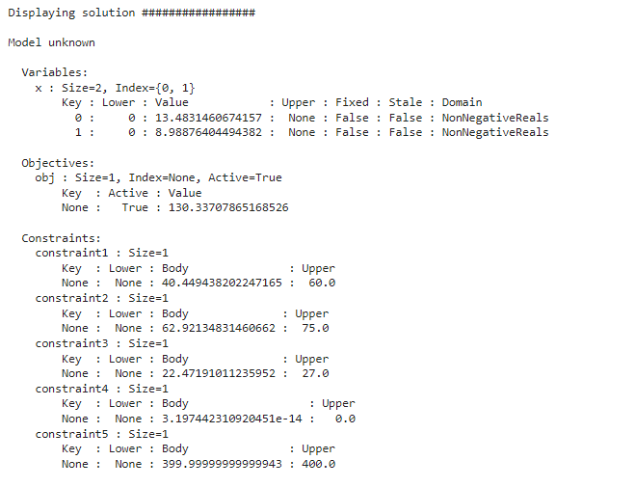

2.

This appears to be manageable no long term build up of jobs, some unused capacity, but clearly this does not affect the jobs being completed.

Again, this appears to be manageable no long term build up of jobs, some unused capacity, but clearly this does not affect the jobs being completed.

Whilst we would need to examine the long-term behaviour of the system, we can see the following:
- The job load for a single worker with increased demand appears manageable.
- In the case of the additional worker there appears to be a lot of unused capacity, i.e. idle time.

The cost analysis also suggests that a single worker is the best option.
If we analyse the expected increased demand and the expected workrate we see that the single worker has a value of 9.1 and the expected increased demand is 8.1. Hence a single worker is enough.
Interestingly the expected current demand of 8.4 is more than 8.1.

3.
a.

b.

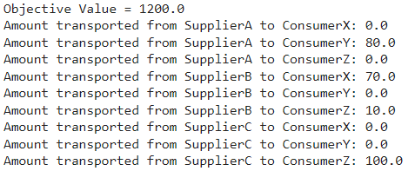

c.

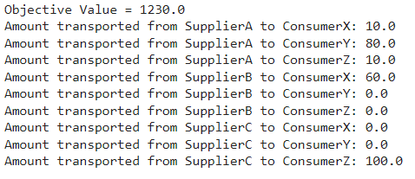

d.

Yes we should use as the objective is lower than previously
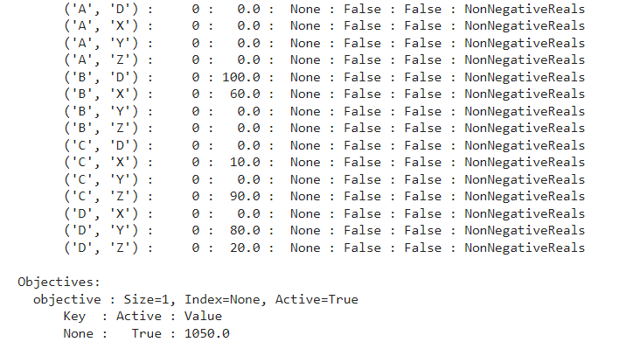

4.
$$T\left(Q\right)=PD+\frac{KD}{Q}+\frac{hQ}{2}$$

$$EOQ=\frac{\sqrt{2KD}}{h}=\sqrt{\frac{2⋅10⋅10000}{0.2}}=1000$$

As we have price breaks, the optimal order will occur at either EOQ or just past a price break larger than EOQ.
$$T\left(1000\right)=£8200 \\ T\left(1200\right)=£8103.33 \\ T\left(4000\right)=£8225$$

Thus we have a minimum, $Q^{*}=1200, T\left(Q^{*}\right)=£8103.33$
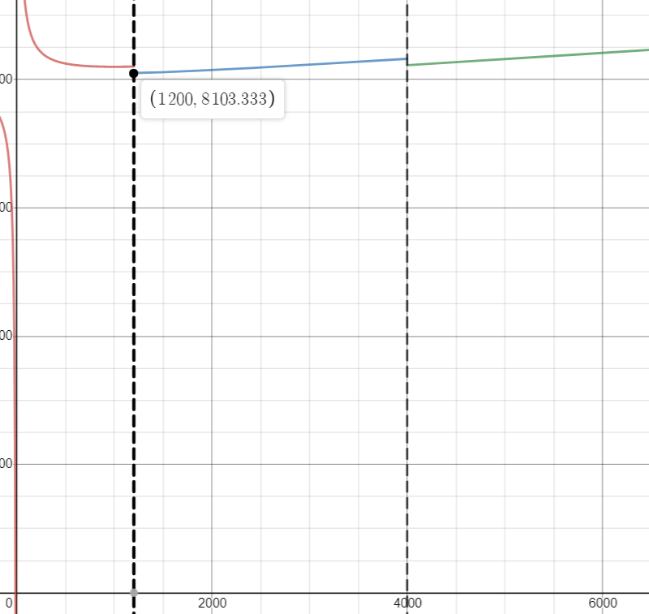

5.Assume Y=T+S+R
Compute a 2X4-MA to estimate the trend (T), then compute the seasonality (S) and remainder (R).
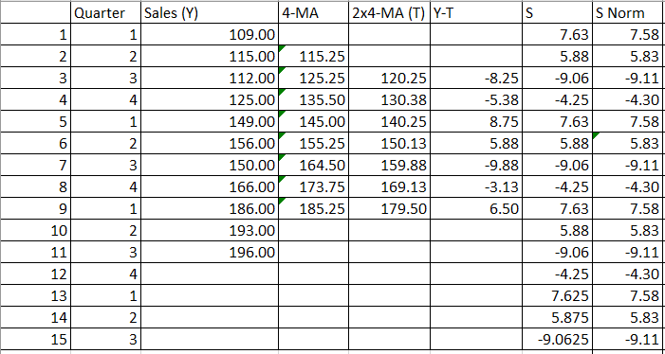
Thus, our additive decomposition looks as follows.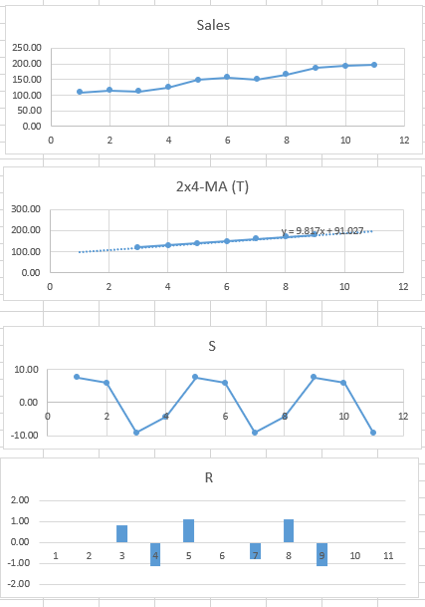

Fit a model to the trend, here we fit a linear model, if you are doing this by hand you would draw a straight line through the data.
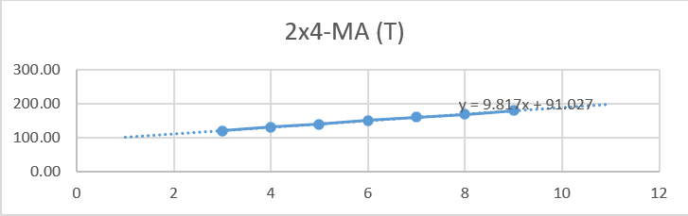
The linear model for T is:
$$y=9.817x+91.027$$

Use this plus the seasonality to predict the future quarters…
