Part A
- For the following linear program:

maximise $x+3y$
subject to:
$$x+2y≤20$$
$$3x+y≤30$$
$$x+10y≤80$$
$$x≥0$$
$$y≥0$$

  - Solve the linear program graphically.
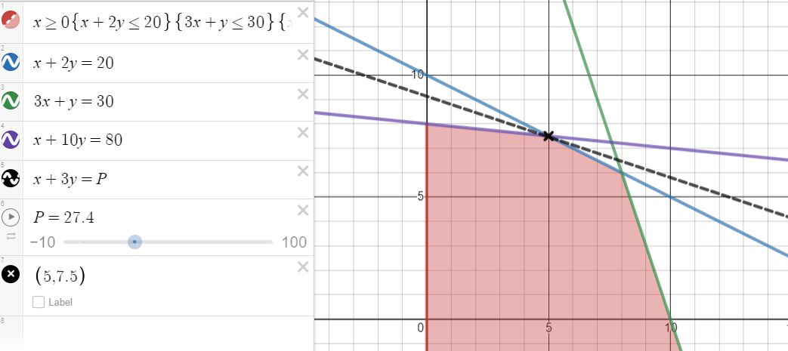
  - Convert into the following matrix form (useful for MATLAB).

minimise ${ c}^{T}x$
subject to:
$$Ax≤b \\ x≥0$$

  - Solve the linear program via MATLAB using the matrix form.
(15 marks)

- You have a total of £10,000 to invest in three different funds - ToyTown, C&G and Pixel Ltd.
The expected return and risk level for each of the fund is:

Toy Town | 6% | Low
C&G | 7% | Medium
Pixel Ltd | 10% | High

To minimise your risk across the three fund you decide to invest at least twice as much in Toy Town as you invest in C&G. You also decide that as Pixel Ltd is considered a high-risk fund, to limit the amount you invest in this fund to £2000.

Taking account of your decisions to minimise the risk, produce a model and determine the optimal amount to invest in each of the three funds?

What does your solution tell you about the problem?

ANSWER

$$x-Investment in Toy Town$$
$$y-Investment in C\&G$$
$$z-Investment in Pixel Ltd$$

Maximise
$$0.06x+0.07y+0.1z$$
or
$1.06x+1.07y+1.1z$ (give then a 7, this isn’t technically correct for variants of this problem).

Subject to:
$$x≥2y \\ z≤2000$$
$$x+y+z≤10000$$
and
$$x,y,z≥0$$

Simplified
Note that $z=10000-x-y$ as all money will be invested…
Maximise
$$1.06x+1.07y+1.1\left(10000-x-y\right)⟺-0.04x-0.03y$$
Or equivalent with 0.06 etc…
Subject to:
$$x≥2y$$
$$z≥0⟺10000-x-y≥0⟺x+y≤10000 \\ z≤2000⟺10000-x-y≤2000⟺x+y≥8000$$
and
$$x,y≥0$$

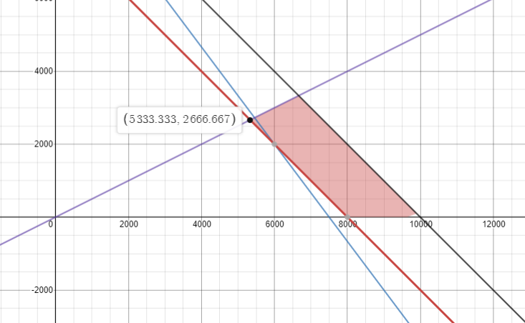

NOTE: The solution will prompt the students to realise they can compute the answer manually.

Manually – Work out high-risk – low-risk, in that order:
- Choose £2000 (upper limit) for $z$
- This leaves £8000, of which you will split 2:1 in favour of low:medium.
  - $\frac{8000}{3}×2=£5333.33$
  - $\frac{8000}{3}×2=£2666.67$

Also there is no risk in the objective function, thus it is only the limit on the high risk fund that caps things, this is very manual…

(15 marks)
- The following items (see Table 1) are being given away for free and you wish to maximise the value of the items that you take away. Your rucksack has a maximum weight of 15kg and a maximum volume of 30 litres.

Item | Weight (Kg) | Volume (Litre) | Value (£)
1 | 3.5 | 4 | 5
2 | 2.4 | 4 | 2
3 | 0.9 | 5 | 3
4 | 2.5 | 2 | 1
5 | 3.1 | 11 | 11
6 | 4.2 | 9 | 7
7 | 5.1 | 11 | 5
8 | 3.5 | 8 | 2
9 | 4.5 | 11 | 5
10 | 2.9 | 8 | 7
Table 1:Item Information

  - Formulate an ILP model.
  - Solve your model.
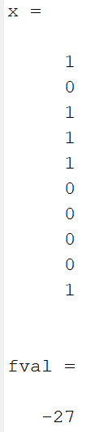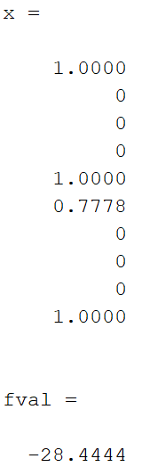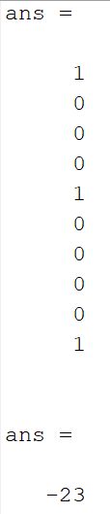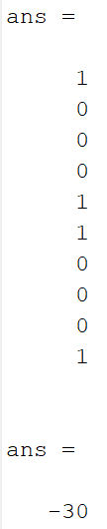
MILP, LP, Rounded down LP, Rounded Up LP
Rounded UP LP is infeasible. Best is MILP.
  - Relax the integer constraints and solve.
  - Round your solution both up and down and compare it with the integer solution. How does this compare and what can you say integer programming and linear programming problems?

Something about rounding not necessarily being optimal.
(20 marks)

