Operational Research
5CM522

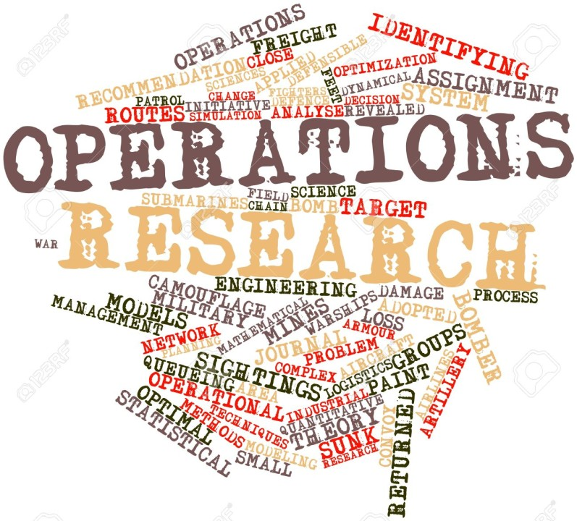

5CM522 Assessment Brief – Coursework Part A

Dr Sam O’Neill

Operational Research (5CM522)
Contents
Module Leader 3
Key dates and details 3
Description of the assessment 3
Learning Outcomes 3
Assessment Regulations 3
Guidance and Presentation 4
Submission Requirements 4
Viva Voce (Oral Examination) 4
Questions 5
Appendix A 8
Presentation Rubric 8

Module Leader
- Dr Sam O’Neill
- Contact via the module page

Key dates and details

Assessment Type: | Individual
Assessment weighting: | 25%
Learning Outcomes: | 1, 2
Submission Method: | Electronic Submission via Course Resources
Submission Date: | 12/12/25
Provisional Feedback Release Date: | 16/01/26

Description of the assessment
Students will be required to model and answer a series of questions related to Operational Research

Learning Outcomes
- Demonstrate an understanding of Operational Research methods and methodology.
- Build models to enable the analysis and solution of case study problems.

Assessment Regulations
The University’s regulations, policies and procedures for students define the framework within which teaching, and assessment are conducted. Please make sure you are familiar with these regulations, policies, and procedures.

Guidance and Presentation

Marks are given for presentation based on the following weighting:
- 15% for presentation and quality of write up. Please see the rubric in Appendix A.
- 85% for answers given in the report.

You are expected to write up your models and answers. This includes defining notation, e.g. variables, constants etc.

You should try and use the built-in equation editor in word, or Latex; however, you may provide handwritten answers that are scanned into one document. Please ensure that any handwritten answers are neat and legible.

Submission Requirements
Students are required to submit a word/pdf document that contains all their answers to the questions. They should also submit any Python code used for the solutions to the models as separate files that are clearly labelled with the question no. If these are .ipynb (Google Colab) files then you can download the notebook and submit this.
Screenshots are encouraged to show the output of your Python code and solutions to the problems.
These should all be submitted to the submission point before the deadline.

Viva Voce (Oral Examination)
Students will be asked to demonstrate their work over a 10-15 minute period. This is to ensure that the work submitted is the student's own and inline with the academic assessment regulations and policy on Generative AI.
Assessment Rubric
Please see the assessment rubric section.
Assessment AI-assistance
You are not permitted to use Generative AI for this assignment.
Any suspicion that the work is not your own, either through plagiarism, excessive collaboration or use of generative AI will result in a further Oral Examination. This will require you to explain your work in detail, failure to do so will result in a Fail mark.
Any misuse of generative AI tools could be considered ethical academic misconduct (as per Academic Regulations, Academic Misconduct, Section J2). If in doubt, please consult your module leader.

Questions

- For the following linear program:

maximise $x+3y$
subject to:
$$x+2y≤20$$
$$3x+y≤30$$
$$x+10y≤80$$
$$x≥0$$
$$y≥0$$

  - Graph the linear programming problem and solve by inspecting the basic feasible solutions via each possible pair of simultaneous equations formed by the constraints. Show your working.
  - Which constraints are binding?
  - Convert into the following matrix form.

minimise ${ c}^{T}x$
subject to:
$$Ax≤b \\ x≥0$$

  - Solve the linear program using Python.
(30 marks)

- You have a total of £10,000 to invest in three different funds - ToyTown, C&G and Pixel Ltd.
The expected return and risk level for each of the fund is given in table 1:

Fund | Expected Return | Risk Level
Toy Town | 6% | Low
C&G | 7% | Medium
Pixel Ltd | 10% | High
Table 1:Expected return and risk level
To minimise your risk across the three funds you decide to invest at least twice as much in Toy Town as you invest in C&G. You also decide that as Pixel Ltd is considered a high-risk fund, to limit the amount you invest in this fund to £2000.

- Taking account of your decisions to minimise the risk, produce a model to determine the optimal amount to invest in each of the three funds so as to maximise the expected return?
- Solve this model using Python and report the solutions.
- Reduce this model to only two decision variables. What does this tell you about the solution to the problem?
(30 marks)

- The following items (see Table 2) are being given away for free and you wish to maximise the value of the items that you take away. Your rucksack has a maximum weight of 15kg and a maximum volume of 30 litres.

Item | Weight (Kg) | Volume (Litre) | Value (£)
1 | 3.5 | 4 | 5
2 | 2.4 | 4 | 2
3 | 0.9 | 5 | 3
4 | 2.5 | 2 | 1
5 | 3.1 | 11 | 11
6 | 4.2 | 9 | 7
7 | 5.1 | 11 | 5
8 | 3.5 | 8 | 2
9 | 4.5 | 11 | 5
10 | 2.9 | 8 | 7
Table 2: Item information
  - Formulate an Integer Linear Program (ILP) with appropriate notation to solve the problem.
  - Solve this ILP using Python.
  - Relax the integer constraints of the ILP and solve the LP.
  - Round your solution from c) to the nearest integer and compare it with the integer solution from b). How does this compare and what can you say integer programming and linear programming problems?
(40 marks)

Appendix A

Presentation Rubric

