2014 Formula Hybrid Electrical System Form Template

Note: The 2014 Formula Hybrid ESF is different in many ways from FSAE-electric and international competitions. However, this form was produced in cooperation with FSAE-electric and Formula Student Germany.

Complete the following information:
University Name: | My College
Team Name: | My Team
Car Number: | 000

Main Team Contact for ESF related questions:
Name:
e-mail:

Feel free to add team logo, car picture, and the like.

Requirements:

- Read the document “How to pass ESF & FMEA” which can be found at:
http://www.formulastudent.de/uploads/media/FSE2011_How_to_pass_ESF_FMEA_01.pdf
- Maximum number of pages for the complete ESF is 100 pages!
- Links to video or audio data are not permitted.
- If you did not fill out the tables or if you changed the format of the ESF Template, your ESF will be rejected.
- Every part and heading of the ESF Template must be filled with content. If the respective part is not relevant for your concept, describe shortly why not.
- The table of contents must be hyperlinked.
- The generated PDF must contain hyperlinked bookmarks.
- Use internal reference links. For example when describing wiring and mentioning a figure in the text then link it to the figure.
- Do not just copy all of your datasheets in the appendix, e.g. we do not need to know what you have to do to program your motor controller; we do not need the user’s manuals for your microcontrollers, etc. etc.
- Single pages with figures and/or tables extracted from the complete datasheet that show the important parameters, etc. are usually sufficient, but the source/link to the complete datasheet must be provided. If the datasheet describes more than one type, clearly mark in the datasheet which type you are referring to.
- Datasheets should only be used as a reference. Please include the important data in your text by using tables, figures, etc.
- If you refer to parts of a data sheet, then you should provide an internal document link from the text to the respective datasheet and another internal document link back from the datasheet to the text section.
For example a link in the motor controller section “The datasheet can be found here (clickable)” and a link above the motor controller datasheet in the appendix “The section covering the motor controller can be found here (clickable)”.
- If you do not understand the reviewer’s feedback, please e-mail and ask.
- Parts of the ESF which are changed because of reviewer’s feedback must be marked in red.
- When completed, this file must be saved as a pdf and submitted to:

http://formula-hybrid.com/uploads/

Following these guidelines will help the reviewers provide a swift review process.

Table of Contents

I List of Figures vii
II List of Tables viii
III List of Abbreviations ix
Section 1 System Overview 1
Section 2 Electrical Systems 2
2.1 Shutdown Circuit 2
2.1.1 Description/concept 2
2.1.2 Wiring / additional circuitry 2
2.1.3 Position in car 3
2.2 IMD 3
2.2.1 Description (type, operation parameters) 3
2.2.2 Wiring/cables/connectors/ 3
2.2.3 Position in car 3
2.3 Reset / Latching for IMD and BMS 4
2.3.1 Description/circuitry 4
2.3.2 Wiring/cables/connectors 4
2.3.3 Position in car 4
2.4 Shutdown System Interlocks 4
2.4.1 Description/circuitry 4
2.4.2 Wiring/cables/connectors 4
2.4.3 Position in car 4
2.5 Tractive system active light 4
2.5.1 Description/circuitry 4
2.5.2 Wiring/cables/connectors 5
2.5.3 Position in car 5
2.6 Measurement points 5
2.6.1 Description 5
2.6.2 Wiring, connectors, cables 5
2.6.3 Position in car 5
2.7 Pre-Charge circuitry 5
2.7.1 Description 5
2.7.2 Wiring, cables, current calculations, connectors 5
2.7.3 Position in car 6
2.8 Discharge circuitry 6
2.8.1 Description 6
2.8.2 Wiring, cables, current calculations, connectors 6
2.8.3 Position in car 7
2.9 HV Disconnect (HVD) 7
2.9.1 Description 7
2.9.2 Wiring, cables, current calculations, connectors 7
2.9.3 Position in car 7
2.10 Ready-To-Drive-Sound (RTDS) 7
2.10.1 Description 7
2.10.2 Wiring, cables, current calculations, connectors 7
2.10.3 Position in car 8
2.10.4 HV-LV Separation 8
2.10.5 Conduit 8
Section 3 Accumulator 9
3.1 Accumulator pack 1 9
3.1.1 Overview / description / parameters 9
3.1.2 Cell description 9
3.1.3 Cell configuration 10
3.1.4 Cell temperature monitoring 10
3.1.5 Accumulator insulation relays 10
3.1.6 Fusing 11
3.1.7 Battery management system 11
3.1.8 Accumulator indicator 11
3.1.9 Wiring, cables, current calculations, connectors 12
3.1.10 Charging 12
3.1.11 Mechanical Configuration/materials 13
3.1.12 Position in car 13
3.2 Accumulator pack 2 13
Section 4 Motor Controller 14
4.1 Motor Controller 1 14
4.1.1 Description, type, operation parameters 14
4.1.2 Wiring, cables, current calculations, connectors 14
4.1.3 Position in car 15
4.2 Motor Controller 2 15
Section 5 Motors 16
5.1 Motor 1 16
5.1.1 Description, type, operating parameters 16
5.1.2 Wiring, cables, current calculations, connectors 17
5.1.3 Position in car 17
5.2 Motor 2, 3, 4… 17
Section 6 Throttle Position Encoder 18
6.1 Description/additional circuitry 18
6.2 Throttle position encoder plausibility check 18
6.3 Wiring 18
6.4 Position in car/mechanical fastening/mechanical connection 18
Section 7 Additional LV-parts 19
7.1 Electrical Power Distribution Module 19
7.1.1 Description, functions, and purpose 19
7.1.2 Wiring, cables, and circuit layout 20
7.1.3 Position in car 20
7.2 Dashboard Control Unit 21
7.2.1 Description, function, and purpose 21
7.2.2 Wiring, cables, and circuit layout 22
7.2.3 Position in car 23
7.3 Main Wiring Harness 24
7.3.1 Description, function, and purpose 24
7.3.2 Wiring, cables, and layout 24
7.3.3 Position in car 26
7.4 Subordinate Wiring Harnesses 26
7.4.1 Descriptions, function, and purposes 26
7.4.2 Wiring, cables, and layouts 26
7.4.3 Positions in car 27
7.5 Power Safety Loop 28
7.5.1 Description, function, and purpose 28
7.5.2 Wiring, cables, and layout 28
7.5.3 Position in car 29
Section 8 Overall Grounding Concept 30
8.1 Description of the Grounding Concept 30
8.2 Grounding Measurements 30
Section 9 Firewall(s) 31
9.1 Firewall 1 31
9.1.1 Description/materials 31
9.1.2 Position in car 31
9.2 Firewall 2 31
Section 10 Appendix 32

List of Figures

Must be hyperlinked!

List of Tables
Table 1.1 General parameters 1
Table 2.1 List of switches in the shutdown circuit 2
Table 2.2 Wiring – Shutdown circuit 3
Table 2.3 Parameters of the IMD 3
Table 2.4 Parameters of the TSAL 5
Table 2.5 General data of the pre-charge resistor 6
Table 2.6 General data of the pre-charge relay 6
Table 2.7 General data of the discharge circuit 7
Table 3.1 Main accumulator parameters 9
Table 3.2 Main cell specification 10
Table 3.3 Basic AIR data 11
Table 3.4 Basic fuse data 11
Table 3.5 Wire data of company A, 0.205 mm² 12
Table 3.6 General charger data 12
Table 4.1 General motor controller data 14
Table 5.1 General motor data 16
Table 6.1 Throttle Position encoder data 18

Must be hyperlinked!

List of Abbreviations

AIR Accumulator Isolation Relay
AMS Accumulator Management System
BSPD Brake System Plausibility Device
GLVS Grounded Low-Voltage System
TS Tractive System
TSAL Tractive System Active Light
TSMP Tractive System Measurement Point

System Overview
Person primarily responsible for this section:
Name:
e-mail:

- Short description of the system’s concept
- Rough Schematic (blocks) showing all parts affected with the electrical systems and function of the tractive-system
- No detailed wiring
- Additionally fill out the following table, replacing the values with your specifications:

Maximum Tractive-system voltage: | 300 VDC
Nominal Tractive-system voltage: | 260 VDC
Control-system voltage: | 12 VDC, 24 VDC
Accumulator configuration: | 200s 3p
Total Accumulator capacity: | 200 Ah
Motor type: | Permanent magnet synchronous motor
Number of motors: | Total 4, one per wheel
Maximum combined motor power in kW | 150
Table 1.1 General parameters

Electrical Systems
Person primarily responsible for this section:
Name:
e-mail:

Shutdown Circuit

Description/concept
Describe your concept of the shutdown circuit, the master switches, shut down buttons, brake over travel switch, etc.
Additionally fill out the following table replacing the values with your specification and append additional switches from your setup:
Part | Function
Main Switch (for control and tractive-system; CSMS, TSMS) | Normally open
Brake over travel switch (BOTS) | Normally closed
Shutdown buttons (SDB) | Normally closed
Insulation Monitoring Device (IMD) | Normally open
Battery Management System (BMS) | Normally open
Interlocks | Closed when circuits are connected
Table 2.2 List of switches in the shutdown circuit

Wiring / additional circuitry
Describe wiring and additional circuitry, show extra schematics for example if additional transistors etc. are used, also describe the function of additional circuitry and make good use of figures.
Additionally fill out and add information to the following table:
Total Number of AIRs: | 10
Current per AIR: | 0.5 A
Additional parts consumption within the shutdown circuit: | 2 A
Total current: | 7 A
Cross sectional area of the wiring used: | 0.205 mm²
Table 2.3 Wiring – Shutdown circuit

Position in car
Provide CAD-renderings showing the relevant parts. Mark the parts in the renderings, if necessary.

IMD

Description (type, operation parameters)
Describe the IMD used and use a table for the common operation parameters, like supply voltage, temperature, etc. Also describe how the IMD indicator light is wired, etc.
Additionally fill out the following table replacing the values with your specification:
Supply voltage range: | 10..36 VDC
Supply voltage | 24 VDC
Environmental temperature range: | -40..105°C
Self-test interval: | Always at startup, then every 20 minutes
High voltage range: | DC 0..1000 V
Set response value: | 300 kΩ (500 Ω/Volt)
Max. operation current: | 500 mA
Approximate time to shut down at 50% of the response value: | 27s
Table 2.4 Parameters of the IMD

Wiring/cables/connectors/
Describe wiring, show schematics, describe connectors and cables used and show useful data regarding the wiring.

Position in car
Provide CAD-renderings showing the relevant parts. Mark the parts in the rendering, if necessary.

Reset / Latching for IMD and BMS

Description/circuitry
Describe the concept and circuitry of the latching/reset system for a tripped IMD or BMS.

Wiring/cables/connectors
Describe wiring, show schematics, describe connectors and cables used and show useful data regarding the wiring.

Position in car
Provide CAD-renderings showing the relevant parts. Mark the parts in the rendering, if necessary.

Shutdown System Interlocks

Description/circuitry
Describe the concept and circuitry of the Shutdown System Interlocks.

Wiring/cables/connectors
Describe wiring, show schematics, describe connectors and cables used and show useful data regarding the wiring.

Position in car
Provide CAD-renderings showing the relevant parts. Mark the parts in the rendering, if necessary.

Tractive system active light

Description/circuitry
Describe the tractive system active light and additional circuitry.
Additionally fill out the table:
Supply voltage: | 12 VDC
Max. operational current: | 700 mA
Lamp type | LED
Power consumption: | 4.5 W
Brightness | 100 Lumen
Frequency: | 1.5 Hz
Size (length x height x width): | 20 mm x 10 mm x 50 mm
Table 2.5 Parameters of the TSAL

Wiring/cables/connectors
Describe wiring, show schematics, describe connectors and cables used and show useful data regarding the wiring.

Position in car
Provide CAD-renderings showing the relevant parts. Mark the parts in the rendering, if necessary.

Measurement points

Description
Describe the housing used and how it can be accessed, etc.

Wiring, connectors, cables
Describe wiring, show schematics, and describe connectors and cables used and show useful data regarding the wiring.

Position in car
Provide CAD-renderings showing the relevant parts. Mark the parts in the rendering, if necessary.

Pre-Charge circuitry

Description
Describe your concept of the pre-charge circuitry.

Wiring, cables, current calculations, connectors
Describe wiring, show schematics, describe connectors and cables used and show useful data regarding the wiring.
- Give a plot “Percentage of Maximum Voltage” vs. time
- Give a plot Current vs. time
- For each plot, give the basic formula describing the plots
Additionally fill out the tables:
Resistor Type: | ABC Resistor
Resistance: | 680 Ω
Continuous power rating: | 60 W
Overload power rating: | 200 W for 30 sec
Voltage rating: | 1500 V
Cross-sectional area of the wire used: | 0.205 mm²
Table 2.6 General data of the pre-charge resistor

Relay Type: | DEF Relay
Contact arrangement: | SPDT, SPST, SPCO, SPTT, DPST, ….
Continuous DC current: | 25 A
Voltage rating | 2000 VDC
Cross-sectional area of the wire used: | 0.205 mm²
Table 2.7 General data of the pre-charge relay

Position in car
Provide CAD-renderings showing all relevant parts. Mark the parts in the rendering, if necessary.

Discharge circuitry

Description
Describe your concept of the discharge circuitry.

Wiring, cables, current calculations, connectors
Describe wiring, show schematics, describe connectors and cables used and show useful data regarding the wiring.
- Give a plot “Voltage” vs. time
- Give the formula describing this behavior
- Give a plot “Discharge current” vs. time
- Give the formula describing your plot
Additionally fill out the table:
Resistor Type: | ABC Resistor
Resistance: | 680 Ω
Continuous power rating: | 350 W
Overload power rating: | 600 W for 20 sec
Voltage rating: | 1500 V
Maximum expected current: | 0.7 A
Average current: | 0.3 A
Cross-sectional area of the wire used: | 0.205 mm²
Table 2.8 General data of the discharge circuit

Position in car
Provide CAD-renderings showing all relevant parts. Mark the parts in the rendering, if necessary.

HV Disconnect (HVD)

Description
Describe your concept of the HVD and how it can be operated.

Wiring, cables, current calculations, connectors
Describe wiring, show schematics, describe connectors and cables and show useful data regarding the wiring.

Position in car
Provide CAD-renderings showing all relevant parts. Mark the parts in the rendering, if necessary.

Ready-To-Drive-Sound (RTDS)

Description
Describe your concept of the RTDS, how is the sound produced, what are the parameters for activating the RTDS, etc.

Wiring, cables, current calculations, connectors
Describe wiring, show schematics, describe connectors and cables and show useful data regarding the wiring.

Position in car
Provide CAD-renderings showing all relevant parts. Mark the parts in the rendering, if necessary.

HV-LV Separation
Document separation of LV and HV wiring, showing pictures of spacing and/or insulation materials.

Conduit
Describe conduit used for tractive system wiring outside of electrical enclosures, and how the conduit is anchored.

Accumulator
Person primarily responsible for this section:
Name:
e-mail:

Accumulator pack 1

Overview / description / parameters
Describe concept of accumulator pack, provide table with main parameters like number of cells, cell stacks separated by maintenance plugs, cell configuration, resulting voltages->minimum, maximum, nominal, currents, capacity etc.
Fill out the following table:
Maximum Voltage: | 250 VDC
Nominal Voltage: | 200 VDC
Minimum Voltage: | 180 VDC
Maximum output current: | 405 A for 10 sec
Maximum nominal current: | 250 A
Maximum charging current: | 50 A
Total numbers of cells: | 200
Cell configuration: | 100s2p
Total Capacity: | 4.2 kWh
Number of cell stacks < 120VDC | 5
Table 3.9 Main accumulator parameters

Cell description
Describe the cell type used and the chemistry, provide table with main parameters.
Fill out the following table:
Cell Manufacturer and Type | Kokam XYZ
Cell nominal capacity: | 5.4 Ah
Maximum Voltage: | 4.2 V
Nominal Voltage: | 3.7 V
Minimum Voltage: | 2.8 V
Maximum output current: | 20 C for 10s
Maximum nominal output current: | 15 C
Maximum charging current: | 5 C
Maximum Cell Temperature (discharging) | 65°C
Maximum Cell Temperature (charging) | 55°C
Cell chemistry: | LiFePO4
Table 3.10 Main cell specification

Cell configuration
Describe cell configuration, show schematics, cover additional parts like internal cell fuses etc.

Cell temperature monitoring
Describe how the temperature of the cells is monitored, where the temperature sensors are placed, how many cells are monitored, etc. Show schematics, cover additional parts, etc.

Accumulator insulation relays
Describe the AIRs used and their main operation parameters, use tables, etc.
Additionally fill out the following table:
Relay Type: | ABC Relay
Contact arraignment: | SPST
Continuous DC current rating: | 100 A
Overload DC current rating: | 200 A for 10 sec
Maximum operation voltage: | 200 VDC
Nominal coil voltage: | 24 VDC
Normal Load switching: | Make and break up to 300 A
Maximum Load switching | 10 times at 1500 A
Table 3.11 Basic AIR data

Fusing
Describe the fuses used and their main operation parameters use tables, etc.
Additionally fill out the following table:
Fuse type: | MNO Fuse
Continuous current rating: | 150 A
Max. operating voltage (specify AC or DC) | 500 VDC
Type of fuse: | Fast Acting
I²t rating: | 1500 A² Sec. at 450 VDC
Interrupt Current (maximum current at which the fuse can interrupt the current) | 10000 A
Table 3.12 Basic fuse data
Create a table with components and wires protected by the fuse(s) and the according continuous current rating. Ensure that the rating of all of the components is greater than the rating of the fuse such that none of the other components become the fuse.

Battery management system
Describe the BMS used including at least the following:
- Sense wiring protection (fusing / fusible link wire used)
- What upper and lower voltage does the BMS react at and how does it react?
- What cell temperature does the BMS react at and how does it react?
- Show tables of operation parameters
- Describe how many cells are sensed by each BMS board, the configuration of the cells, the configuration of the boards and how any communications wiring between boards is protected
- Describe how the BMS is able to open the AIRs if any error is detected

Accumulator indicator
Describe the indicator, show wiring, provide tables with operation etc.

Wiring, cables, current calculations, connectors
Describe the internal wiring, show schematics, provide calculations for currents and voltages and show data regarding the cables and connectors used.
- Discuss maximum expected current, DC and AC how long will this be provided?
- Compare the maximum values to nominal currents
- Give a table for each kind of wire in your tractive-system:
- Describe your maintenance plugs, provide pictures
- Use tables like the one shown below:
Wire type | Company A,
Continuous current rating: | 150 A
Cross-sectional area | 0.205 mm²
Maximum operating voltage: | 800 VDC
Temperature rating: | 150 °C
Wire connects the following components: | Cell and BMS
Table 3.13 Wire data of company A, 0.205 mm²

Charging
Describe how the accumulator will be charged. How will the charger be connected? How will the accumulator be supervised during charging? Show schematics, CAD-Renderings, etc., if needed.
Additionally fill out the table:
Charger Type: | ABC Charger
Maximum charging power: | 3 kW
Maximum charging voltage: | 250 V
Maximum charging current: | 20 A
Interface with accumulator | CAN-Bus, proprietary, serial communication...
Input voltage: | 230 VAC
Input current: | 16 A
Table 3.14 General charger data

Mechanical Configuration/materials
Describe the concept of the container, show how the cells are mounted, use CAD-Renderings, show data regarding materials used, etc.

Position in car
Provide CAD-renderings showing the relevant parts. Mark the parts in the rendering, if necessary. Ensure that the required mechanical structure to protect the accumulator and other electrical components is clearly identified.

Accumulator pack 2
…
If identical parts are used, just refer to the corresponding sections, don’t copy and paste.

Motor Controller
Person primarily responsible for this section:
Name:
e-mail:

Motor Controller 1

Description, type, operation parameters
Describe important functions; provide table with main parameters like resulting voltages->minimum, maximum, nominal, currents etc.
Fill out the following table:
Motor controller type: | ABC Controller
Maximum continuous power: | 60 kW
Maximum peak power: | 75 kW for 10s
Maximum Input voltage: | 300 VDC
Output voltage: | 250 VAC
Maximum continuous output current: | 100 A
Maximum peak current: | 200 A for 5s
Control method: | PWM, analog signal...
Cooling method: | Air, water, oil...
Auxiliary supply voltage: | 24 VDC
Table 4.15 General motor controller data

Wiring, cables, current calculations, connectors
Describe the wiring, show schematics, provide calculations for currents and voltages and show data regarding the cables and connectors used.
Additionally fill out table:
Wire type: | Company A, 0.205 mm²
Current rating: | 150 A
Maximum operating voltage: | 800 V
Temperature rating: | 150 °C

Position in car
Provide CAD-renderings showing the relevant parts. Mark the parts in the rendering, if necessary.

Motor Controller 2
…
If identical parts are used, just refer to the corresponding sections, don’t copy and paste.
.

Motors
Person primarily responsible for this section:
Name:
e-mail:

Motor 1

Description, type, operating parameters
Describe the motor used, provide table with main parameters like resulting voltages->minimum, maximum, nominal, currents, resulting motor power, use figures to show important characteristics.
Additionally fill out table:
Motor Manufacturer and Type: | ABC Motor
Motor principle | Asynchronous, permanently excited
Maximum continuous power: | 25 kW
Peak power: | 70 kW for 5 sec
Input voltage: | 250 VAC
Nominal current: | 50 A
Peak current: | 70 A
Maximum torque: | 60 Nm
Nominal torque: | 20 Nm
Cooling method: | Water, oil, air,...
If liquid cooled, coolant: | Pure Water
Table 5.16 General motor data
- Give a plot of power vs. Rpm including a line for nominal and maximum power
- give a plot of torque vs. rpm including a line for nominal and maximum torque

Wiring, cables, current calculations, connectors
Describe the wiring, show schematics, provide calculations for currents and voltages and show data regarding the cables and connectors used.

Position in car
Provide CAD-renderings showing all relevant parts. Mark the parts in the rendering, if necessary and clearly identify the structure used to protect all relevant parts.

Motor 2, 3, 4…
…
If identical parts are used, just refer to the corresponding sections, don’t copy and paste.

Throttle Position Encoder
Person primarily responsible for this section:
Name:
e-mail:

Description/additional circuitry
Describe the type of the throttle position encoder(s) used, provide tables with main operation parameters, and describe additional circuitry used to check or manipulate the signal going to the motor controller. Describe how the system reacts if an implausibility or error (e.g. short circuit or open circuit or equivalent) is detected.
Encoder manufacturer and type: | ABC Encoder
Encoder principle: | Potentiometer
Supply voltage: | 5V
Maximum supply current: | 20mA
Operating temperature: | -20..180 °C
Used output: | 0-5V
Table 6.17 Throttle Position encoder data

Throttle position encoder plausibility check
Describe additional circuitry used to check or manipulate the signal going to the motor controller. Describe how failures (e.g. Implausibility, short circuit or open circuit or equivalent) are detected and how the system reacts if an implausibility or errors is detected.

Wiring
Describe the wiring, show schematics, show data regarding the cables and connectors used.

Position in car/mechanical fastening/mechanical connection
Provide CAD-renderings showing all relevant parts and discuss the mechanical connection of the sensors to the pedal assembly. Mark the parts in the rendering, if necessary.

Additional LV-parts
Person primarily responsible for this section:
Name: | Brian Margosian
e-mail: | bmargosi@umich.edu

Electrical Power Distribution Module

Description, functions, and purpose
The Electrical Power Distribution Module (EPDM) is a custom-designed printed circuit board (PCB) on the vehicle to organize harness wiring and overall electrical organization. It connects the major low voltage systems together and provides data across the control systems to maintain stability. The board is split into two parts, and mounted in a project enclosure with a connecting header. Figures XX and XY show the front and back layouts of both boards created in CadSoft EAGLE. For those unfamiliar, red signifies top copper and blue signifies bottom copper.

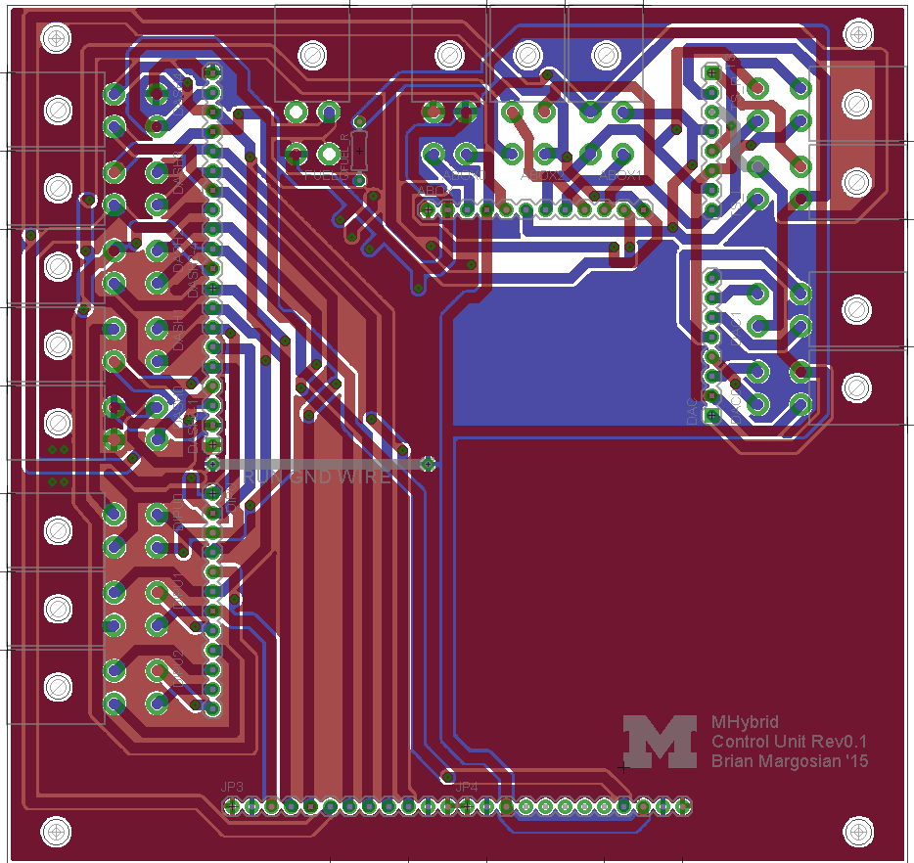Figure XX: PCB layout of the top board for the Electrical Power Distribution Module.
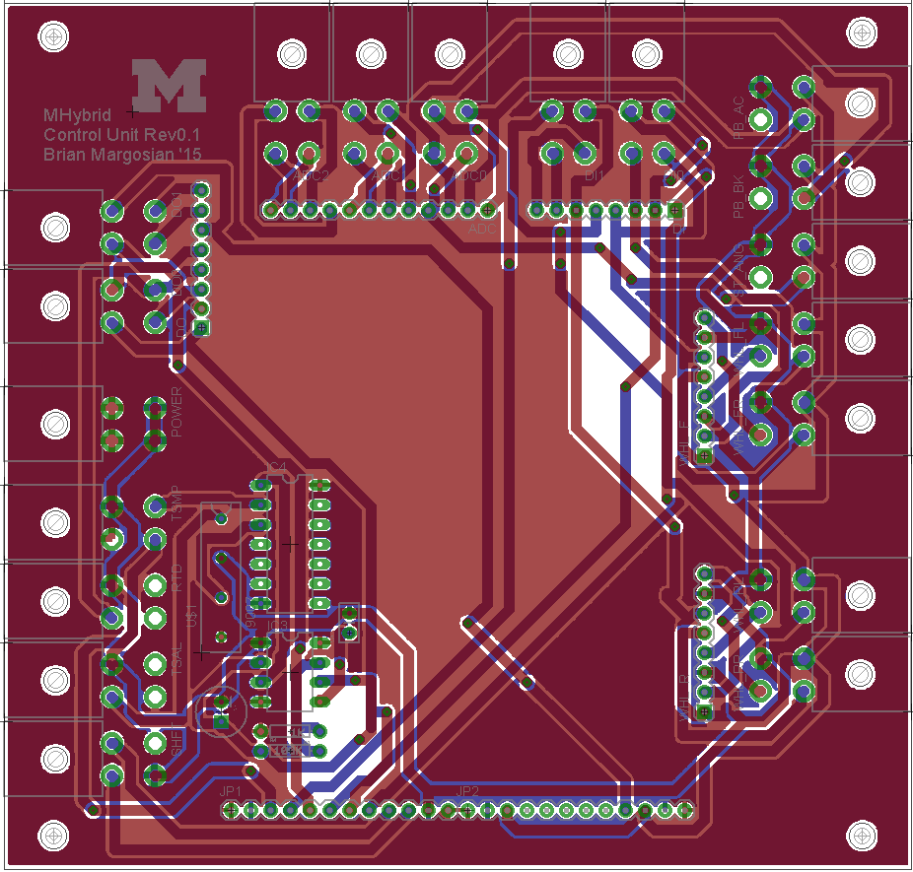
Figure XY: PCB layout of the bottom board for the Electrical Power Distribution Module.

Wiring, cables, and circuit layout
Wiring for the Power Distribution Module is mostly internal, however it supports debugging/testing external wiring if new applications are needed or if there were to be a malfunction. Figure XZ is a comprehensive schematic for the board, and contains all electrical connections in the above layouts. Cables exit the board via soldered Molex Mini-Fit 4-pin connectors (part 26013115), and are attached to the Main and Subordinate Wiring Harnesses (7.3 & 7.4).

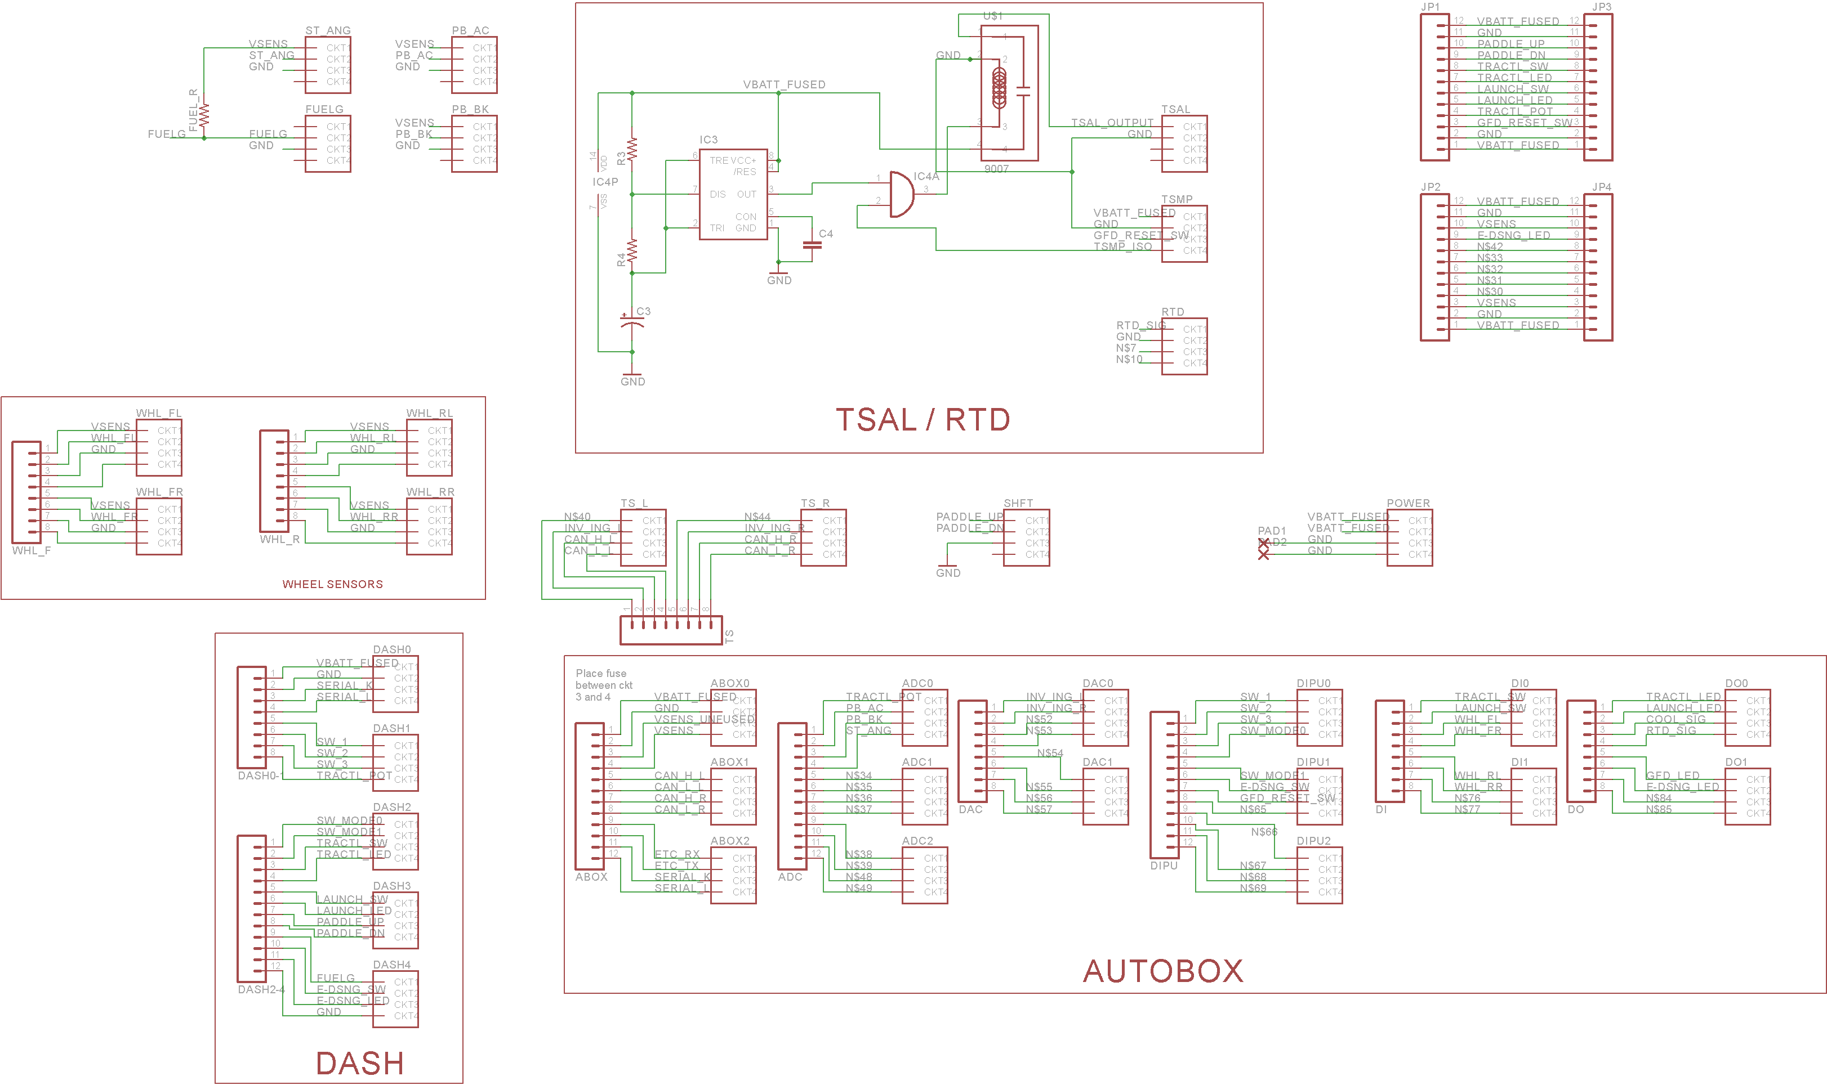
Figure XZ: Schematic layout for the Electrical Power Distribution Module PCB. Electrical connections are made by calling two or more nets by the same name, or by connecting with a green line.

Position in car
The Electrical Power Distribution Module is located under and behind the driver’s seat, in front of the firewall. It is attached to a carbon fiber-based bracket along with the Power distribution module (X.X?). Figure AA shows the location of the Electrical Power Distribution Module on the vehicle body.

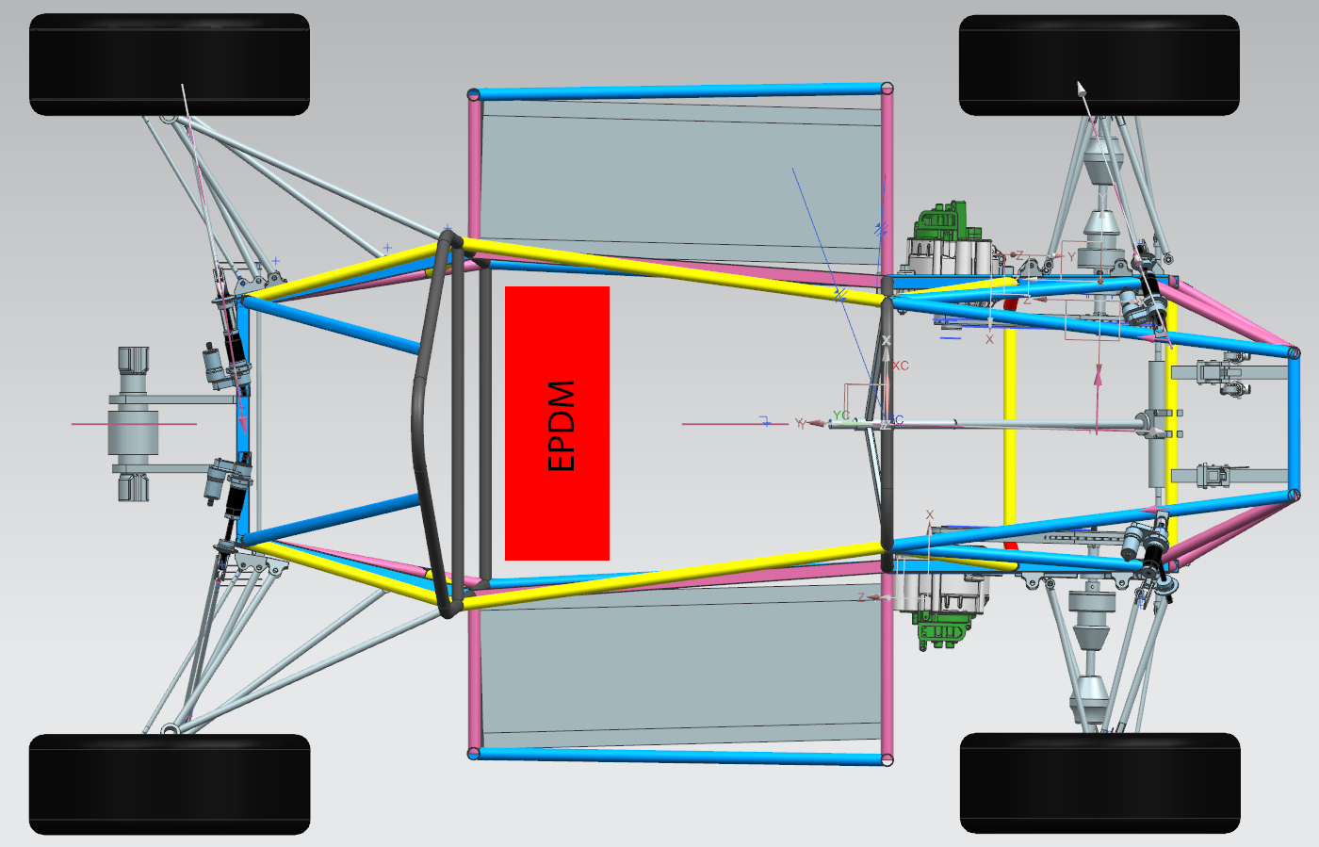
Figure AA: Location of the Electrical Power Distribution Module on the vehicle.

Dashboard Control Unit

Description, function, and purpose
The Dashboard Control Unit (DCU), put simply, controls the dashboard. It consists of a custom-built PCB shield for the Arduino Mega (link) and an Arduino Mega microcontroller inside of a project box. The PCB routes signals coming from the various interfaces on the dash to the EPDM (7.1) for control of the vehicle. Figure CA shows the EAGLE board layout. We again used Molex Mini-fit connectors (part 26013115) for keeping harnesses tidy.

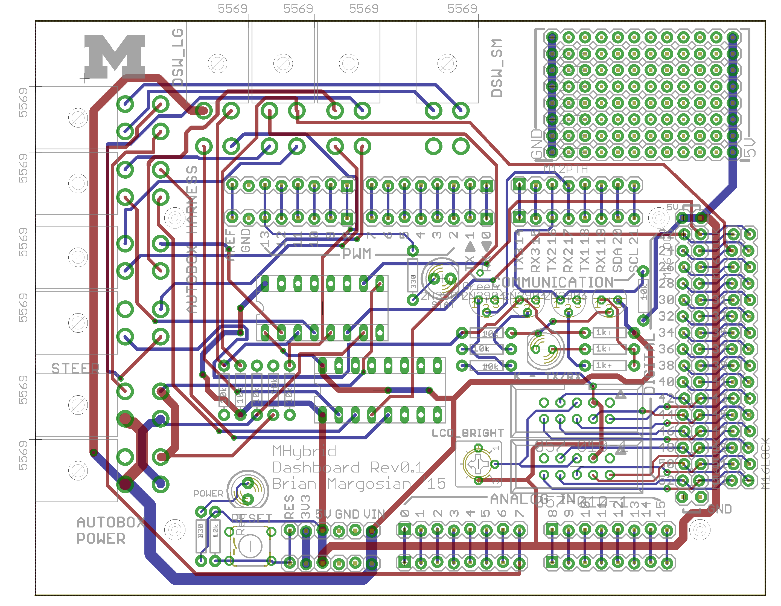
Figure CA: EAGLE board layout for the DCU. Again, blue signifies bottom copper and red signifies top copper.

Wiring, cables, and circuit layout
Wiring for the DCU is mostly internal, however it supports debugging/testing external wiring if new applications are needed or if there were to be a malfunction. Figure CB is a comprehensive schematic for the board, and contains all electrical connections in the above layouts. Cables exit the board via soldered Molex Mini-Fit 4-pin connectors (part 26013115), and are attached to the Main Wiring Harness (7.3) for communication with the EPDM (7.1).

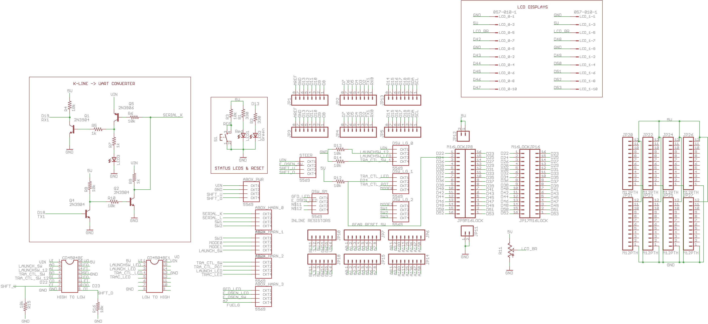
Figure CB: Schematic of the above layout for the DCU. Electrical connections are made by calling two or more nets by the same name.

Position in car
The DCU is located in a project box mounted to the back of the carbon-fiber dashboard component, as displayed by Figure CC.

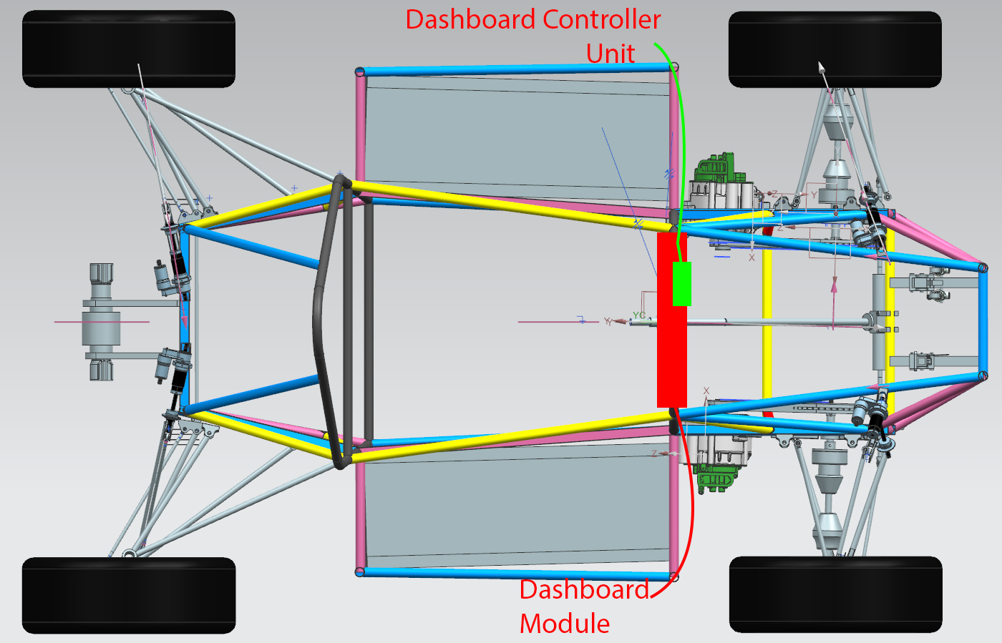
Figure CC: Physical location of the DCU project box on the vehicle.

Main Wiring Harness

Description, function, and purpose
The Main Wiring Harness is a bundle of wires connecting the Electrical Power Distribution Module (7.1) to the front-side of the vehicle. Included in the bundle is connections for the Dashboard Control Unit (7.2), front wheel speed sensors (?.?), as well as the steering angle sensor, and both pedal sensors (?.? and ?.?). The purpose of this harness is to organize wiring along the frame of the vehicle and distribute signals and power to the smaller LV systems.

Wiring, cables, and layout
All signal wires are 22 AWG, and power/ground wires are 20 AWG. However, we expect very low current through all these wires, the power signals are fused at the EPDM (7.1). The harness is encased in 3/4” ABS corrugated plastic (part XXXXXXX) and branches out to 1/4” where less wiring is needed. The ends have color coded Molex Mini-fit connectors (part 39012040) and spade/ring terminals for connecting to the EPDM and the sensors. Wires in the harness are listed in table BA.

Wire Purpose | From | To | AWG | Addl. info
VBATT_FUSED | EPDM | DASH | 20
GND | EPDM | DASH | 20
SERIAL_K | EPDM | DASH | 22 | Bi-directional
SERIAL_L | EPDM | DASH | 22
SW_1 | DASH | EPDM | 22
SW_2 | DASH | EPDM | 22
SW_3 | DASH | EPDM | 22
TRACTL_POT | DASH | EPDM | 22
SW_MODE0 | DASH | EPDM | 22
SW_MODE1 | DASH | EPDM | 22
TRACTL_SW | DASH | EPDM | 22
TRACTL_LED | EPDM | DASH | 22
LAUNCH_SW | DASH | EPDM | 22
LAUNCH_LED | EPDM | DASH | 22
PADDLE_UP | DASH | EPDM | 20 | 750mA max
PADDLE_DN | DASH | EPDM | 20 | 750mA max
FUELG | EPDM | DASH | 22
E-DSNG_SW | DASH | EPDM | 22
E-DSNG_LED | EPDM | DASH | 22
VSENS | EPDM | Front sensors | 20
GND | EPDM | Front sensors | 20
WHL_FL | Front left wheel | EPDM | 22
WHL_FR | Front right wheel | EPDM | 22
ST_ANG | Steering column | EPDM | 22
PB_AC | Accelerator pedal | EPDM | 22
PB_BK | Brake pedal | EPDM | 22
Table BA: Detailed layout of the main wiring harness.

Position in car
See figure AB for the location in the vehicle. The harness branches at various points to gain access to the sensors located at the front wheels, pedal area, and dashboard.

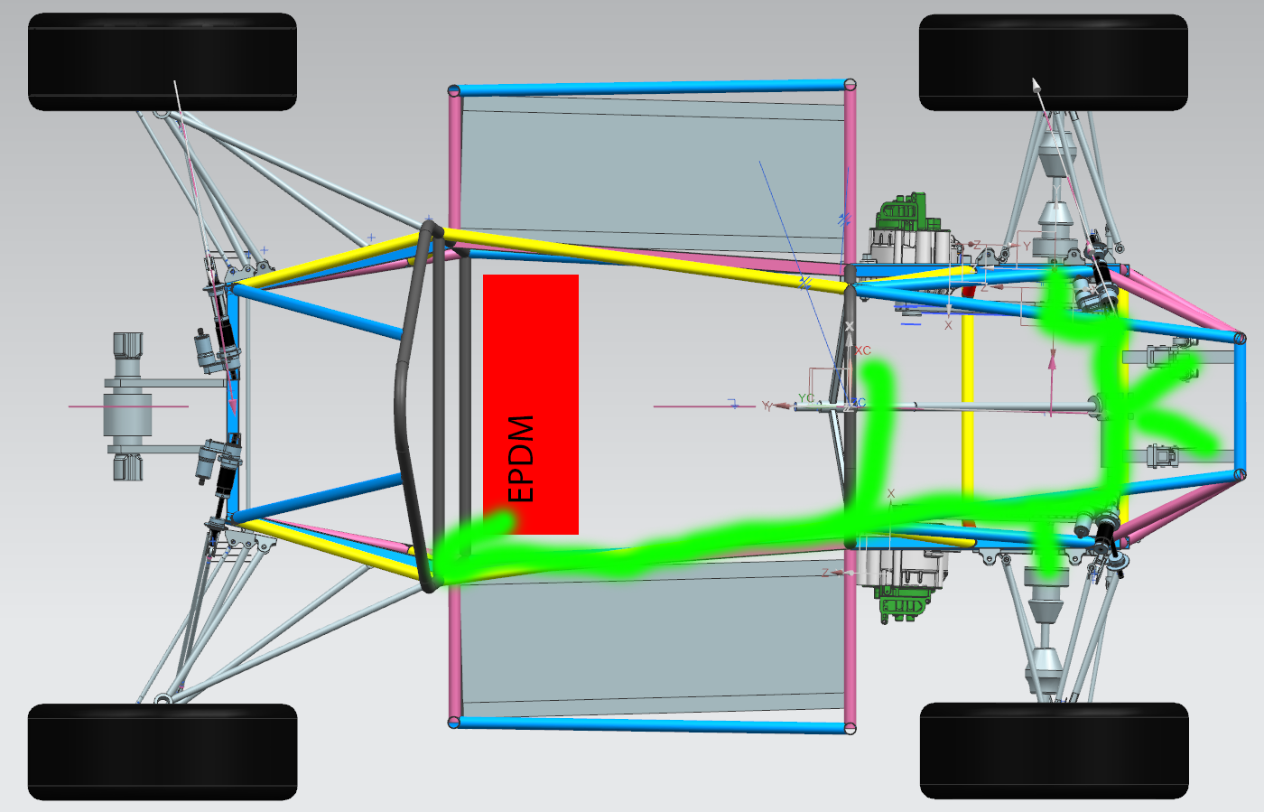
Figure AB: Location of the Main Wiring Harness in the vehicle. The red box is the EPDM (7.1), and the actual harness is represented by the green line.

Subordinate Wiring Harnesses

Descriptions, function, and purposes
These are smaller wiring harnesses that transfer signals, data, and power to the rear elements of the vehicle from the EPDM (7.1). These LV elements include TSAL (?.?),TSMP (?.?), Brake light (?.?), Throttle controller (?.?), Shifters (?.?), CAN to both tractive systems (?.?), and the E-stop system (?.?). There is a separate harness for high voltage lines to the TSMP.

Wiring, cables, and layouts
All signal wires are 22 AWG, and power/ground wires are 20 AWG. However, we expect very low current through all these wires, the power signals are fused at the EPDM (7.1). The harness is encased in 3/4” ABS corrugated plastic (part XXXXXXX) and branches out to 1/4” where less wiring is needed. The ends have color coded Molex Mini-fit connectors (part 39012040) and spade/ring terminals for connecting to the EPDM and the sensors. Wires in the harness are listed in table DA.

Wire Purpose | From | To | AWG | Addl. info
VSENS | EPDM | WHL_RR | 20
GND | EPDM | WHL_RR | 20
WHL_RR | WHL_RR | EPDM | 22
VSENS | EPDM | WHL_RL | 20
GND | EPDM | WHL_RL | 20
WHL_RL | WHL_RL | EPDM | 22
SHIFT_UP | EPDM | SHIFTER | 20
SHIFT_DN | EPDM | SHIFTER | 20
GND | EPDM | SHIFTER | 20
BK_LHT | EPDM | BK_LIGHT | 20
GND | EPDM | BK_LIGHT | 20
VBATT_FUSED | EPDM | TSMP | 20
GND | EPDM | TSMP | 20
GFD_RESET | TSMP | EPDM | 22
TSMP_ISO | EPDM | TSMP | 20
VSENS | EPDM | ETC | 20
GND | EPDM | ETC | 20
ETC_TX | ETC | EPDM | 22
ETC_RX | EPDM | ETC | 22
TSAL_OUT | EPDM | TSAL | 20
GND | EPDM | TSAL | 20
Table DA: Detailed descriptions of the wires inside the subordinate wiring harnesses.

Positions in car
See figure DB for the location in the vehicle. The harness branches at various points to gain access to the sensors located at the rear wheels, TSAL, tractive system, and engine sensors.

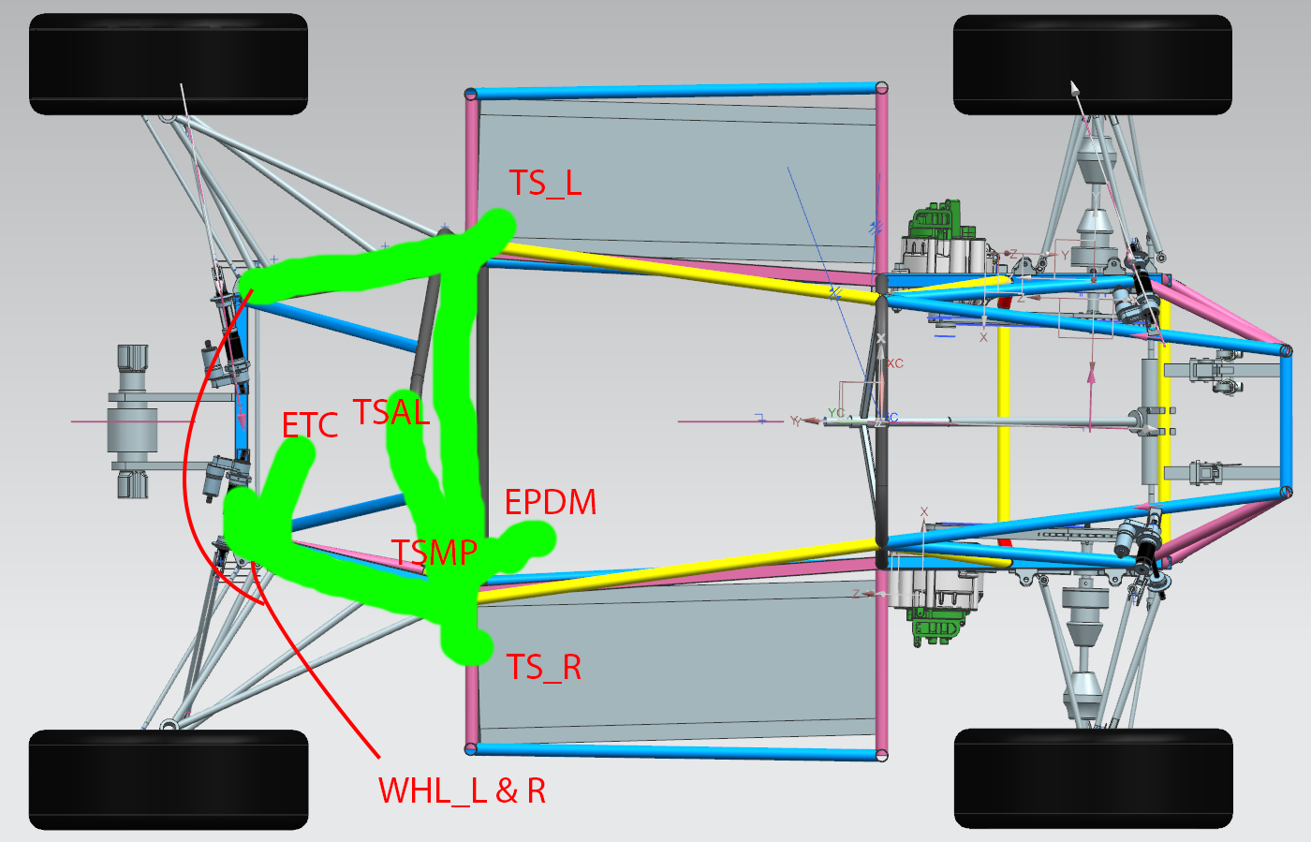
Figure DB: Location of the Main Wiring Harness in the vehicle. The red box is the EPDM (7.1), and the actual harness is represented by the green line.

Power Safety Loop

Description, function, and purpose
The Power Safety Loop is a wiring harness that, in an emergency, will shut down all LV systems on the vehicle. It is literally a direct cut of power, where, all LV current runs through the loop, so that the line runs through a series of switches, and when interrupted anywhere, the system is dead. It also kills the engine through the use of a relay.

Wiring, cables, and layout
All wires used for the safety loop are 12 AWG. See Figure FA for a schematic diagram of the power loop. The loop runs around the perimeter of the car to its various emergency switches.
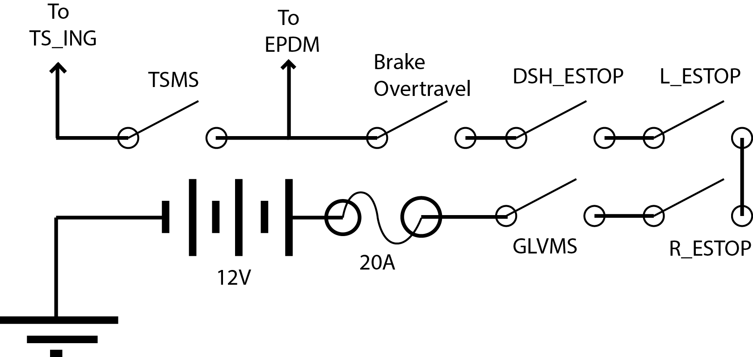
Figure FA: Schematic diagram of the power safety loop.

Position in car
See Figure FB for the location of the safety loop in the vehicle.

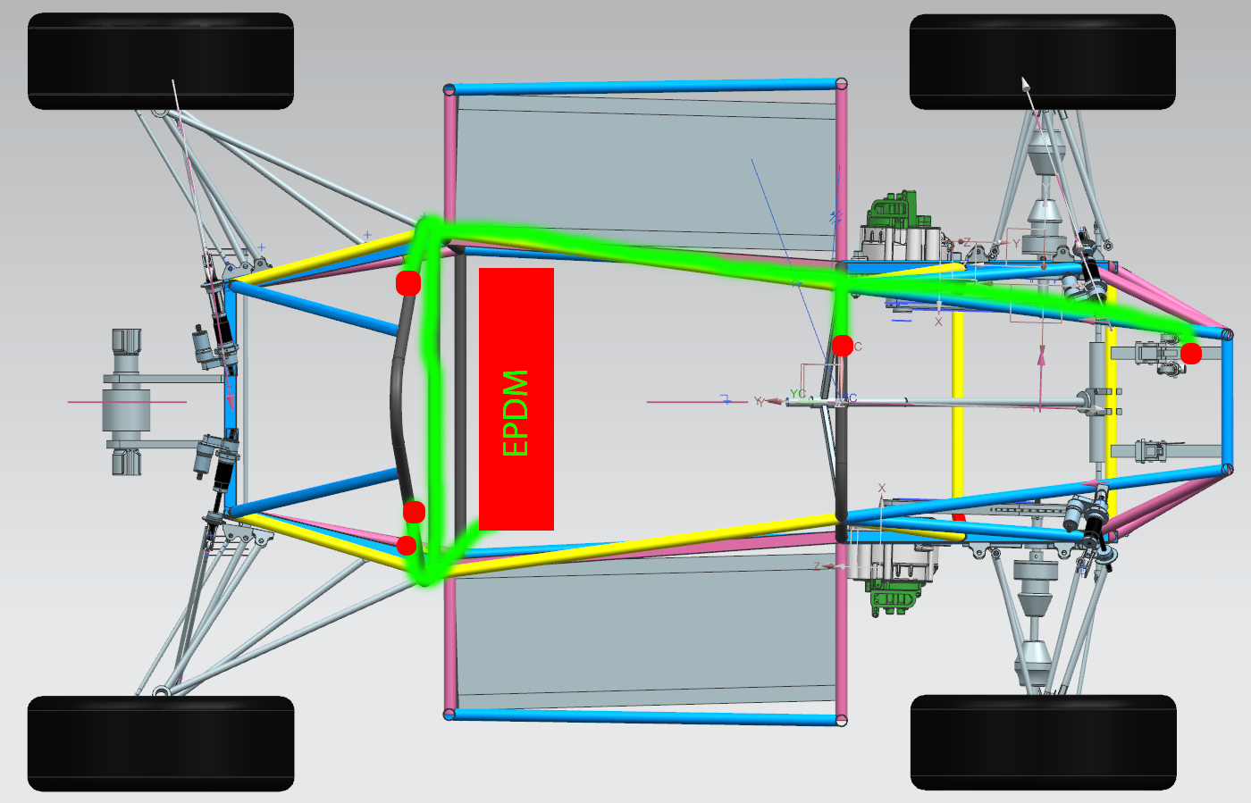
Figure FB: Green denotes wiring for the power safety loop. Switches in series with the loop are marked in red.

Overall Grounding Concept
Person primarily responsible for this section:
Name:
e-mail:

Description of the Grounding Concept
Describe how you intend to achieve the resistances between components at the required levels as defined in EV4.3.

Grounding Measurements
Describe which measurements you will take to ensure that EV4.3 is achieved

Firewall(s)
Person primarily responsible for this section:
Name:
e-mail:

Firewall 1

Description/materials
Describe the concept, layer structure and the materials used for the firewall. Show how the low resistance Control System ground connection is achieved.

Position in car
Provide CAD-renderings showing all relevant parts. Mark the parts in the rendering, if necessary.

Firewall 2

Appendix

Number appendices according to the relevant chapter.
i.e. A datasheet for motor controller one should be numbered: 4.1.n

