A description...Departamento de Computación  
Introducción a los Sistemas Distribuidos – 75.43

Trabajo Práctico

Configuración de Red

1º Cuatrimestre - Año 2011

Grupo Nº: 5

**Integrantes:**

85709 - Bazzano, Agustina

88449 - Bruno, Tomás

88300 - Garbarini, Lucía

88817 - Invernizzi, Esteban Ignacio

88435 - Meller, Gustavo Ariel

88528 - Mouso, Nicolás

**Fecha de entrega:** 14 de junio de 2011

Índice

1. Determinación de las Subredes 3

División de redes 3

Diagrama de la Red 3

Asignación de subredes 5

Asignación de nombres y direcciones de host 6

2. Tablas de ruteo 8

Tabla de ruteo para H1 8

Tabla de ruteo para H102 8

Tabla de ruteo para H104 9

Tabla de ruteo para H106 9

Tabla de ruteo para H108 10

Tabla de ruteo para H111 10

Tabla de ruteo para H113 11

Tabla de ruteo para H114 11

Tabla de ruteo para H116 12

Tabla de ruteo para H117 12

Tabla de ruteo para H121 13

Tabla de ruteo para H121 13

3.DNS 15

4. Simulación 16

5. Fuentes 17

# 1. Determinación de las Subredes

En esta sección detallamos la división de los segmentos IP disponibles en la cantidad de subredes necesarias según se identifican en el diagrama provisto.

Luego se indica la asignación de direcciones IP a cada host de las redes, con especial detalle en los que estarán involucrados en la simulación. Asimismo se incluye la asignación de nombres de subdominio y de terminal a las redes y hosts respectivamente.

## División de redes

Dividimos los segmentos que tenemos a disposición suponiendo las siguientes máscaras:

|  |  |  |  |
| --- | --- | --- | --- |
| Dirección | Clase | Máscara | Direcciones |
| 192.168.8.0 | C | 255.255.255.0 | 256 |
| 10.31.6.0 | A | 255.255.255.0 | 256 |
| 10.11.6.192 | A | 255.255.255.192 | 64 |
| 130.63.5.0 | B | 255.255.255.0 | 256 |
| 172.23.5.192 | B | 255.255.255.192 | 64 |
| 10.54.5.0 | A | 255.255.255.0 | 256 |
| 10.54.17.0 | A | 255.255.255.0 | 256 |
| 10.54.9.128 | A | 255.255.255.0 | 128 |

Para ello tenemos en cuenta que los servidores tienen direcciones IP fijas, lo cual condiciona las subredes que pueden asignarse a los segmentos en que están involucrados. Hay además otras dos condiciones: la red 130.63.5.0 será asignada a los hosts en internet, y la 172.23.5.192 a la red X.25.

## Diagrama de la Red

A continuación presentamos el gráfico lógico de la red con la asignación de los nombres de subdominio.

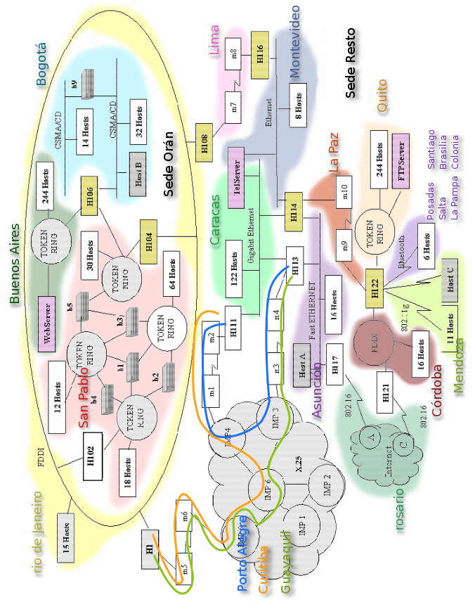

## Asignación de subredes

A partir de las redes mostradas en el gráfico, se asigna una subred IP del tamaño adecuado a cada una, teniendo en consideración la RFC 950.

|  |  |  |  |
| --- | --- | --- | --- |
| Ciudad | Nº de hosts | Tamaño del bloque | Subred |
| San Pablo | 127 | 256 | 10.31.6.0/24 |
| Buenos Aires | 246 | 256 | 192.168.8.0/24 |
| Bogotá | 48 | 64 | 10.11.6.192/26 |
| Rio de Janeiro | 19 | 32 | 10.54.5.64/27 |
| Lima | 2 | 4 | 10.54.5.40/30 |
| Montevideo | 11 | 16 | 10.54.5.128/28 |
| Caracas | 126 | 128 | 10.54.9.128/25 |
| Asunción | 20 | 32 | 10.54.5.96/27 |
| Quito | 246 | 256 | 10.54.17.0/24 |
| La Paz | 2 | 4 | 10.54.5.44/30 |
| Córdoba | 18 | 32 | 10.54.5.0/27 |
| Rosario | 4 | 8 | 130.63.5.0/29 |
| Porto Alegre | 2 | 4 | 172.23.5.192/30 |
| Curitiba | 2 | 4 | 172.23.5.196/30 |
| Guayaquil | 2 | 4 | 172.23.5.200/30 |
| Mendoza | 13 | 16 | 10.54.5.160/28 |
| Posadas | 2 | 4 | 10.54.5.176/30 |
| Salta | 2 | 4 | 10.54.5.180/30 |
| La Pampa | 2 | 4 | 10.54.5.184/30 |
| Santiago | 2 | 4 | 10.54.5.188/30 |
| Brasilia | 2 | 4 | 10.54.5.192/30 |
| Colonia | 2 | 4 | 10.54.5.196/30 |

## Asignación de nombres y direcciones de host

A continuación asignamos a los hosts presentados en el gráfico una dirección IP y un nombre de host, referidos a la subred correspondiente. Los routers tendrán naturalmente varias direcciones y nombres, por formar parte de distintas redes IP. Por simplicidad no se detallan los hosts que aparecen *agrupados* en el gráfico, pero cabe notar que bastaría con incrementar la mayor dirección IP de cada subred y el mayor sufijo numérico del nombre de cada subdominio para obtener los nombres restantes.

| Host | Red | Dirección IP | Nombre |
| --- | --- | --- | --- |
| H102 | 10.31.6.0/24 | 10.31.6.1 | sanpablo01 |
| H104 | 10.31.6.0/24 | 10.31.6.2 | sanpablo02 |
| H106 | 10.31.6.0/24 | 10.31.6.3 | sanpablo03 |
| Web Server | 192.168.8.0/24 | 192.168.8.1 | buenosaires01 |
| H106 | 192.168.8.0/24 | 192.168.8.2 | buenosaires02 |
| H106 | 10.11.6.192/26 | 10.11.6.193 | bogota01 |
| Host B | 10.11.6.192/26 | 10.11.6.194 | bogota02 |
| H102 | 10.54.5.64/27 | 10.54.5.65 | riodejaneiro01 |
| H104 | 10.54.5.64/27 | 10.54.5.66 | riodejaneiro02 |
| H1 | 10.54.5.64/27 | 10.54.5.67 | riodejaneiro03 |
| H108 | 10.54.5.64/27 | 10.54.5.68 | riodejaneiro04 |
| H108 | 10.54.5.40/30 | 10.54.5.41 | lima01 |
| H116 | 10.54.5.40/30 | 10.54.5.42 | lima02 |
| H114 | 10.54.5.128/28 | 10.54.5.129 | montevideo01 |
| TelServer | 10.54.5.128/28 | 10.54.5.130 | montevideo02 |
| H116 | 10.54.5.128/28 | 10.54.5.131 | montevideo03 |
| TelServer | 10.54.9.128/25 | 10.54.9.129 | caracas01 |
| H111 | 10.54.9.128/25 | 10.54.9.130 | caracas02 |
| H113 | 10.54.9.128/25 | 10.54.9.131 | caracas03 |
| H114 | 10.54.9.128/25 | 10.54.9.132 | caracas04 |
| H113 | 10.54.5.96/27 | 10.54.5.97 | asuncion01 |
| H114 | 10.54.5.96/27 | 10.54.5.98 | asuncion02 |
| H117 | 10.54.5.96/27 | 10.54.5.99 | asuncion03 |
| Host A | 10.54.5.96/27 | 10.54.5.100 | asuncion04 |
| H122 | 10.54.17.0/24 | 10.54.17.1 | quito01 |
| FTPServer | 10.54.17.0/24 | 10.54.17.2 | quito02 |
| H114 | 10.54.5.44/30 | 10.54.5.45 | lapaz01 |
| H122 | 10.54.5.44/30 | 10.54.5.46 | lapaz02 |
| H121 | 10.54.5.0/27 | 10.54.5.1 | cordoba01 |
| H122 | 10.54.5.0/27 | 10.54.5.2 | cordoba02 |
| H117 | 130.63.5.0/30 | 130.63.5.1 | rosario01 |
| H121 | 130.63.5.0/30 | 130.63.5.2 | rosario02 |
| "A" | 130.63.5.0/30 | 130.63.5.3 | rosario03 |
| "C" | 130.63.5.0/30 | 130.63.5.4 | rosario04 |
| H111 | 172.23.5.192/30 | 172.23.5.193 | portoalegre01 |
| H113 | 172.23.5.192/30 | 172.23.5.194 | portoalegre02 |
| H1 | 172.23.5.196/30 | 172.23.5.197 | curitiba01 |
| H111 | 172.23.5.196/30 | 172.23.5.198 | curitiba02 |
| H1 | 172.23.5.200/30 | 172.23.5.201 | guayaquil01 |
| H113 | 172.23.5.200/30 | 172.23.5.202 | guayaquil02 |
| H122 | 10.54.5.160/28 | 10.54.5.161 | mendoza01 |
| Host C | 10.54.5.160/28 | 10.54.5.162 | mendoza02 |
| H122 | 10.54.5.176/30 | 10.54.5.177 | posadas01 |
| H122 | 10.54.5.180/30 | 10.54.5.181 | salta01 |
| H122 | 10.54.5.184/30 | 10.54.5.185 | lapampa01 |
| H122 | 10.54.5.188/30 | 10.54.5.189 | santiago01 |
| H122 | 10.54.5.192/30 | 10.54.5.193 | brasilia01 |
| H122 | 10.54.5.196/30 | 10.54.5.197 | colonia01 |

# 2. Tablas de ruteo

Tablas de ruteo para todos los routers.

### Tabla de ruteo para H1

|  |  |  |  |  |  |
| --- | --- | --- | --- | --- | --- |
| Red | Ciudad | Ip de la Red | Mask | Metric | Gateway |
| **A** | San Pablo | 10.31.6.0 | 255.255.255.0 | 1 | 10.54.5.66 |
| **B** | Buenos Aires | 192.168.8.0 | 255.255.255.0 | 2 | 10.54.5.66 |
| **C** | Bogotá | 10.11.6.192 | 255.255.255.192 | 2 | 10.54.5.66 |
| **E** | Lima | 10.54.5.40 | 255.255.255.252 | 1 | 10.54.5.68 |
| **F** | Montevideo | 10.54.5.128 | 255.255.255.240 | 2 | 10.54.5.68 |
| **G** | Caracas | 10.54.9.128 | 255.255.255.128 | 1 | 172.23.5.198 |
| **H** | Asunción | 10.54.5.96 | 255.255.255.224 | 1 | 172.23.5.202 |
| **I** | Quito | 10.54.17.0 | 255.255.255.0 | 3 | 172.23.5.202 |
| **J** | La Paz | 10.54.5.44 | 255.255.255.252 | 2 | 172.23.5.202 |
| **K** | Córdoba | 10.54.5.0 | 255.255.255.224 | 3 | 172.23.5.202 |
| **L** | Rosario | 130.63.5.0 | 255.255.255.252 | 2 | 172.23.5.202 |
| **M** | Porto Alegre | 172.23.5.192 | 255.255.255.252 | 1 | 172.23.5.198 |
| ***P*** | *Mendoza* | 10.54.5.160 | 255.255.255.252 | 3 | 172.23.5.202 |
| ***Q*** | *Posadas* | 10.54.5.176 | 255.255.255.252 | 3 | 172.23.5.202 |
| ***R*** | *Salta* | 10.54.5.180 | 255.255.255.252 | 3 | 172.23.5.202 |
| ***S*** | *La Pampa* | 10.54.5.184 | 255.255.255.252 | 3 | 172.23.5.202 |
| ***T*** | *Santiago* | 10.54.5.188 | 255.255.255.252 | 3 | 172.23.5.202 |
| ***U*** | *Brasilia* | 10.54.5.192 | 255.255.255.252 | 3 | 172.23.5.202 |
| ***V*** | *Colonia* | 10.54.5.196 | 255.255.255.252 | 3 | 172.23.5.202 |

### Tabla de ruteo para H102

|  |  |  |  |  |  |
| --- | --- | --- | --- | --- | --- |
| Red | Ciudad | Ip de la Red | Mask | Metric | Gateway |
| **B** | Buenos Aires | 192.168.8.0 | 255.255.255.0 | 1 | 10.31.6.3 |
| **C** | Bogotá | 10.11.6.192 | 255.255.255.192 | 1 | 10.31.6.3 |
| **E** | Lima | 10.54.5.40 | 255.255.255.252 | 1 | 10.54.5.68 |
| **F** | Montevideo | 10.54.5.128 | 255.255.255.240 | 2 | 10.54.5.68 |
| **G** | Caracas | 10.54.9.128 | 255.255.255.128 | 2 | 10.54.5.67 |
| **H** | Asunción | 10.54.5.96 | 255.255.255.224 | 2 | 10.54.5.67 |
| **I** | Quito | 10.54.17.0 | 255.255.255.0 | 4 | 10.54.5.68 |
| **J** | La Paz | 10.54.5.44 | 255.255.255.252 | 3 | 10.54.5.68 |
| **K** | Córdoba | 10.54.5.0 | 255.255.255.224 | 4 | 10.54.5.68 |
| **L** | Rosario | 130.63.5.0 | 255.255.255.252 | 3 | 10.54.5.67 |
| **M** | Porto Alegre | 172.23.5.192 | 255.255.255.252 | 2 | 10.54.5.67 |
| **N** | Curitiba | 172.23.5.196 | 255.255.255.252 | 1 | 10.54.5.67 |
| **O** | Guayaquil | 172.23.5.200 | 255.255.255.252 | 1 | 10.54.5.67 |
| ***P*** | *Mendoza* | 10.54.5.160 | 255.255.255.252 | 4 | 10.54.5.68 |
| ***Q*** | *Posadas* | 10.54.5.176 | 255.255.255.252 | 4 | 10.54.5.68 |
| ***R*** | *Salta* | 10.54.5.180 | 255.255.255.252 | 4 | 10.54.5.68 |
| ***S*** | *La Pampa* | 10.54.5.184 | 255.255.255.252 | 4 | 10.54.5.68 |
| ***T*** | *Santiago* | 10.54.5.188 | 255.255.255.252 | 4 | 10.54.5.68 |
| ***U*** | *Brasilia* | 10.54.5.192 | 255.255.255.252 | 4 | 10.54.5.68 |
| ***V*** | *Colonia* | 10.54.5.196 | 255.255.255.252 | 4 | 10.54.5.68 |

### Tabla de ruteo para H104

|  |  |  |  |  |  |
| --- | --- | --- | --- | --- | --- |
| Red | Ciudad | Ip de la Red | Mask | Metric | Gateway |
| **B** | Buenos Aires | 192.168.8.0 | 255.255.255.0 | 1 | 10.31.6.3 |
| **C** | Bogotá | 10.11.6.192 | 255.255.255.192 | 1 | 10.31.6.3 |
| **E** | Lima | 10.54.5.40 | 255.255.255.252 | 1 | 10.54.5.68 |
| **F** | Montevideo | 10.54.5.128 | 255.255.255.240 | 2 | 10.54.5.68 |
| **G** | Caracas | 10.54.9.128 | 255.255.255.128 | 2 | 10.54.5.67 |
| **H** | Asunción | 10.54.5.96 | 255.255.255.224 | 2 | 10.54.5.67 |
| **I** | Quito | 10.54.17.0 | 255.255.255.0 | 4 | 10.54.5.68 |
| **J** | La Paz | 10.54.5.44 | 255.255.255.252 | 3 | 10.54.5.68 |
| **K** | Córdoba | 10.54.5.0 | 255.255.255.224 | 4 | 10.54.5.68 |
| **L** | Rosario | 130.63.5.0 | 255.255.255.252 | 3 | 10.54.5.67 |
| **M** | Porto Alegre | 172.23.5.192 | 255.255.255.252 | 2 | 10.54.5.67 |
| **N** | Curitiba | 172.23.5.196 | 255.255.255.252 | 1 | 10.54.5.67 |
| **O** | Guayaquil | 172.23.5.200 | 255.255.255.252 | 1 | 10.54.5.67 |
| ***P*** | *Mendoza* | 10.54.5.160 | 255.255.255.252 | 4 | 10.54.5.68 |
| ***Q*** | *Posadas* | 10.54.5.176 | 255.255.255.252 | 4 | 10.54.5.68 |
| ***R*** | *Salta* | 10.54.5.180 | 255.255.255.252 | 4 | 10.54.5.68 |
| ***S*** | *La Pampa* | 10.54.5.184 | 255.255.255.252 | 4 | 10.54.5.68 |
| ***T*** | *Santiago* | 10.54.5.188 | 255.255.255.252 | 4 | 10.54.5.68 |
| ***U*** | *Brasilia* | 10.54.5.192 | 255.255.255.252 | 4 | 10.54.5.68 |
| ***V*** | *Colonia* | 10.54.5.196 | 255.255.255.252 | 4 | 10.54.5.68 |

### Tabla de ruteo para H106

|  |  |  |  |  |  |
| --- | --- | --- | --- | --- | --- |
| Red | Ciudad | Ip de la Red | Mask | Metric | Gateway |
| **D** | Rio de Janeiro | 10.54.5.64 | 255.255.255.224 | 1 | 10.31.6.2 |
| **E** | Lima | 10.54.5.40 | 255.255.255.252 | 2 | 10.31.6.2 |
| **F** | Montevideo | 10.54.5.128 | 255.255.255.240 | 3 | 10.31.6.2 |
| **G** | Caracas | 10.54.9.128 | 255.255.255.128 | 3 | 10.31.6.2 |
| **H** | Asunción | 10.54.5.96 | 255.255.255.224 | 3 | 10.31.6.2 |
| **I** | Quito | 10.54.17.0 | 255.255.255.0 | 5 | 10.31.6.2 |
| **J** | La Paz | 10.54.5.44 | 255.255.255.252 | 4 | 10.31.6.2 |
| **K** | Córdoba | 10.54.5.0 | 255.255.255.224 | 5 | 10.31.6.2 |
| **L** | Rosario | 130.63.5.0 | 255.255.255.252 | 4 | 10.31.6.2 |
| **M** | Porto Alegre | 172.23.5.192 | 255.255.255.252 | 3 | 10.31.6.2 |
| **N** | Curitiba | 172.23.5.196 | 255.255.255.252 | 2 | 10.31.6.2 |
| **O** | Guayaquil | 172.23.5.200 | 255.255.255.252 | 2 | 10.31.6.2 |
| ***P*** | *Mendoza* | 10.54.5.160 | 255.255.255.252 | 5 | 10.31.6.2 |
| ***Q*** | *Posadas* | 10.54.5.176 | 255.255.255.252 | 5 | 10.31.6.2 |
| ***R*** | *Salta* | 10.54.5.180 | 255.255.255.252 | 5 | 10.31.6.2 |
| ***S*** | *La Pampa* | 10.54.5.184 | 255.255.255.252 | 5 | 10.31.6.2 |
| ***T*** | *Santiago* | 10.54.5.188 | 255.255.255.252 | 5 | 10.31.6.2 |
| ***U*** | *Brasilia* | 10.54.5.192 | 255.255.255.252 | 5 | 10.31.6.2 |
| ***V*** | *Colonia* | 10.54.5.196 | 255.255.255.252 | 5 | 10.31.6.2 |

### Tabla de ruteo para H108

|  |  |  |  |  |  |
| --- | --- | --- | --- | --- | --- |
| Red | Ciudad | Ip de la Red | Mask | Metric | Gateway |
| **A** | San Pablo | 10.31.6.0 | 255.255.255.0 | 1 | 10.54.5.66 |
| **B** | Buenos Aires | 192.168.8.0 | 255.255.255.0 | 2 | 10.54.5.66 |
| **C** | Bogotá | 10.11.6.192 | 255.255.255.192 | 2 | 10.54.5.66 |
| **F** | Montevideo | 10.54.5.128 | 255.255.255.240 | 1 | 10.54.5.42 |
| **G** | Caracas | 10.54.9.128 | 255.255.255.128 | 2 | 10.54.5.67 |
| **H** | Asunción | 10.54.5.96 | 255.255.255.224 | 2 | 10.54.5.67 |
| **I** | Quito | 10.54.17.0 | 255.255.255.0 | 3 | 10.54.5.42 |
| **J** | La Paz | 10.54.5.44 | 255.255.255.252 | 2 | 10.54.5.42 |
| **K** | Córdoba | 10.54.5.0 | 255.255.255.224 | 3 | 10.54.5.42 |
| **L** | Rosario | 130.63.5.0 | 255.255.255.252 | 3 | 10.54.5.42 |
| **M** | Porto Alegre | 172.23.5.192 | 255.255.255.252 | 2 | 10.54.5.67 |
| **N** | Curitiba | 172.23.5.196 | 255.255.255.252 | 1 | 10.54.5.67 |
| **O** | Guayaquil | 172.23.5.200 | 255.255.255.252 | 1 | 10.54.5.67 |
| ***P*** | *Mendoza* | 10.54.5.160 | 255.255.255.252 | 3 | 10.54.5.42 |
| ***Q*** | *Posadas* | 10.54.5.176 | 255.255.255.252 | 3 | 10.54.5.42 |
| ***R*** | *Salta* | 10.54.5.180 | 255.255.255.252 | 3 | 10.54.5.42 |
| ***S*** | *La Pampa* | 10.54.5.184 | 255.255.255.252 | 3 | 10.54.5.42 |
| ***T*** | *Santiago* | 10.54.5.188 | 255.255.255.252 | 3 | 10.54.5.42 |
| ***U*** | *Brasilia* | 10.54.5.192 | 255.255.255.252 | 3 | 10.54.5.42 |
| ***V*** | *Colonia* | 10.54.5.196 | 255.255.255.252 | 3 | 10.54.5.42 |

### Tabla de ruteo para H111

|  |  |  |  |  |  |
| --- | --- | --- | --- | --- | --- |
| Red | Ciudad | Ip de la Red | Mask | Metric | Gateway |
| **A** | San Pablo | 10.31.6.0 | 255.255.255.0 | 2 | 172.23.5.197 |
| **B** | Buenos Aires | 192.168.8.0 | 255.255.255.0 | 3 | 172.23.5.197 |
| **C** | Bogotá | 10.11.6.192 | 255.255.255.192 | 3 | 172.23.5.197 |
| **D** | Rio de Janeiro | 10.54.5.64 | 255.255.255.224 | 1 | 172.23.5.197 |
| **E** | Lima | 10.54.5.40 | 255.255.255.252 | 2 | 10.54.9.132 |
| **F** | Montevideo | 10.54.5.128 | 255.255.255.240 | 1 | 10.54.9.132 |
| **H** | Asunción | 10.54.5.96 | 255.255.255.224 | 1 | 172.23.5.194 |
| **I** | Quito | 10.54.17.0 | 255.255.255.0 | 2 | 10.54.9.132 |
| **J** | La Paz | 10.54.5.44 | 255.255.255.252 | 1 | 10.54.9.132 |
| **K** | Córdoba | 10.54.5.0 | 255.255.255.224 | 2 | 10.54.9.132 |
| **L** | Rosario | 130.63.5.0 | 255.255.255.252 | 2 | 10.54.9.132 |
| **O** | Guayaquil | 172.23.5.200 | 255.255.255.252 | 1 | 172.23.5.194 |
| ***P*** | *Mendoza* | 10.54.5.160 | 255.255.255.252 | 2 | 10.54.9.132 |
| ***Q*** | *Posadas* | 10.54.5.176 | 255.255.255.252 | 2 | 10.54.9.132 |
| ***R*** | *Salta* | 10.54.5.180 | 255.255.255.252 | 2 | 10.54.9.132 |
| ***S*** | *La Pampa* | 10.54.5.184 | 255.255.255.252 | 2 | 10.54.9.132 |
| ***T*** | *Santiago* | 10.54.5.188 | 255.255.255.252 | 2 | 10.54.9.132 |
| ***U*** | *Brasilia* | 10.54.5.192 | 255.255.255.252 | 2 | 10.54.9.132 |
| ***V*** | *Colonia* | 10.54.5.196 | 255.255.255.252 | 2 | 10.54.9.132 |

### Tabla de ruteo para H113

|  |  |  |  |  |  |
| --- | --- | --- | --- | --- | --- |
| Red | Ciudad | Ip de la Red | Mask | Metric | Gateway |
| **A** | San Pablo | 10.31.6.0 | 255.255.255.0 | 2 | 172.23.5.201 |
| **B** | Buenos Aires | 192.168.8.0 | 255.255.255.0 | 3 | 172.23.5.201 |
| **C** | Bogotá | 10.11.6.192 | 255.255.255.192 | 3 | 172.23.5.201 |
| **D** | Rio de Janeiro | 10.54.5.64 | 255.255.255.224 | 1 | 172.23.5.201 |
| **E** | Lima | 10.54.5.40 | 255.255.255.252 | 2 | 10.54.5.98 |
| **F** | Montevideo | 10.54.5.128 | 255.255.255.240 | 1 | 10.54.5.98 |
| **I** | Quito | 10.54.17.0 | 255.255.255.0 | 2 | 10.54.5.98 |
| **J** | La Paz | 10.54.5.44 | 255.255.255.252 | 1 | 10.54.5.98 |
| **K** | Córdoba | 10.54.5.0 | 255.255.255.224 | 2 | 10.54.5.98 |
| **L** | Rosario | 130.63.5.0 | 255.255.255.252 | 1 | 10.54.5.99 |
| **N** | Curitiba | 172.23.5.196 | 255.255.255.252 | 1 | 172.23.5.193 |
| ***P*** | *Mendoza* | 10.54.5.160 | 255.255.255.252 | 2 | 10.54.5.98 |
| ***Q*** | *Posadas* | 10.54.5.176 | 255.255.255.252 | 2 | 10.54.5.98 |
| ***R*** | *Salta* | 10.54.5.180 | 255.255.255.252 | 2 | 10.54.5.98 |
| ***S*** | *La Pampa* | 10.54.5.184 | 255.255.255.252 | 2 | 10.54.5.98 |
| ***T*** | *Santiago* | 10.54.5.188 | 255.255.255.252 | 2 | 10.54.5.98 |
| ***U*** | *Brasilia* | 10.54.5.192 | 255.255.255.252 | 2 | 10.54.5.98 |
| ***V*** | *Colonia* | 10.54.5.196 | 255.255.255.252 | 2 | 10.54.5.98 |

### Tabla de ruteo para H114

|  |  |  |  |  |  |
| --- | --- | --- | --- | --- | --- |
| Red | Ciudad | Ip de la Red | Mask | Metric | Gateway |
| **A** | San Pablo | 10.31.6.0 | 255.255.255.0 | 3 | 10.54.5.131 |
| **B** | Buenos Aires | 192.168.8.0 | 255.255.255.0 | 4 | 10.54.5.131 |
| **D** | Rio de Janeiro | 10.54.5.64 | 255.255.255.224 | 2 | 10.54.5.97 |
| **E** | Lima | 10.54.5.40 | 255.255.255.252 | 1 | 10.54.5.131 |
| **I** | Quito | 10.54.17.0 | 255.255.255.0 | 1 | 10.54.5.46 |
| **K** | Córdoba | 10.54.5.0 | 255.255.255.224 | 1 | 10.54.5.46 |
| **L** | Rosario | 130.63.5.0 | 255.255.255.252 | 1 | 10.54.5.99 |
| **M** | Porto Alegre | 172.23.5.192 | 255.255.255.252 | 1 | 10.54.9.130 |
| **N** | Curitiba | 172.23.5.196 | 255.255.255.252 | 1 | 10.54.9.130 |
| **O** | Guayaquil | 172.23.5.200 | 255.255.255.252 | 1 | 10.54.5.97 |
| ***P*** | *Mendoza* | 10.54.5.160 | 255.255.255.252 | 1 | 10.54.5.46 |
| ***Q*** | *Posadas* | 10.54.5.176 | 255.255.255.252 | 1 | 10.54.5.46 |
| ***R*** | *Salta* | 10.54.5.180 | 255.255.255.252 | 1 | 10.54.5.46 |
| ***S*** | *La Pampa* | 10.54.5.184 | 255.255.255.252 | 1 | 10.54.5.46 |
| ***T*** | *Santiago* | 10.54.5.188 | 255.255.255.252 | 1 | 10.54.5.46 |
| ***U*** | *Brasilia* | 10.54.5.192 | 255.255.255.252 | 1 | 10.54.5.46 |
| ***V*** | *Colonia* | 10.54.5.196 | 255.255.255.252 | 1 | 10.54.5.46 |

### Tabla de ruteo para H116

|  |  |  |  |  |  |
| --- | --- | --- | --- | --- | --- |
| Red | Ciudad | Ip de la Red | Mask | Metric | Gateway |
| **A** | San Pablo | 10.31.6.0 | 255.255.255.0 | 2 | 10.54.5.41 |
| **B** | Buenos Aires | 192.168.8.0 | 255.255.255.0 | 3 | 10.54.5.41 |
| **C** | Bogotá | 10.11.6.192 | 255.255.255.192 | 3 | 10.54.5.41 |
| **D** | Rio de Janeiro | 10.54.5.64 | 255.255.255.224 | 1 | 10.54.5.41 |
| **G** | Caracas | 10.54.9.128 | 255.255.255.128 | 1 | 10.54.5.129 |
| **H** | Asunción | 10.54.5.96 | 255.255.255.224 | 1 | 10.54.5.129 |
| **I** | Quito | 10.54.17.0 | 255.255.255.0 | 2 | 10.54.5.129 |
| **J** | La Paz | 10.54.5.44 | 255.255.255.252 | 1 | 10.54.5.129 |
| **K** | Córdoba | 10.54.5.0 | 255.255.255.224 | 2 | 10.54.5.129 |
| **L** | Rosario | 130.63.5.0 | 255.255.255.252 | 2 | 10.54.5.129 |
| **M** | Porto Alegre | 172.23.5.192 | 255.255.255.252 | 2 | 10.54.5.129 |
| **N** | Curitiba | 172.23.5.196 | 255.255.255.252 | 2 | 10.54.5.129 |
| **O** | Guayaquil | 172.23.5.200 | 255.255.255.252 | 2 | 10.54.5.129 |
| ***P*** | *Mendoza* | 10.54.5.160 | 255.255.255.252 | 2 | 10.54.5.129 |
| ***Q*** | *Posadas* | 10.54.5.176 | 255.255.255.252 | 2 | 10.54.5.129 |
| ***R*** | *Salta* | 10.54.5.180 | 255.255.255.252 | 2 | 10.54.5.129 |
| ***S*** | *La Pampa* | 10.54.5.184 | 255.255.255.252 | 2 | 10.54.5.129 |
| ***T*** | *Santiago* | 10.54.5.188 | 255.255.255.252 | 2 | 10.54.5.129 |
| ***U*** | *Brasilia* | 10.54.5.192 | 255.255.255.252 | 2 | 10.54.5.129 |
| ***V*** | *Colonia* | 10.54.5.196 | 255.255.255.252 | 2 | 10.54.5.129 |

### Tabla de ruteo para H117

|  |  |  |  |  |  |
| --- | --- | --- | --- | --- | --- |
| Red | Ciudad | Ip de la Red | Mask | Metric | Gateway |
| **A** | San Pablo | 10.31.6.0 | 255.255.255.0 | 3 | 10.54.5.97 |
| **B** | Buenos Aires | 192.168.8.0 | 255.255.255.0 | 4 | 10.54.5.97 |
| **C** | Bogotá | 10.11.6.192 | 255.255.255.192 | 4 | 10.54.5.97 |
| **D** | Rio de Janeiro | 10.54.5.64 | 255.255.255.224 | 2 | 10.54.5.97 |
| **E** | Lima | 10.54.5.40 | 255.255.255.252 | 2 | 10.54.5.98 |
| **F** | Montevideo | 10.54.5.128 | 255.255.255.240 | 1 | 10.54.5.98 |
| **G** | Caracas | 10.54.9.128 | 255.255.255.128 | 1 | 10.54.5.97 |
| **I** | Quito | 10.54.17.0 | 255.255.255.0 | 2 | 10.54.5.98 |
| **J** | La Paz | 10.54.5.44 | 255.255.255.252 | 1 | 10.54.5.98 |
| **K** | Córdoba | 10.54.5.0 | 255.255.255.224 | 1 | 130.63.5.2 |
| **M** | Porto Alegre | 172.23.5.192 | 255.255.255.252 | 1 | 10.54.5.97 |
| **N** | Curitiba | 172.23.5.196 | 255.255.255.252 | 2 | 10.54.5.98 |
| **O** | Guayaquil | 172.23.5.200 | 255.255.255.252 | 1 | 10.54.5.97 |
| ***P*** | *Mendoza* | 10.54.5.160 | 255.255.255.252 | 2 | 10.54.5.98 |
| ***Q*** | *Posadas* | 10.54.5.176 | 255.255.255.252 | 2 | 10.54.5.98 |
| ***R*** | *Salta* | 10.54.5.180 | 255.255.255.252 | 2 | 10.54.5.98 |
| ***S*** | *La Pampa* | 10.54.5.184 | 255.255.255.252 | 2 | 10.54.5.98 |
| ***T*** | *Santiago* | 10.54.5.188 | 255.255.255.252 | 2 | 10.54.5.98 |
| ***U*** | *Brasilia* | 10.54.5.192 | 255.255.255.252 | 2 | 10.54.5.98 |
| ***V*** | *Colonia* | 10.54.5.196 | 255.255.255.252 | 2 | 10.54.5.98 |

### Tabla de ruteo para H121

|  |  |  |  |  |  |
| --- | --- | --- | --- | --- | --- |
| Red | Ciudad | Ip de la Red | Mask | Metric | Gateway |
| **A** | San Pablo | 10.31.6.0 | 255.255.255.0 | 4 | 130.63.5.1 |
| **B** | Buenos Aires | 192.168.8.0 | 255.255.255.0 | 5 | 130.63.5.1 |
| **C** | Bogotá | 10.11.6.192 | 255.255.255.192 | 5 | 130.63.5.1 |
| **D** | Rio de Janeiro | 10.54.5.64 | 255.255.255.224 | 3 | 130.63.5.1 |
| **E** | Lima | 10.54.5.40 | 255.255.255.252 | 3 | 130.63.5.1 |
| **F** | Montevideo | 10.54.5.128 | 255.255.255.240 | 2 | 130.63.5.1 |
| **G** | Caracas | 10.54.9.128 | 255.255.255.128 | 2 | 130.63.5.1 |
| **H** | Asunción | 10.54.5.96 | 255.255.255.224 | 1 | 130.63.5.1 |
| **I** | Quito | 10.54.17.0 | 255.255.255.0 | 1 | 10.54.5.2 |
| **J** | La Paz | 10.54.5.44 | 255.255.255.252 | 1 | 10.54.5.2 |
| **M** | Porto Alegre | 172.23.5.192 | 255.255.255.252 | 2 | 130.63.5.1 |
| **N** | Curitiba | 172.23.5.196 | 255.255.255.252 | 3 | 130.63.5.1 |
| **O** | Guayaquil | 172.23.5.200 | 255.255.255.252 | 2 | 130.63.5.1 |
| ***P*** | *Mendoza* | 10.54.5.160 | 255.255.255.252 | 1 | 10.54.5.2 |
| ***Q*** | *Posadas* | 10.54.5.176 | 255.255.255.252 | 1 | 10.54.5.2 |
| ***R*** | *Salta* | 10.54.5.180 | 255.255.255.252 | 1 | 10.54.5.2 |
| ***S*** | *La Pampa* | 10.54.5.184 | 255.255.255.252 | 1 | 10.54.5.2 |
| ***T*** | *Santiago* | 10.54.5.188 | 255.255.255.252 | 1 | 10.54.5.2 |
| ***U*** | *Brasilia* | 10.54.5.192 | 255.255.255.252 | 1 | 10.54.5.2 |
| ***V*** | *Colonia* | 10.54.5.196 | 255.255.255.252 | 1 | 10.54.5.2 |

### Tabla de ruteo para H121

|  |  |  |  |  |  |
| --- | --- | --- | --- | --- | --- |
| Red | Ciudad | Ip de la Red | Mask | Metric | Gateway |
| **A** | San Pablo | 10.31.6.0 | 255.255.255.0 | 4 | 10.54.5.45 |
| **B** | Buenos Aires | 192.168.8.0 | 255.255.255.0 | 5 | 10.54.5.45 |
| **C** | Bogotá | 10.11.6.192 | 255.255.255.192 | 5 | 10.54.5.45 |
| **D** | Rio de Janeiro | 10.54.5.64 | 255.255.255.224 | 3 | 10.54.5.45 |
| **E** | Lima | 10.54.5.40 | 255.255.255.252 | 2 | 10.54.5.45 |
| **F** | Montevideo | 10.54.5.128 | 255.255.255.240 | 1 | 10.54.5.45 |
| **G** | Caracas | 10.54.9.128 | 255.255.255.128 | 1 | 10.54.5.45 |
| **H** | Asunción | 10.54.5.96 | 255.255.255.224 | 1 | 10.54.5.45 |
| **L** | Rosario | 130.63.5.0 | 255.255.255.252 | 1 | 10.54.5.1 |
| **M** | Porto Alegre | 172.23.5.192 | 255.255.255.252 | 2 | 10.54.5.45 |
| **N** | Curitiba | 172.23.5.196 | 255.255.255.252 | 2 | 10.54.5.45 |
| **O** | Guayaquil | 172.23.5.200 | 255.255.255.252 | 2 | 10.54.5.45 |

# 3.DNS

Para la configuración del servicio DNS utilizamos una jerarquía de dos niveles como se indica en el enunciado, con un servidor de primer nivel y dos servidores de segundo nivel. El servidor de primer nivel (o *root*) se limita a hacer *forwarding* de las *queries* realizadas por los de segundo nivel. Esto es necesario porque dichos servidores de segundo nivel son autoridad sobre su zona, y además son el único servidor visible en cada una de ellas.

Se implementa tanto la función de DNS directo como reverso, esta última mediante aliasing para resolver el forwarding de manera simple. Esto implica que no haya necesidad de especificar en el *root* exactamente qué redes IP forman parte de cada sede, basta con englobar las resoluciones inversas bajo un alias correspondiente a la sede, del estilo reversa.oran.salta.dc.fi.uba.ar.

Las consultas se realizan directamente al servidor de cada zona, es decir que el *root* no recibe consultas directamente de los hosts (por determinación de nuestra configuración en el archivo /etc/resolv.conf), sino que son los servidores de segundo nivel los que recurren a él cuando deben resolver el nombre o la dirección de un host de la otra zona.

# 4. Simulación

En la simulación se incluyen los siguientes equipos (los tres hosts y los tres servidores se simulan en un mismo equipo)

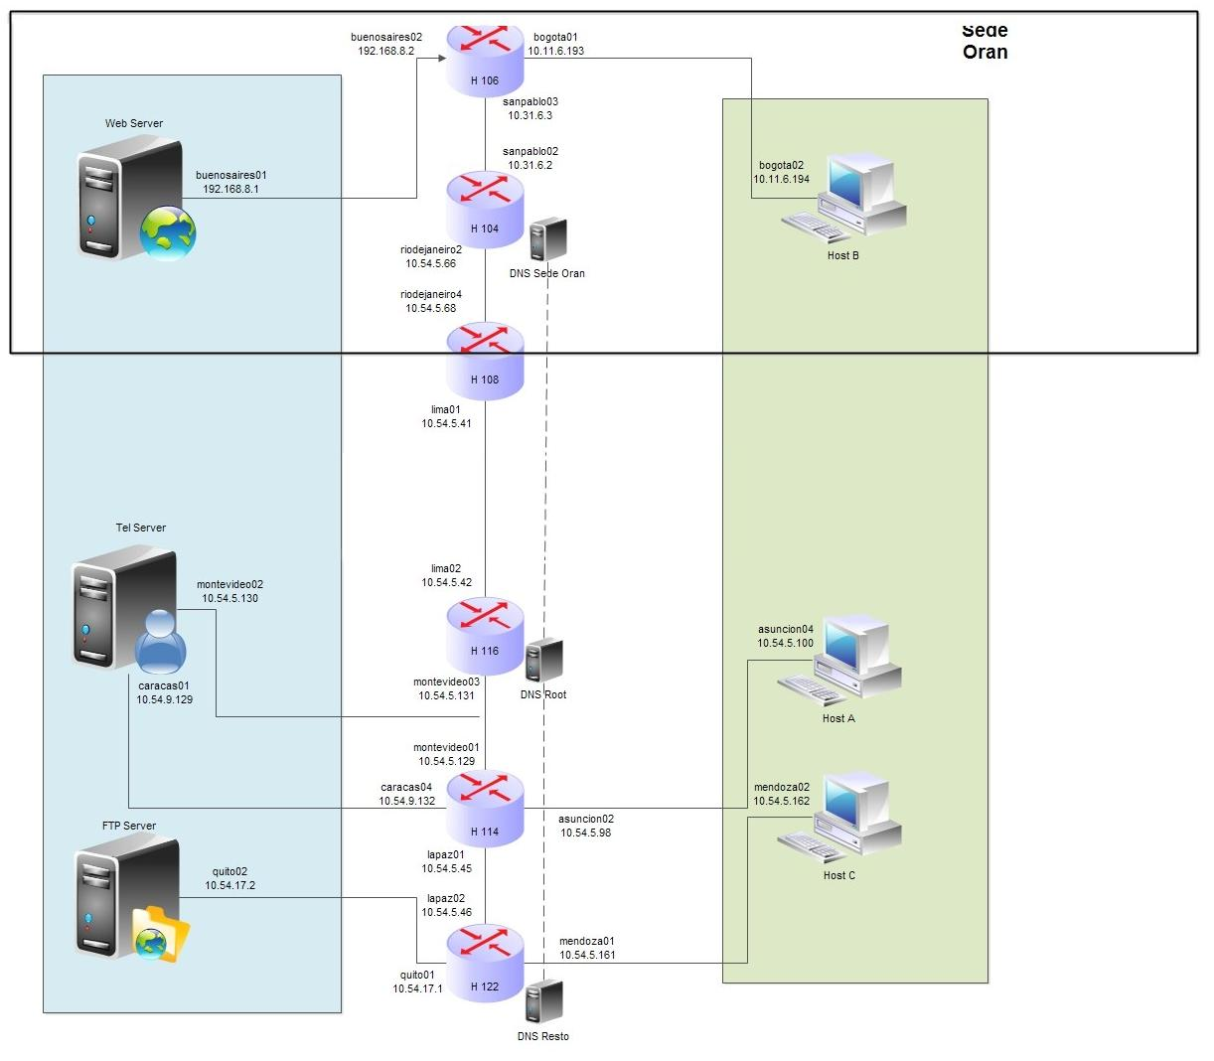

# 5. Fuentes

Para el armado de las subredes no se utilizaron más fuentes que los apuntes de las clases teóricas del tema, incluyendo las restricciones de la RFC 950 que se revisaron en clase.

Para el cálculo de las rutas óptimas y alternativas se recurrió al algoritmo aplicado por el protocolo OSPF, el algoritmo de camino mínimo de Dijkstra. A partir de ello se desarrolló un script en Python que calcula las rutas óptimas de cada router a todos los demás, y genera los scripts de configuración de las tablas de ruteo.

Para la configuración de la jerarquía de servidores DNS recurrimos a material disponible en la web:

Referencia de configuración de BIND9: <http://www.net.cmu.edu/groups/netdev/docs/bind9/Bv9ARM.ch06.html>

Libro online sobre DNS con BIND: <http://www.zytrax.com/books/dns/ch6/>

El DNS HOWTO de linuxdoc.org, sitio de soporte comunitario sobre GNU/Linux: <http://www.linuxdoc.org/HOWTO/DNS-HOWTO.html>