HeeChan Kang

CSC431

**Assignment #3**

1)

#include <stdio.h>

#include <stdlib.h>

double myavg(double db1, double db2, double db3, double db4) {

return (db1 + db2 + db3 + db4)/4;

}

void main(void)

{

double avg, w, x, y, z;

w = 10.0;

x = 20.0;

y = 30.0;

z = 40.0;

avg = myavg(w,x,y,z);

printf("The average of %6.2lf, %6.2lf, %6.2lf, and %6.2lf is

%6.2lf\n", w, x, y, z, avg);

}

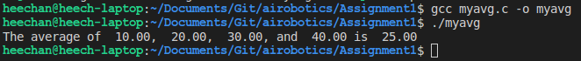**Output:**

2)

#include <stdio.h>

#include <stdlib.h>

double myavg(double db1, double db2, double db3, double db4) {

return (db1 + db2 + db3 + db4)/4;

}

void main(void)

{

double avg, w, x, y, z;

printf("Please input a double (w): ");

scanf("%lf", &w);

printf("Please input second double (x): ");

scanf("%lf", &x);

printf("Please input third double (y): ");

scanf("%lf", &y);

printf("Please input fourth double (z): ");

scanf("%lf", &z);

avg = myavg(w,x,y,z);

printf("The average of %6.2lf, %6.2lf, %6.2lf, and %6.2lf is %6.2lf\n", w, x, y, z, avg);

}

**Output:**

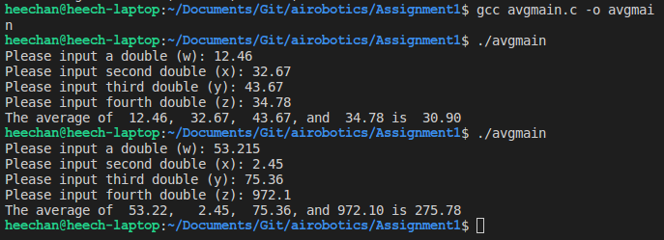

3)

**Initial Output:**

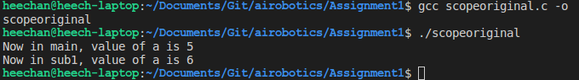

#include <stdio.h>

#include <stdlib.h>

void sub1(int a);

void main(void) {

int a = 5; **/* Switched this line with below */**

sub1(a);

printf("Now in main, value of a is %d \n", a);

}

void sub1(int a) {

a = a + 1;

printf("Now in sub1, value of a is %d \n", a);

}

**After Change Output:**

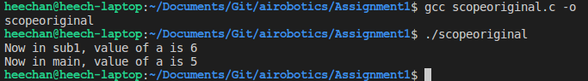

First of all, when calling sub1, the method that the main ends up calling is the sub1() below of the main – this is interesting because the method above must have been overridden by the method on the bottom. Secondly, the variable names aren’t interchangeable within methods (localized variables?) and this is the case with many other programming languages. A is initialized as 5, then when calling sub1(a), this just does what it’s supposed to do with the number it receives: add 1 and print out 6. Then we get to the printf in the main, where a is still 5, and we print out 5.

4)

#include <stdio.h>

#include <stdlib.h>

void sub1(int a);

void sub2(int a);

void main(void) {

int a = 5;

sub1(a);

printf("Now in main, value of a is %d \n", a);

}

void sub1(int a) {

a = a + 1;

printf("Now in sub1, value of a is %d \n", a);

sub2(a);

printf("Returned to sub1 (after sub2), value of a is %d \n", a);

}

void sub2(int a) {

a = a * 2;

printf("Now in sub2, value of a is %d \n", a);

}

**Output:**

