/*

* HeeChan Kang

* CSC 431 - AI Robotics

* Assignment 2

* Dollar to Yen

*/

#include <stdio.h>

#include <stdlib.h>

/* Multiply dollars and exchange rate to get yen */

double exchange(double dollars, double exrate) {

return dollars * exrate;

}

void main(void) {

double dollars, exrate, yen;

dollars = 2345.67;

exrate = 100;

yen = exchange(dollars, exrate);

printf("$ %8.2lf at an exchange rate of %6.2lf equals %12.2lf yen\n", dollars, exrate, yen);

}

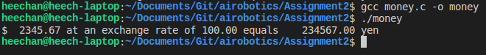

/*

* HeeChan Kang

* CSC 431 - AI Robotics

* Assignment 2

* Dollar to Yen with User Input

*/

#include <stdio.h>

#include <stdlib.h>

/* Multiply dollars and exchange rate to get yen */

double exchange(double dollars, double exrate) {

return dollars * exrate;

}

void main(void) {

double dollars, exrate, yen;

/* Take user input for dollar and exrate */

printf("Please input dollar spent: ");

scanf("%lf", &dollars);

printf("Please input exchange rate: ");

scanf("%lf", &exrate);

yen = exchange(dollars, exrate);

printf("$ %8.2lf at an exchange rate of %6.2lf equals %12.2lf yen\n", dollars, exrate, yen);

}

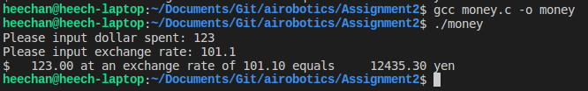

/*

* HeeChan Kang

* CSC 431 - AI Robotics

* Assignment 2

* Print Hundreds!

*/

#include <stdio.h>

#include <stdlib.h>

#include "checkwriter.h"

/*

* writeHundreds takes an integer between zero and a thousand and prints out,

* with appropriate spaces, the English word for that number.

*/

void writeHundreds(int number) {

int hundreds, tens;

if (number < 100 && number > 0) {

writeTens(number);

printf("\n");

return;

}

else if (number > 100 && number < 1000) {

hundreds = number/100;

writeOnes(hundreds);

printf(" hundred and ");

tens = number % 100;

writeTens(tens);

printf("\n");

}

else {

printf("Invalid input.\n");

return;

}

}

void main(void) {

int input;

printf("Enter integer between 0 and 1000: ");

scanf("%d", &input);

writeHundreds(input);

}

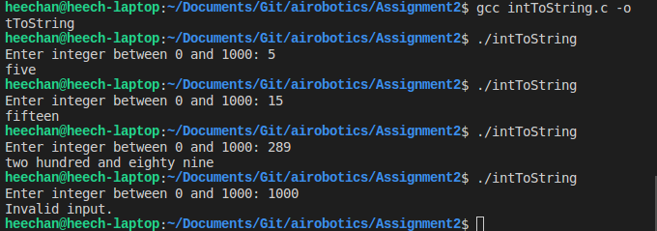

/*

* HeeChan Kang

* CSC 431 - AI Robotics

* Assignment 2

* Print Check!

*/

#include <stdio.h>

#include <stdlib.h>

#include "checkwriter.h"

/*

* writeHundreds takes an integer between zero and a thousand and prints out,

* with appropriate spaces, the English word for that number.

*/

void writeHundreds(int number) {

int hundreds, tens;

if (number < 100 && number > 0) {

writeTens(number);

return;

}

else if (number > 100 && number < 1000) {

hundreds = number/100;

writeOnes(hundreds);

printf(" hundred and ");

tens = number % 100;

writeTens(tens);

}

else {

printf("Invalid input.\n");

return;

}

}

void writeCheck(int number) {

printf("\n----------------------------------------------------------------------\n\n");

printf("HeeChan Kang\t\t\t\t\t\tCheck #123456\n");

printf("Minneapolis\t\t\t\t\t\n");

printf("Minnesota\t\tAugsburg Bank Visa\t January 30, 2018\n");

printf("Pay to the order of: \t\t\t\t\t $ %d.00\n", number);

writeHundreds(number);

printf(" and 00/100 dollars\n\n");

printf("CSC Department\n");

printf("Hagfors Center\t\t\t\tSignature:___________\n");

printf("\n----------------------------------------------------------------------\n\n");

}

void main(void) {

int input;

printf("Enter integer between 0 and 1000: ");

scanf("%d", &input);

writeCheck(input);

}

