Diel and artificial light effects on nearshore communities revealed by eDNA metabarcoding
Running title: Diurnal patterns in a nearshore eDNA community

Supplementary information
To ensure that sequencing depth was not a limiting factor in representing the taxonomic diversity of our samples, we evaluated sequencing effort through rarefaction (sequencing effort) curves, using the rarecurve function in the vegan package (Oksanen et al., 2022) in R. In addition, we assessed the adequacy of our sampling effort by constructing species accumulation (sampling effort) curves using the specaccum function in vegan
Table S1. Primer information and bioinformatics output
Attribute | COI (mlCOIintF/LoboR1) | 12S (MarVer1)
Forward primer (5’-3’) | GGWACWGGWTGAACWGTWTAYCCYCC | CGTGCCAGCCACCGCG
Reverse primer (5’-3’) | TAAACYTCWGGRTGWCCRAARAAYCA | GGGTATCTAATCCYAGTTTG
Amplicon length | 313 bp | 202 bp
Target taxa | Metazoans | Vertebrates
Number of samples | 63 | 74
Day (Light / No Light) | 20 / 16 | 20 / 17
Night (Light / No Light) | 16 / 11 | 19 / 18
Raw reads basecalled | 20,216,729 | 18,458,998
Reads retained through the pipeline | 7,411,763 | 4,715,640
% of reads assigned to target organisms | 32.9% | 70.6%

Table S2. Design matrix for the beta regression model of pairwise community dissimilarity (D). Columns correspond to predictor variables, and entries (0/1) indicate whether the associated parameter (Greek letter coefficient) is excluded (0) or included (1) in the linear predictor for each condition. Additional variables include elapsed time between samples (d), phase difference (t), biological replicate (r), and the total number of samples included in the pairwise comparisons (N).
 | Treatment during day | Treatment during night
Day – day = 0  Day – night = 1 | Light - light = 0  No light – no light = 0  Light – no light = 1  No light – light = 1 | Light - light = 0  No light – no light = 0  Light – no light = 1  No light – light = 1 | Date difference (in days) | Biological replicate = 1 (indicating all conditions are similar) | Total number of pair-wise sample comparison
t | l₁ | l₂ | d | r | N
0 | 0 | 0 | 0 | 1 | 56
0 | 0 | 0 | 1 | 0 | 124
0 | 0 | 0 | 2 | 0 | 106
0 | 0 | 0 | 3 | 0 | 90
0 | 0 | 0 | 4 | 0 | 54
0 | 0 | 0 | 5 | 0 | 37
0 | 0 | 0 | 6 | 0 | 18
0 | 0 | 1 | 0 | 0 | 29
0 | 0 | 1 | 1 | 0 | 35
0 | 0 | 1 | 2 | 0 | 30
0 | 0 | 1 | 3 | 0 | 36
0 | 0 | 1 | 4 | 0 | 20
0 | 0 | 1 | 5 | 0 | 17
0 | 0 | 1 | 6 | 0 | 9
0 | 1 | 0 | 0 | 0 | 46
0 | 1 | 0 | 1 | 0 | 81
0 | 1 | 0 | 2 | 0 | 70
0 | 1 | 0 | 3 | 0 | 54
0 | 1 | 0 | 4 | 0 | 36
0 | 1 | 0 | 6 | 0 | 12
1 | 0 | 0 | 0 | 0 | 65
1 | 0 | 0 | 1 | 0 | 122
1 | 0 | 0 | 2 | 0 | 111
1 | 0 | 0 | 3 | 0 | 80
1 | 0 | 0 | 4 | 0 | 60
1 | 0 | 0 | 5 | 0 | 30
1 | 0 | 0 | 6 | 0 | 18
1 | 0 | 0 | 7 | 0 | 10

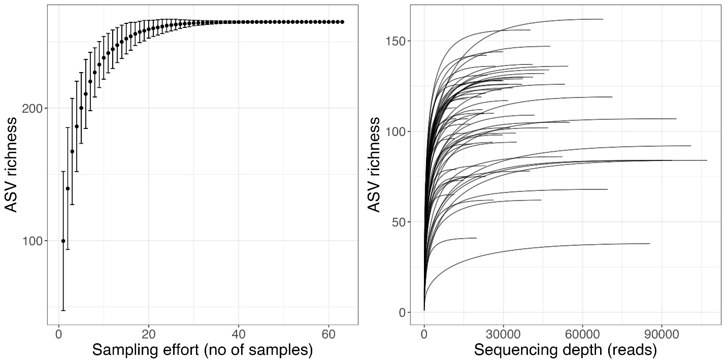
Figure S1: Rarefaction and species accumulation curves for the COI dataset. The different curves in the sequencing depth plot (right) represent different samples.

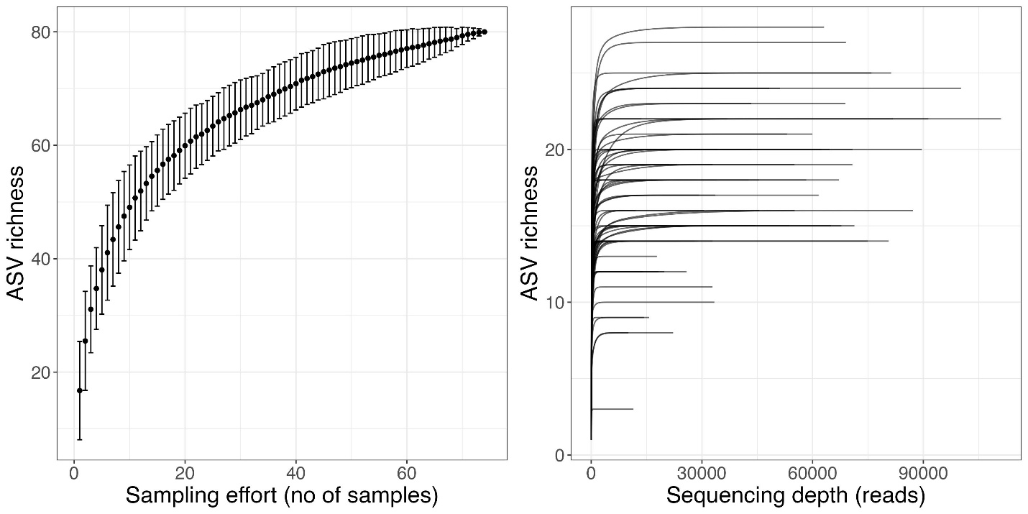
Figure S2: Rarefaction and species accumulation curves for the MV1 dataset. The different curves in the sequencing depth plot (right) represent different samples.

