REF. INVESTIGACION DE OPERACIONES, TAHA

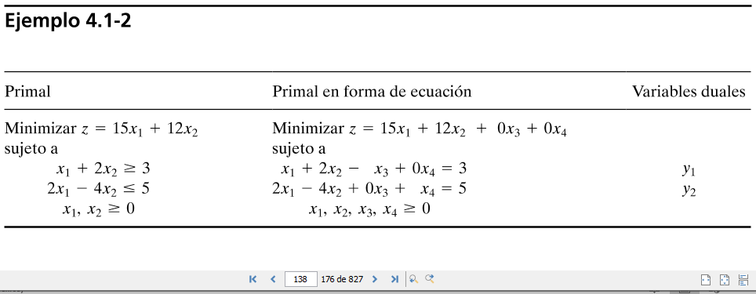

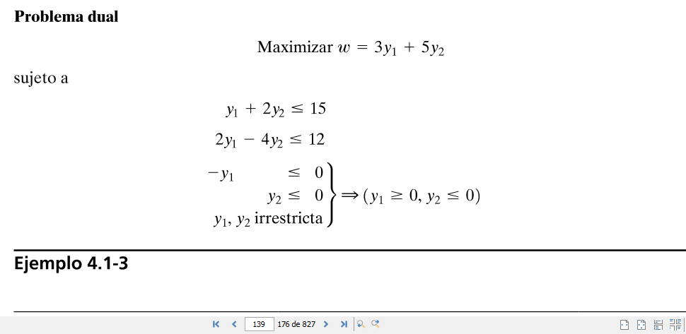

Considere el siguiente modelo de programación lineal

%FontSize=12
%TeXFontSize=12
\documentclass{article}
\pagestyle{empty}
\begin{document}
\begin{eqnarray}
\mbox{min }\omega&=&-y_{1}+9y_{2}\nonumber\\
\mbox{sujeto a}&&\nonumber\\
-y_{1}+y_{2}&\geq&c_{1}\nonumber
\end{eqnarray}
\end{document}

%FontSize=12
%TeXFontSize=12
\documentclass{article}
\pagestyle{empty}
\begin{document}
\begin{eqnarray}
\mbox{y\ \ }&&\nonumber\\
y_{1}&\geq&0,\mbox{\ }y_{2}\mbox{\ \ }\geq\mbox{\ \ }0.\nonumber
\end{eqnarray}
\end{document}

Equivalentemente, en forma matricial

%FontSize=12
%TeXFontSize=12
\documentclass{article}
\pagestyle{empty}
\begin{document}
\begin{eqnarray}
\mbox{min }\omega\,&=&\,\left[\begin{array}{cc}y_{1}&y_{2}\end{array}\right]\left[\begin{array}{r}
-1\\
9
\end{array}\right]\nonumber\\
\mbox{sujeto a}&\,\,&\nonumber\\
&&\left[\begin{array}{cc}y_{1}&y_{2}\end{array}\right]\left[\begin{array}{r}
-1\\
1
\end{array}\right]\geq
\left[c_{1}\right]\nonumber
\end{eqnarray}
\end{document}

%FontSize=12
%TeXFontSize=12
\documentclass{article}
\pagestyle{empty}
\begin{document}
\begin{eqnarray}
\mbox{y\ \ \ }&&\nonumber\\
y_{1}&\geq&0,\mbox{\ }y_{2}\mbox{\ \ }\geq\mbox{\ \ }0.\nonumber
\end{eqnarray}
\end{document}