1. Projection for the current age is not seen here. Could you please correct it.
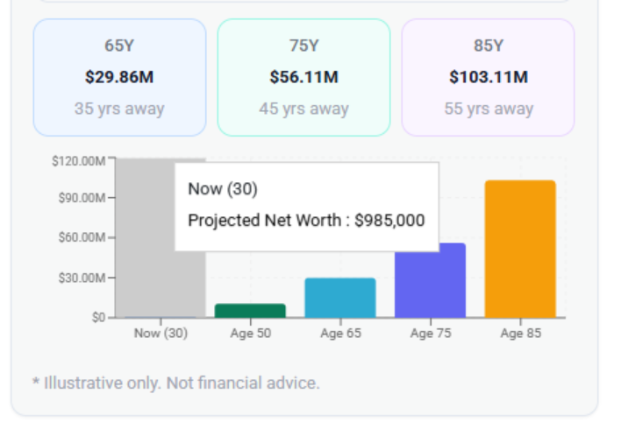
2. Risk Profile: Inconsistent output due to flawed calculation logic, with varying percentages in the second question indicating issues in formulas, data handling, or accuracy.
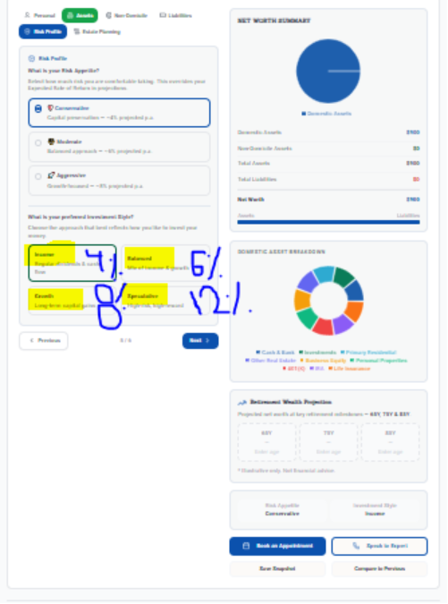
3. Assets Section: Annual savings are excluded from total value, and interest rates above 100% are being accepted, causing inaccurate calculations.
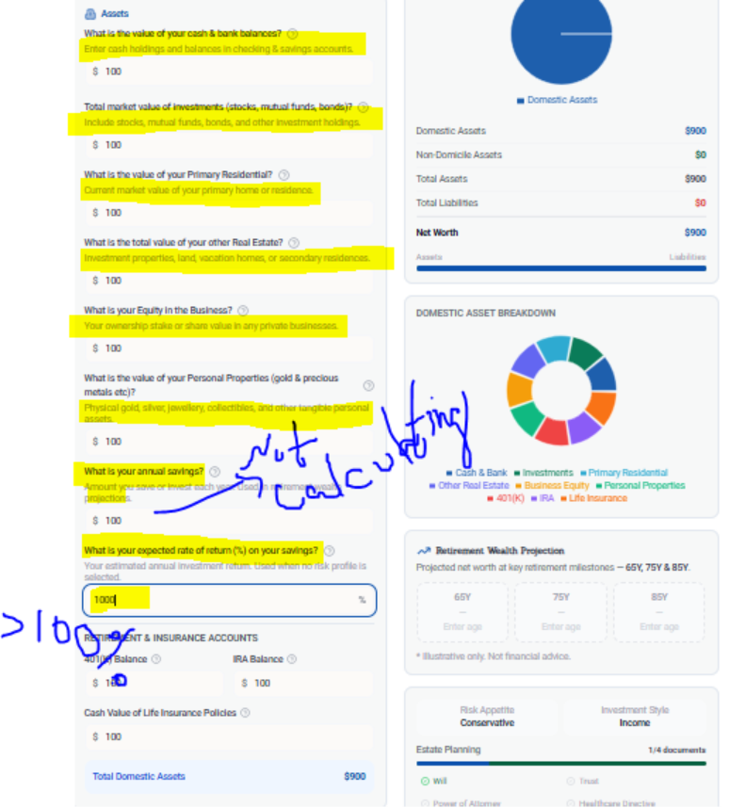
4. Make all the short question to long and interactive sir.
