Dear Sir,
here I am sharing you all the details need to be included in our financial calculators from the wealth snapshot calculators with some changes and suggestions included by our team.
1.Personal Details:
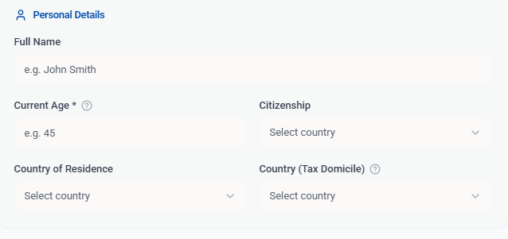
> Need this entire block questions to be added to our financial calculators.
Note: If a person opts for Citizenship, the Tax Domile should be automatically selected respectively.
> Need to add Planned Retirement Age?
2. Assets: the exisiting questions are good to go.
Need to add some more questions as mentioned below,
> Primary Residencial
> Other Real Estate
> Equity in the Bussiness
> Personal Properties (gold & precious metals).
> What is your annual savings?
> What is your expected rate of return (%) on your savings?
> 401(K) Calculations need to be added
> IRA Calculations need to be added
> Cash Value of Life Insurance Policies?
3.New tab creation : Non Domicile Assets
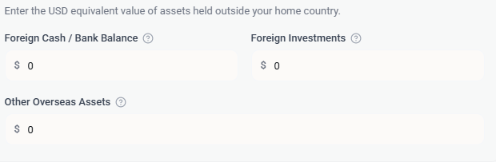
> The first question is good to go. Need to rename the other 2 questions as mentioned below.
> Rename Foreign Investments to Foreign Real Estate
> Rename Other Overseas Assets to Any Other Assets
4. Liabilities: Looks good. Mention this as below. Ouput results should be shown on the right hand side.
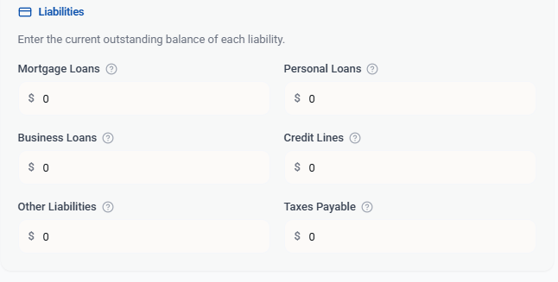
5. Risk Profile: Looks good to use as it is. Ouput results should be shown on the right hand side.
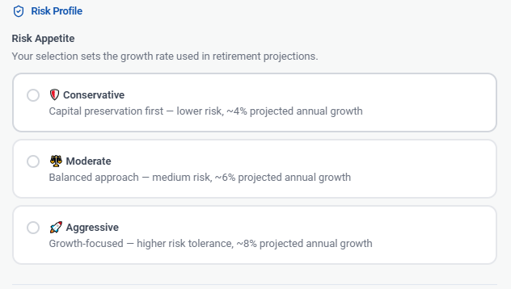
6. Estate Planning: Looks good to make us of these question as it is in financial calculators temple style.
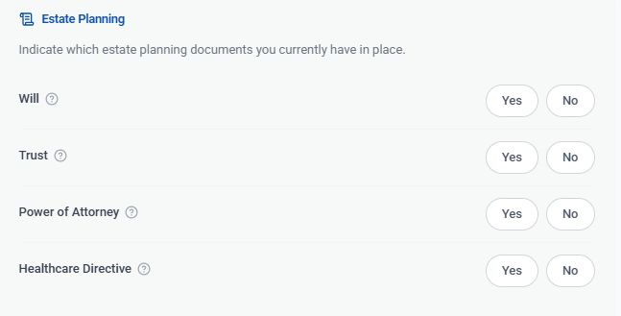
Finally, including all the calculative reports, we need also to give the data for the
Retirement Wealth Projection - Need the projections for the ages of 65Y, 75Y & 85Y.

