Warehouse Management
Version 2009.2

Client 3PL
Publications Department
RedPrairie Corporation has made every effort to ensure the accuracy of the information included in this document. This document is subject to change without notice. The information contained in this document may not reflect the final design in some instances.
Copyright 2009 RedPrairie Corporation. All rights reserved. This publication contains proprietary information of RedPrairie Corporation. No part of this publication may be reproduced, stored in a retrieval system, or transmitted in any form by any means, electronic, mechanical, photocopying, recording or otherwise without the prior written permission of RedPrairie Corporation.
COPLEX, RedPrairie and the RedPrairie logo are registered trademarks of RedPrairie Corporation. E2e is a trademark of RedPrairie Corporation. Preferred Methods and RedPrairie Approach are service marks of RedPrairie Corporation.
ActiveState, ActivePerl, PerlScript and Perl for Win32 are trademarks of ActiveState Corporation.
All other registered trademarks, trademarks and service marks are the property of their respective holders.
Beacon House, Ibstone Road, Stokenchurch, Buckinghamshire, HP14 3AQ, UK
Client 3PL
Client 3PL White Paper 4
Overview of Client (3PL) Functionality 4
Setting Up Client (3PL) Functionality 5
Adding a Client 5
Client Groups 6
Client Visibility Group 7
Function Accesses and Client Functionality 8
Global Function Access 8
Site Global Function Access 8
Site Client Global Function Access 9
How do I create a function access client group and add clients to this group? 10
Global User / Workstation Function Access 11
User / Workstation Group Function Access 11
Example 1: 11
Example 2: 12
Using Client (3PL) Functionality in Warehouse Management 13
Client Specific Data 13
Restricted views of Data 13
Reports and Labels 13

Client 3PL White Paper

Overview of Client (3PL) Functionality
Third party logistics (3PL) functionality describes businesses that provide one or many of a variety of logistics-related services, for example, warehousing and transportation or distribution management.
A 3PL provider may take over all receiving, storage, value added, shipping and transportation responsibilities for a client and conduct these tasks within their warehouse using their equipment and employees.
Third party logistics providers enable firms to achieve reduced operating costs and increased revenues in new and existing markets by reducing ownership of assets. 3PLs also bring their specialized expertise in managing logistics with technology and systems to the relationship.
Warehouse Management enables multiple sites and clients in one installation, thereby providing software for customers in the 3PL sector to better manage warehouse operations.
In the 3PL warehouse environment, each client operation is controlled by what is effectively a separate and unique warehouse management system (although they exist in the same instance of the database). The uniqueness of a client operation is recognized and addressed by the warehouse management system in the use of configured client functionality. Warehouse and zone configurations will not suffice in an environment where client stock is constantly moved between zones and warehouses and mixed in with stock owned by other clients.
The following definitions are used within Warehouse Management:
- The third party logistics provider using Warehouse Management is called a company.
- The customer of the 3PL company is called a client.
- The company being shipped to by Warehouse Management is called a customer.
The company that is currently viewed as having financial responsibility for inventory is called an owner. Owners are specific to clients.

Setting Up Client (3PL) Functionality
Warehouse Management provides many facilities to enable effective 3PL warehouse management.
To be able to use client functionality in Warehouse Management, ensure that you have enabled the hidden global function access ‘THIRD_PARTY’.

Adding a Client
Use the Client Maintenance window to add a client to the system. The third party logistics provider can enter details about the client in this window and supply a unique ID that will be used to identify the client’s inventory in the warehouse.
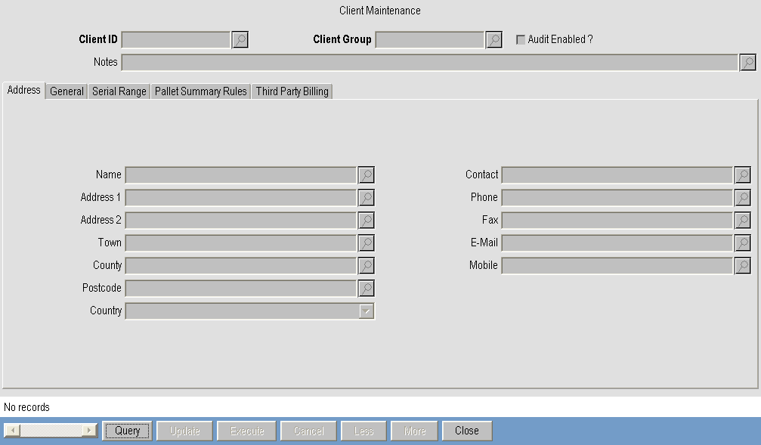
- Client Query / Maintenance Screen
Every new client can be linked to a function access client group and a data visibility client group.

Client Groups
There are two different types of client groups, namely, function access and data visibility client groups.
Each type of group is created in the Client Group Maintenance screen.
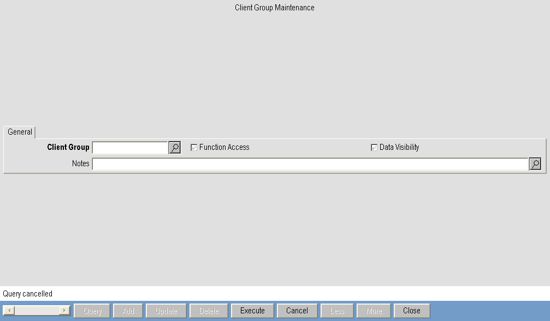
- Client Group Maintenance screen
A function access client group is used to control the functionality access of the clients included in that client group at a global, site and user/workstation group level. If a function access is disabled for a client group, the clients within that group do not have access to the functionality.
To add a client to a function access client group, use the Client Maintenance screen and select the client group in the ‘Client Access Group’ field.
A data visibility client group ensures that clients included in the group can only view details about specific inventory related to their client ID.

Client Visibility Group
To add a client ID to a data visibility group, use the Client Visibility Groups screen.
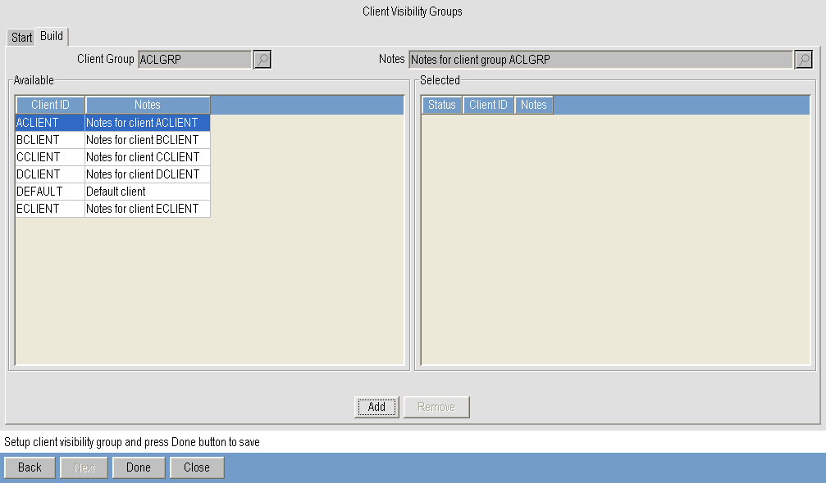
- Client Visibility Groups - Adding Clients to a Data Visibility Client Group
Select the data visibility group from the ‘Client Group’ field on the Start tab and press Next. Add client IDs to the group by adding them to the ‘Selected’ section on the Build tab using the Add button.
Press Done to save the changes.
If a user is subsequently tied to this user group in the User Maintenance window, they will only be able to view details about inventory for the clients included in the client group.
For example, add ACLIENT and BCLIENT to the data visibility group ACLGRP and the function access client group DEFAULT.
In the User Maintenance window, enter ACLGRP in the ‘Client Visibility Group’ field to tie that user to inventory for ACLIENT and BCLIENT.
When, for example, you are viewing inventory records in the Inventory Query window or inventory transaction logs in the Inventory Transaction Query window, you will only be able to view records for inventory that belongs to ACLIENT and BCLIENT.
If ACLIENT and BCLIENT do not allow operators to receive more inventory than is specified on a pre-advice line, you can disable the client global function access ‘Pre-Advice Receiving - Allow Over Receipt’ for the function access client group DEFAULT. This will ensure that when receiving inventory for ACLIENT or BCLIENT, you can only receive less than or the same quantity of inventory that is specified on the pre-advice line.

Function Accesses and Client Functionality
This section concentrates on the functionality provided to enable the company (the third party logistics provider) to setup function accesses in Warehouse Management that will allow or disallow certain options to be set individually for each client. For example, CLIENT001 might require SKU confirmation functionality to be enabled, whereas CLIENT002 is more concerned about location confirmation being enabled.
When picking inventory for CLIENT001, users will be prompted to confirm that they have picked the correct SKU by entering the SKU ID. However, users will be prompted to confirm that they have picked inventory from the correct location by entering the location check string when picking inventory for CLIENT002.
To further understand how to configure the function accesses for each client in the system, it is important to first understand how function accesses work in general in Warehouse Management.

Global Function Access
At the highest level are the global function accesses. These control the application-wide options and are divided (technically) into two areas:
- Hidden global function accesses, for example, enabling order archiving or auditing. These function accesses are not displayed in the Global Function Access window, and are normally set only once when the system is configured for the 3PL.
Visible global function accesses, for example, enabling the container picking or dropping pool functionality in Warehouse Management. Generally, these function accesses can be enabled /disabled by the 3PL at any time.
These global function accesses can be viewed on the Global tab in the Global Function Access window.

Site Global Function Access
The second level is the site global function accesses. These generally contain the same options as the global function accesses.
The Site Global Function Access window enables the equivalent of the global function accesses to be set for a specific site. The ‘Use Global’ box indicates whether or not the global setting of the function access is to be assumed for the site as well. That is, if the ‘Use Global’ box is checked, the value of the site global function access (enabled or disabled) will be set to the same value as the global function access.
If the ‘Use Global’ box is checked, the ‘Enabled’ box is automatically set (checked or unchecked) to match the current value of the global function access in the Global Function Access window. The site global function access is dependent on the global function access, i.e. if the global function access is updated from enabled to disabled, the site global function access is also set to disabled.
If you want the site global function access to be completely independent of the global function access, you need to uncheck the ‘Use Global’ box. The site global function access can then be enabled or disabled independently of the global setting, using the ’Enabled’ box.
The GLOBAL_ONLY column in the FUNCTION_ACCESS table determines whether or not function accesses are displayed in the Global Function Access or Site Global Function Access windows. If the GLOBAL_ONLY column is set yes (Y) for a function access, the option is only available in the Global Function Access window and cannot be set on an individual site basis.
‘Use Global’ Checkbox | ‘Enabled’ Checkbox | Enabled for Site? | Dependent on Global Function Access?
Checked | Checked | Yes | Yes
Unchecked | Checked | Yes | No
Unchecked | Unchecked | No | No

- Site Global Function Access Settings Summarized

Site Client Global Function Access
Warehouse Management provides the ability to set specific function accesses per client in the Site Client Global Function Access.
By default, each client is assigned the global function access settings selected in the Global Function Access window and any site global function access settings in the Site Global Function Access window. This window enables client-site and client-global function accesses to be made independent of the system-wide options.
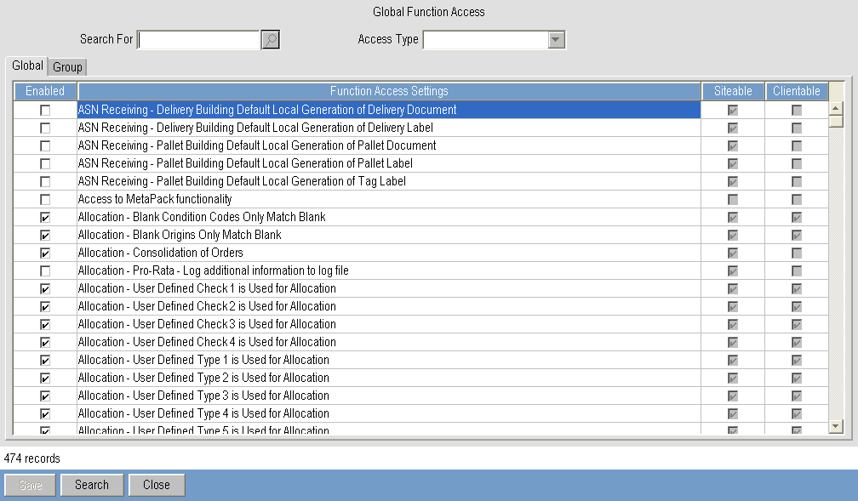
- Site Client Global Function Accesses
If a site ID is selected in the ‘Site ID’ field, the site global function access settings related to that site will be displayed. To reflect this, a ‘Use Site’ column is displayed in this window. If no site ID is supplied, this column is called ‘Used Global’ as you will use the global function access settings.
When a box in the ‘Use Global’/‘Use Site’ column is checked, you will be accepting the value (enabled or disabled) of that global or site global function access. Therefore, if the setting of the global or site global function access is updated, the setting of the client global or site client global function access will also be updated to match this new setting.
When a box in the ‘Use Global’/’Use Site’ column is unchecked, the setting of the global or site global function access is ignored and does not apply to the client global or site client global function access. In this case, the ‘Enabled’ column alone is used to determine whether or not the option is enabled.
To make the site options for a client group independent of the system-wide settings, first select the site ID in the ‘Site ID’ field, then select the client group in the ‘Client Group’ field, uncheck the box in the ‘Use Site’ column and check or uncheck the ‘Enabled’ column to enable or disable the site client global function access.

How do I create a function access client group and add clients to this group?
- To create a function access client group, use the Client Group Maintenance window. Enter the identifier of the group and check the ‘Function Access’ box.
- To add clients to a function access client group, select the function access client group in the ‘Client Access Group’ in the Client Maintenance window for the client.
Any function accesses that you enable for the function access client group will be enabled for any clients included in that function access client group.
When an operator is performing a task for a client such as picking, the client ID on the move task is used to determine whether a function access is disabled or enabled.
The CLIENT_GLOBAL_ONLY column in the FUNCTION_ACCESS table determines whether or not function accesses are displayed in the Site Client Global Function Access window. If the CLIENT_GLOBAL_ONLY column is set yes (Y) for a function access, the option is available in the Site Client Global Function Access window.
The GLOBAL_ONLY and CLIENT_GLOBAL_ONLY columns in the FUNCTION_ACCESS table are mutually exclusive and must be manually controlled.

Global User / Workstation Function Access
To enable functionality such as SKU and location confirmation during picking and putaway, and access to all client windows and RDT screens, use the global user/workstation function accesses. These function accesses are completely separate from the global function accesses (and, therefore, also the site global function accesses).
Enabling a global user/workstation function access at this level does not actually enable the functionality for any particular user or workstation. Instead, it allows that option to be visible in the User Group Function Access and Workstation Group Function Access windows so that this option can be enabled, if required. Users and workstations are included in groups using the User Group Maintenance and Workstation Group Maintenance windows.
These global user/workstation function accesses can be viewed on the Group/Workstation tab in the Global Function Access window.
There is also an equivalent site-specific window for the global user/workstation function accesses. These site global user/workstation function accesses can be viewed on the Group/Workstation tab in the Site Global Function Access window.
The same ‘Use Global’ and ‘Enabled’ check boxes as described above are used on this tab in the Site Global Function Access window.

User / Workstation Group Function Access
The available user/workstation group function accesses are displayed in the User Group Function Access and Workstation Group Function Access windows.
In order for a user and/or workstation to obtain access to a particular area of functionality, the function access must first be enabled either at the global user/workstation function access level, or the site global user/workstation function access level.
Once this is done, the function access becomes available in the Group Function Access windows and you need to enable it in the User Group Function Access AND the Workstation Group Function Access windows.
An example of a user/workstation group function access is confirming that you have picked the correct SKU by entering the SKU ID during picking.

Example 1:
If you have two users in SITE001 and you want to enable the ‘Picking - SKU Confirmation on RDTs’ group/workstation function access for only one user (USER001), setup the function accesses as follows:
Enable the ‘Picking - SKU Confirmation on RDTs’ on the Group/Workstation tab in the Global Function Access window.
Add USER001 to a user group and enable the ‘Picking - SKU Confirmation on RDTs’ function access in both the User Group Function Access window for that user group, and the Workstation Group Function Access window for the workstation that the user will be operating.
From this setup, when USER001 logs into a workstation in the workstation group, he will be prompted to scan the identifier of the SKU he is picking to confirm that he has picked the correct SKU.

Example 2:
Assume you have two users in the same user group with one user tied to SITE001 and the other tied to SITE002. If you want to enable the ‘Picking - SKU Confirmation on RDTs’ group/workstation function access for only the user in SITE001, setup the function accesses as follows:
Enable the ‘Picking - SKU Confirmation on RDTs’ on the Group/Workstation tab in the Global Function Access window.
Disable the ‘Picking - SKU Confirmation on RDTs’ on the Group/Workstation tab in the Site Global Function Access window for SITE002 by unchecking the ‘Use Global’ box and unchecking the ‘Enabled’ box.
Enable the ‘Picking - SKU Confirmation on RDTs’ function access in both the User Group Function Access and Workstation Group Function Access windows for the user and workstation groups.
From this setup, when the user in SITE001 logs into a workstation in the workstation group, he will be prompted to scan the identifier of the SKU he is picking to confirm that he has picked the correct SKU.
The user tied to SITE002 will not be required to scan the SKU ID during the picking process.

Using Client (3PL) Functionality in Warehouse Management
For third party logistics providers, the need to support multiple clients in one or more warehouses requires an extremely flexible system that is user-configurable and enables the 3PL to exactly track all inventory for each client.
Within Warehouse Management, the tracking of individual client information is facilitated by ensuring that the majority of the functions can be client-specific.

Client Specific Data
For example, when setting up a new SKU, order, pre-advice receipts, reason codes, putaway and allocation algorithms, merge rules and various other data entities, users are required to specify the client ID to which these items belong.
The SKU ID/client ID combination is the unique identifier of an individual SKU - this means that not only can each item of inventory for each client be tracked, but clients are also able to have SKUs with the same identifiers in one system; Warehouse Management can be configured to meet the needs of each client.
Move tasks are also client-specific in Warehouse Management, and this provides another measure of the movement of each client’s inventory within the warehouse.

Restricted views of Data
It is also possible to tie a user to a specific client group, thereby ensuring that the user only has visibility of the clients’ inventory included in the group. Function access client groups control the functionality enabled for each client to ensure that their specific business rules are considered and enforced.
If a user is tied to a client visibility group (using the ‘Client Visibility Group’ field in the User Maintenance window) and only ONE client is linked to that client visibility group, the user will not see the ‘Client ID’ field anywhere in the Warehouse Management application. Instead, the ‘Client Group’ field is defaulted with the single client ID and hidden.

Reports and Labels
Reports can be run to view the number of orders that are shipped or pre-advice receipts that are received for each client - thereby providing Warehouse Management, the 3PL and the clients with a measurement of their relevant success in the warehouse.
Additionally reports are easily modified using the designer so that client specific reports and labels can be output as appropriate

