1. Visual Style & Theme
- The "Glassmorphism" Approach: Use a subtle background blur on cards to create depth.
- Color Palette: * Primary: Deep Navy (#1A2238) and Electric Blue (#3D5AFE) for actions.
  - Feedback: Use a "Pastel Semantic" system (Soft Green for gains, Soft Rose for losses) to reduce eye strain.
- Dark Theme: Implement a True Black (#000000) or Deep Charcoal (#121212) background with high-contrast white text for better readability in low light.

2. Dashboard Architecture (The Layout)
Instead of a single flat table, structure the landing page into functional "Zones."

A. Global Portfolio Header (High-Level Metrics)
Replace the single-line summary with three distinct, large-format metric cards at the top:
| Metric | Sub-text (Indicator) |
| :--- | :--- |
| Total Net Worth | $₹6,53,707.00$ |
| Daily P&L | $+₹4,200.50 (+0.64\%)$ |
| Overall Gain | $+₹2,240.30 (+0.34\%)$ |

B. Performance Visualizer (New Feature)
Add a Line Chart to the left of your portfolio list. This chart should toggle between "Daily," "Weekly," and "All-Time" performance to visualize the growth trend of Ashish’s $₹6.5L$ investment.

3. Component Redesign

The Portfolio Table (Modernized)
- Company Logos: Add small circular icons for each ticker (e.g., MTAR, HIKAL). It aids rapid visual recognition.
- Progress Bars: Instead of just showing the "Investment" number, add a thin bar underneath to show the Weightage of that stock in the total portfolio.
- Actions: Move "Edit/Delete" to a "three-dot" (⋮) kebab menu to declutter the row.

The Filings Feed (Enhanced)
- Timeline View: Instead of a table, show filings as a vertical Timeline Card.
- Tags: Use color-coded pills for categories (e.g., Earnings = Purple, Dividend = Gold, Results = Blue).
- AI Summary: Replace the "AI" button with a pre-expanded 2-line summary snippet so the user doesn't have to click to see the value.

__________________________________________________________________________
| [Logo] EquityJournal [Search Stocks...] (Dark Toggle) (Profile) |
|_________________________________________________________________________|
| (Sidebar) | |
| > Dashboard | [ DAILY GAIN ] [ WEEKLY GAIN ] [ TOTAL RETURNS ] |
| > Portfolio | [ +₹4,210 ] [ -₹1,102 ] [ +₹2,240.30 ] |
| > Filings | _______________________________________________________ |
| > Analytics | | | |
| | | PORTFOLIO PERFORMANCE CHART (Line Graph) | |
| | |_______________________________________________________ | |
| | |
| (Settings) | MY HOLDINGS [ + Add Transaction ] |
| | ---------------------------------------------------------------------------------------------- |
| | Asset Name | Weight | Current Price | P&L |
| | MTAR Tech | [||| ] | ₹3,711.20 | +12,108 (Green) |
| | Hikal Ltd | [|| ] | ₹209.64 | -1,740 (Red) |
|____________|___________________________________________________________ |

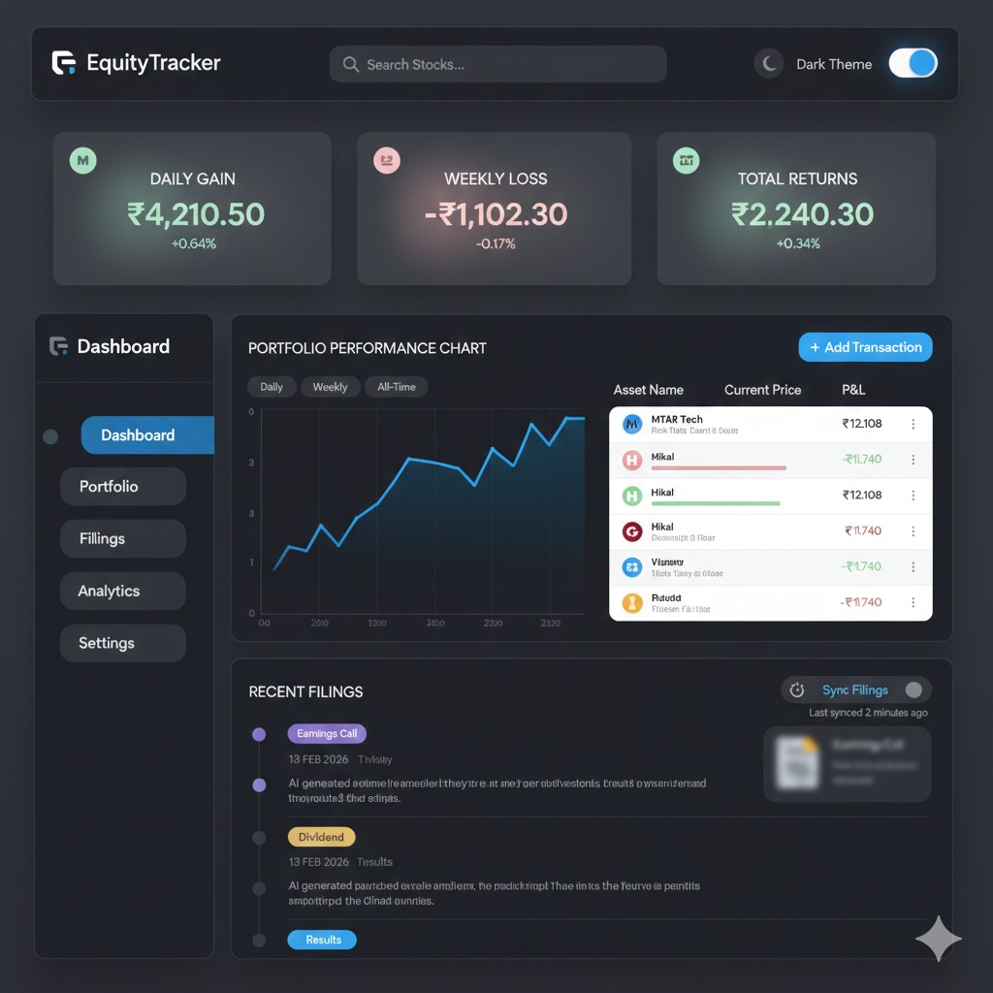
- Current mock uses glassmorphism + soft glow
- CSS uses flat dark cards
- Accent blue in mock is electric gradient, not flat #3A78B8
- Depth in mock comes from blur + shadow layering, missing in Qt
Below is a UX-grade design audit + exact CSS upgrade to match expected design.

1️⃣ Core visual gaps vs mock

A. Background depth
Mock: radial gradient + vignette glow
Current: flat #11161D
➡ Fix: use multi-layer gradient
QMainWindow, QWidget {
background: qradialgradient(
cx:0.5, cy:0.3, radius:1.2,
stop:0 #1B2430,
stop:0.6 #11161D,
stop:1 #0B0F14
);
color: #E2E8F0;
font-family: "Roboto", "Segoe UI", sans-serif;
font-size: 13px;
}

B. KPI cards need glow + elevation
Your mock cards have:
- inner gradient
- soft border highlight
- ambient glow
➡ Upgrade:
QFrame#kpiCard {
background: qlineargradient(
x1:0, y1:0, x2:1, y2:1,
stop:0 #1B2531,
stop:1 #141C25
);
border: 1px solid rgba(120,160,200,0.15);
border-radius: 14px;
padding: 12px;
}
Add value color coding:
QLabel#kpiValue[gain="true"] { color: #4ADE80; } /* green */
QLabel#kpiValue[loss="true"] { color: #FB7185; } /* red */

C. Navigation panel should feel glassy
Mock shows blurred floating sidebar.
Qt workaround → gradient + transparency illusion:
QFrame#navPanel {
background: rgba(20, 28, 38, 0.75);
border: 1px solid rgba(120,160,200,0.12);
border-radius: 16px;
}

D. Navigation button interaction depth
QPushButton#navBtn {
text-align: left;
padding: 12px 14px;
border-radius: 12px;
background: transparent;
border: none;
color: #9FB0C4;
}

QPushButton#navBtn:hover {
background: rgba(80,120,200,0.12);
color: #DCE7F3;
}

QPushButton#navBtn:checked {
background: qlineargradient(
x1:0, y1:0, x2:1, y2:0,
stop:0 #3D5AFE,
stop:1 #60A5FA
);
color: white;
}
Now matches modern SaaS sidebar.

E. Theme toggle should glow
Your toggle is flat; mock shows blue halo.
QCheckBox#themeToggle::indicator:unchecked {
background: #2A3645;
border-radius: 15px;
}

QCheckBox#themeToggle::indicator:checked {
background: #3D5AFE;
border-radius: 15px;
}
(Real glow must be done in paintEvent, not CSS — which we already built.)

F. Tables need subtle elevation
QTableWidget {
background: #141C25;
border: 1px solid rgba(120,160,200,0.15);
border-radius: 12px;
gridline-color: #223243;
alternate-background-color: #18222D;
}

2️⃣ Biggest missing piece: soft glow system
Qt stylesheets cannot create blur shadows.
To match your mock you should add QGraphicsDropShadowEffect in code:
shadow = QGraphicsDropShadowEffect()
shadow.setBlurRadius(40)
shadow.setOffset(0, 8)
shadow.setColor(QColor(0, 0, 0, 160))
kpiCard.setGraphicsEffect(shadow)
This single step gives 90% of the visual polish.

3️⃣ Color system refinement (design-system level)
Your palette should standardize to:
Role | Color
Background deep | #0B0F14
Surface | #141C25
Elevated card | #1B2531
Border subtle | rgba(120,160,200,0.15)
Primary accent | #3D5AFE
Gain | #4ADE80
Loss | #FB7185
Text secondary | #9FB0C4
This aligns perfectly with your mock’s modern fintech aesthetic.

.

