

SDL In Practice
Keep It Small and Simple

SDL_image

Setup Environment
&
Load Image By SDL_image

inviassassin@gmail.com

Setup Environment
Install
sudo apt-get install libsdl2-image-dev

Load Image By SDL_image
hello_sdl_image.cpp
#include <SDL2/SDL.h>
#include <SDL2/SDL_image.h>

int main()
{
SDL_Init(SDL_INIT_VIDEO);
SDL_Window *pWindow = SDL_CreateWindow("SDL_image", 100, 100, 500, 500, 0);
SDL_Surface *pWindowSurface = SDL_GetWindowSurface(pWindow);

IMG_Init(IMG_INIT_PNG);
SDL_Surface *pImageSurface = IMG_Load("assassin.png");

SDL_FillRect(pWindowSurface, NULL, 0x3b5999);
SDL_BlitSurface(pImageSurface, NULL, pWindowSurface, NULL);
SDL_UpdateWindowSurface(pWindow);

SDL_Delay(5000);

SDL_FreeSurface(pImageSurface);
SDL_DestroyWindow(pWindow);
IMG_Quit();
SDL_Quit();

return 0;
}

Compile
g++ hello_sdl_image.cpp -o demo -lSDL2 -lSDL2_image

Run
./demo

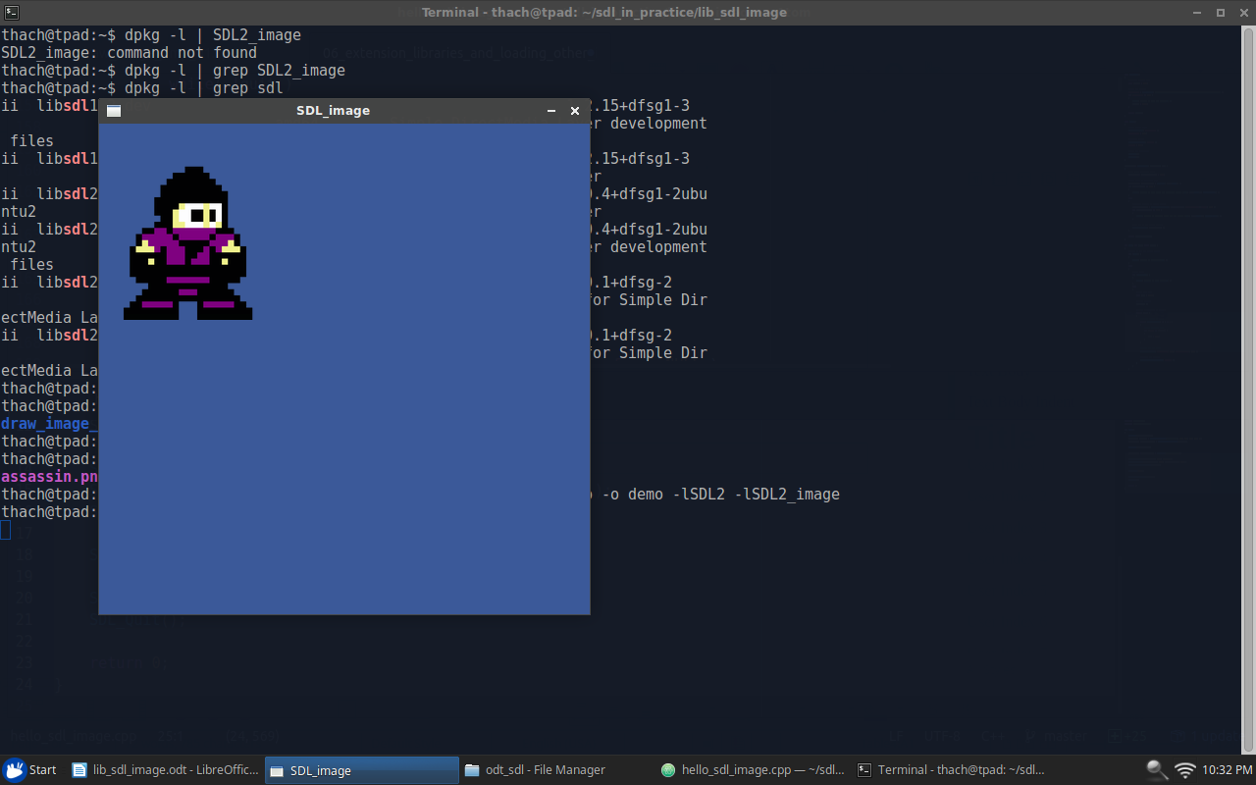

SDL_image In Theory
SDL image is a library used to load images of various formats to SDL surfaces.
Support image formats: ico, bmp, png, xpm, lbm, pcx, gif, jpeg, pnm, tga, tiff, xv.
The flow to use SDL_image
- Init SDL_image
- Load image to surface
- Render surface
- Free the surface when it is no longer needed
- Quit SDL_image

Init SDL_image
In this step, we have to register which image format we will use.
int IMG_Init(int flags)

For example, we will use png format
IMG_Init(IMG_INIT_PNG)

If we will use png and jpg formats
IMG_Init(IMG_INIT_JPG | IMG_INIT_PNG)

Load Image To Surface
SDL_Surface *pImageSurface = IMG_Load("assassin.png");
This function can load all supported image files. We have to call SDL_FreeSurface to release the returned surface pointer. If the image format supports a transparent pixel, the color of this pixel will be the color of the surface.
Render Surface
SDL_BlitSurface(pImageSurface, NULL, pWindowSurface, NULL);

Free Surface
SDL_FreeSurface(pImageSurface);

Quit SDL_image
SDL_Quit()
This function is used to unload all dynamically loaded image: clean up all dynamically loaded library handles and release memory.

