

TinyXml In Practice
Keep It Small and Simple

TiXmlDocument
Build XML Document & Write To File
&
Load & Add Element To XML Document

inviassassin@gmail.com

Build XML Document & Write To File
#include "tinyxml.h"

int main()
{
TiXmlDocument doc;

//add declaration
TiXmlDeclaration *pDeclaration = new TiXmlDeclaration("1.0", "", "");
doc.LinkEndChild(pDeclaration);

//init element
TiXmlElement *pElement = new TiXmlElement("Hero");

TiXmlText *pText = new TiXmlText("Ninja");
pElement->LinkEndChild(pText);

//add attribute to element
pElement->SetAttribute("role", "ganker");
pElement->SetAttribute("speed", 890);
pElement->SetAttribute("strength", 450);

//add element
doc.LinkEndChild(pElement);

doc.Print();

//write document to file
doc.SaveFile("ninja.xml");

return 0;
}

Compile And Run
make
./demo

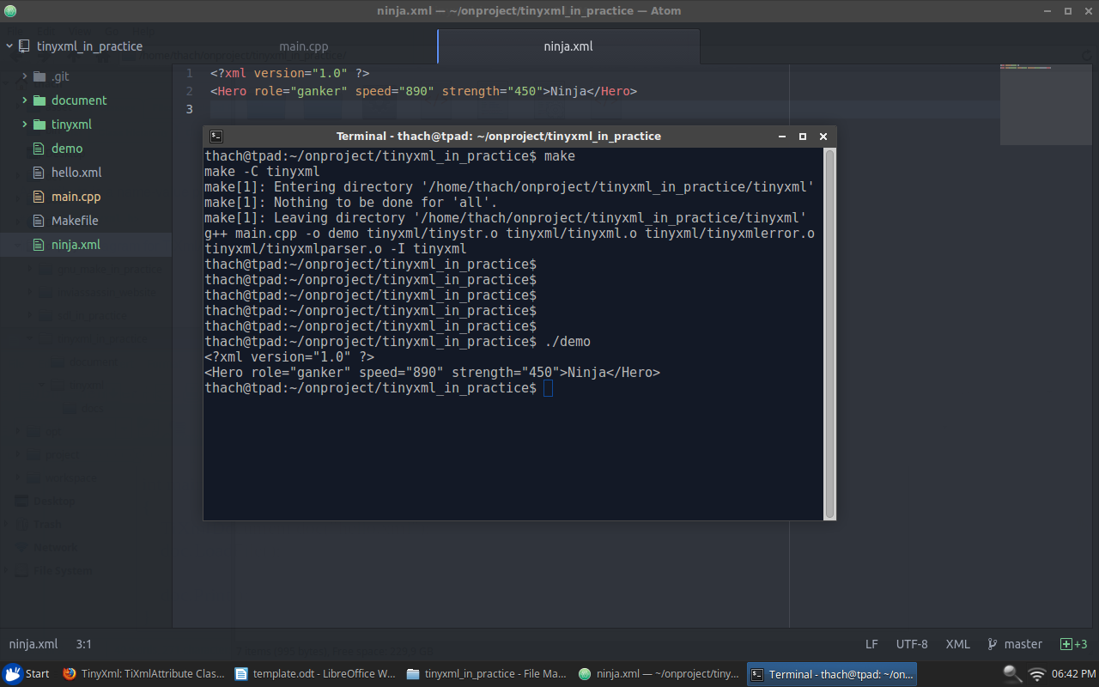

Load & Add Element To XML Document
#include "tinyxml.h"

int main()
{
TiXmlDocument doc;
doc.LoadFile("ninja.xml");

//init element
TiXmlElement *pElement = new TiXmlElement("Hero");
TiXmlText *pText = new TiXmlText("Nuker");
pElement->LinkEndChild(pText);

//add attribute to element
pElement->SetAttribute("role", "intelligence");
pElement->SetAttribute("speed", 600);
pElement->SetAttribute("magic", 800);

//add element
doc.LinkEndChild(pElement);

doc.Print();

doc.SaveFile("ninja.xml");

return 0;
}

