

TinyXml In Practice
Keep It Small and Simple

Setup Environment
&
Write Your First Application

inviassassin@gmail.com

Setup Environment
Download and extract
http://www.grinninglizard.com/tinyxml/

Build
make

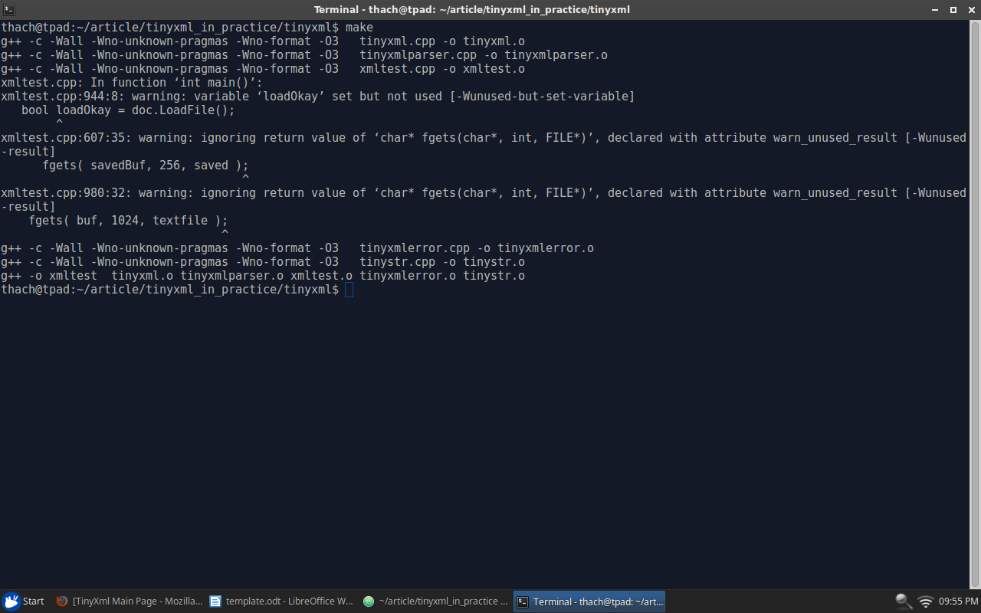

Run demo
./xmltest

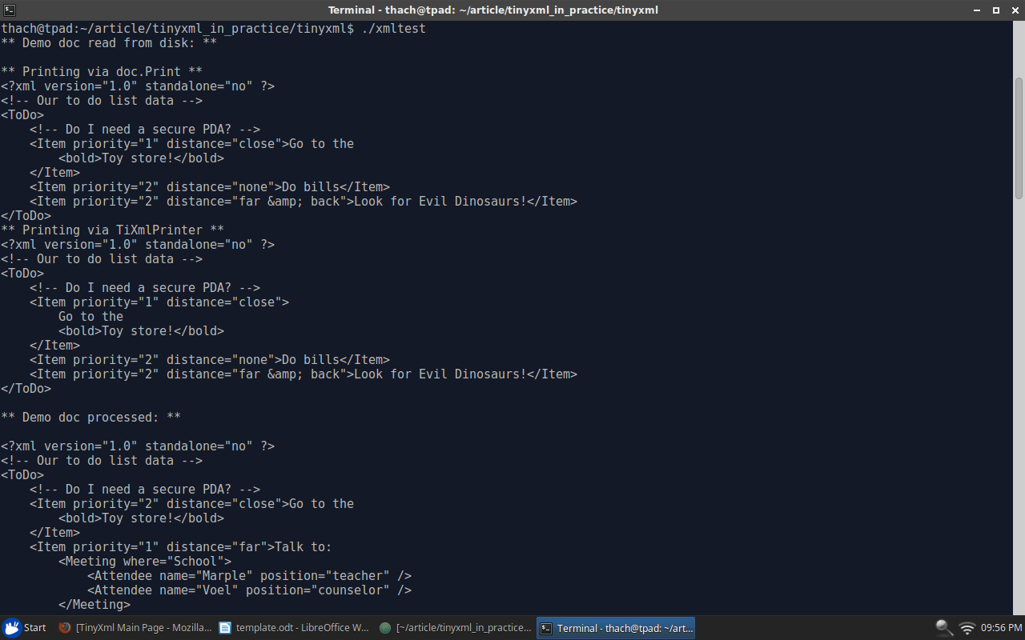

Write Your First Application
We use TinyXml as library, so we will don't write code inside tinyxml folder.
Create files: main.cpp, hello.xml, Makefile outside tinyxml folder.
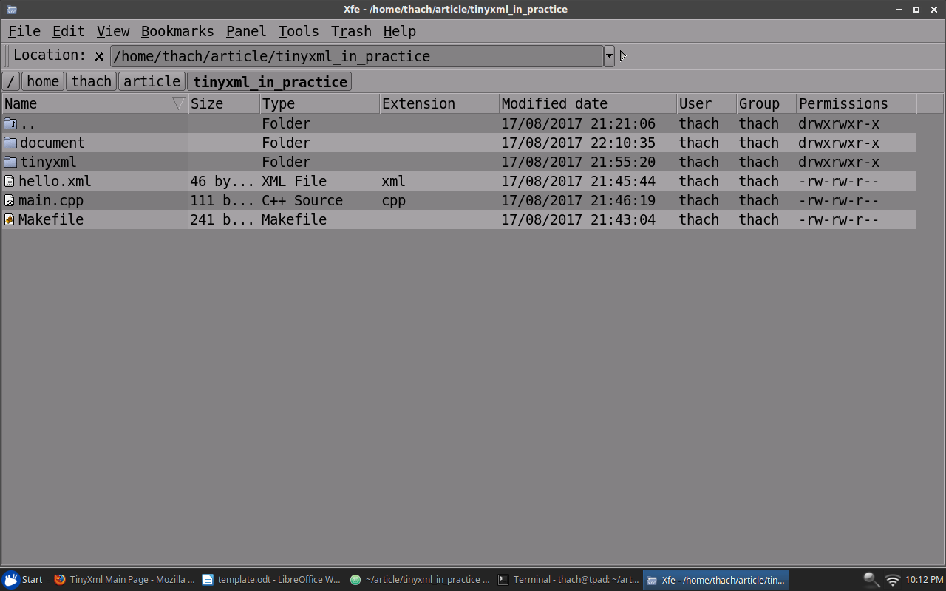

Create xml data
hello.xml
<?xml version="1.0">
<Text>Hello World</Text>

Add code to load and print data
main.cpp
#include "tinyxml.h"

int main()
{
TiXmlDocument doc("hello.xml");
doc.LoadFile();

doc.Print();
}

Add Makefile to compile source
Makefile
TINY_OBJ = tinyxml/tinystr.o \
tinyxml/tinyxml.o \
tinyxml/tinyxmlerror.o \
tinyxml/tinyxmlparser.o

TINY_INC = -I tinyxml

.PHONY: all tinyxml

all: tinyxml
g++ main.cpp -o demo ${TINY_OBJ} ${TINY_INC}

tinyxml:
make -C tinyxml

Compile and run
make
./demo

