1.1 Motivation and Context
Generative artificial intelligence (GenAI) tools such as GitHub Copilot, OpenAI Codex, and Claude Code have altered how software is developed, offering AI-powered assistance for code generation, debugging, refactoring, and documentation. Ulfsnes et al. found that GenAI represents a "paradigm shift" in developer workflows, enabling increased efficiency and reducing repetitive tasks [1]. However, this rapid adoption has outpaced the development of structured guidance for integrating AI-generated code into professional practice, leaving developers to navigate tool usage without established process safeguards.
1.2 Problem Statement
Despite productivity benefits, the integration of GenAI into software development remains largely unstructured. Developers frequently accept AI-generated code without systematic verification, introducing significant risks. Pearce et al. found that approximately 40% of code generated by GitHub Copilot contained security vulnerabilities when evaluated against MITRE's Common Weakness Enumeration scenarios [2]. Fu et al. analyzed AI-generated snippets in real GitHub projects and found that 29.5% of Python and 24.2% of JavaScript code exhibited security weaknesses spanning 43 CWE categories [3]. Beyond security, large language models are prone to hallucinations, generating code that deviates from user intent or misaligns with project context [4]. Without a disciplined approach, developers risk introducing security flaws, functional defects, and long-term technical debt into production systems.
1.3 Contribution of This Work
This paper proposes a structured workflow framework for GenAI-assisted software development that introduces explicit stages, decision points, and verification checkpoints to address the lack of workflow-level guidance identified in prior empirical studies. The framework is evaluated through a comparative case study demonstrating reduced defects without sacrificing productivity.
1.4 Paper Organization
The remainder of this paper is organized as follows. Section 2 establishes terminology and conceptual scope. Section 3 reviews background and related work on GenAI in software development. Section 4 defines the problem space and design requirements. Section 5 presents the proposed workflow framework. Section 6 describes a comparative case study and its results. Section 7 discusses implications, limitations, and ethical considerations. Section 8 concludes with a summary and directions for future work.

Section 2: Terminology and Conceptual Scope
2.1 Definitions
This paper adopts the following definitions to ensure clarity and consistency:
Generative AI (GenAI): Artificial intelligence systems capable of producing new content—including source code, documentation, and test cases—based on learned patterns from training data. In this work, GenAI refers specifically to large language model (LLM)-based tools used in software development contexts.
AI-Assisted Software Development: A development paradigm in which human developers collaborate with GenAI tools to complete programming tasks. The developer retains decision-making authority while leveraging AI-generated suggestions, code snippets, or complete functions.
Workflow Framework: A structured sequence of stages, decision points, and verification checkpoints that guide how developers integrate AI-generated artifacts into a software project. Unlike ad-hoc tool usage, a workflow framework imposes explicit process controls.
Hallucination: In the context of code generation, output that appears syntactically correct but deviates from user intent, conflicts with project context, or misuses APIs and libraries [4]. Hallucinations may compile successfully yet fail functionally or introduce latent defects.
Verification Checkpoint: A defined point in the workflow where AI-generated output is evaluated against correctness, security, and contextual fit criteria before integration into the codebase.

2.2 Scope and Assumptions
This work focuses on individual developer workflows when using GenAI tools for code generation tasks. The following scope boundaries and assumptions apply:
In Scope:
- Use of GitHub Copilot, OpenAI Codex, and Claude Code for code generation, refactoring, and debugging
- Single-developer or small-team integration scenarios
- Verification practices applicable during active development
Out of Scope:
- Organizational-level adoption policies and governance
- Training or fine-tuning of custom LLMs
- Fully autonomous code generation without human oversight
Assumptions:
- Developers possess sufficient domain knowledge to evaluate AI-generated suggestions
- GenAI tools are accessed via standard interfaces (IDE plugins, chat interfaces, or API calls)
- The development environment includes access to standard verification tools such as linters, static analyzers, and test frameworks

Section 4: Problem Definition and Design Requirements
Based on your TOC, Section 4 has four subsections:
- 4.1 Failure Modes in Unstructured AI-Assisted Development
- 4.2 Sources of Risk and Uncertainty
- 4.3 Requirements for a Defensible Workflow Framework

4.1 Failure Modes in Unstructured AI-Assisted Development
When developers adopt GenAI tools without systematic process controls, several failure modes emerge. These failure modes are not theoretical—they are observable in empirical studies and directly inform the design of the proposed workflow framework.
Failure Mode | Description | Consequence | Source
FM1: Uncritical Acceptance | Developer accepts AI-generated code without verification, assuming correctness | Security vulnerabilities, functional defects integrated into codebase | Pearce et al. [2]
FM2: Prompt Underspecification | Developer provides vague or incomplete prompts, yielding irrelevant or partially correct output | Wasted iteration cycles; code requires substantial rework | Implicit in hallucination literature [4]
FM3: Hallucination Propagation | AI generates plausible but incorrect code (fabricated APIs, deprecated syntax, invalid patterns) that passes superficial review | Latent defects; runtime failures; maintenance burden | Liu et al. [4], Fu et al. [3]
FM4: Security Blindness | Developer lacks security expertise to recognize vulnerabilities in generated code | Exploitable weaknesses deployed to production | Pearce et al. [2], Fu et al. [3]
FM5: Context Mismatch | AI output ignores project conventions, architectural constraints, or environmental requirements | Integration friction; technical debt; inconsistent codebase | Observed in practice
FM6: Verification Gaps | Developer performs incomplete testing—syntax check only, or functional test without security review | False confidence; undetected defects | Derived from rubric dimensions R1–R7
These failure modes are not mutually exclusive. A single AI-assisted development session may exhibit multiple failures simultaneously, compounding risk.

4.2 Sources of Risk and Uncertainty
The failure modes identified above arise from three categories of risk inherent to GenAI-assisted development:
Model-Level Risks:
Risk | Description
Training data limitations | LLMs learn from public code repositories containing both secure and insecure patterns; models may reproduce vulnerabilities present in training data
Knowledge cutoff | Models lack awareness of recent library updates, deprecated functions, or emerging security advisories
Stochastic output | Non-deterministic generation means identical prompts may yield different outputs, complicating reproducibility
Interaction-Level Risks:
Risk | Description
Prompt quality variance | Output quality is highly sensitive to prompt construction; developers vary in prompting skill
Context window limitations | Models may lose relevant context in complex tasks, leading to inconsistent or incomplete solutions
Feedback loop absence | Without structured iteration protocols, developers may accept suboptimal output or over-iterate without improvement
Process-Level Risks:
Risk | Description
Verification omission | No enforced checkpoint requiring security, functional, and contextual review before integration
Attribution ambiguity | AI-generated code may lack documentation, complicating future maintenance and auditing
Learning loss | Developers may not capture lessons from successful or failed AI interactions, preventing workflow improvement

4.3 Requirements for a Defensible Workflow Framework
To address the failure modes and risks identified above, a workflow framework for GenAI-assisted development must satisfy the following requirements:
Requirement | Description | Addresses Failure Mode(s)
REQ1: Explicit Task Specification | The framework must require clear task definition before AI invocation, including functional requirements, constraints, and non-functional considerations | FM2 (Prompt Underspecification)
REQ2: Structured Prompt Construction | The framework must guide prompt design as an engineering artifact, with checkpoints for context adequacy and constraint articulation | FM2, FM5 (Context Mismatch)
REQ3: Triage Gate | The framework must include an initial assessment stage to detect obvious hallucination indicators before deep verification | FM3 (Hallucination Propagation)
REQ4: Multi-Layer Verification | The framework must enforce verification across static analysis, functional testing, and contextual review dimensions | FM1 (Uncritical Acceptance), FM4 (Security Blindness), FM6 (Verification Gaps)
REQ5: Defined Failure Paths | The framework must specify recovery actions when verification fails, including return to earlier stages | FM1, FM3, FM6
REQ6: Integration Controls | The framework must require documentation and attribution before code enters the codebase | FM5 (Context Mismatch)
REQ7: Feedback Capture | The framework must include mechanisms to log successful patterns and failure modes for continuous improvement | FM6, Process-Level Risks
Mapping Requirements to Evaluation Rubric:
Requirement | Related Rubric Dimension(s)
REQ1 | R6 (Completeness)
REQ2 | R5 (Contextual Fit), R6 (Completeness)
REQ3 | R1 (Syntactic Correctness), R4 (API/Library Accuracy)
REQ4 | R1, R2, R3, R4, R5, R7
REQ5 | Framework transition logic
REQ6 | R5 (Contextual Fit), R7 (Code Readability)
REQ7 | Stage 6 (Monitoring and Feedback Loop)

Section 5.2: Workflow Stages and Decision Points
The proposed framework consists of six sequential stages, each with an explicit decision point and verification checkpoint. The stages are designed to preserve developer authority while imposing systematic controls on AI-generated code integration.
Pre-Generation Control (Stages 1–2). The workflow begins with Task Specification, where the developer defines the programming task with sufficient clarity before invoking GenAI assistance. This includes functional requirements, constraints, target language or framework, and non-functional considerations such as performance expectations, security requirements, and compatibility constraints. The decision gate at this stage asks: is the task well-defined enough to generate a meaningful prompt? If not, the task must be decomposed or clarified before proceeding. Once the task is specified, Prompt Construction translates it into an effective prompt that maximizes the likelihood of useful AI output. The developer evaluates whether the prompt provides adequate context—relevant code snippets, API references, and project conventions. A prompt quality checklist serves as the verification checkpoint, assessing specificity, context inclusion, constraint articulation, and example provision where applicable.
Evaluation and Verification (Stages 3–4). Upon receiving AI-generated output, the developer performs Output Generation and Initial Triage—a rapid assessment for structural soundness and responsiveness to the prompt. The verification checkpoint at this stage includes syntax checking, structural alignment with the request, and absence of obvious hallucination indicators such as references to nonexistent libraries or fabricated APIs. If the output fails triage, the developer refines the prompt and regenerates. Code that passes triage advances to Verification and Validation, where it undergoes systematic evaluation across three layers: static analysis (linting, security scanning), functional testing (unit tests, edge cases), and contextual review (project conventions, dependencies, licensing). The decision gate permits three outcomes: full pass proceeds to integration, partial pass triggers modification and re-verification, and failure returns the developer to Stage 2 or Stage 1 depending on the nature of the defect.
Integration and Learning (Stages 5–6). Verified code enters Integration and Documentation, where it is incorporated into the codebase with appropriate attribution and documentation in accordance with applicable team or organizational policy. The pre-commit verification checkpoint confirms code comments, commit message clarity, AI-assistance attribution, and updated tests. Finally, Monitoring and Feedback Loop tracks integrated code performance over time. If post-deployment issues emerge, the developer triggers remediation and documents the failure pattern. Successful integrations are logged to capture effective prompt strategies and verification approaches, enabling continuous improvement of the developer's GenAI-assisted workflow.

Figure 1: Workflow Framework Overview (Description for Diagram)
For the actual paper, create a figure with:
Element | Visual Representation
Stages 1–6 | Rectangular boxes, numbered
Decision Points | Diamond shapes with Yes/No paths
Verification Checkpoints | Small boxes or annotations attached to each stage
Backward Paths | Arrows returning to earlier stages on failure
Forward Flow | Primary arrows connecting stages sequentially

Suggested Layout:
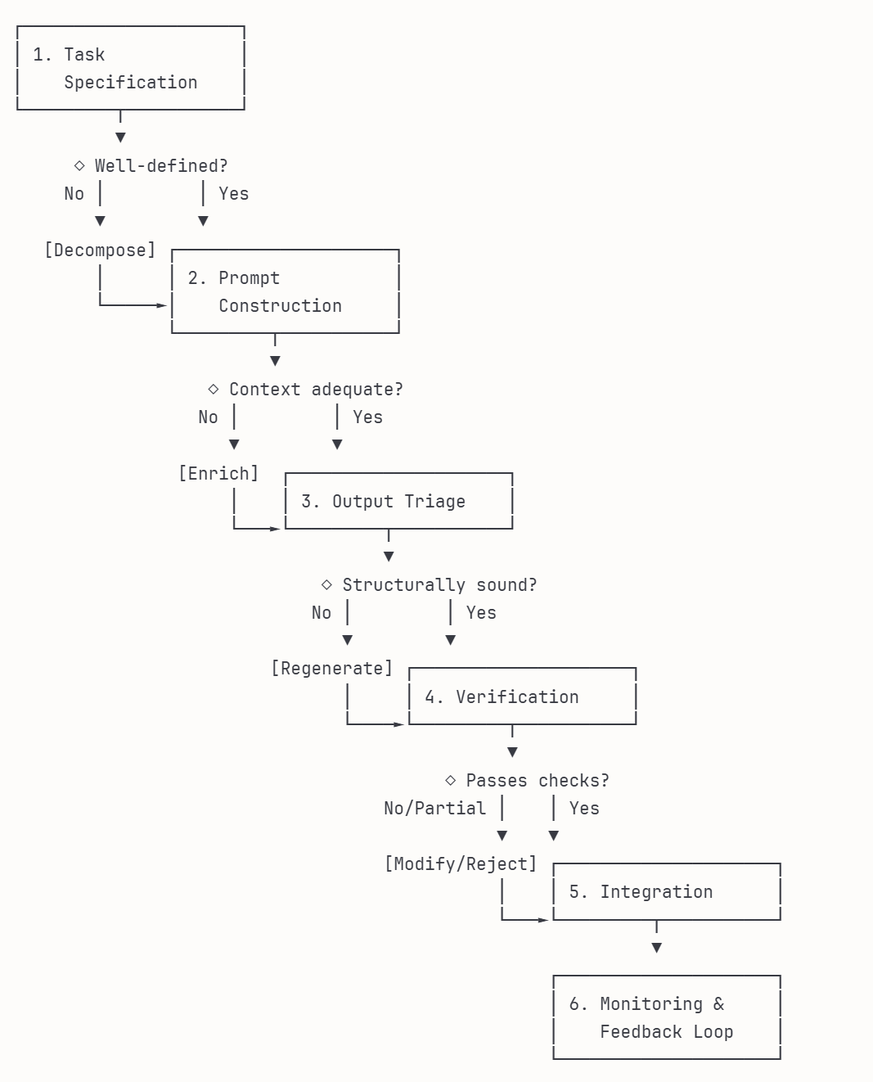

Section 6.1: Case Study Design

6.1.1 Task Selection and Rationale
The case study task is the development of a user authentication module in JavaScript for a front-end web application. The module encompasses the following functional requirements:
- Login and registration form UI with appropriate input fields
- Client-side input validation (required fields, email format, password strength)
- API integration for authentication requests (fetch to REST endpoint)
- Token reception and secure storage (with consideration of localStorage vs. sessionStorage vs. cookies)
- Authenticated state management and protected route logic
- Token refresh handling
- Logout functionality with token invalidation
- Error handling and user feedback for authentication failures
This task was selected according to the following criteria:
Criterion | Justification
Complexity | The task requires coordination across UI components, validation logic, asynchronous API communication, state management, and security considerations. It cannot be solved trivially with a single prompt, ensuring meaningful engagement with all six workflow stages.
Security Sensitivity | Client-side authentication involves multiple security considerations including XSS prevention, secure token storage, and CSRF mitigation. These concerns are measurable against OWASP front-end security guidelines and connect directly to the risks identified in Section 1.2.
Hallucination Exposure | Correct implementation requires accurate async/await patterns, proper error handling, and security best practices for token management. These are documented weak points for large language models, with GenAI frequently producing outdated or insecure patterns [4].
Verifiability | Outputs can be systematically evaluated through static analysis (ESLint), accessibility auditing (axe-core), unit and integration testing (Jest), and security review against OWASP guidelines, enabling reproducible assessment.
Reproducibility | The task uses a mock API endpoint with a defined contract, allowing any researcher to replicate the study without external account dependencies or provider-specific configuration.
Stage Traversal | Task complexity increases the likelihood of triggering decision gates and backward transitions within the framework, particularly at Stage 3 (hallucination indicators in API handling) and Stage 4 (security compliance failures).
Implementation Constraints:
Constraint | Specification
Language | JavaScript (ES6+)
Framework | Vanilla JavaScript or React (developer's choice based on prompt)
API | Mock REST endpoint with defined authentication contract (see Appendix C)
Scope Exclusions | No external OAuth providers; no server-side implementation
Deliverable | Self-contained authentication module with login, registration, protected route, and logout functionality

6.1.2 GenAI Tools and Versions Evaluated
Three GenAI coding assistants were selected to represent distinct interaction paradigms prevalent in contemporary software development practice:
Tool | Model/Version | Interaction Paradigm | Access Method
GitHub Copilot | GPT-4 based (Copilot Chat) | IDE-integrated; inline suggestions and chat | WebStorm Plugin
OpenAI Codex | GPT-4o | Conversational; prompt-response | CLI interface
Claude Code | Claude Sonnet 4 | Agentic; autonomous multi-step execution | CLI interface
Selection Rationale:
These tools were selected not as a benchmark comparison but to demonstrate that the proposed workflow framework remains operational across fundamentally different human-AI interaction models:
- GitHub Copilot represents the most widely adopted IDE-integrated assistant, where suggestions appear inline during active coding within the WebStorm development environment.
- OpenAI Codex represents conversational code generation, where developers submit discrete prompts and receive complete code blocks via command line interaction.
- Claude Code represents the emerging agentic paradigm, where the AI autonomously executes multi-step tasks including file creation, dependency management, and test execution.
Control Conditions:
Control | Specification
Prompt Equivalence | Each tool received semantically identical prompts derived from the same template (see Appendix A)
Configuration | Default temperature and generation settings; no custom tuning
Iteration Protocol | Initial generation captured verbatim; refinement permitted only when triggered by framework decision gates (Stages 1–4)
Agentic Constraint | Claude Code's autonomous execution was permitted, but all verification (Stage 4) was performed externally using the same toolchain applied to other outputs
Output Capture | All generated code recorded prior to any human modification
Interaction Protocol for Agentic Tools:
Because Claude Code operates autonomously, the following additional constraints ensure fair comparison:
- Claude Code may create files and execute commands as part of its generation process
- Any self-executed tests by Claude Code are logged but not counted toward Stage 4 verification
- All outputs undergo identical external verification (static analysis, security scanning, functional testing) regardless of tool-internal validation
- Maximum autonomous iteration limited to three cycles before human intervention is required

6.1.4 Evaluation Rubric and Scoring Criteria
The evaluation rubric operationalizes the verification checkpoint defined in Stage 4 (Verification and Validation) of the workflow framework. Each dimension corresponds to a specific verification layer and is scored on a three-point scale.
Scoring Scale:
Score | Definition
0 | Fails criterion; significant defects, omissions, or violations present
1 | Partially meets criterion; minor issues identified requiring correction
2 | Fully meets criterion; no defects detected
Rubric Dimensions:
ID | Dimension | Verification Layer | Evaluation Criteria | Measurement Method
R1 | Syntactic Correctness | Static Analysis | Code parses without errors; no syntax violations; no runtime exceptions on load | ESLint, browser console
R2 | Security Compliance | Static Analysis | No XSS vulnerabilities; secure token storage pattern; no sensitive data exposure; proper input sanitization | ESLint security plugins, OWASP ZAP, manual review against OWASP front-end guidelines
R3 | Functional Correctness | Functional Testing | Passes unit and integration tests covering login, registration, invalid input handling, token storage, protected route access, and logout | Jest with predefined test suite (Appendix B)
R4 | API/Library Accuracy | Hallucination Detection | Correct fetch API usage; valid async/await patterns; no fabricated methods or deprecated syntax | Manual review against MDN documentation
R5 | Contextual Fit | Contextual Review | Consistent coding patterns; appropriate error handling; proper separation of concerns; adherence to specified constraints | Manual code review
R6 | Completeness | Functional Testing | All specified functional requirements addressed; no missing components (login, registration, protected route, logout, error handling) | Requirements checklist verification
R7 | Code Readability | Contextual Review | Meaningful variable and function names; appropriate comments; logical code organization; consistent formatting | ESLint style rules, manual review
Rubric-to-Framework Mapping:
Dimension | Stage 4 Verification Layer | Stage 3 Triage Applicability
R1: Syntactic Correctness | Static Analysis | Primary triage gate
R2: Security Compliance | Static Analysis | —
R3: Functional Correctness | Functional Testing | —
R4: API/Library Accuracy | Hallucination Detection | Triage flag (obvious hallucination indicators)
R5: Contextual Fit | Contextual Review | —
R6: Completeness | Functional Testing | —
R7: Code Readability | Contextual Review | —
Score Aggregation:
Rating | Total Score (0–14) | Interpretation | Framework Outcome
Pass | 12–14 | Code integrable with minimal or no modification | Proceed to Stage 5 (Integration)
Partial | 7–11 | Code requires targeted corrections before integration | Modify and re-verify (Stage 4 loop)
Fail | 0–6 | Code rejected; fundamental defects present | Return to Stage 2 or Stage 1
Weighting:
All dimensions are weighted equally in this study. Differential weighting based on risk priority (e.g., elevated weight for security compliance) is identified as a refinement for future work in Section 7.

References Used in Introduction
# | Citation
[1] | R. Ulfsnes, N.B. Moe, V. Stray, and M. Skarpen, "Transforming Software Development with Generative AI: Empirical Insights on Collaboration and Workflow," in Generative AI for Effective Software Development, Springer, 2024.
[2] | H. Pearce, B. Ahmad, B. Tan, B. Dolan-Gavitt, and R. Karri, "Asleep at the Keyboard? Assessing the Security of GitHub Copilot's Code Contributions," in Proc. IEEE Symposium on Security and Privacy, 2022, pp. 754–768.
[3] | Y. Fu et al., "Security Weaknesses of Copilot-Generated Code in GitHub Projects: An Empirical Study," ACM Trans. Software Engineering and Methodology, vol. 34, no. 8, 2025.
[4] | F. Liu et al., "Exploring and Evaluating Hallucinations in LLM-Powered Code Generation," arXiv:2404.00971, 2024.
# | Citation

