Princess In Distress Solution

Tools Used
- Stegsolve http://www.caesum.com/handbook/Stegsolve.jar
- Various custom scripts (included throughout the writeup)
- Gronsfield cipher online cracker http://www.geocachingtoolbox.com/index.php?page=gronsfeldCipher
- Binwalk, xxd, strings, and other linux cmd line utilities.

Stage 1: The html file
The first stage of this challenge (and arguably the hardest to crack) was in the form of an html file. The first thing I noticed was that the file contained 5 copies of the same wikipedia entry about video games, making it a pretty big file.

After looking for low hanging fruit such as hidden links or hints I found that the solution would take a bit more work. I decided to split the file into its five parts and see if they differed, I hashed each part, telling me that even though they looked the same in a browser, the underlying html was different in each part.
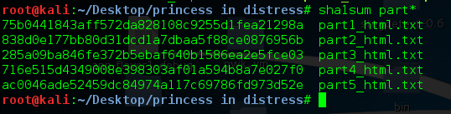

The obvious question to ask was, what data can be hidden in html that would appear normal in a browser that would cause the hashes to be different? The first answer would be the <html><body> tags in part1 and part5. However that should mean that parts 2-4 should be the same. Eventually I found that each part had differences in how each word was spaced (sort of). What I found was that in places within the html, double spaces had been added between words, this wouldn't be visible in a browser as it doesn't recognise multiple spaces.

The next question came naturally, how can someone embed data in a file based on the occurences of spaces and double spaces? I decided that the first thing I should do is strip all of the alphabetic characters and html code from the file, and make the double spaces more visible, hoping I might see a pattern.
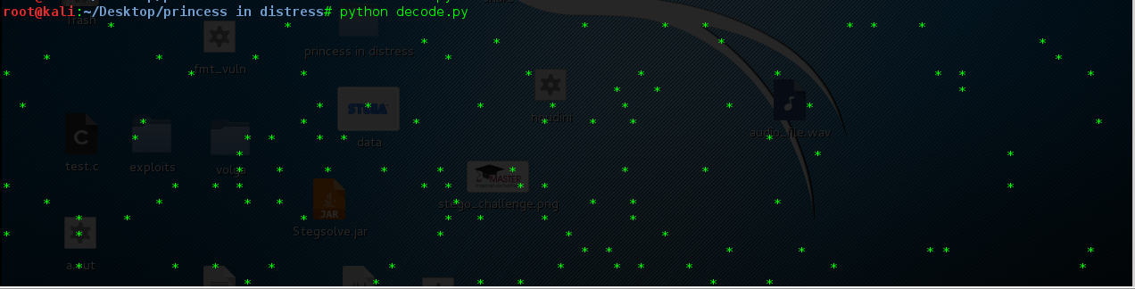
Looking at this, I decided that the solution could be in the distance between each point, I then wrote a script that takes the distance from one point to the next and writes that integer as a byte to a new file, long story short this didn't work at all, but it did help brush up on some regex skills (which I'll need for the next part). The first attempt script was as such:
import struct
import re

newLine = re.sub('\s\s', '*', open("video_games.html", "r").read()) #replace double space with *
newLine = re.sub('[^*]', ' ', newLine) #get rid of everything that isn't a *

print newLine
out = open("attempt1", "wb")

for i in range(0, len(line)):
if(line[i] == '*'):
i = i + 1
for j in range(i, len(line)):
if(line[j] == '*'):
byte = struct.pack("<I", j-i)
print byte
out.write(byte)
i = j
break

After some further pondering, I decided to try something similar. This time I would take every occurence of a single space to indicate a 0, and every occurence of a double space to be a 1. Using similar regex replacement as before, I came up with the following script.

import re
import array

#start of by getting rid of any ~ characters in the file
newLine = re.sub('~', '', open("video_games.html", "r").read())

#every double space becomes a ~
newLine = re.sub('\s\s', '~', newLine) #~=1

#every single space becomes a *
newLine = re.sub('\s', '*', newLine)

#strip everything from the file but * and ~
newLine = re.sub('[^*~]', '', newLine)

binary_string = ""

#Iterate over our string and build the bit string from each symbol
for i in range(len(newLine)):
if(newLine[i] == '~'):
binary_string += "1"
elif(newLine[i] == '*'):
binary_string += "0"

#Slice up our bit string into bytes and convert those to integers
data = [int(binary_string[x:x+8], 2) for x in range(0, len(binary_string), 8)]

#turn each integer to a character byte
data = ''.join(chr(i) for i in data)
print data

Finally, I got confirmation that this was the correct solution to the first part.
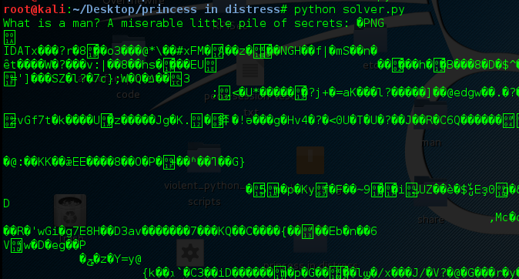

Stage 2: Getting the pictures and doing some Steganography
Instantly we see the magic bytes for a PNG file, I wondered if anything else was embedded so used binwalk to scan the file for known file types.
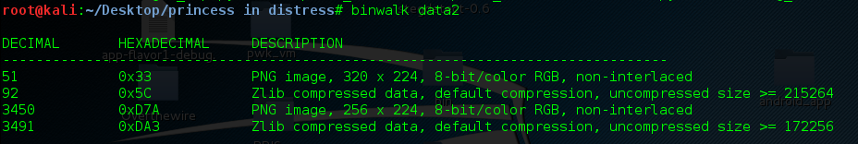
So we have 2 PNG's. The problem was binwalk didn't seem to want to extract them, just the zlib files. I decided to update my script from above so that it would solve the first part of the challenge, and then carve the png files from the produced data. The final code for this part was as follows.
import re
import array

#start of by getting rid of any ~ characters in the file
newLine = re.sub('~', '', open("video_games.html", "r").read())

#every double space becomes a ~
newLine = re.sub('\s\s', '~', newLine) #~=1

#every single space becomes a *
newLine = re.sub('\s', '*', newLine)

#strip everything from the file but * and ~
newLine = re.sub('[^*~]', '', newLine)

binary_string = ""

#Iterate over our string and build the bit string from each symbol
for i in range(len(newLine)):
if(newLine[i] == '~'):
binary_string += "1"
elif(newLine[i] == '*'):
binary_string += "0"

#Slice up our bit string into bytes and convert those to integers
data = [int(binary_string[x:x+8], 2) for x in range(0, len(binary_string), 8)]

#turn each integer to a character byte
data = ''.join(chr(i) for i in data)

print data
outfile = open("png1", "wb")

index = 0
#We need to iterate past the ascii text
for i in range(len(data)):
if(data[i] == "P"):
index = i-1
break

#82 marks the end of the first png file and the beginning of the next
#82 89 50 4e 47 0d 0a
for i in range(index, len(data)):
#this if statement is a little messy, but I wanted to make sure it would be stable
#we look for \x82 and if the following bytes are the png magic bytes
#and the current index is larger than 100 (basically we arent at the beginning of the file)
#then we are at the end of the first png, so break
if(data[i] == "\x82" and data[i+1] == "\x89" and data[i+2] == "\x50" and i > 100): #looking for end of PNG
print "BREAKING"
index = i+1
break
else:
outfile.write(data[i]) #otherwise write the data to the first png file

png2 = open("png2", "wb")
#now we just iterate over the rest of the file and write the data to the next png file
for i in range(index, len(data)):
png2.write(data[i])

png2.close()
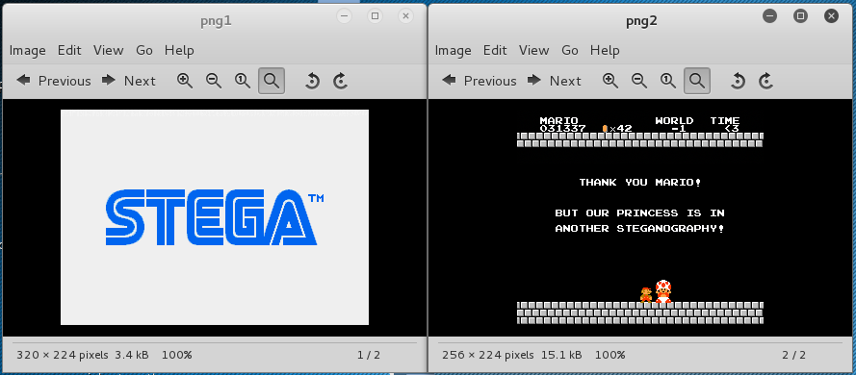
outfile.close()

We now have two images to work with, and a pretty obvious hint as to how to crack them. Admittedly I don't have much experience in writing programs to solve steganography challenges, and so with not much finesse, I turned to the StegSolve application, and basically tried random bit planes until I got a hit.
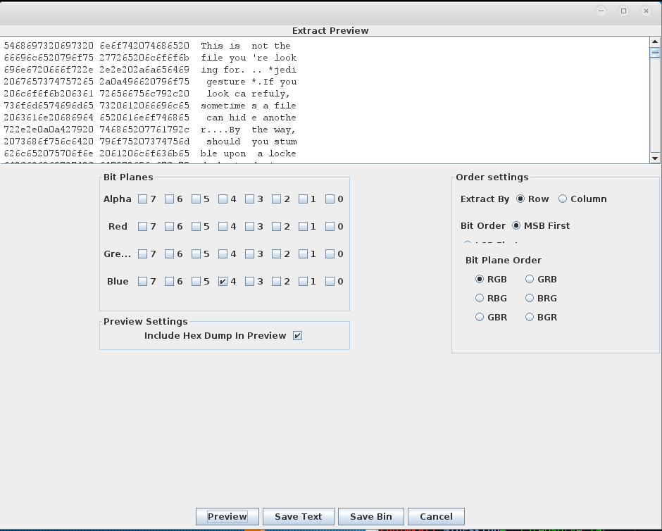

This was the first hint to be uncovered. It tells me that I should find a "locked chest", to which the ciphered key is BQRAIHUJBVWSF, and that key can be deciphered using the magic number 1337.

I then moved on to the second png file. I don't know if this is correct or not, but for some reason the time in the picture "< 3" made me think that I should try bit planes smaller than 3, either way it worked and I found a hidden zip file.
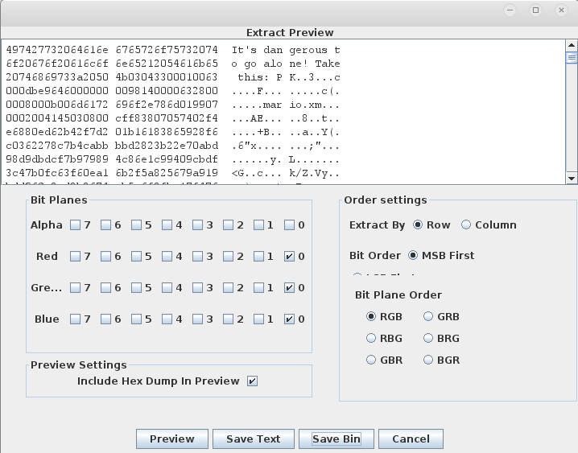

A similar problem came about with the png files, so I wrote another script that carved it out of the binary.
data = open("extracted_zip", "r").read()
out = open("cleaned_zip", "wb")
index = 0
for i in range(len(data)):
#\x50 marks the start of a zip file
if(data[i] == "\x50"):
index = i
break

for i in range(index, len(data)):
out.write(data[i])

out.close()
And finally, I had my zip file.

Stage 3: Unlocking the zip and saving the princess!
This stage took me a little longer than I would have liked. The key to the hint is the use of the word "uncipher", which made me look at classical ciphers such as caeser and viginere. Eventually I decided to google "cipher uses numeric key", and found the gronsfeld cipher uses a numeric key.

I then used the following website to decipher the key: http://www.geocachingtoolbox.com/index.php?page=gronsfeldCipher.
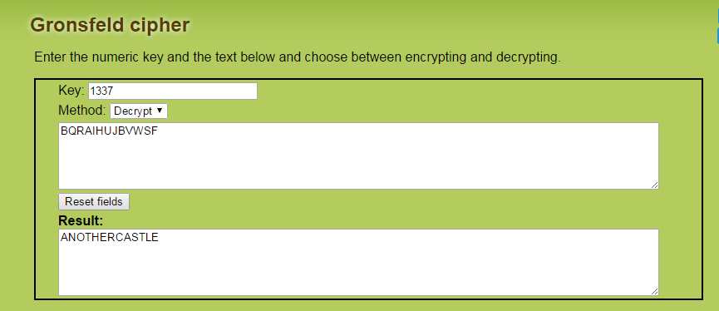
That looked pretty promising, and indeed was the password required to extract an audio file from the zip.

I decided to play the audio file and see if I could spot anything, it sounded a bit sped up, but nothing out of the ordinary. Without expecting too much, I figured it couldn't hurt to inspect the hex dump of the audio file, which showed me it contained ascii strings. Using xxd:
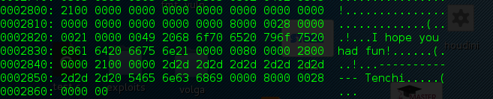

Instead of searching all of the hex, I then used strings to find all of the ascii strings hidden in the audio:
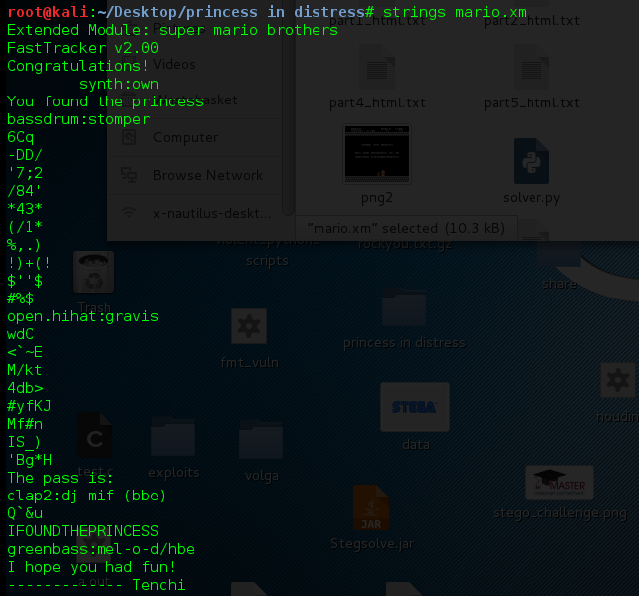

And finally, it looks like we have saved the princess, the password (flag) being IFOUNDTHEPRINCESS.

