----------------------------------------------------------------- PERSONAL DATA -------------------------------------------------------------

|  |  |
| --- | --- |
| **Name:** | Vitaly Nichiporenko |
| **Date of Birth:** | 10/08/1988 |
| **Loction:** | Belarus, Gomel (mobile) |
| **Mobile:** | +375 (44) 717-59-82 |
| **E-mail:** | nichiporenko.vitaly@gmail.com |
| **Skype:** | Vitaly N |
| **LinkedIn:** | [**www.linkedin.com/in/vitalynichiporenko**](http://www.linkedin.com/in/vitalynichiporenko) |

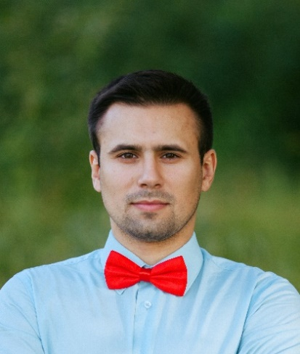

--------------------------------------------------------------------- OBJECTIVE ------------------------------------------------------------------

**Desired Position:** Software Engineer

------------------------------------------------------- SUMMARY OF QUALIFICATION ----------------------------------------------------

I have been working with information technology since 2011.

My current stack of technologies is:SystemAdmin, SQL, Oracle DBA, C#.

I am engaged in complex information protection and audit of computer information systems.

--------------------------------------------------------------- TECHNICAL SKILLS ------------------------------------------------------------

* SQL, Oracle 9i, 10G, 11G
* Basic knowledge of C#, PHP, Java
* Basic knowledge of HTML, CSS
* GitHub, Visual Studio, Git Bash
* Experience in developing sites WordPress & OpenCard, writing plugins
* Basic knowledge BPMN, UML

----------------------------------------------------------- RELEVANT EXPERIENCE --------------------------------------------------------

* Team management
* Projects and features development

------------------------------------------------------------------- LANGUAGES ------------------------------------------------------------------

* English – Elementary
* Russian – Native Speaker

------------------------------------------------------------------- EDUCATION -------------------------------------------------------------------

* 2006-2011 / Francisk Skarina Gomel State Universities / [Physics, teacher of physics and Informatics](https://www.linkedin.com/school/10761/?legacySchoolId=10761) / diploma / Gomel, Belarus
* 2014 / Institute of advanced training and retraining in the field of Informatization and management technologies BSU / Comprehensive information protection / certificate / Minsk, Belarus
* 2016-2018 / IBA Institute of IT & Business Administration / Experts in Information Technology Software design / Programmer / diploma / Minsk, Belarus

----------------------------------------------------------------------- ABOUT ME -----------------------------------------------------------------

|  |
| --- |
| I prefer a healthy lifestyle, free from bad habits, I like cycling, jogging and active fishing for spinning.  In my free time I do self-development. At the moment, I am taking an online BigData course "Hadoop. System for processing large amounts of data."  I have an analytical mindset, I am able to rationally organize my working day, I have managerial skills. My strong point is the ability to find innovative solutions, to be optimistic about problems that are absolutely not confusing, and even motivate to action.  I have experience teaching other people.  I have experience in public speaking from 3 to 50 listeners.  Driver's license category A1, A, B, driving experience 5 years. |

----------------------------------------------------------- PROFESSIOANL EXPERIENCE -------------------------------------------------

**Ministry of Internal Affairs**

|  |  |
| --- | --- |
| **Senior software engineer** department of operation of automated systems,  Gomel  2015/02 | Organization of a team of 5 people, maintenance of computer networks, administration, installation, configuration of servers Windows 2003/2008 / 2012, Linux (DB Oracle, AD, FTP, VMWARE, Active Directory, DNS, DHCP), full technical support for users (150 PC), setting up video surveillance systems, administering Oracle 9i, 10G, 11G databases, writing SQL scripts for reports and analyzed data, developing stored procedures, triggers, improving existing functionality, developing an internal web resource, writing technical documentation, providing technical Information security, audit of computer information systems. |
| **Head**  of technical department,  Minsk  2012/10 – 2015/02 | Planning and organization of the team’s work, administration of Windows 2003/2008 / 2012 servers, 1C server, Kerio Control, website development, full support and development of IT infrastructure, writing technical documentation, drawing up technical specifications, installation, configuration and programming of internal PBX, conducting trainings on staff training in modern IT technologies, ensuring technical protection of information, audit of computer information systems. |
| **Senior engineer**  technical department  (system administrator),  Minsk  2011/08 - 2012/10 | IT infrastructure support, server administration, user support for about 100 workstations, website administration, Windows 2003/2008 / 2012 server administration, technical information protection, audit of computer information systems. |