Record of change

*A - Added M - Modified D - Deleted

|  |  |  |  |  |
| --- | --- | --- | --- | --- |
| Effective Date | Changed Items | A* M, D | Change Description | New Version |
| 16/5 | Create new | A |  | V1.0 |
|  |  |  |  |  |
|  |  |  |  |  |
|  |  |  |  |  |
|  |  |  |  |  |
|  |  |  |  |  |
|  |  |  |  |  |
|  |  |  |  |  |
|  |  |  |  |  |
|  |  |  |  |  |
|  |  |  |  |  |
|  |  |  |  |  |
|  |  |  |  |  |
|  |  |  |  |  |
|  |  |  |  |  |
|  |  |  |  |  |
|  |  |  |  |  |
|  |  |  |  |  |
|  |  |  |  |  |
|  |  |  |  |  |
|  |  |  |  |  |

TABLE OF CONTENTS

1.problem definition 4

**1.1 Name of this Capstone Project...…………………………………………………..4**

**1.2 Problem Abstract...……………………………………………………………………..4**

**1.3 Project Overview**……………………….…………………………………………………………………………..4

1.3.1 The Current System…………………………………………………..………………………………….4

1.3.2 The Proposed System…………………………………………………………………………………...4

1.3.3 Boundaries of the System……………………………………………………………………………..4

1.3.4 Development Environment…………………………………………………………………………….4

2.Project organization 4

2.1 Software Process Model…………………………………………………….………………………………4

2.2 Roles and Responsibilities…………………………………………………………….…………………..4

2.3 Tools and Techniques………………………………………………………………………………..………4

3.Project management plan 4

3.1 Tasks 4

3.2 Task Sheet 7

3.3 All Meeting Minutes 7

4.Coding convention 7

|  |
| --- |
|  |

II> Report No.2: Software Project Management Plan (SPMP)

# 1 - Problem Definition

## Name of this Capstone Project

This Capstone Project’s name is E-learning.

## 1.2. Problem Abstract

Nowadays online services are developing quickly in Viet Nam; one of them is online studying. It has been common in development countries, there are many famous schools and training centers used this service. For example, granting Java’s certificates to trainees by Oracle, grating Animation Mentor to trainees by Animation Mentor School… Trying to imagining in the next few years, form of online studying and taking an exam will become commonly, changing form of normal studying as going to school, training centers, and students can sit in front of a computer which connects to internet and study like sitting in class. The tool will provide lectures as video or text, after each of period, students which participate at the period will be provided exercises concern to the period content. The benefit of the form bring out: lectures which they registered will be saved in their account, they can watch again many time if having one problem isn’t clear yet. They can send mail with teacher which taught the period to have better support. Moreover, we create favorable conditions for students can take an online exam on our website .We will make a forum is creative and self-motivated to help members are able to exchange information and learn in groups effectively. The website will emphasize on bring comfortable and user-friendly, users will familiarize fast when first time accessing the website, simple and elegance in design but effective in functions. We want to guide Vietnamese to use internet such as a tool which serves effectively their study, making an individual environment to practice and really self-motivated.

## 1.3. Project Overview

**1.3.1. The Existing System**

Most of existing systems are concentrating on paying fees users. Below are the existing methods that these websites about studying online:

- Collecting data:

Nowadays, most of websites focus on studying and preparing for a university entrance examination’s objects. These websites collect data under 2 ways:

+ Collecting information about theories and exercises of subjects on internet. They usually concentrate at learning forums.

+ Working with large organizations, training centers to create courses. Since then, members can register to learn.

+ Working with illustrious teachers: They will make lectures as video and provide exercises concern.

- Online Course:

Most of courses are video. Members must purchase to watch the courses. These courses are divided into theories.

- Preparing exam:

Most of them are preparing for a university entrance examination. They are divided into many courses, each of course talk about a part of knowledge in exam question. After a course finished, students will be provided forms of exercises concern the learning.

- Exercises Library:

Using data which is collected by many sources: schoolbook, learning forums, teachers,… They are saved by .pdf files. Students can download and do on their computer.

Below are the limitations of the existing systems:

- Data: exercises Libraries are old, content of lectures aren’t visual, most of lectures are video, they don’t update frequently.

- Forums: the operations aren’t effective, don’t be cared yet, there are a few members.

**1.3.2. The Proposed System**

The website will include to 8 sites:

|  |  |
| --- | --- |
| **Priority** | **Site** |
| 1 | Home page “Trang chủ” |
| 2 | Theories “Lý thuyết” |
| 3 | Exercise “Thư viện bài tập” |
| 4 | Self-study exams “Đề tự luyện” |
| 5 | Forum “Diễn đàn” |
| 6 | Member “Thành viên” |
| 7 | News “Tin tức” |
| 8 | Exam online “Thi trực tuyến” |

* **Home page “Trang chủ”**

This site has main functions: login, link to other sites, show some main information: hot topics, subject and news during the day…

The page will include some components: logo, banner and slogan, menu bar, hot topics (it shows some outstanding news which we choose according to each of day), news, login form, and search bar. At the front page, we put subjects’ module which is divided by grade or by topics, and news about education, training, and examinations… Some functions will be added to the page after finishing Capstone Project, such as ranking schools, mark of university’s exam…

Menu bar include links to other sites. They are common sites of the website:

* Home page “Trang chủ”
* News “Tin tức”
* Theories “Lý thuyết”
* Exercise “Thư viện bài tập”
* Self-study exams “Đề tự luyện”
* Exam online “Thi trực tuyến”
* Forum “Diễn đàn”
* Member “Thành viên”

* **Theories “Lý thuyết”**

The site has main function: show theories and knowledge of subjects and refer exercises.

This site provides theories of subject with two kinds: grade and topic. They are particular features:

* Grade theory:
  + When a student chooses this, he can learn basic theories depend on which grade he is in.
  + Grade theory is developed to focus on supporting students who want to learn new knowledge.
* Topic theory:
* When a student chooses this, he can learn collective theories about concrete topic.
* Topic theory is developed to focus on supporting students who want to take university exams.
* **Exercise “Thư viện bài tập”**

The site has two main functions:

+ Showing exercises from databases. Students can do multiple choice exercises as the system provide by ticking answers.

+ Students can choose level of exercises (from simple to difficult) and estimate level of an exercise.

The site provides many kinds of exercises, questions and answers for students. Exercises can be divided by grades, subjects or students can do collective knowledge exercise here. It’s different from theories site in which, students just can do basic and simple exercises.

* **Self-study exams “Đề tự luyện”**

The site allows student choose exam’s attributes, show exam’s questions and time, count down and finish exam when user agree to finish or time up, show mark after user finish the exam.

The site provides many kinds of exams for students. To do an exam, students can choose exam from library of the system. There is a built examination library that includes many exams of many subjects. Students can choose one of them to self-study. An exam has some important attributes: time, number of question, level of questions.

* **Forum “Diễn đàn”**

This site is a place which members can share experience, discuss, exchange some problems need care. It provides helpful information for members. We will create an environment which is creative and self-motivated for students.

* **Member “Thành viên”**

This site helps a student manage individual information: e-mail, name, age, marks, birthday…

* **News “Tin tức”**

This site includes some news about education: Information of schools, Information of entrance exam, university ranking… News will be updated during the day.

* **Exam online “Thi trực tuyến”**

At certain hours, we will create some exams about subjects and add authority to members which are appropriate to do.

Functions of this site are different from self-study exams. In this site, administrators or people with authority can give special exams. These exams are informed before about start time, end time, number of questions. And when an exam is started, students can take the exam in beginning 15 minutes and like self-study exam. After exam finishes, mark of examinees will be sent to each student and some of them can take the next one (round 2, 3, 4…) if they have good mark. Exam can also be taken by group of users.

**1.3.3. Boundaries of the System**

*<List the scope/boundaries of the system under development. This can be paraphrased from the Customer’s Requirements>*

**1.3.4. Development Environment**

1.3.4.1 Software environment

* Operating system: Windows XP/Windows 7
* WAMP server
* Apache Tomcat version 2.2.21
* PHP version 5.3.10
* MySQL version 5.5.20
* Open source Frameworks

1.3.4.2 Hardware environment

Required (minimum) Specs

+ CPU: Intel Pentium(R) 4 2.4 GHz or better supported

+ RAM: 512MB

+ Hard Drive: 2GB or free space

Recommended Specs

+ CPU: Dual core 2.4GBz or better supported

+ RAM: 1GB for Windows XP, 2GB for Windows 7

+ Hard Drive: 2GB of free space

# 2 - Project organization

## 2.1. Software Process Model

In the Capstone Project, we choose Iterative Model because an iterative lifecycle model does not attempt to start with a full specification of requirements. Instead, development begins by specifying and implementing just part of the software, which can then be reviewed in order to identify further requirements. This process is then repeated, producing a new version of the software for each cycle of the model. Consider an iterative lifecycle model which consists of repeating the following four phases in sequence:

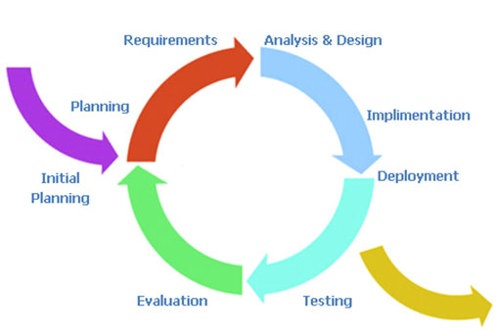

Figure 1: iterative model [1]

- A ***Requirements*** phase, in which the requirements for the software are gathered and analyzed. Iteration should eventually result in a requirements phase that produces a complete and final specification of requirements.

- A ***Design*** phase, in which a software solution to meet the requirements is designed. This may be a new design, or an extension of an earlier design.  
- An ***Implementation and Test*** phase, when the software is coded, integrated and tested.  
- A ***Review*** phase, in which the software is evaluated, the current requirements are reviewed, and changes and additions to requirements proposed.  
For each cycle of the model, a decision has to be made as to whether the software produced by the cycle will be discarded, or kept as a starting point for the next cycle (sometimes referred to as incremental prototyping). Eventually a point will be reached

[1] <http://www.arctern.com/uploadedimages/iterative-model.jpg>

where the requirements are complete and the software can be delivered, or it becomes impossible to enhance the software as required, and a fresh start has to be made.  
The iterative lifecycle model can be likened to producing software by successive approximation. Drawing an analogy with mathematical methods that use successive approximation to arrive at a final solution, the benefit of such methods depends on how rapidly they converge on a solution.

## 2.2. Roles and Responsibilities

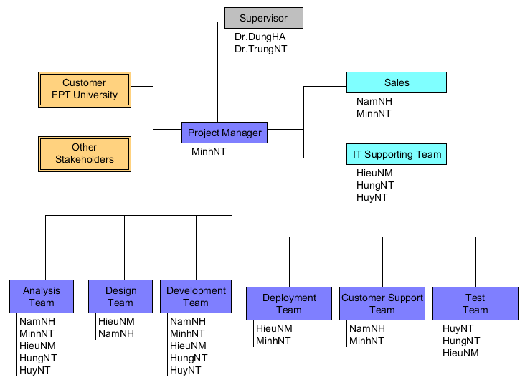

Figure 2: Project organization in “E-Learning” project

|  |  |
| --- | --- |
| Title | Roles |
| Project Manager | Responsible for developing, in conjunction with the Project Sponsor, a definition of the project. The Project Manager then ensures that the project is delivered on time, to budget and to the required quality standard (within agreed specifications). He/she ensures the project is effectively resourced and manages relationships with a wide range of groups (including all project contributors).  The Project Manager is also responsible for managing the work of consultants, allocating and utilizing resources in an efficient manner and maintaining a co-operative, motivated and successful team. |
| Responsibilities | |
| * Managing and leading the project team. * Recruiting project staff and consultants. * Managing co-ordination of the partners and working groups engaged in project work. * Developing and maintaining a detailed project plan. * Managing project deliverables in line with the project plan. * Recording and managing project issues and escalating where necessary. * Resolving cross-functional issues at project level. * Managing project scope and change control and escalating issues where necessary. * Monitoring project progress and performance. * Providing status reports to the Project Sponsor. * Managing project training within the defined budget. * Liaison with, and updates on progress to, Project Steering Board/Senior Management. * Managing project evaluation and dissemination activities. * Managing consultancy input within the defined budget. * Final approval of the design specification. * Working closely with users to ensure the project meets business needs. * Definition and management of the User Acceptance Testing programme. * Identifying user training needs and devising and managing user training programmes. | |

|  |  |
| --- | --- |
| Title | Roles |
| Supervisor | The person who commissions others to deliver the project and champions the cause throughout the project. They will normally be a senior member of staff with a relevant area of responsibility that will be affected by the outcome of the project. They are involved from the start of the project, including defining the project in conjunction with the Project Manager. Once the project has been launched they should ensure that it is actively reviewed. |
| Responsibilities | |
| * Acts as champion of the project. * Is accountable for the delivery of planned benefits associated with the project. * Ensures resolution of issues escalated by the Project Manager or the Project Board. * Sponsors the communications programme; communicates the programme’s goals to the organization as a whole. * Makes key organization/commercial decisions for the project. * Assures availability of essential project resources. * Approves the budget and decides tolerances. * Leads the Project Steering Board. * Ultimate authority and responsibility for the project. | |

|  |  |
| --- | --- |
| Title | Roles |
| Project Team Member | The staff who actively work on the project, at some stage, during the lifetime of the project. This could be further broken down into specific roles as required – such as Project Administrator, etc. |
| Responsibilities | |
| Team member roles will vary depending on the type of project. Typically they might be to:   * Provide functional expertise in an administrative process. * Work with users to ensure the project meets business needs. * Documentation and analysis of current and future processes/systems. * Identification and mapping of information needs. * Defining requirements for reporting and interfacing. * User training. | |

|  |  |
| --- | --- |
| Title | Roles |
| Customer | These are the people who will actually use the deliverables of the project. These people are also involved heavily in the project in activities such as defining business requirements. In other cases, they may not get involved until the testing process. Sometimes you want to specifically identify the user organization or the specific users of the solution and assign a formal set of responsibilities to them, like developing use cases or user scenarios based on the needs of the business requirements. |

|  |  |
| --- | --- |
| Title | Roles |
| Designer | The Designer is responsible for understanding the business requirements and designing a solution that will meet the business needs. There are many potential solutions that will meet the client's needs. The Designer determines the best approach. A Designer typically needs to understand how technology can be used to create this optimum solution for the client. The  Designer determines the overall model and framework for the solution, down to the level of designing screens, reports, programs and other components. He or she also determines the data needs. The work of the Designer is then handed off to the programmers and other people who will construct the solution based on the design specifications. |
| Responsibilities | |
| Typically Designer roles might be to:   * Have a basic understanding of technology in order to know what is or is not possible given certain technology realities. * Quickly and accurately recognize performance/knowledge gaps. * Creativity tempered with an understanding of the intended audience, client culture, and learning preferences. * Understanding of human computer factors and interface design. * Ability and willingness to a adapt to a dynamic set of standards and tools. | |

|  |  |
| --- | --- |
| Title | Roles |
| Analysis | The Analyst is responsible for ensuring that the requirements of the business clients are captured and documented correctly before a solution is developed and implemented.  In some companies, this person might be called a Business Analyst, Business Systems Analyst, Systems Analyst or Requirements Analyst. |
| Responsibilities | |
| * Analyzing and understanding the current state processes to ensure that the context and implications of change are understood by the clients and the project team * Developing an understanding of how present and future business needs will impact the solution * Identifying the sources of requirements and understanding how roles help determine the relative validity of requirements * Developing a Requirements Management Plan and disseminating the Plan to all stakeholders * Identifying and documenting all business, technical, product and process requirements * Working with the client to prioritize and rationalize the requirements * Helping to define acceptance criteria for completion of the solution | |

|  |  |
| --- | --- |
| Title | Roles |
| Tester | The Tester role is responsible for the core activities of the test effort, which involves conducting the necessary tests and logging the outcomes of that testing. |
| Responsibilities | |
| * Identifying the most appropriate implementation approach for a given test * Implementing individual tests * Setting up and executing the tests * Logging outcomes and verifying test execution * Analyzing and recovering from execution errors | |

## 2.3. Tools and Techniques

- App Server: WAMP server v2.2

- UML Tools: StarUML and Umlet

- IDE: Dreamwaver 8.0

- Design tool: Photoshop CS5

- Microsoft Word 2007

- Microsoft Project 2007

# 3 - Project management plan

## 3.1. Tasks:

3.1.1 Task-1: Planning

* Description:

Planning to manage the project include human, designing and confirming the project goals and objectives, identifying tasks and how goals will be achieved, quantifying the resources needed and determining budgets and timelines for completion. It also includes managing the implementation of the project plan.

* Deliverables:

Software Project Management Plan (SPMP)

* Resources Needed:

MinhNT

3.1.2 Task-2: System Design

* Description:

Design functional and non-functional requirement in the top-level diagram.

* Deliverables:
* Software Requirement Specification (SRS)
* Resources Needed:

- NamNH

- MinhNT

- HieuNM

3.1.3 Task-3: Detailed System Design

* Description:

Design detailed architecture of system, component design, diagrams…

* Deliverables:

Software Design Description (SDD)

* Resources Needed:

- NamNH

- MinhNT

- HieuNM

- HuyNT

- HungNT

* Dependencies and Constraints: SRS
* Risks

3.1.4 Task-4: Code

* Description:

Using Joomla framework to build the website, creating some of new modules about: exam online and exercises library…

* Deliverables: source code, fully implemented system.
* Resources Needed: NamNH, HieuNM, HuyNT, HungNT
* Dependencies and Constraints:

SRS, System Design

* Risks: time

3.1.5 Task-5: Test Plan

* Description:

Create test plan for the system including Test Design

* Deliverables:

Software Test Document

* Resources Needed:

MinhNT

* Dependencies and Constraints:

SRS, implemented system

* Risks:

3.1.6 Task-6: System Testing

* Description:

Executing test following the test design document and preparing test report

* Deliverables:

Software Testing Report

* Resources Needed:

MinhNT

3.1.7 Task-7: Deliver Software

* Description:

After fixing all the defects, beautiful source code, Project Manager need build a full package to deliver

* Deliverables:

Software’s package and user’s guideline.

* Resources Needed:

MinhNT

NamNH

HieuNM

## 3.2. Task Sheet: Assignments and Timetable

Assignments and Timetable is described as the following:

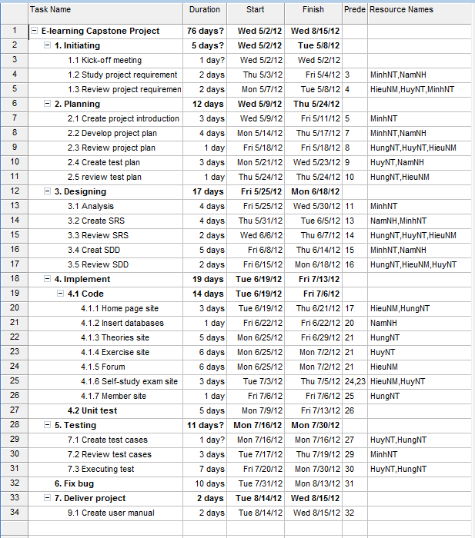

## 3.3. All Meeting Minutes

Each week, we always have a meeting about 2h on Thursday to track rate of progress and to discuss any new issues. All problems will be discussed as brainstorming work and we bring out suggestions and comments. After that, we will report the next works and deadline.

Table 3.3: Meeting minutes May 2, 2012

|  |  |  |  |
| --- | --- | --- | --- |
| Name of Organization: Unicorn Team  Purpose of Meeting: Kick-off project and choose team leader for project  Data/Time: Wednesday May 2, 2012  Location: FPT University | | | |
| **Topic** | **Discussion** | **Action** | **Person Responsible** |
| Kick-off project | Discuss content of project and learn about capstone project | - Background of project  - Discuss project organizational structure  - Discuss of project scope, time and list of action items from meeting | All team members (MinhNT, NamNH, HuyNT, HungNT, HieuNM) |
| Team leader | Choose team leader for project | MinhNT is the leader of project | All team members |
| Team name | Create team name | “Unicorn” is the name of team | All team members |

|  |  |  |  |
| --- | --- | --- | --- |
| Name of Organization: Unicorn Team  Purpose of Meeting: divide works, define roles and responsibilities for team, choose tools and techniques for developing on, and configure environment.  Data/Time: Saturday May 19, 2012  Location: FPT University | | | |
| **Topic** | **Discussion** | **Action** | **Person Responsible** |
| Divide works | Divide works for each of member: | - MinhNT :analyze system and write documents.  - NamNH: create and design template of website. Design and insert database.  - HieuNM, HungNT, HuyNT: code modules and extensions of website. | All team members |
| Define roles and responsibilities for team | - Leader  - Developer  - Designer | All members of project will have specific roles in each phase of development process. | All team members |
| Tools and techniques | Choose tools and techniques:  - PHP, MySQL  - WAMP server  - Joomla framework  - Phpbb or Vbullettin | The tools and techniques choosed:  - PHP, MySQL  - Joomla framework  - Phpbb | All team members |
| Configure environment | Using Windows 7-32 bit, install tools which need for project | - Install WAMP server and Joomla framework  - Install Dreamwaver 8.0 to code. | All team members |

# 4 - Coding Convention