In Cassandra the tables are designed according to the queries.

so we have one table for each query

so basically we model our tables according to our queries.

Partitioning ,Rings and Tokens

Cassandra partitions data based on partition key.

All data with the same partition key will be on the same node in the cluster.

Cassandra hashes the partition key

different partition keys will have different hash values.

Same partition key-same hash value

Partitions the cluster which is like a ring into intervals based on the hash value

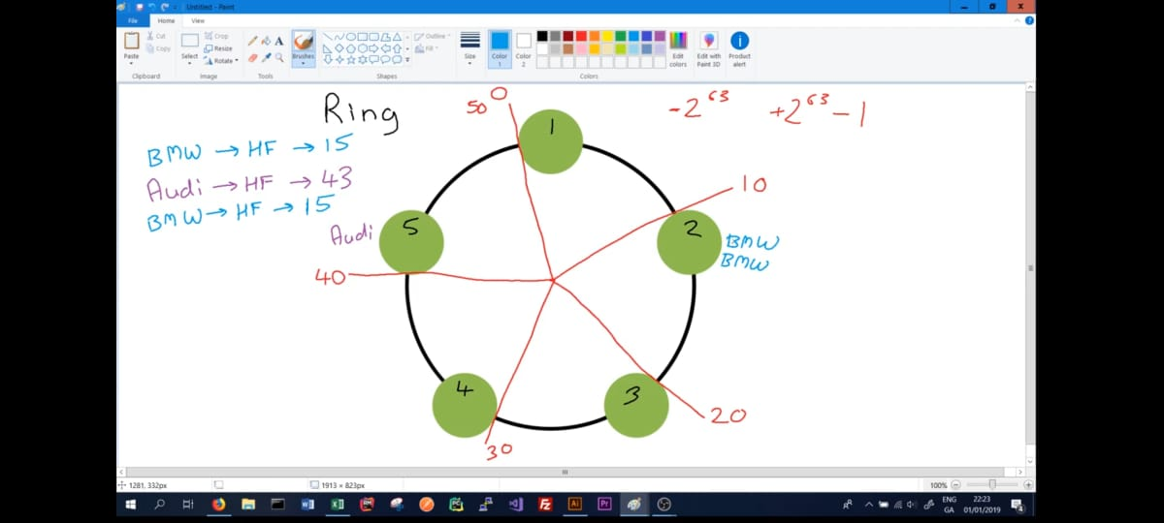

DataCenters

Cassabdra has can be divided based on datacenters

like u can have a EU datacenter and a USA datacenter

Datacenters are further divided into racks

when we assign nodes to datacenters we have to assign it to a certain rack

Replication factor is how many nodes in the keyspace shud the data be stored in

so if one node goes down or is poorly performing we can still get the data easily

CQL consistency levels

Consistency level:any

say RF is 3, as long as it writes to even one of the nodes it will return as a successful write

Consistency level:1 or 2 or 3

if it is 2 when the data is successfully written to 2 of the nodes which is chosen as part of the Replication factor it will return as successful

if it is 3 then we need a response from all 3 nodes

When we are reading data

If consistency is 2:

we will wait till we recieve data from 2 nodes , even if one gives us the data faster-say one data is older cassandra will return the newer data and update the data of the older node

Timestamps in cassandra

we can get the write time also in cassandra

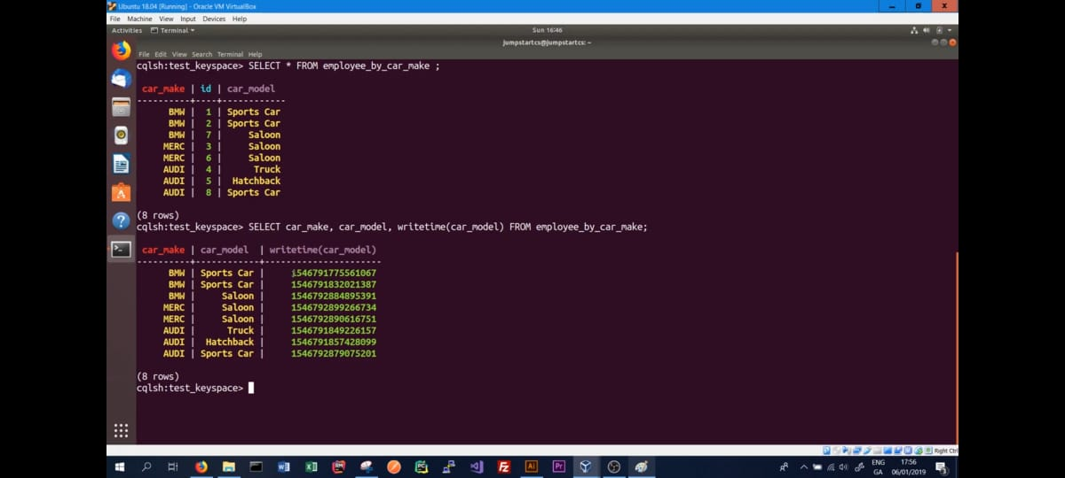

TTL – TIME TO LIVE-IT WILL EXPIRE AFTER THIS MUCH TIME

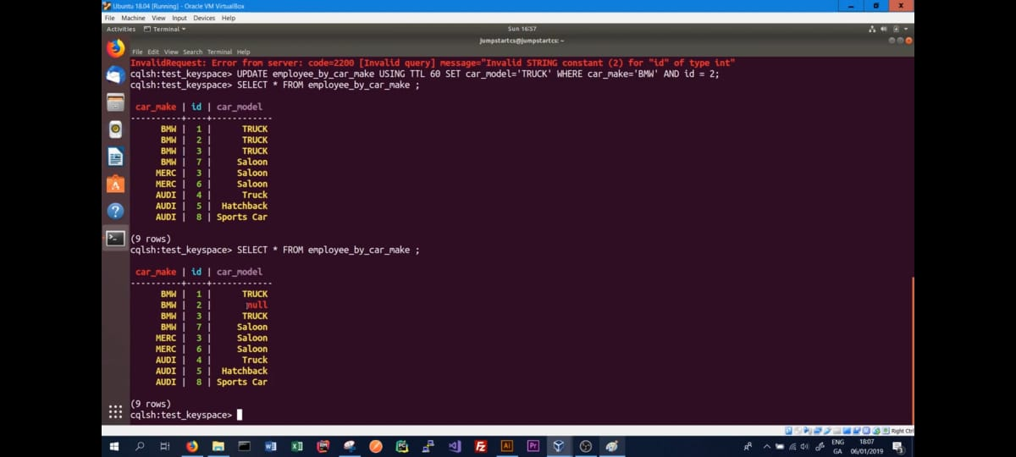  
AFTER THAT CERTAIN AMOUNT OF TIME THE DATA WILL BE SET TO NULL IT WONT GO BACK TO ITS PREVIOUS VALUE

UUID()

TIMEUUID()