STACK AND HEAP IN GO

We have stack memory and heap memory.
there are stacks for every goroutine.
it does not matter where are variables are for the correctness of our program however it does for the performance.
The data stored in the heap is managed by the garbage collector which adds some latency

we shud try to optimize for correctness first and then optimization
stack variables get automically cleaned up like in c++/c
passing pointers and references to things typically stays on the stack

if we return a pointer the returned variable excapes from the heap

When are values constructed on the heap?
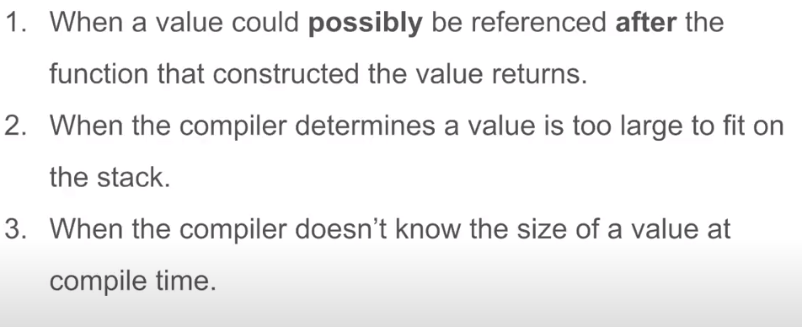
Commonly allocated values on the heap

GO MEMORY LAYOUT

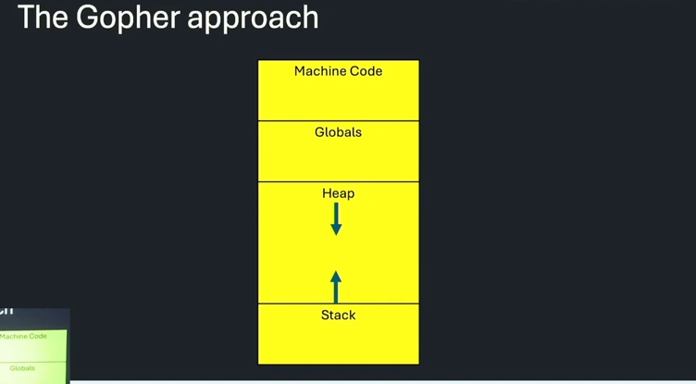
GARBAGE COLLECTION IN GO
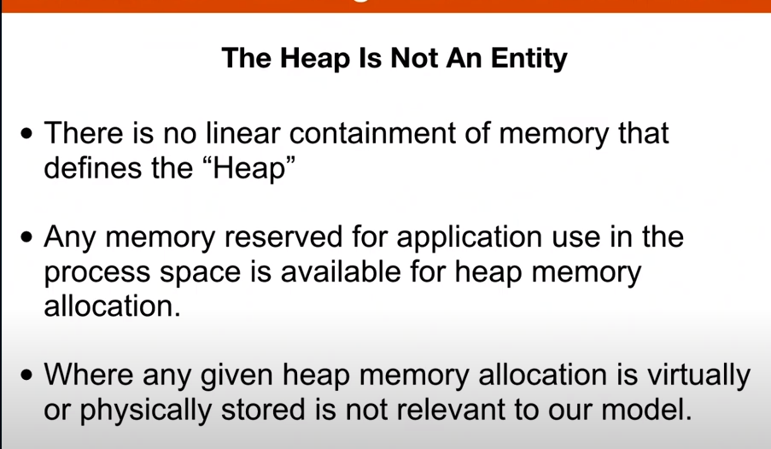
WHAT DOES GARBAGE COLLECTORS DO
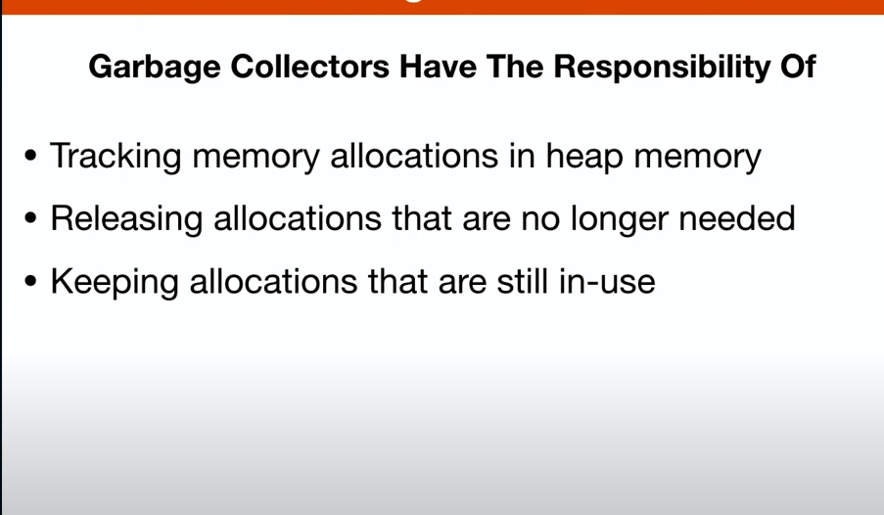
WRITE BARRIERS: HAPPENS WHEN ALL THE GOROUTINES ARE STOPPED AND ALSO STOPS THE SWEEPING ALGORITHM FROM HAPPENING

MARKING PHASE OF GC
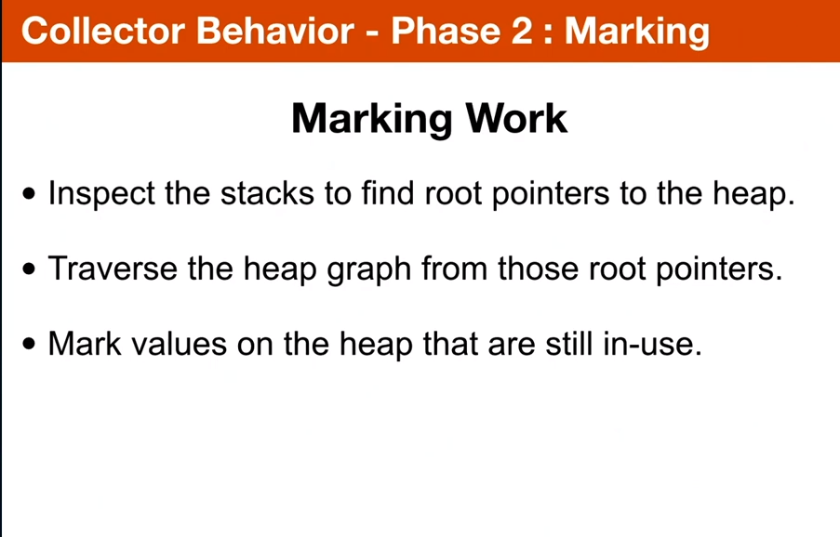
2.
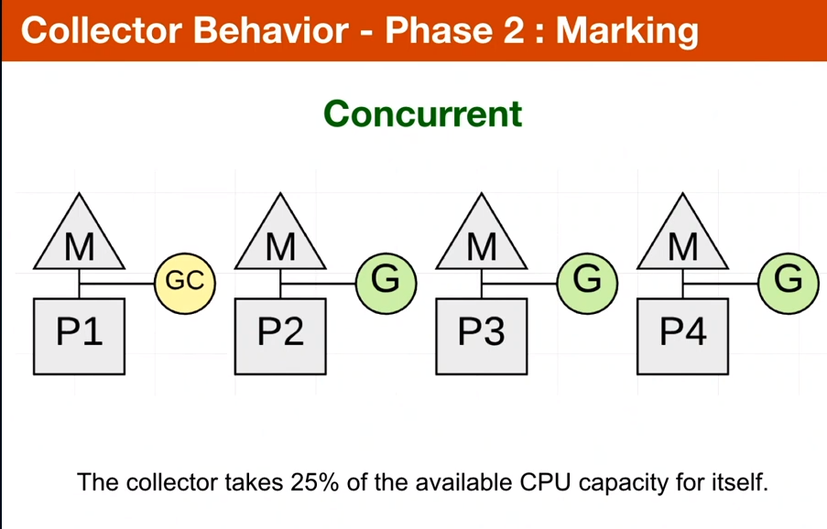

3.

4.
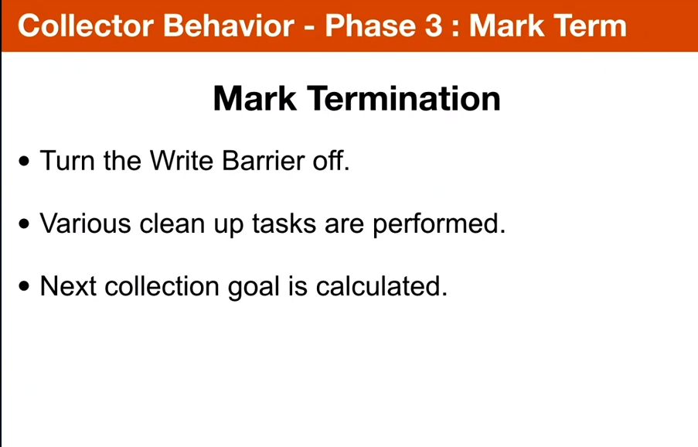
happens in order of microseconds

SWEEPING:happens in the background
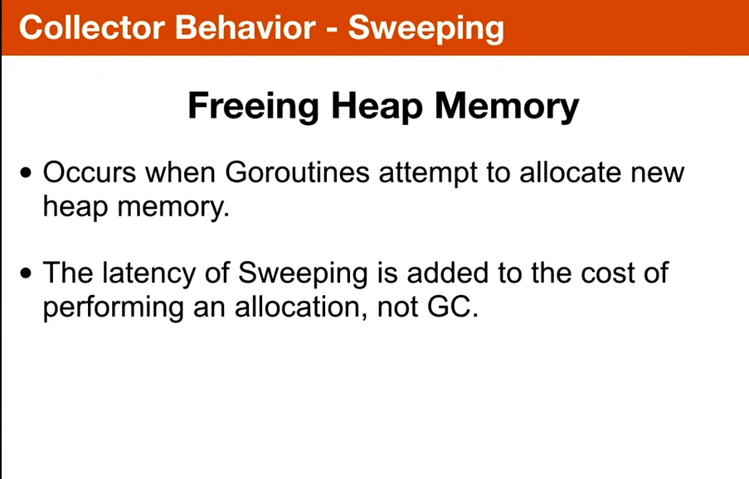
2.
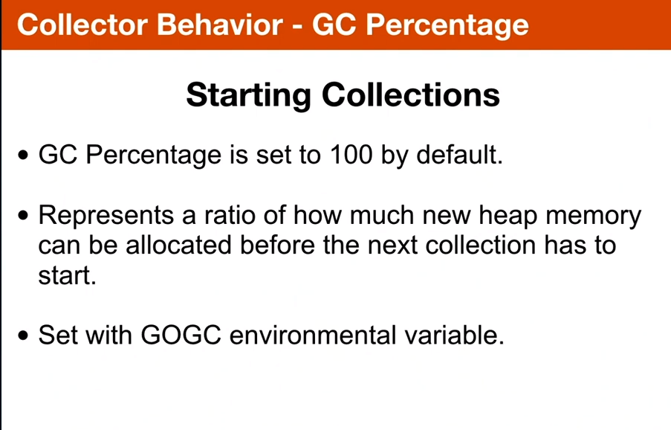

GC TRACE

1.
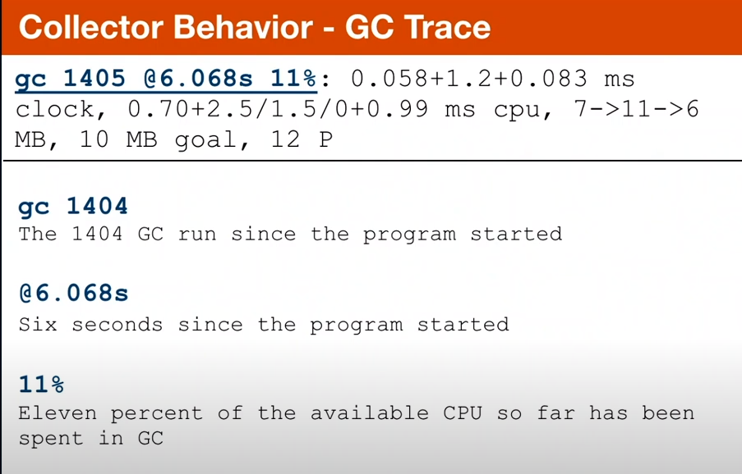
2.
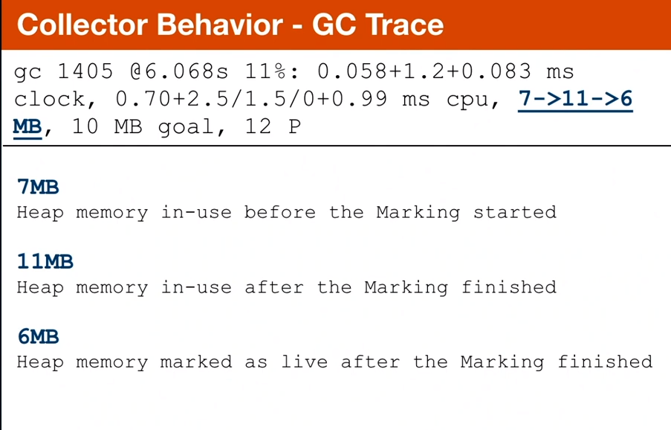
6MB IS SAYING THAT IF WE CONDUCT THE SWEEP RIGHT NOW HOW MUCH MEMORY WILL BE LEFT
3.
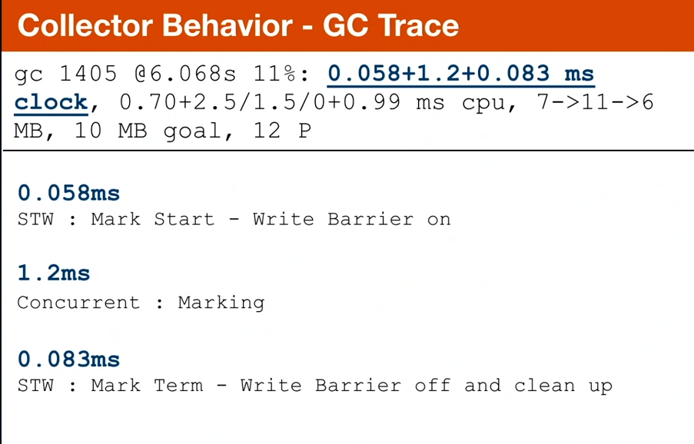
4.
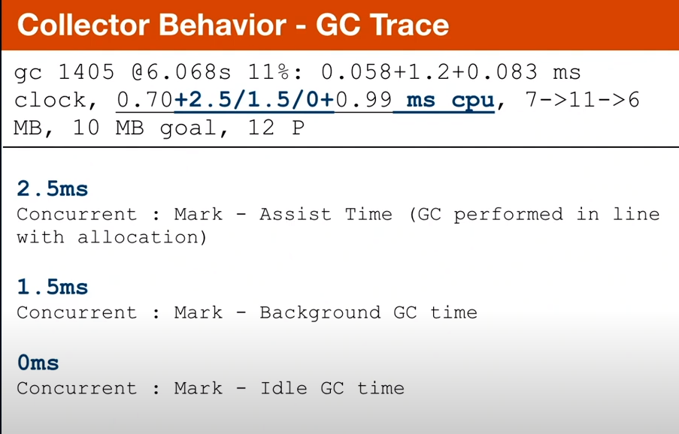

5.
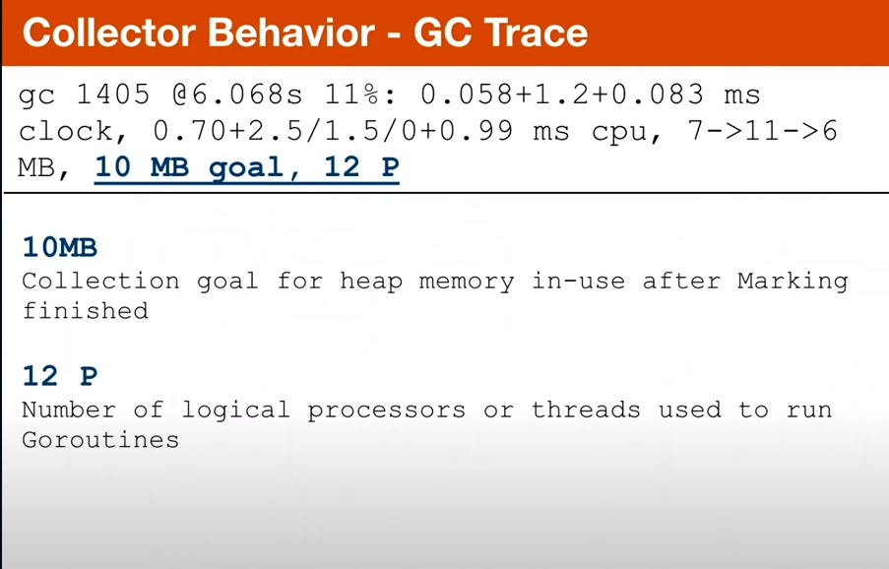

WHEN GARBAGE IS GENERATED
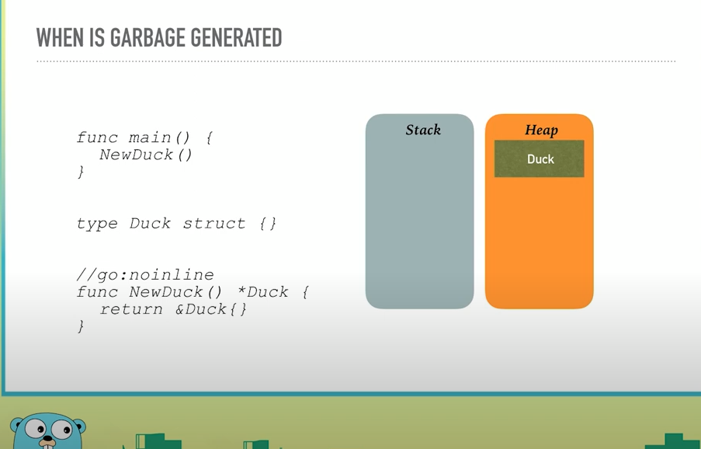

WHEN DO MEMORY LESAKS OCCUR

