GOROUTINES DO NOT RUN ON SEPARATE THREADS

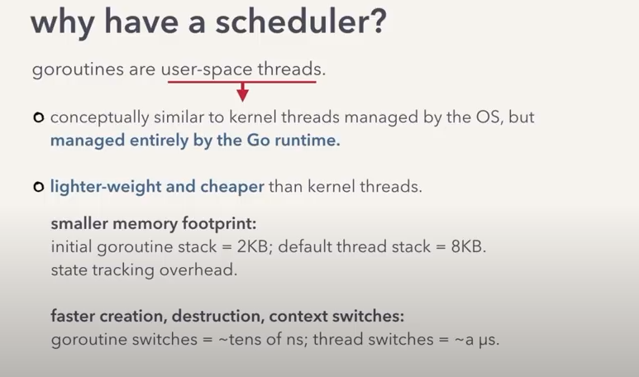
OS ONLY KNOWS HOW TO PUT KERNEL THREADS ON THE HARDWARE.
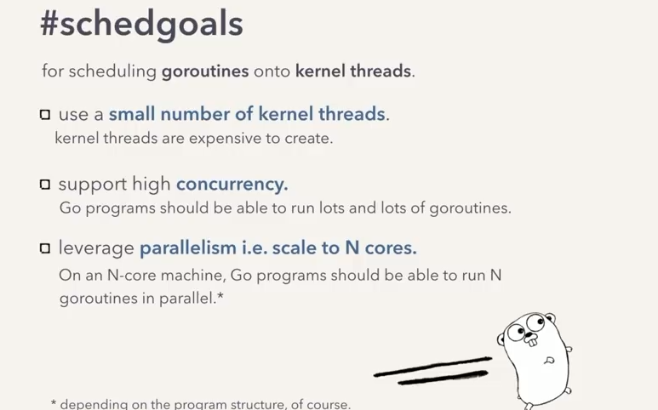
SO HOW WILL WE PUT THE USER THREADS ON THE KERNEL THREADS – USING THE SCHEDULER
GOALS OF THE SCHEDULER

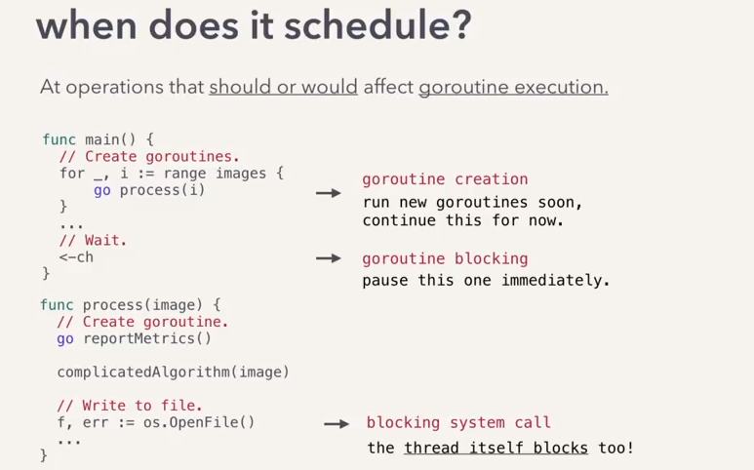
STRUCTURE TO STORE GOROUTINES

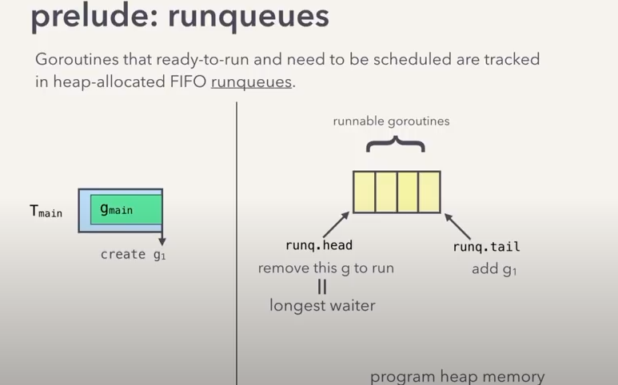
IDEAS TO SUPPORT GOROUTINES

1.BAD IDEA
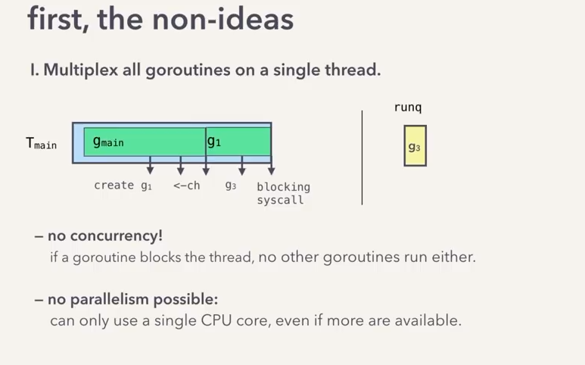
2.BAD IDEA

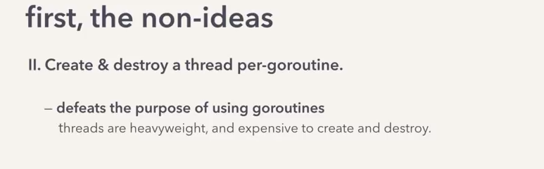
3.
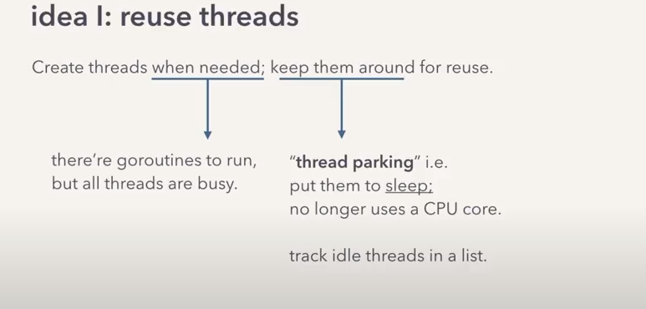
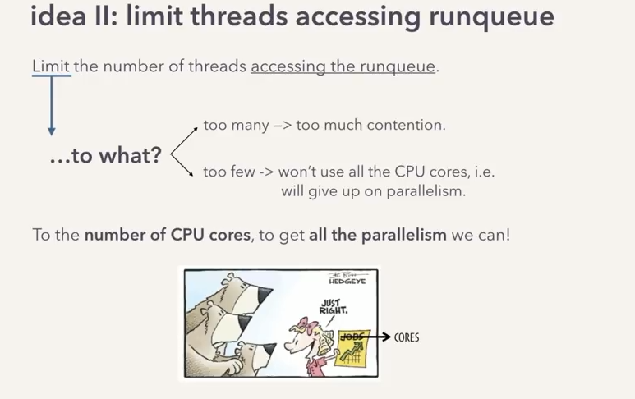
1.

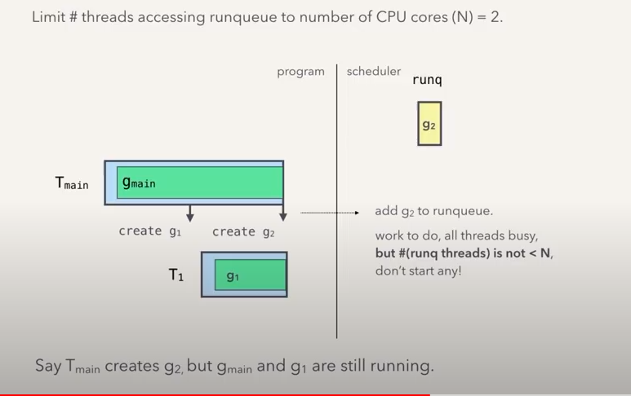
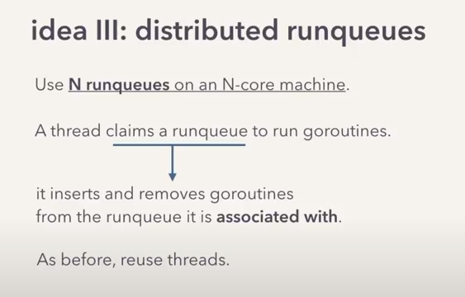
g2 will be run when g1 blocks

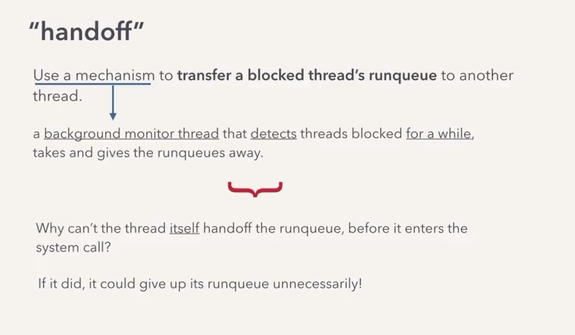
IF A THREAD GETS BLOCKED DUE TO SOME HEAVY OPERATION

RUNNING THREADS ONLY CONTRIBUTE TO THE MAXIMUM AMOUNT OF THREADS

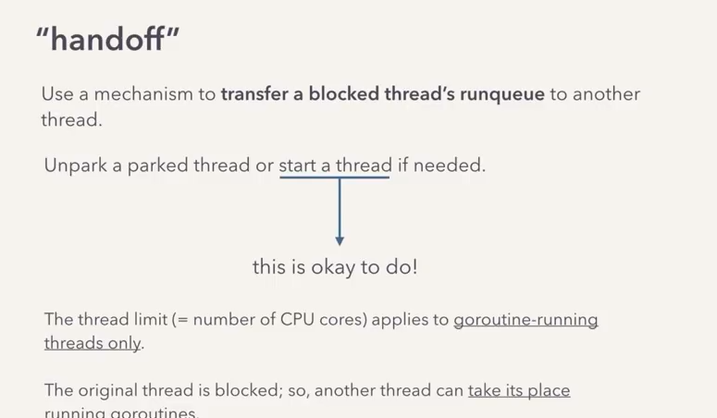
GOSCHEDULER ALSO HAS PRE-EMPTIVE SCHEDULING

1.
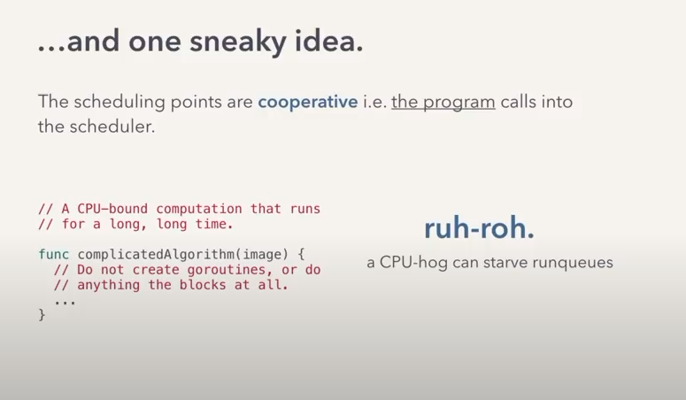

2.
IT RUNS A BACKGROUND THREAD CALLED THE SYSMON
TO DETECT LONG RUNNING GOROUTINES (>10 MS)
AND UNSHCEDULES THEM WHEN POSSIBLE
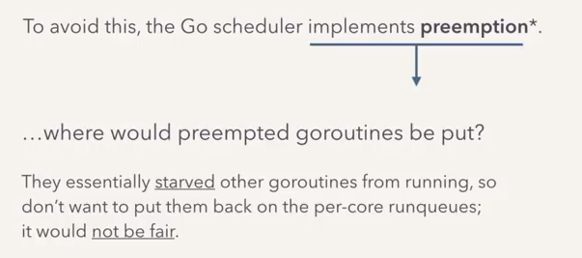
THE GO SCHEDULE PUTS THESE GOROUTINES ON A GLOBAL RUNQUEUE AND THIS RUNQUEUE IS LIKE A LOW PRIORITY RUN QUEUE , WHICH THREADS ACCESS LESS FREQUENTLY THAN THEIR LOCAL RUNQUEUES
