Fantasy Map Assets Lite
(Free Assets Pack, no attributions required)
Watch full tutorial and preview on link below:
https://www.youtube.com/watch?v=1T_TB2nIJ14
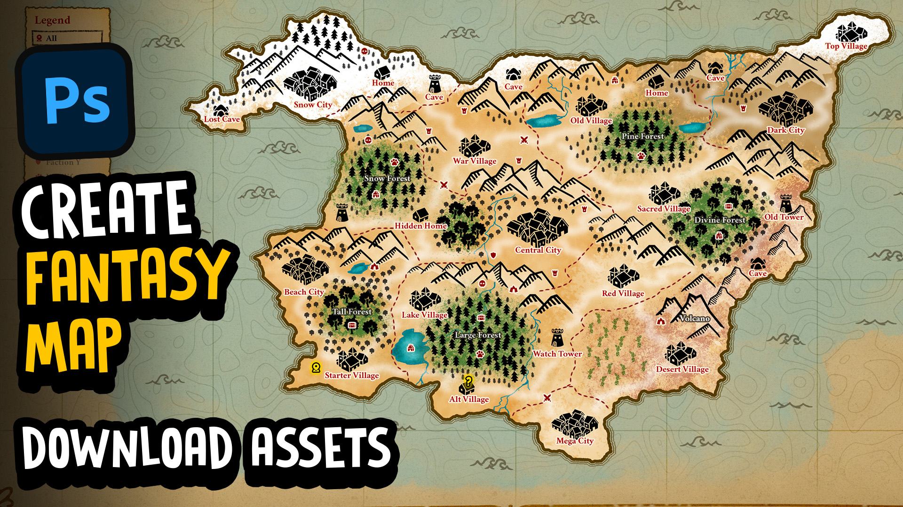

You are free to use the assets and icons as you wish. You can credit us (as Deface Games) with link to our website as defacegames.com if you want to but not required.
In Source PSD the icons and assets are all placed and organized in order of their type and relevance.
To Export any of these assets in full resolution (512x512), you need to Open the PSD in Photoshop and navigate to the smart layer you wish to edit or export, double click it to open it in new tab, there you can manually export it as png in full resolution.

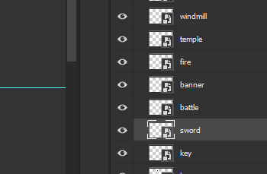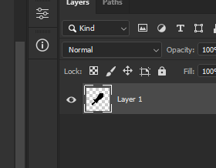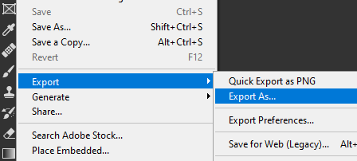

This asset pack is personally crafted to create maps for fantasy game projects (check demo image and video). You are going to need photoshop to create maps (it can be done in any image editor or unity itself but Photoshop is recommended). Basically, you will get everything to create your fantasy map from scratch in this pack. It includes 50 plus assets, named and organized properly in folders, several different styles and all in both black and white colors.

Assets Size: 512x512px to 3840x2160px (4K).
(icons are all 512x512px, other assets are bigger in size)
This pack contains following:
- Backgrounds
- Overlays
- Water backgrounds
- Buildings
- Icons
- Islands
- Mountains
- Trees and Plants
- Misc (Waves, compass, etc)
- Photoshop Brushes & Actions
To make this, I did extensive research about the real maps from professionals and old cartographers, explored many popular game maps such as skyrim, witcher and dungeons & dragons maps. I am working on this actively and also open to suggestions. This pack is going to get updated pretty regularly.

DISCLAIMER:
To create maps, you need Photoshop or another image editor. You can create in Unity also but Photoshsop is recommended. Also, Refunds will not be accepted if the asset has been downloaded.

