**Adifect Documentation**

**“Sign In Successful” Message**

Lets change the smiley face to Adifect logo and the maybe change the color from  
green to the Adifect colors.



If the user gets an unsuccessful message - they should still see the adifect logo  
but in red.

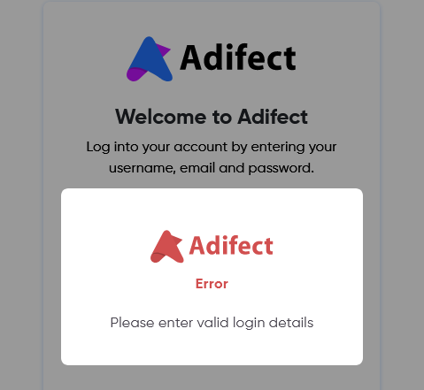

**Marketing Agency Account Job Submissions page:**

The job submission page is different under the “admin” account than it is under an “agency” account.

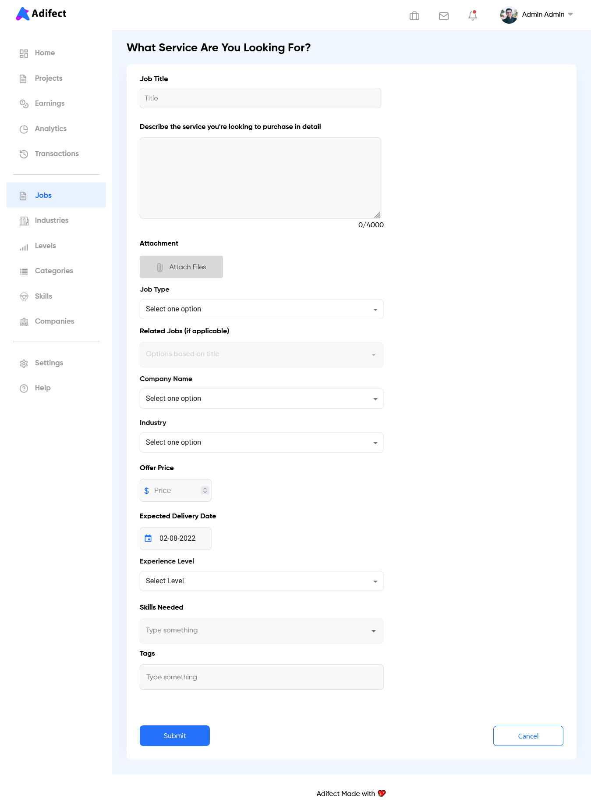

The job submission page is different under the “admin” account than it is under an “agency” account.

**Now both Users (Admin & Agency) “Create a Job” screens are same**

The “Related Jobs” drop-down does not open up:

The “Company Name” drop-down is almost non-existent (the same thing is happening on the “Industry” drop down, right below it)

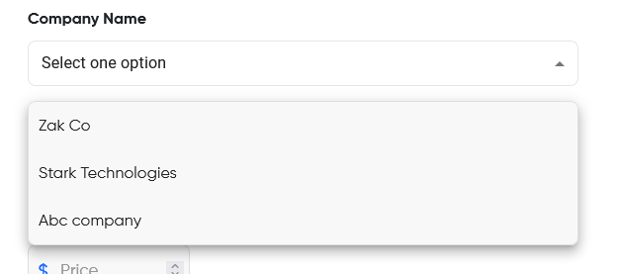

The “Expected Delivery Date” should be displayed as - mm-dd-yyyy

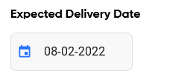

Under “Skills needed” - when typing in a skill and there is not an option, hitting enter should submit that skill to the list and apply it

**Yes now it is working**

We should not be forcing a file to be uploaded in order to submit a new job submission

**Yes attachment tab is not mandatory**

**Analytics Page:**

Let's add all of the “dummy” data, from the homepage/dashboard to the “analytics page” for now. Maybe even add a few random graphs of data just show to the different performance measures/metrics we will provide.

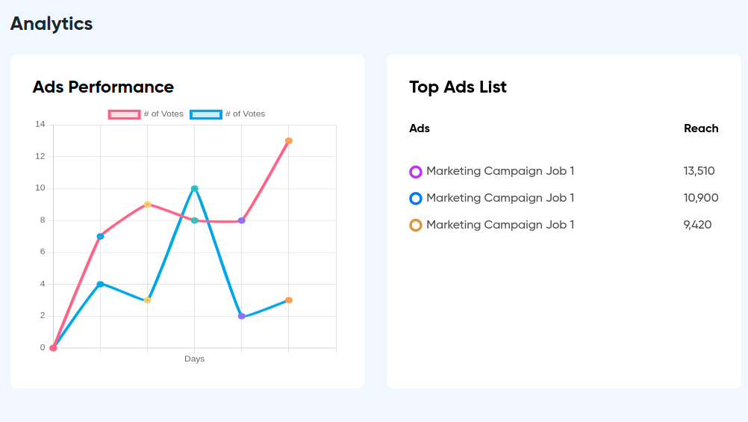

**Profile Page:**

Need the option to “Edit Profile”

**Currently I am working on this page.**

Need to add “Preferred Method of Communication”

- Whatever they choose, they will need to provide the conneciton for it - email, text,

slack, ms teams, etc..

**Please explain me this task.**

**Content Creator Account Jobs Tab:**

Should we allow for “Content Creator to “create job”? I would think no?

**I have removed the Create job functionality from creator user.**

**Admin Account Jobs Tab:**

The “view” icon is linking ot a blank page. Ideally this would popout the “job card” and shop the full job details.

**I am still working on this page. Attached is the screenshot of the quick job screen design.**

