# Issue 1: Where do we define the Single Product Offers?

I created a bogo offer and product discount record for a product and it is not reflecting in the Single Product Offers. What is the logic to define Single Product Offers.?

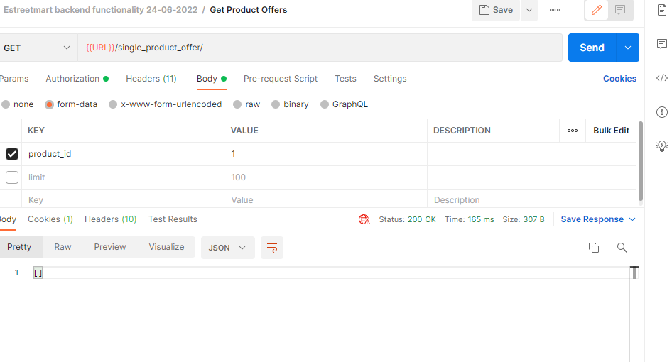

# Issue 2: Where do we define the Category Offers?

We are getting the below error while running the api.

What are the parameters to be passed?

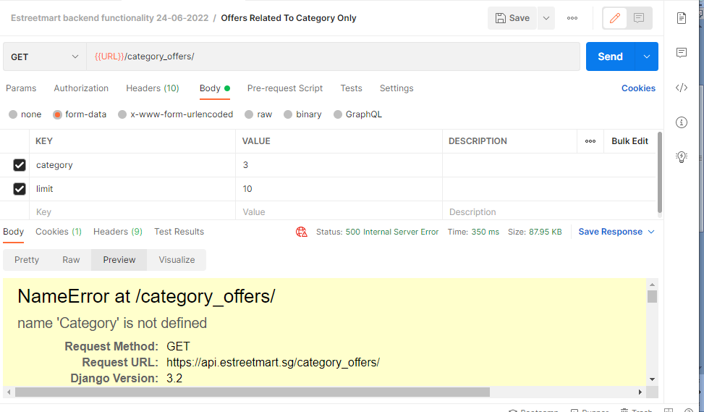

# Issue 3: Can we change the category selection similar to the below one in Django admin?

# From

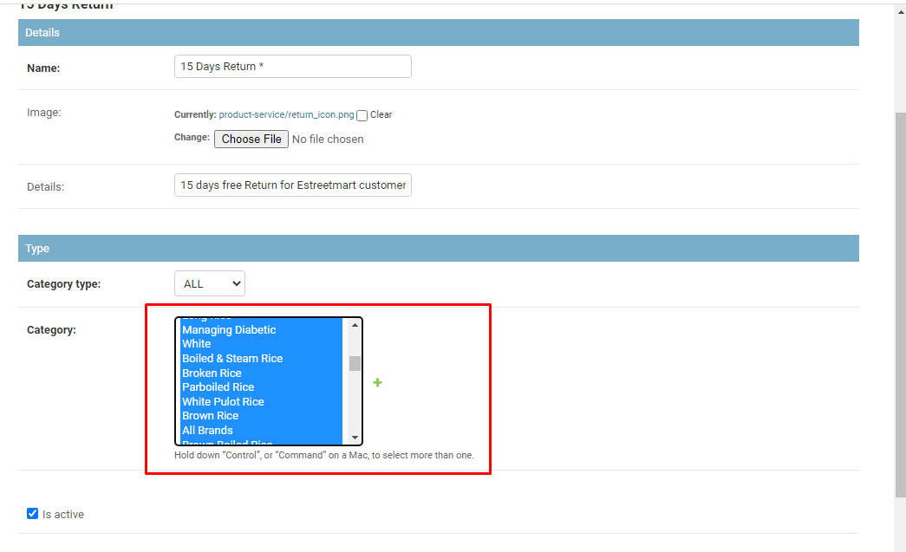

# To

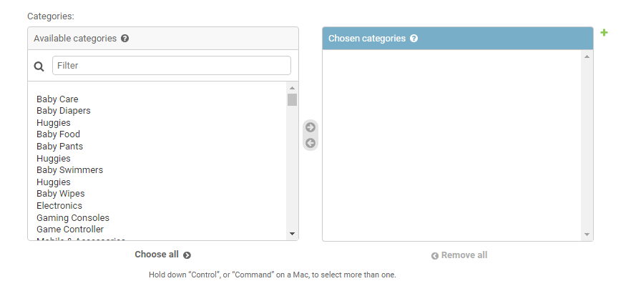

# Issue 4: Product Availability is not accepting Saturday/Sunday. It is throwing the below error.

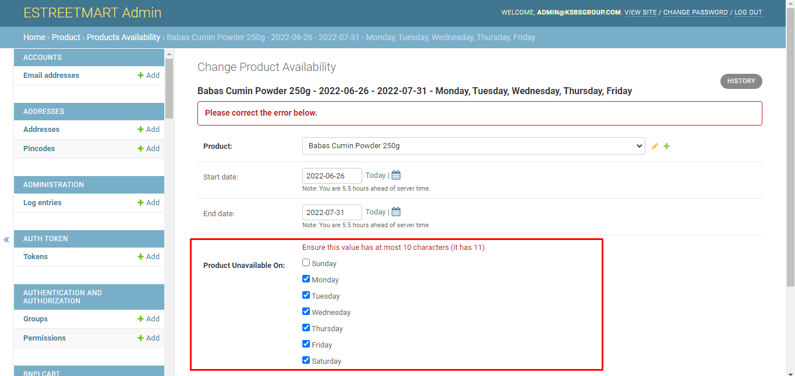

# Issue 5: Can we have the Product Availability selected by default for all the products?

All the products will be available on all days except Sunday. If we want to change the product availability we should be able to go and uncheck the particular day.

# Issue 6: Apply Voucher API is throwing error as You already used this coupon.

But this is the first time I created a voucher and applied it.

Expected: It should be applied before placing the order. The voucher code applied should be applied and reflected in the final amount to be paid by the customer.

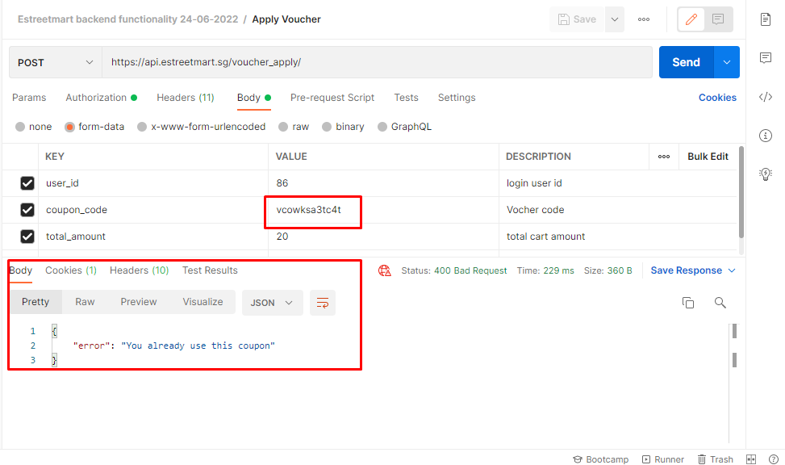

# Issue 7: The voucher code will be given by the sales team. The voucher code should be editable by the admin user.

# Issue 8: Delivery Types – List of All Deliveries is throwing the below error.

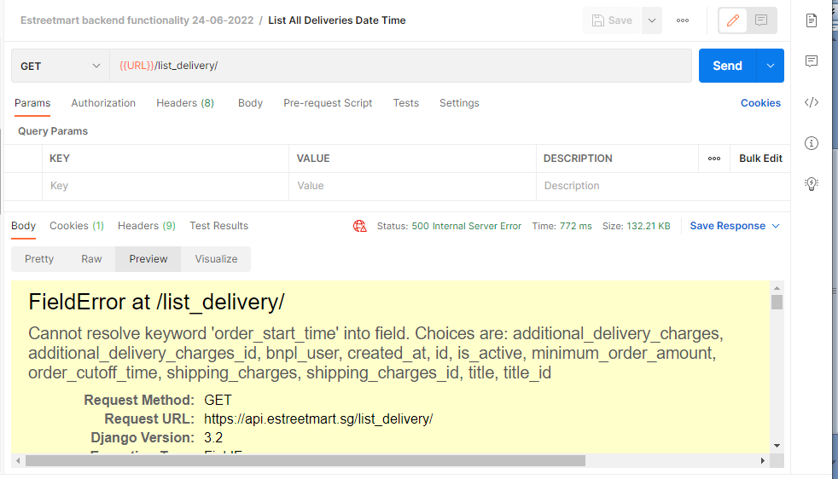

# Issue 9: In the above screenshot, the other fields like additional delivery charges, minimum order amount, order cutoff time, shipping charges are missing in the Django admin. Only Delivery Type is listed.

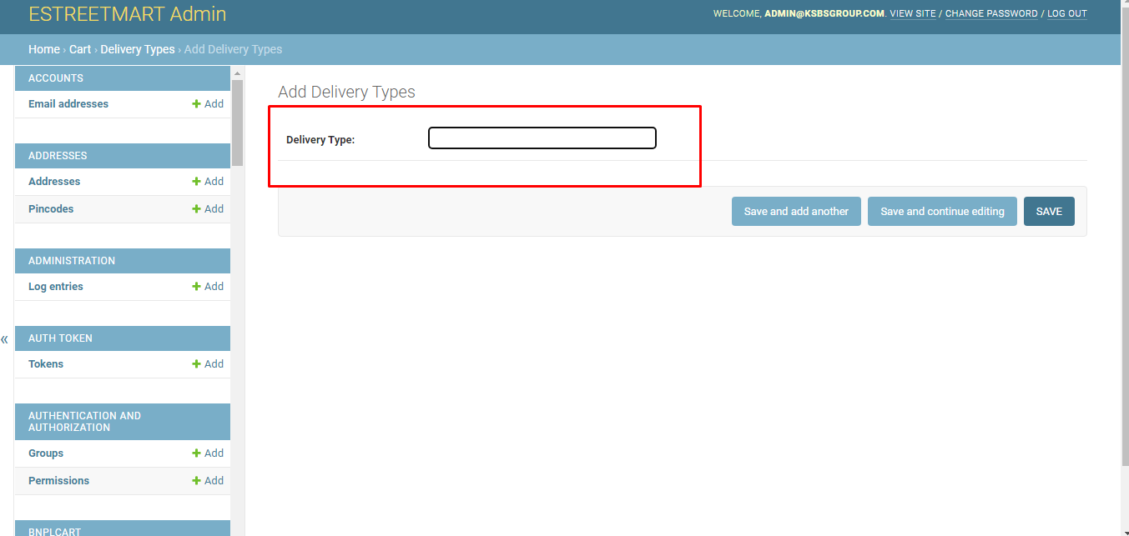

# Issue 10: The Api delivery_by_user_info is throwing error.

