BTech IV Semester in Information Technology, SOE, CUSAT

IT 14L2 Data Structures Lab Cycle

Exercise I (Jan second week)

- Write a program to multiply two matrices.
- Write a program to remove all occurrence of a character from a string

Exercise II (Jan third week)

- Write a program to calculate and print the first m Fibonacci numbers
- Write a program to reverse the digits of the number
- Write a program that computes and prints a table of factorials for any given m

Exercise III (Jan fourth week)

- Write a program that accepts a shopping list of five items from the command line and stores them in a array and perform the following task
  - To delete an item in the list
  - To add an item at a specified location in the list
  - To print the content of the array
- Write a program to find the transpose of a sparse matrix
- Write a program to perform polynomial addition

Exercise IV (Jan fifth week)
- Write a program to implement a stack using array.(Check whether the stack is empty or full while popping and pushing respectively).
- Write a program to convert an expression from infix to postfix using stack and evaluate that postfix expression.

Exercise V (Feb first week)

- Write a program to implement a circular queue using linked list
- Write a program to perform each of following operations using doubly linked list
  - Concatenate two doubly linked list
  - Delete the nth element from a doubly linked list
  - Insert an element to the nth position
- Write a menu driven program to add and delete elements from either end of a deque

Exercise VI (Feb second week)

- A list of student details and their ranks are given. Organize this data as a binary search tree. Given a rank number display the student name. Also display the entire rank list in ascending order.
- Write a program to implement Threaded Binary tree

Exercise VII (Feb third week)

- Trace the DFS, BFS on the following graph
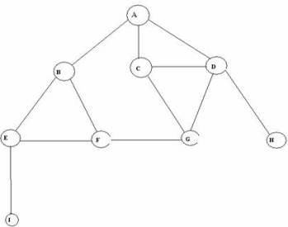

Exercise VIII (Feb fourth week)

- Write a program to perform the following sorting
  - Quick sort
  - Selection sort
  - Insertion sort
  - Bubble Sort
- Write a program to perform binary search on sorted list.

Instruction to students
Aim, algorithm, program in printout form and output of the record of work done in the previous class shall be submitted in neat form at beginning of every laboratory class

