Perennial Pepperweed Mapping

Noxious Weeds Monitoring 2025-2026 LORP Workplan

2025-09-18

Table of contents

# 1. Summary

This data report covers the monitoring of **Lepidium latifolium** (perennial pepperweed) in the Lower Owens River Project (LORP) area from 2018 to 2025. The data is sourced from the [ArcGIS Online Noxious Weeds 2025 feature service](https://services.arcgis.com/0jRlQ17Qmni5zEMr/arcgis/rest/services/Noxious_Weeds_2025_view/FeatureServer/0) and provides updated spatial occurrence as of 2025.

“Perennial pepperweed (Lepidium latifolium), an introduced plant from southeastern Europe and Asia, is invasive throughout the western United States. It can establish in a wide range of environments and is a common problem in flood plains, irrigation structures, pastures, wetlands, riparian areas, roadsides, and residential site. Recent surveys identify perennial pepperweed as a weed problem in nearly all of California, and both the California Department of Food and Agriculture (CDFA) and California Invasive Plant Council (Cal-IPC) list it as a noxious weed of great ecological concern.” - [UC IPM](https://ipm.ucanr.edu/home-and-landscape/perennial-pepperweed/#gsc.tab=0)

**California Invasive Plant Council (Cal-IPC) Rating: High**  
High – These species have severe ecological impacts on physical processes, plant and animal communities, and vegetation structure. Their reproductive biology and other attributes are conducive to moderate to high rates of dispersal and establishment. Most are widely distributed ecologically.

**California Department of Food and Agriculture (CDFA) Rating: -**\*  
* – included in the CCR Section 4500 list of California State Noxious Weeds.

LORP Area Filter Applied:  
- Northernmost 2025 point latitude: 36.9747 °N  
- Filtered dataset now contains 1647 observations

## 1.1 Data Overview

The dataset includes 1647 total observations across 8 years, with peak survey activity in 2025 (426 records).

## 1.2 Key Findings Summary

* **Total Observations**: 1647 records across all years (2018-2025)
* **Peak Survey Year**: 2025 with 426 observations
* **Recent Activity**: 852 observations in 2022-2025
* **Historical Baseline**: 795 observations in 2018-2021
* **Data Coverage**: 100% of records have complete date information (using observation date with creation date fallback)

# 2. Interactive Map Comparison

The following interactive map shows pepperweed populations across all years (2018-2025). Use the layer controls in the top-right corner to toggle between different years. The map includes all 1647 documented observations, with feature creation dates used when observation dates are unavailable.

Data Downloads

📊 Download GeoJSON 🌍 Download KML

Complete dataset with all 1647 pepperweed observations

Study Area Boundaries

North: 36.9747°N

South: 36.5478°N

East: -117.981°W

West: -118.2343°W

Center: 36.7612°N, -118.1077°W

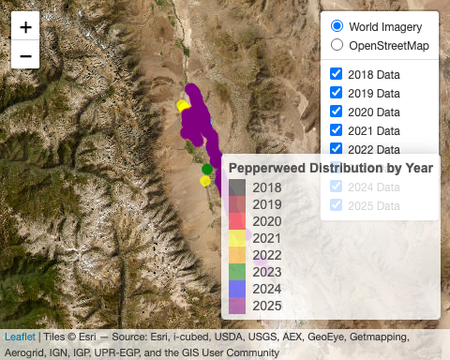

## 2.1 2025 Distribution - plants per site estimated from field observations

The following histogram shows the distribution of abundance values for all pepperweed point locations documented in 2025:

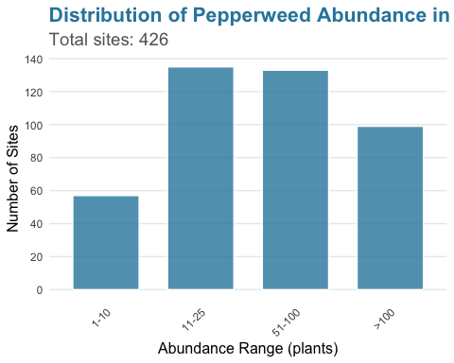

### 2025 Site Distribution  
- **Total Sites**: 426   
- **Small Sites (≤ 100 plants)**: 325 sites ( 76.3 %)  
- **Large Sites (> 100 plants)**: 99 sites ( 23.2 %)  
  
### Detailed Abundance Distribution  
- **1 plants**: 57 sites  
- **2 plants**: 135 sites  
- **4 plants**: 133 sites  
- **5 plants**: 99 sites  
  
### Abundance Range  
- **Minimum**: 5 plants  
- **Maximum**: 200 plants

The interactive map above provides the primary visualization of pepperweed distribution patterns.

### 2.1.1 Recent Sites

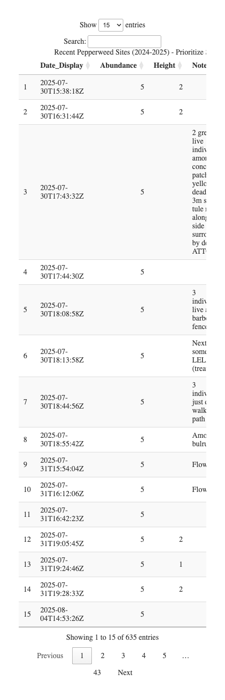

# 3. Data Quality and Limitations

## 3.1 Data Sources

* **Primary Source**: [ArcGIS Online Noxious Weeds 2025 Feature Service](https://services.arcgis.com/0jRlQ17Qmni5zEMr/arcgis/rest/services/Noxious_Weeds_2025_view/FeatureServer/0)
* **Last Updated**: August 11, 2025
* **Coordinate System**: WGS84 (EPSG:4326)

## 3.2 Limitations

* Data represents documented observations only
* Population estimates may vary based on survey timing and conditions
* Some areas may be under-sampled due to access constraints
* Abundance categories are based on field estimates

# 4. Field Documentation

## 4.1 Field Documentation Images

Pepperweed observations with field photos:

Feature ID: 1369 | Date: 2025-04-02 | Abundance: 200 plants

Feature ID: 1370 | Date: 2025-04-02 | Abundance: 200 plants

Feature ID: 1371 | Date: 2025-05-14 | Abundance: 200 plants

Notes: Dense vegetative cluster around low ditch

Feature ID: 1398 | Date: 2025-07-30 | Abundance: 200 plants

Notes: Among the tule next to the water, north of the willow

Feature ID: 1401 | Date: 2025-07-30 | Abundance: 200 plants

Notes: Among tule next to water, south of willow

Feature ID: 1465 | Date: 2025-07-30 | Abundance: 200 plants

Notes: W BAHY + SCAC

Feature ID: 1467 | Date: 2025-07-30 | Abundance: 200 plants

Notes: 10-15m south of rivers edge

Feature ID: 1473 | Date: 2025-07-30 | Abundance: 200 plants

Notes: 8-10m from waters edge; 12-15m long stretch of LELA bordering large TARA

Feature ID: 1475 | Date: 2025-07-30 | Abundance: 200 plants

Notes: 20m long stretch 2-5m from river, dense

Feature ID: 1482 | Date: 2025-07-31 | Abundance: 200 plants

Feature ID: 1485 | Date: 2025-07-31 | Abundance: 200 plants

Notes: W/ ASFA

Feature ID: 1490 | Date: 2025-07-31 | Abundance: 200 plants

Notes: W/ dead BAHY

Feature ID: 1495 | Date: 2025-07-31 | Abundance: 200 plants

Notes: W) ASFA ELTR TYPHA

Feature ID: 1501 | Date: 2025-07-31 | Abundance: 200 plants

Notes: W/ ASFA

Feature ID: 1506 | Date: 2025-07-31 | Abundance: 200 plants

Feature ID: 1507 | Date: 2025-07-31 | Abundance: 200 plants

Feature ID: 1508 | Date: 2025-07-31 | Abundance: 200 plants

Feature ID: 1510 | Date: 2025-07-31 | Abundance: 200 plants

Feature ID: 1515 | Date: 2025-07-31 | Abundance: 200 plants

Feature ID: 1516 | Date: 2025-07-31 | Abundance: 200 plants

Feature ID: 1527 | Date: 2025-07-31 | Abundance: 200 plants

Feature ID: 1529 | Date: 2025-07-31 | Abundance: 200 plants

Feature ID: 1535 | Date: 2025-07-31 | Abundance: 200 plants

Feature ID: 1538 | Date: 2025-07-31 | Abundance: 200 plants

Feature ID: 1545 | Date: 2025-07-31 | Abundance: 200 plants

Feature ID: 1547 | Date: 2025-07-31 | Abundance: 200 plants

Feature ID: 1563 | Date: 2025-07-31 | Abundance: 200 plants

Feature ID: 1583 | Date: 2025-08-04 | Abundance: 200 plants

Notes: Along bank, flowering

Feature ID: 1598 | Date: 2025-08-04 | Abundance: 200 plants

Notes: Several large patches around this point

Feature ID: 1650 | Date: 2025-08-04 | Abundance: 200 plants

Feature ID: 1367 | Date: 2025-04-01 | Abundance: 100 plants

*Field documentation images provide visual confirmation of pepperweed sites and help verify site characteristics.*

# 5. Conclusion

The 2018-2025 data reveals expanding pepperweed distribution within the LORP area. The interactive mapping tool provides land managers with a visualization tool for identifying and prioritizing treatment areas over time.

This report will be updated as new data are added to the live feature service. The data source is available at: [ArcGIS REST Service](https://services.arcgis.com/0jRlQ17Qmni5zEMr/arcgis/rest/services/Noxious_Weeds_2025_view/FeatureServer/0)

## 5.1 Data Disclaimer

The data presented in this report are collected for monitoring and management purposes by the Inyo County Water Department. While every effort is made to ensure accuracy, field conditions, survey timing, and observer experience may affect data quality. Users should verify critical information independently before making management decisions.

**Inyo County Water Department**  
© 2025 Inyo County, California. All rights reserved.

*This analysis is automatically updated when new data is added to the ArcGIS feature service.*