Pepperweed Populations LORP 2018–2024

Interactive Analysis of Lepidium latifolium Distribution in Owens Valley

Noxious Weeds Monitoring Program

2025-09-17

Table of contents

# 1. Executive Summary

This interactive analysis examines the distribution and population dynamics of **Lepidium latifolium** (perennial pepperweed) in the Lower Owens River Project (LORP) area from 2018 to 2025. The data is sourced from the [ArcGIS Online Noxious Weeds 2025 feature service](https://services.arcgis.com/0jRlQ17Qmni5zEMr/arcgis/rest/services/Noxious_Weeds_2025_view/FeatureServer/0) and provides comprehensive insights into spatial occurrence over multiple years.

# 2. Data Loading and Processing

## 2.1 Data Overview

The dataset includes 1782 total observations across 8 years, with peak survey activity in 2025 (426 records).

## 2.2 Key Findings Summary

* **Total Observations**: 1782 records across all years (2018-2025)
* **Peak Survey Year**: 2025 with 426 observations
* **Recent Activity**: 890 observations in 2022-2025
* **Historical Baseline**: 892 observations in 2018-2021
* **Data Coverage**: 100% of records have complete date information (using observation date with creation date fallback)

# 3. Interactive Map Comparison

The following interactive map shows pepperweed populations across all years (2018-2025). Use the layer controls in the top-right corner to toggle between different years. The map includes all 1782 documented observations, with feature creation dates used when observation dates are unavailable.

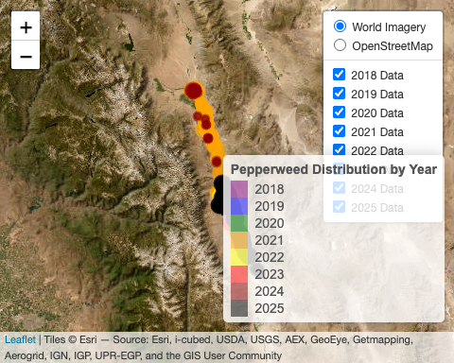

The interactive map above provides the primary visualization of pepperweed distribution patterns. The following analysis focuses on management priorities based on population characteristics and spatial patterns.

### 3.0.1 Recent Sites Requiring Attention

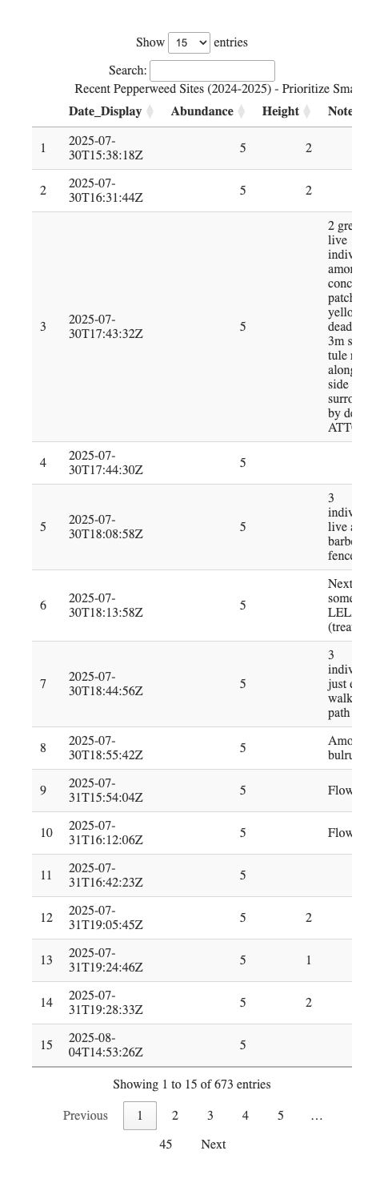

### 3.0.2 Management Responsibility

Treatment implementation is the responsibility of: - **LADWP** (Los Angeles Department of Water and Power) - **Inyo/Mono County Agricultural Commissioner’s Office**

This analysis provides spatial data to inform management decisions.

# 4. Data Quality and Limitations

## 4.1 Data Sources

* **Primary Source**: [ArcGIS Online Noxious Weeds 2025 Feature Service](https://services.arcgis.com/0jRlQ17Qmni5zEMr/arcgis/rest/services/Noxious_Weeds_2025_view/FeatureServer/0)
* **High-Resolution Imagery**: [Inyo County GIS Services](https://gis.inyo.gov/server/rest/services/)
  + [LORP South 2025](https://gis.inyo.gov/server/rest/services/Imagery/LORP_South_2025/ImageServer)
  + [LORP Central 2025](https://gis.inyo.gov/server/rest/services/Imagery/LORP_Central_2025/ImageServer)
  + [LORP North 2025](https://gis.inyo.gov/server/rest/services/Imagery/LORP_North_2025/ImageServer)
* **Last Updated**: 1.7549326^{12}
* **Coordinate System**: WGS84 (EPSG:4326)

## 4.2 Limitations

* Data represents documented observations only
* Population estimates may vary based on survey timing and conditions
* Some areas may be under-sampled due to access constraints
* Abundance categories are based on field estimates

# 5. Conclusion

The comprehensive 2018-2025 analysis reveals important trends in pepperweed distribution within the LORP area. The interactive mapping tool provides land managers with a visualization tool for identifying treatment areas over time.

*This analysis is automatically updated when new data is added to the ArcGIS feature service.*