Table of Contents

Laws (LAW118) – goals achieved 2017 1

South Bishop (BIS097) – Goals not met 3

Big Pine (BGP160) – goals not met 5

West Big Pine (BGP160) – goals not met 7

Tinemaha (TIN054) – goals not met 8

Blackrock (BLK016E) – goals achieved 2010 10

Independence 105 (IND 105) – goals achieved 2017 11

Independence 131 N (IND131) – goals achieved 2012 12

Independence 131 S – goals not met 12

Independence 123 (IND123) – goals achieved 2006 12

# Laws (LAW118) – goals not met

Data show goals achieved in 2017

LA OVR 2018 states goals project is fully implemented but has not yet attained cover goals



C:\Revegdocs\law118.wmf

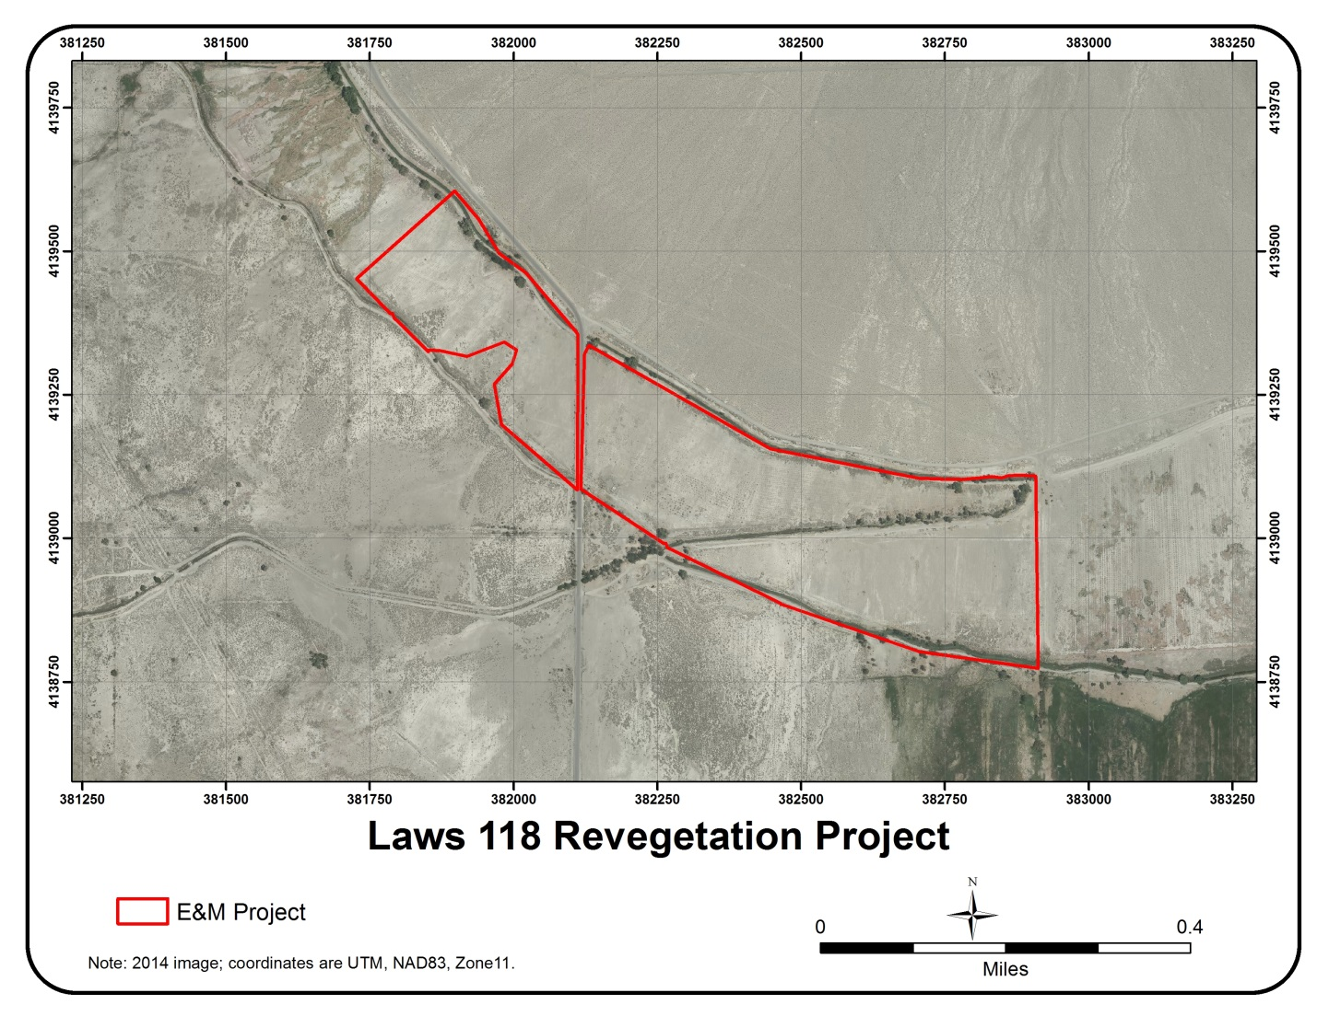

# South Bishop (BIS097) – Goals not met

bish97.wmf

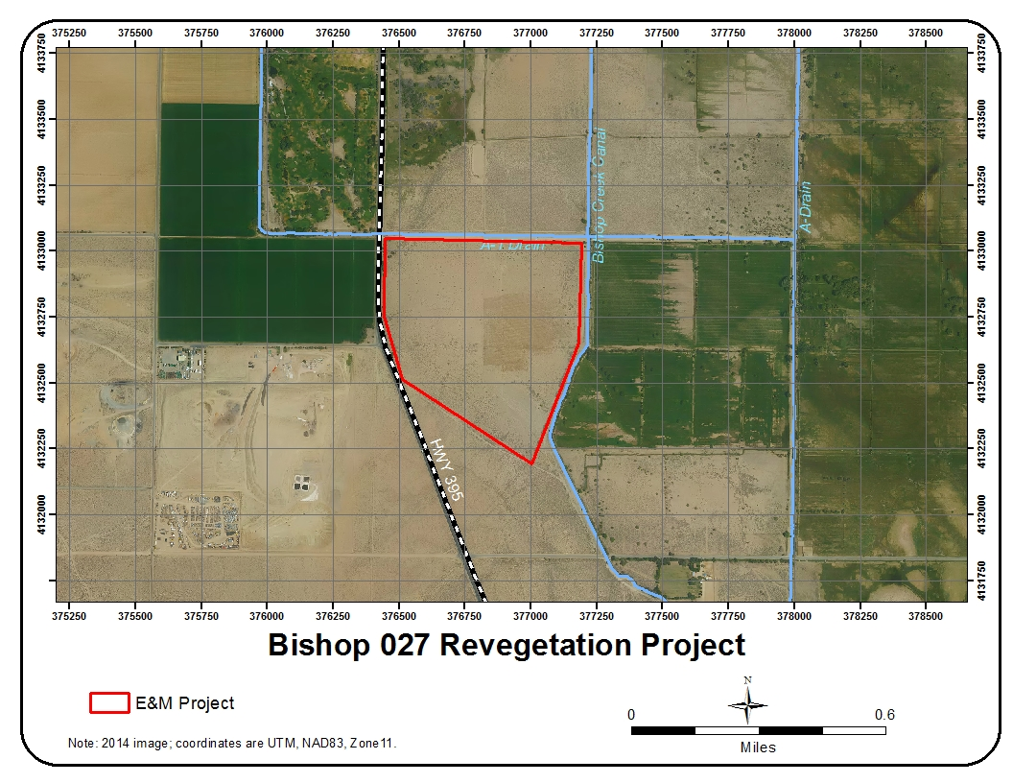



# Big Pine (BGP160) – goals not met

C:\Revegdocs\bigpine160.wmf

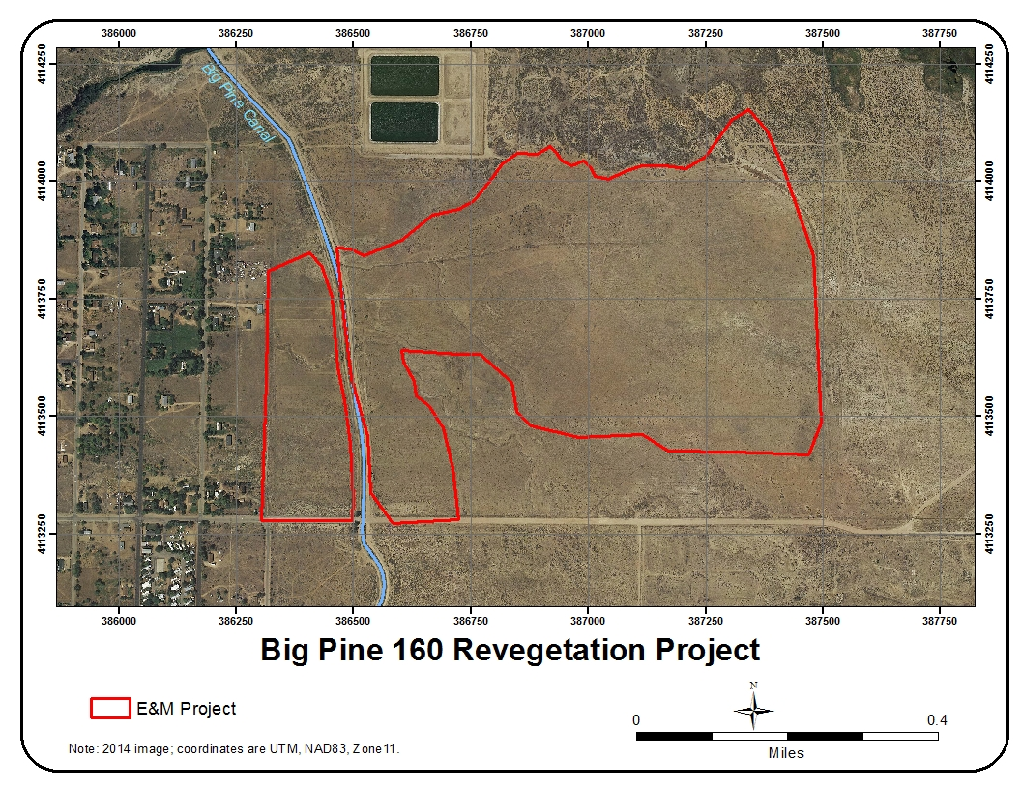



# West Big Pine (BGP160) – goals not met



# Tinemaha (TIN054) – goals not met

tin54.wmf

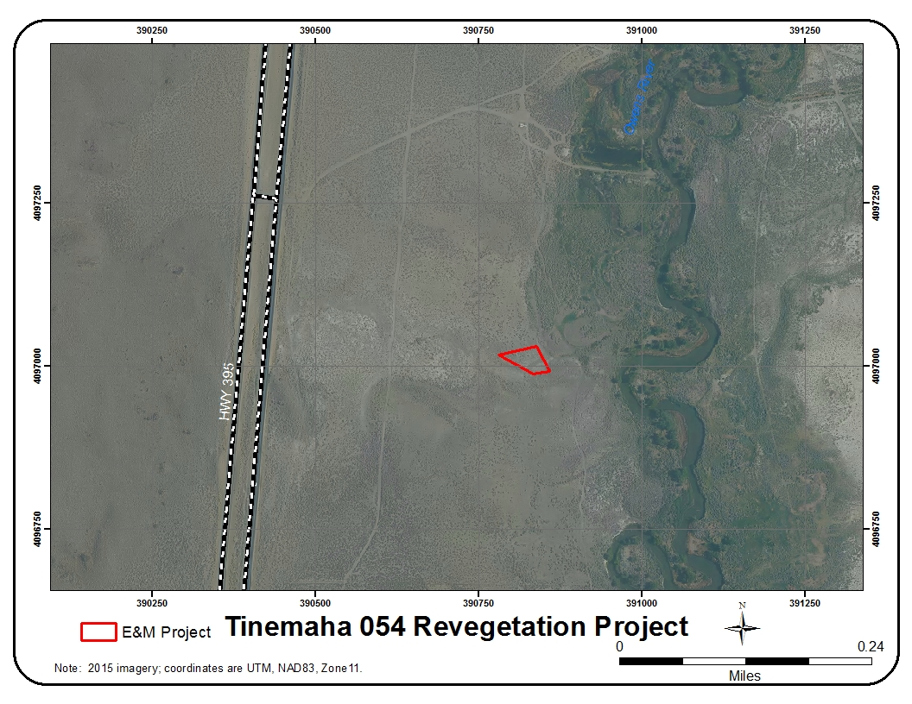



# Hines Springs South (BLK011 and BLK016) – goals not met

LADWP OVR 2018 Fully implemented but not meeting goals

# Blackrock (BLK016E) – goals achieved 2010





# Independence 105 (IND 105) – goals achieved 2017





# Independence 131 N (IND131) – goals achieved 2012



# Independence 131 S – goals not met

Request transect locations from LA. Not included in maps.

LA monitored this site in 2017. But now is questioning legal requirements of revegetation since not included in 91 EIR. This portion was added to the 1999 plan and reported on by P. Hubbard to SC in 2011.



# Independence 123 (IND123) – goals achieved 2006

Request transect locations from LA

