**Having fun with Raspberry PI**

## What is Raspberry Pi?

* It is a small computer
* Computer is composed of
  + CPU
  + Memory
  + Disk: micro SD card
  + Input / Output (I/O): Keyboard, mouse, monitor, network (WiFi), camera …
* Human vs. Computer

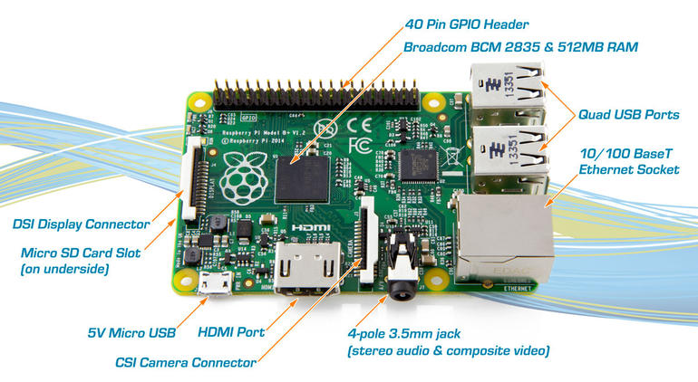

## Build Raspberry Pi and connect to the power!

* You know how to Lego, you know how to build. If you are done building it, the connect to the power to see it on.
* Make sure to connect camera.

## Connect Input / Outputs

* Connect mouse, keyboard, and monitor (HDMI)
* Plug-in Wi-Fi stick

## Download Operating System for Raspberry PI

<https://www.raspberrypi.org/downloads/> What do you like?

Follow the instruction and copy OS image to SD card.

## Copy Operating System (Raspbian) to SD card

* You can find Raspbian Instruction from <https://www.raspberrypi.org/downloads/raspbian/>

$ sudo diskutil unmount /Volumes/NO\ NAME

$ sudo dd bs=1m if=ubuntu-mate-15.10.1-desktop-armhf-raspberry-pi-2.img \

of=/dev/rdisk2s1

## Log in to Raspberry PI

* Input user name and password

Default credential: pi / raspberry

Q: Do you want change password?

* Initial Raspbian configuration

$ sudo raspi-config

## Bring up GUI (Graphical User Interface) environment

* Type in the following from the console

$ startx

## Configure Wi-Fi and connect to internet

Edit wpa_supplicant.conf (<https://www.raspberrypi.org/documentation/configuration/wireless/wireless-cli.md>)

$ sudo nano /etc/wpa_supplicant/wpa_supplicant.conf

(Put in your wifi SSID and passowrd)

network={ ssid="The_ESSID_from_earlier"

psk="Your_wifi_password"

}

## Play Minecraft

* Click Menu 🡪 Game 🡪 Minecraft Pi

Minecraft Pi with Python  
<https://www.raspberrypi.org/learning/getting-started-with-minecraft-pi/>  
<https://mcpipy.wordpress.com>

* Learn Python language. It is easy and run.

<https://mcpipy.wordpress.com>

## Play with Camera

* Use Python again.