CHAPTER I

INTRODUCTION

*Overview of the Current State of Technology*

Students’, specifically those assigned with programming courses cannot easily grasp in taking off on the basics of understanding programming concepts. Though a lot of these student’s may say that it is a challenging task, the process of understanding the basics is the foundation to become skillful in a specific programming platform. A programming instructors’ intervention provided to the students covers programming concept topics, of which, is difficult to be managed when a class has a size of 40 students. Students taking computer programming courses very often come with various backgrounds and ability levels (Wang, F.L., Wong, T.-L., 2008). Since the level of the students’ skill is not easily identified, various rubrics are developed, which may possibly measure the skill set of the student through a scoring method, but can never measure the programming skill level.

Classroom management, especially on teaching programming courses is a great challenge to both the instructor and students since the interaction and the monitoring of learnings is very wide ranged.

Computer Aided Instruction (CAI) is one of the vast innovating technologies needed to support classroom intervention of a student to develop a skill, especially in the aspect of ones’ programming skills to become adept on a programming platform. It has been showed that CAI technology can be a more effective way of teaching introductory programming courses (Anderson & Skwarecki, 1986), which can be used by the instructor as a supplementary teaching tool in a classroom intervention.

*Problems of the Study*

1. Different programming concepts and fundamentals resources are being used to assist students on their programming queries.
2. Insufficient information examples on code structures pertaining to programming fundamentals.
3. Unavailability of instructors to cater students’ queries outside of their class schedules.
4. Insufficient instructional materials to supplement in the development of a computer program.

Objectives of the Study

*General Objectives*

To develop a Computer Aided Instruction using Conversational Artificial Intelligence.

*Specific Objectives*

1. To provide students with a learning tool to enhance their computer programming skills.
2. To develop a knowledge base of various programming concepts and principle fundamentals to provide more instructional materials for students.
3. To provide an online and onsite console that will be accessible to students who are learning programming.

*Theoretical and Conceptual Framework*

*Theoretical Framework*

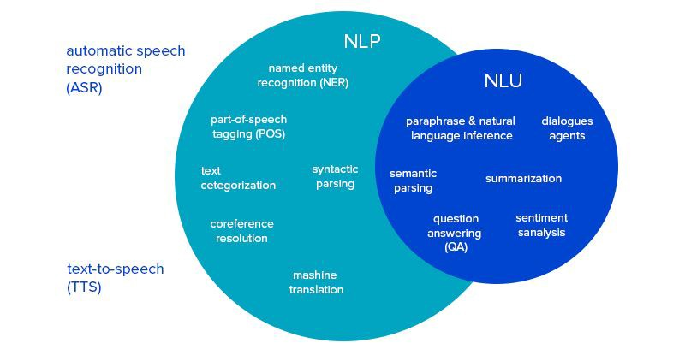

Figure 1. Theoretical Framework of the Study

Natural Language Processing (NLP) services and applications programming interfaces are theories used to support the foundation in building chatbots, or in any case, conversational programs. It is intended for all type of businesses, small-scaled to large scaled. The main point here is that Smart Bots have the potential to help increase the customer satisfaction based by improving the customer support services via the NLP service.

Due to the constantly changing nature and development of new technology, a gap exists in researching the effectiveness of new tools on teaching and learning.  Positioning educational technologies as artifacts within their social applications of teaching and learning, and providing a grammar of practice  identifying specific techno-pedagogical competencies allows faculty to make the work of practitioners at the

center of syntactic parsing in a community of practice (Grossman, 2011; Lave, 1991).

Technology is a broad and constantly changing skill-set required of the instructors, and selecting the appropriate techno-pedagogical strategies to effectively engage students in the content is a separate skill-set. Media literacy influences student development, and developing a critical analysis of media consumption is an important skill for students.

There is a need for instructors, as well as the institutional level, to identify and articulate the occupational realities when technology and competencies intersect, while understanding and communicating how technological resources and strategies can engage students and enhance student learning (Moore & Readence, 1984). The Technological Pedagogical Content Knowledge is a collaboratively developed framework of scholars and researchers seeking to conceptualize and clarify the competencies that evolve from the intersection between pedagogy and technology. Investments in new and interactive technologies in education require both the technical and pedagogical skills to use them. According to the National Educational Technology Standards, faculty should be competent in designing digital assessments, modeling digital work creatively, promoting digital citizenry, as well as inspiring student learning.

*Conceptual Framework*

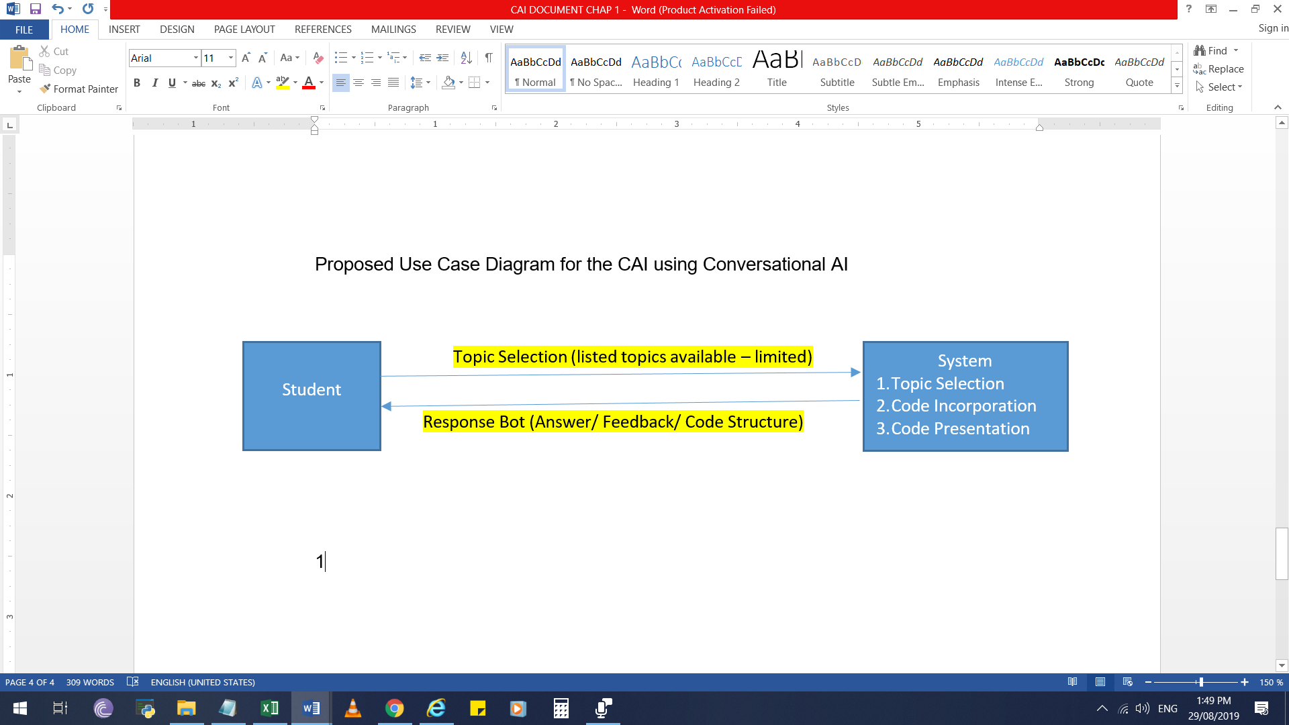

Figure 2. Student Intervention to System and Receiving Response

The system entails the student as the main user of the system. Upon access to the system, a topic selection is available for the student to be able to interact with the system. With this, a query is sent to the system wherein it will be process and deliver an output through a response bot.

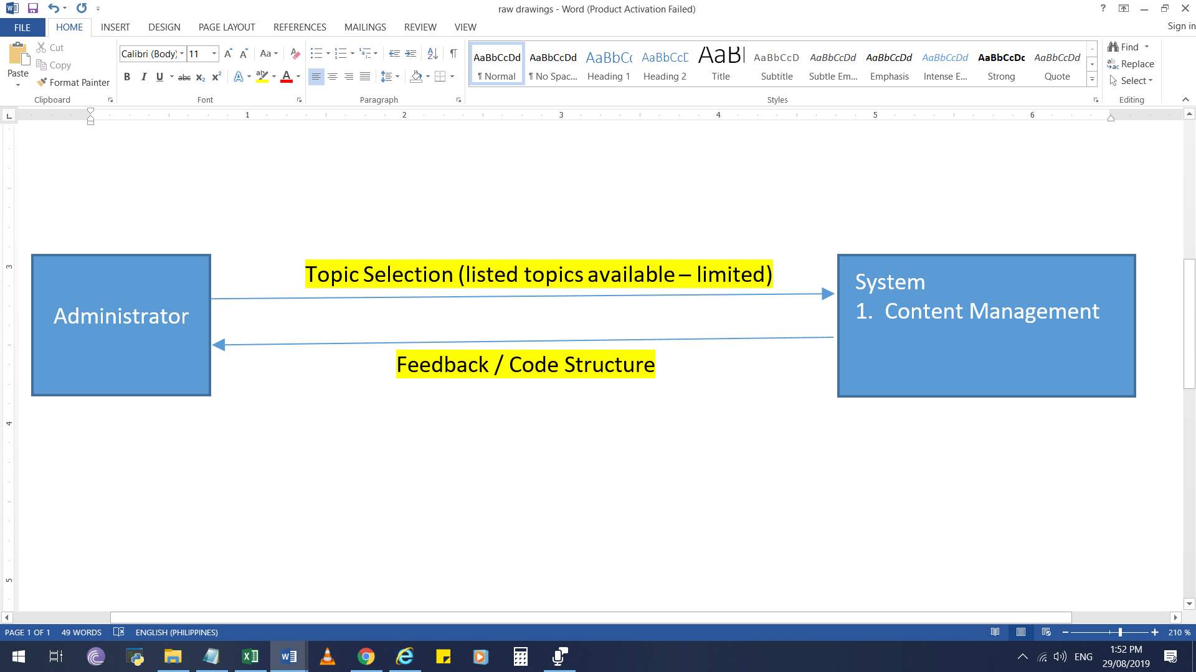

Figure 3.Encoding and Update of Content

In the area of administering and managing the system, it will be able to upload data and other information as co-related with a programming platform concept that involved program structure discussions and other related topics.

*Topic Selection*

The ability to develop a good research topic is an important skill. An instructor may assign you a specific topic, but most often instructors require you to select your own topic of interest (umflint.edu).

*Code Incorporation*

Refers to input data and output data in the process or algorithm. Understanding data and control structures and design patterns does matter very much, especially in allowing program coding to be presented on a manner of how it will be incorporated unto the selected programming scenario.

*Code Presentation*

The presentation of code refers to showing the user the program structure from the basic of a platform, leading to either intermediate or advance coding presentation. This will assist the student on how to initially take a start off on its programming skills.

*Content Management*

Various types of content management systems exist to meet the needs of users in a range of different industries. Content management can entail anything from managing a programs, discussion on program platforms, website’s digital assets to storing enterprise documents such as branding guidelines, business plans, emails, and more (vasont.com).

*Algorithm: Word2Vec*

Word2vec is a two-layer neural net that processes text. Its input is a text corpus and its output is a set of vectors: feature vectors for words in that corpus. While Word2vec is not a [deep neural network](https://skymind.ai/wiki/neural-network), it turns text into a numerical form that deep nets can understand (deeplearning4j.org).

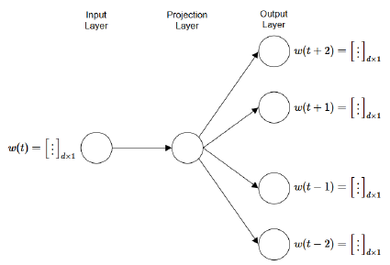

Figure 4. Word2Vec Algorithmic Representation

Word2vec’s applications extend beyond parsing sentences in the wild. It can be applied just as well to [genes, code, likes, playlists, social media graphs and other verbal or symbolic series](https://skymind.ai/wiki/word2vec#sequence) in which patterns may be discerned.

Words are simply discrete states like the other data mentioned above, and looking for the transitional probabilities between those states: the likelihood that they will co-occur is high.

The purpose and usefulness of Word2vec is to group the vectors of similar words together in vectorspace. That is, it detects similarities mathematically. Word2vec creates vectors that are distributed numerical representations of word features, features such as the context of individual words. It does so without human intervention.

Given sufficient data, usage and contexts, Word2vec can make highly accurate guesses about a word’s meaning based on past appearances. The guesses can be used to establish a word’s association with other words, or cluster documents and classify them by topic. Those clusters can form the basis of search, [sentiment analysis](https://github.com/deeplearning4j/dl4j-examples/blob/master/dl4j-examples/src/main/java/org/deeplearning4j/examples/recurrent/word2vecsentiment/Word2VecSentimentRNN.java) and recommendations in such diverse fields as scientific research, legal discovery, e-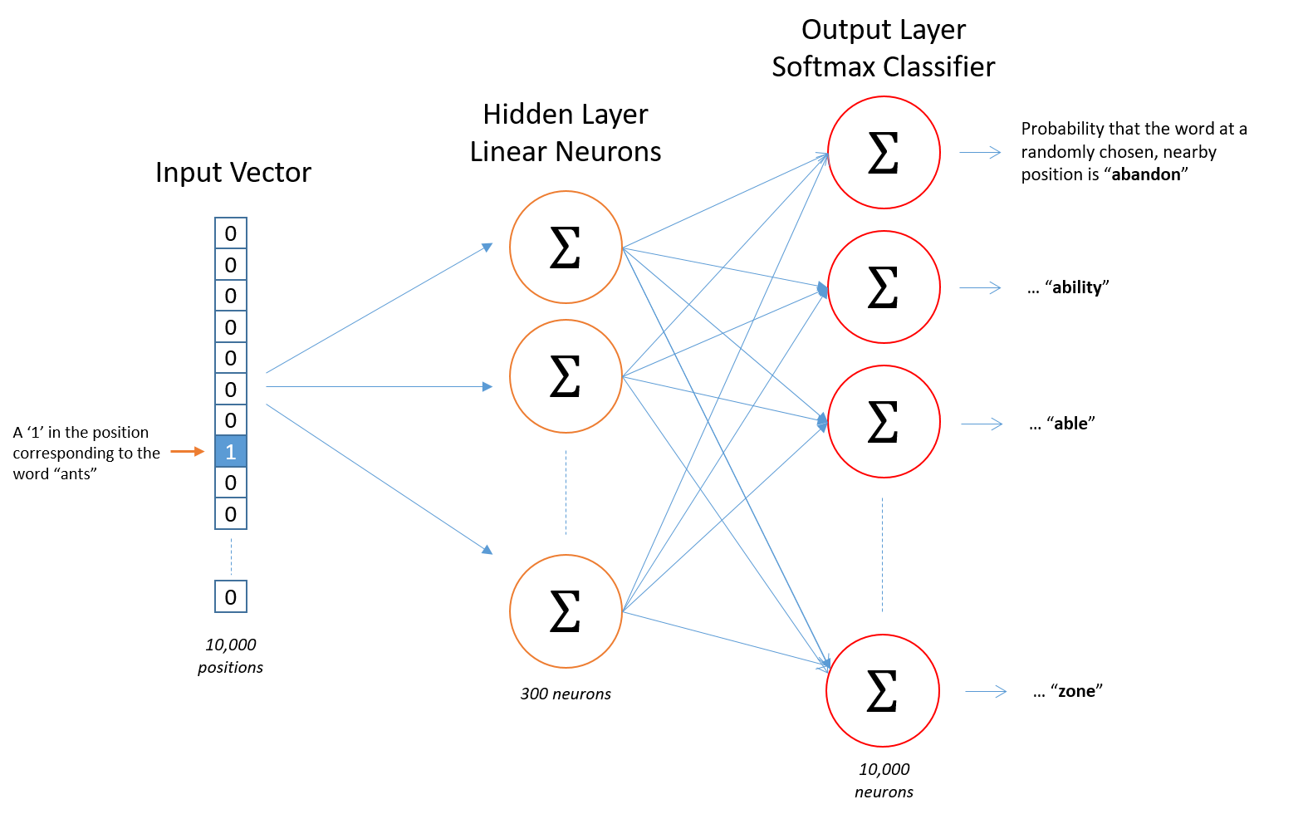commerce and customer relationship management.

Figure 5. Word2Vec Algorithmic Visualization

The output of the Word2vec neural net is a vocabulary in which each item has a vector attached to it, which can be fed into a deep-learning net or simply queried to detect relationships between words.

As the algorithm is implemented in the chat feature of the system to be developed, it will have a data bank wherein keywords resides that would be used in the evaluation and processing of the entered keywords or phrases by the user. As the input is received by the system, it then evaluates to be able to provide an appropriate response to the user. For newly encountered terminologies that are not yet available in the databank, the system has a trainer feature that will allow to grasp the unidentified keyword and it will be captured by the system. This new terminologies will then go through a review process and will be evaluated by the Administrator if the entered keyword is a related keyword to be placed in the data bank.

*Scope and Limitations*

As the limitations on development has been set only to focus on the need of a specific type of programming platform to be used, a deliberation has to be made to be able to access which one will be selected and be made available to the students on which will be included on the system to be developed. Focusing mainly for its availability on various programming languages that is delivered for the different courses for Central Philippine University, College of Computer Studies.

This will then arise to the availability of expanding the content of the current information to further enhance the capability of the system, more likely to those who entail it to develop it on a different and better perspective.

Expansion of the system is essential to enable the further growth of its development and it being able to stay up to date with the latest programming topics that would be include.

*Significance of the Study*

This study helps in gaining further understanding of the faculty and students of Central Philippine University in preparation for the use of a Computer Aided Instruction with conversational AI.

*University*. As the need of innovation is implemented in the University, adopting to changes can entirely bring the level unto a new scenario that could be an advantage on many aspects. Investments in new and interactive technologies as applied in education may require both technical and intuitive skills to be able to put them in proper use.

*Faculty*. The need of the faculty, as well as in the institutional level is to identify and articulate the occupational realities when technology and competencies intersect, while understanding and communication how technological resources and strategies can engage the student in enhanced and independent learning.

One of the many benefits to instructors implementing this will allow them to fully utilized the programming skills and pace students who are advanced and those that may need more focus on

*Students*. The accessibility of these resources can be the most advantageous when students uses the CAI more often. By developing programs independently, the skills on programming will be intensely developed and enhanced.