Name

**InzaAnwar**

Registration #

**2022-ag-2459**

Class

**MSSE(3rd)**

Subject

**Expert System and Applied Artificial Intelligence (MIS-703)**

**1st Lab**

**Constant , Variables , Case Sensitivity , mnemonic variables**

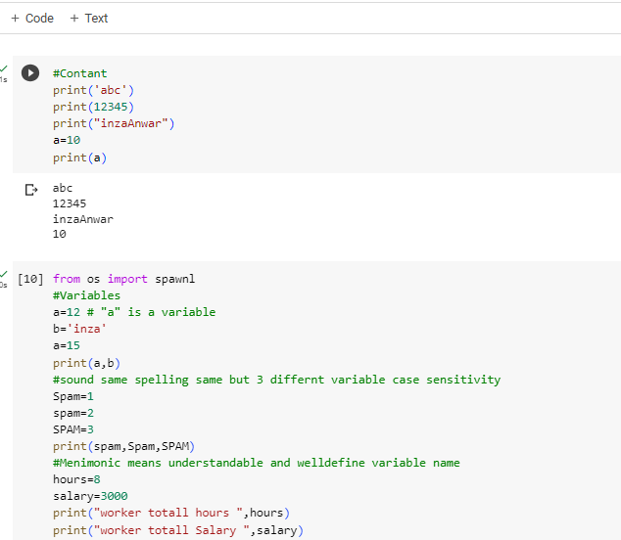

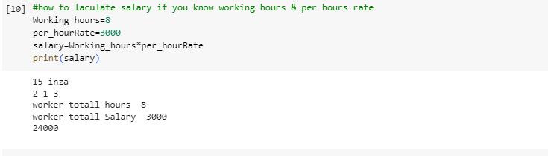

**Assignment operator & expressions**

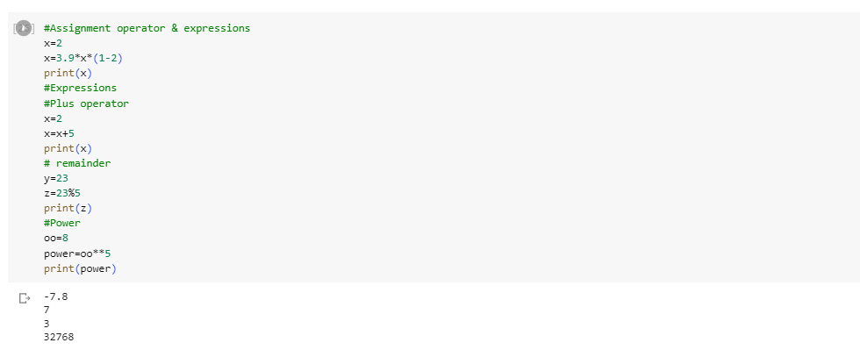

**Type()**

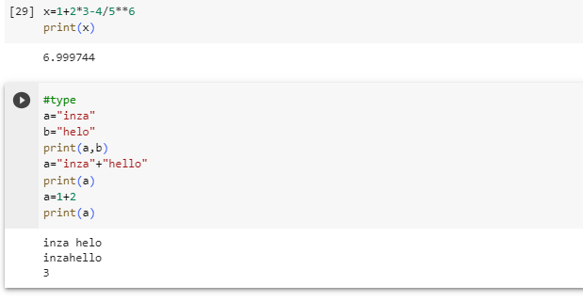

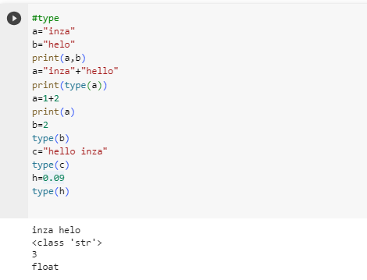

**Convert into float & int**

**Integer division gives answer in float**

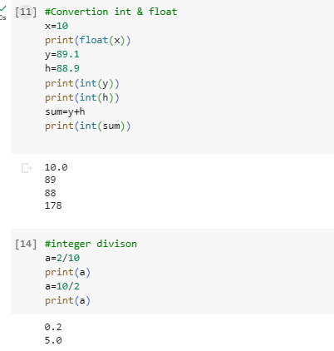

**String Conversion & input()**

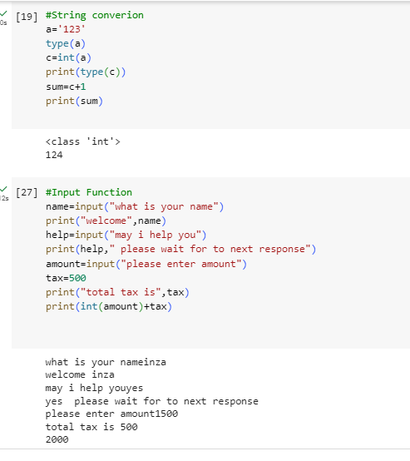

Open file from Pc and read the file this program is not working because am working online that is why I have no access of my pc files

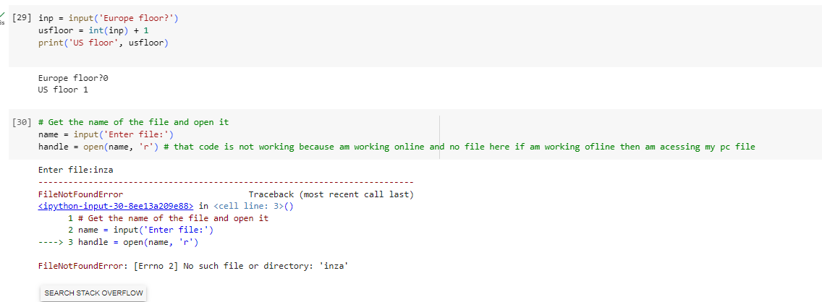

**Exercise question**

