My Personal Words List

Each week you will find new words or words you haven’t quite learnt yet.
Familiarisation and a wide vocabulary only develops with frequent exposure. Use
this sheet to identify new words, then revise them regularly.

New word (Write the new word here) | Meaning  (Write down its meaning in your own  words) | New word in sentence (Write a short sentence with your new word in it)



a-e and ire spelling pattern
- Learn the words first. Make sure you know what each word means.
- Test yourself by writing down each word correctly in the first column. Go over any mistakes.
- Get someone to test you and write your answers in the second column. Go over any mistakes.

Look/Learn/Cover | Write/Check 1 | Write/Check 2
w a v e
s e d a t e l y
n a v i g a t e
c a l c u l a t e
u n f o r t u n a t e
w h a l e
r a c e
d e s p e r a t e
v o y a g e
g r a t e f u l
c h o c o l a t e
m e s s a g e
p e r s u a d e
e l a t e d
s a f e t y
s i r e n
d i r e c t
a s p i r e
u m p i r e
c o n s p i r e
d e s i r e
r e q u i r e
f i r e
t i r e d
a d m i r e
d i r e
a c q u i r e
a t t i r e
e x p i r e
s a p p h i r e

a-e and ire spelling pattern
  - You should know these words. If you make any mistakes please go over them to ensure your learning is secure.
  - These exercises are designed to test the spellings you have learnt, check your understanding and further enhance your vocabulary.
Exercise 1 – CLOZE test.
Fill in the missing letters to make the correct words.

The Grateful Whale
Did you know that w _ _ l _ s desire c _ o _ o l _ t _ on their long voyages? Through no other food can they get the energy r _ q u _ _ _ d to cross oceans.
Without it they soon t _ _ _ and cannot n _ v _ g _ t _ . They are so
d _ s _ _ r _ t _ for this that when a w h _ l _ sees a sailing boat it will
c _ n _ p _ _ _ to swim s _ d _ t _ l y alongside and p _ r _ u _ d _ the captain to hand over some c _ o _ o l _ t e without fail. The
u n f _ _ t _ n _ t _ captain, fearing for his s _ f _ t y, gets the m _ _ s _ g e
quickly and throws a bar or two in the d _ _ _ c t _ _ n of the gaping mouth. The w _ _ l e, e l _ t _ d, will smile and race t _ _ _ l e s _ _ y away through the w _ v _ s, f _ _ _ d up with fresh vigour. You have to a _ m _ _ _ them don’t you?
Exercise 2 – The words on the left are opposites of the words on the right. Complete the words on the right.
1. criticise _ d m _ _ _ 2. live _ x p _ _ _
3. good d _ _ _

Exercise 3 – The words on the left mean the same or nearly the same as the words on the right. Complete the words on the right.
1. influence p _ _ s u _ d _ 2. delighted _ l _ t _ d
3. dangerous _ e s p _ r _ t _ 4. collude c _ n _ p _ _ _

Exercise 4 – CLOZE sentences. Fill in the missing letters to complete each sentence.
- I w _ _ _ d goodbye to my aunt.
- The captain n a v _ _ _ t _ _ his ship carefully through the reef.
- When the bombers came over, the s _ r _ _ sounded.
- My father a c _ _ _ _ _ d a new car last week.
- The man on the stage was dressed in very funny a _ t _ _ _ .



You have already learnt these. Fill in the gaps to reveal the correct synonym.
misfortune adv _ _ s _ _ y
friendly ami _ _ l _
old an _ _ _ nt
leave ab _ n _ on
plentiful am _ l _
room a _ co _ _ od _ _ ion
loving aff _ _ ti _ _ ate
help a _ _
hatred an _ m _ _ _ ty
plentiful abu t
shorten abb _ _ v _ _ te
correct ac _ _ r _ te
stick a _ h _ r _
sharp a _ u _ e
dwelling ab _ d _
height alt _ t _ d _
wonder am _ _ _ m _ _ t
sudden ab _ _ p _
quarrelsome agg _ _ ss _ ve
friend a _ _ y
Remember – this is a test and learning exercise. If you get them all correct you will have done incredibly well. If you haven’t just learn the ones you missed. As you progress your vocabulary will grow each week.
Marks / 20

Find the Mistakes (time to get your red pen out!)

B. Becky Butler’s school work for marking

Ive just started playing cricket with other girls but I am getting exasparated. The rooles of cricket are intrecate and very complikated. You have to admyre the umpires who take year’s to aquire the necesary knowledge. What chance do new players like me have.
A battsman can be boled out, stumped, run out, cawght and be given out because his leg was before the wickit, whatever that entales. The game can last from a day to five days. Then if it raines everyone stops playing, unlike in games of football or rugby where running around chacing a ball in the pooring rain seems to be harf the
fun, for boys at least. Im going to take up netball now.

How many mistakes in spelling or grammar did you spot?



Rule 2
Add es to nouns ending in s, ss, sh, ch and x
LISTEN TO THE SOUND!

1. bus |  | buses
2. tax |  | taxes
3. class |  | classes
4. cross |  | crosses
5. bush |  | bushes
6. fox |  | foxes
7. church |  | churches
8. patch |  | patches
9. gas |  | gases
10. glass |  | glasses
11. watch |  | watches
12. sash |  | sashes
13. box |  | boxes
14. wish |  | wishes
15. dress |  | dresses
16. pass |  | passes
17. branch |  | branches
18. witch |  | witches
19. switch |  | switches
20. dish |  | dishes

SCORE 1st attempt
2nd attempt

FOLD

Exercise 2

Write the plurals of the words in this box to fill in the spaces in the story.

witch fox  sandwich | dress  watch wish | patch  dish glass

Peter had been chasing f in the woods and he became lost as it grew darker. In the gloom he met two poor old . They were in a ragged state and their
were torn and covered with . They greeted him kindly, looked at their w and exclaimed, “It’s time for tea!” They took three
g and three d out of their picnic basket. They drank caterpillar tea and ate frog and dandelion s . They told Peter to make three
w as he swallowed his drink. He woke up with a start in his bed! He realised he had been dreaming and rubbed his eyes. Then he saw, on his bedside table, some dandelion petals!

SCORE 1st attempt
2nd attempt

Compound Word Puzzle

Compound words do not have to be traditional e.g. black and board - blackboard, but can simply be two parts of a word that have an unrelated meaning by themselves e.g. or and bit – orbit.
Often you will have to alter pronunciation to solve the puzzle e.g. pop and pies –
poppies or do and me – dome.

Find ten compound words from these parts of words. (Use each part only once.) Write out the words you have found underneath. Learn meanings and spellings if you don’t know them – this is a learning exercise, not a test.

pepper

prim

due
less

off

fort data
end
over

spring
ice
mint
root
rain
rest

up

ate night off

base

1/ | 2/ | 3/ 4/
5/ | 6/ | 7/ 8/
 | 9/ | 10/

Clues: 1/ A monkey or gorilla 2/ Children 3/ A place of work 4/ two weeks 5/ A place to store
information 6/ hold back 7/ late 8/ To thoroughly dig up 9/ A type of herb 10/ forever


Some words are pronounced like other words
but are different in spelling and meaning, e.g. bawl and ball.

Tick off each word as you learn it please.
Ball A round object for use in games
Bawl To scream loudly
Bean An edible vegetable
Been The past of to be - has been; have been
Bow To bend low; the front point of a ship
Bough A branch of a tree
Grate A fireplace; to scrape
Great Important or large
Him e.g. Let him play
Hymn A religious song
Hole An empty space
Whole Complete; all of something
Leak Escape of water, secret information etc.
Leek A long vegetable of the onion family
Peal A long ringing of bells
Peel The skin of fruit like an orange
Peace Quiet; stillness, the opposite of war
Piece A bit or part of something

Choose the correct word from the pair to complete each sentence:

- My mum used self-raising for my birthday cake. flower flour
- The fox was chased down a by the hounds. whole hole
- The of the village joined in the fete. whole hole
- I like to cheese for my pizza. great grate
- We were asked to to the Queen when she visited. bough bow
- As I walked to the church I could hear the of the bells. peel peal
- It was his job every Sunday to hand out the books. him hymn
- He was having and potato soup for lunch. leak leek

To complete each sentence below you need a pair of words from the list. Be sure to put each word in the right place.
- The toddler kicked the into the hedge and could not reach it, so he began to .
- The best of news was that the war was over and we were at at last.

You should learn these off by heart.
Revision Anagrams – Jumbled Letters

  - This exercise uses words you have recently learnt.
  - Use the clues to help you sort the letters out to find the answer.
  - If you are not sure of a word (spelling or meaning) add it to your own personal vocabulary list.

Question | Clue | Answer
1. acutecall | To do sums.
2. geayov | Another word for journey, particularly on a boat.
3. coolcheat | A sweet brown food that often comes in bars.
4. gasesme | Information which you send to someone.
5. fastye | Relates to remaining unharmed.
6. praise | Having an ambition/wanting to do something.
7. reiuqca | To gain something.
8. itrate | Clothes.
9. uniformset | Bad luck.
10. henscrab | Trees usually have lots of these and leaves grow off of them.
11. cashwind | Two slices of bread with a  filling in between.
12. rangset | The opposite of normal.
13. mazemeant | When someone is delighted  or surprised by something.
14. cavemenheit | Doing something successfully.
15. virtueoaf | Something that you like the most.

Crossword Revision Puzzle
You have recently learnt all these words. Use the clues to solve the puzzle. Please revise any you are not sure of.

 |  |  |  |  |  |  |  |  |  | 1
 |  |  |  |  |  |  |  |  |  |  |  |  |  |  | 2 |  |  | 3 |  |  | 4
 |  |  |  |  |  |  |  |  | 5 |  |  |  | 6 E |  | U |  |  | 7 H | Y
 |  |  |  |  |  |  |  |  |  |  | 8
 |  |  |  |  |  |  |  |  | 9 |  |  |  |  |  |  |  | 10 |  | 11
 |  | 12 |  | E |  | 13 |  | S |  |  | F |  |  |  |  |  | R |  | L |  | R
 |  |  |  |  |  |  |  |  |  |  |  |  | 14 |  |  | P | E | R | A | T
 |  |  |  |  |  | D |  | 15 |  |  |  |  |  |  |  |  |  |  | S
 |  |  |  |  | 16  N |  |  | I |  |  | T |  |  | 17
 |  |  |  |  |  |  |  |  |  |  |  |  |  | P |  |  |  |  | S
 |  |  | 18 | E | A |  |  | N
 |  |  |  |  |  |  |  |  |  | 19 | E |  |  | I
 |  |  |  |  |  |  |  |  |  |  |  |  |  | R
 |  |  |  |  |  |  |  |  |  |  |  |  | 20  P |  |  |  |  |  |  | E
Clues across
3. A separate part of a whole. Sounds like peace.
5. Feeling or showing gratitude.
7. A song of praise.
9. Immeasurably small OR a unit of time.
12. The plural for a one-piece garment.
14. A state of despair or loss of hope.
16. To direct movement, particularly of a ship of aircraft.
- The noise of bells.
- Needing something.
- Attempt to win approval or support for.
Clues down
- An official who governs a sports match.
- Sounds like bow – a large branch on a tree.
4. To engage in plotting something.
6. To have high spirits.
8. Something less than ideal.
10. The first meal of the day, eaten in the morning.
11. The plural of glass. A collection of things to drink from.
13. A calm, quiet manner.
15. A device that makes a loud noise to warn people to move.
17. A precious stone or blue colour.

Complete the word on the right so that it has a similar meaning to the word on the left.

CUNNING | CL _ _ ER
HUGE | EN _ _ _ OUS
EMPTY | B _ _ _ K
COURTEOUS | POL _ _ _
DESTITUTE | P _ _ R
READY | _ _ ERT
EMPTY | VAC _ _ _
WEAK | _ _ _ BLE
SCARCE | _ _ _ E
FAITHFUL | _ _ _ AL

Marks /10
If you want to improve your vocabulary make sure you read for at least half an hour every day.

Remember this is a combination test and learning exercise. We expect you to get less than 100%. Take some time to learn the meanings of any you got wrong. You will improve. These questions are at an 11+ level.
Select the word on the right which is most similar to the word on the left.

COWARDLY | brave | stupid | undaunted | afraid
AUDACITY | politeness | greed | impudence | care
NARROW | broad | confined | intensify | shaft
CHIVALROUS | rude | proud | gallant | sexist
BITTER | sour | sweet | bland | brown
CURB | finish | control | pavement | release
DAMAGE | reward | hurt | improvement | revenge
CUNNING | thoughtfulness | sly | suspiciousness | fear
GREGARIOUS | affable | cool | timid | difficult
ADMONISH | curse | reprimand | dismiss | enhance

TIP – if you are really stuck then cross out those words you know are not the answer and make an informed guess.

Marks /10
If you want to improve your vocabulary make sure you read for at least half an hour every day.



Born in Wales at the end of the 4th century, Patrick was a fortunate child. His parents were wealthy and he lived a comfortable early life.
However, when he was sixteen years old, Patrick was captured by Irish raiders who were attacking his family estate. They transported him to Ireland where he spent six years in captivity. Frightened and homesick, he was forced to work as a shepherd. This was a hard and lonely life so he turned to religion for solace, becoming a devout Christian. He wished he could persuade the Irish to adopt his religion, but at the time, most of them believed in pagan gods and magic. Finally, Patrick escaped, walking two hundred miles to the coast from County Mayo where he had been held.
He settled in Wales, but in a vision he was urged by voices to return to Ireland as a Christian missionary. He began a long course of religious study that was to take 15 years during which he was ordained as a priest.
Eventually he was told to go to Ireland to fulfil two tasks - to minister to the Christians there and to persuade the Irish pagans to become Christians. He met the King and challenged him to give up the old gods and become a Christian. The King was impressed by Patrick’s skilful arguments and eventually became a Christian, much to Patrick’s delight.
Patrick became a bishop and spent the rest of his life in Ireland, converting people to Christianity and building churches.
The Irish people now look upon Patrick as their patron saint. St Patrick’s Day is celebrated on 17th March, when many people wear something green and display the national plant of Ireland – the shamrock, a small three leafed clover.
- When and where was Patrick born?

- How old was Patrick when he was captured by the raiders?

- What was his job in captivity?

- Where did he find solace?

- What did the Irish people believe in when Patrick first went there?

- Why did he return to Ireland?

- Tick the word that means ordained:
  - refused b. appointed c. dressed d. recognised

- Tick the word that means solace:
  - comfort b. interest c. humour d. adventure

- Tick the word that means devout:
  - doubting b. thoughtful c. pious d. nervous

- What is the national plant of Ireland?

- What date is St. Patrick’s Day?

- You have five minutes. Children should be working towards scoring 100%.
- Watch out for the changes to + /÷ / - / x
- This test will be repeated five times, where mistakes are made it will be an indication that further times tables work and attention to detail is necessary.

17 – 9 = | 9 + 6 = | 6 x 8 = | 19 – 7 = | 12 + 5 =
8 x 3 = | 7 x 8 = | 63 ÷ 7 = | 6 + 9 = | 11 – 7 =
11 – 6 = | 32 ÷ 8 = | 12 – 9 = | 7 x 4 = | 13 + 6 =
8 x 6 = | 14 – 5 = | 7 + 5 = | 63 ÷ 9 = | 9 x 9 =
5 x 7 = | 2 + 9 = | 45 ÷ 9 = | 4 + 3 = | 13 – 7 =
7 – 2 = | 56 ÷ 8 = | 8 x 12 = | 13 – 8 = | 32 ÷ 4 =
3 + 7 = | 16 – 7 = | 7 + 8 = | 4 x 6 = | 14 – 6 =
12 – 9 = | 9 x 3 = | 11 – 8 = | 49 ÷ 7 = | 5 + 8 =
8 x 9 = | 6 + 7 = | 27 ÷ 9 = | 15 – 4 = | 9 x 7 =
72 ÷ 8 = | 13 – 9 = | 5 x 12 = | 4 + 8 = | 18 - 7 =

Score /50

- Miriam has completed her Mental Maths task but unfortunately she’s made a number of mistakes. Her answers are underlined.
- Circle the mistakes. See if you can work out what she might have done wrong.

① 6 x 7 = 50 - 1

② 73 - 28 = 45

③ Write 578cm to the nearest metre
60m

④ ½ km – 397m = 113

⑤ From the sum of 39 and 6 subtract 20
= 25

⑥ Share £1.20 equally among 5 children How much is one share ? 24p
⑦ Find the cost of 4m of cloth at £0.75 per metre £3
⑧ 600ml x 5 = 30 L

⑨ 16p x 7 = £1.12

⑩ 4½kg – 700g = 3.8kg

⑪ How many minutes from 9.25am to 10.20pm? 55 minutes

⑫ Find the total of 56p and 7p = 63p

Marks /

- Use the notes below each question to help you develop a range of skills. These skills can help you to work more accurately and quickly.

①
3 x 29 =
* Multiply 3 x 30 then subtract 3
②
£6.20 x 4 =
* Double and then double again
③
150 ÷ 5 =
* Divide by 10 and then multiply by 2
④
57 + 18 =
* Add 20 and then subtract 2
⑤
300 ÷ 12 =
* Divide by 3, then 4
⑥
0.4 x 9 =
* Use your tables, 4 x 9 is 36
⑦
2/₅ of 50 =
* Find 1/₅ then multiply by 2
⑧
35 + 11 + 45 =
* It’s easier to add 35 + 45 first = 80
then add 11
⑨
7.1 x 6 =
* Use estimation, the result must be
roughly 42
⑩
19 x 5 =
* The units digit of answer is 5
TIP:
Try to use these skills when you do other Mental Maths work

Marks /10

Try the following questions. Do as many in your head as possible.
①
9² - 4² =
②
5/8 of £56 = £
③
£5.03 = p
④
0.8kg - g = 230g
⑤
7 x = 73 - 17
⑥
2hr 25min = min
⑦
6.17m = cm
⑧
+ 7 + 600 + 3000 = 3677
⑨
¾l - 370ml = ml
⑩
(100x10) + (60x6) =
⑪
Find the radius of a circle the diameter of
which is 6cm. cm
⑫
Multiply 8.7cm by 100. Give the answer in
mm. mm
⑬
500g costs 18p. Find the cost of 2½kg.
p
⑭
What distance in km and m is twice as long
as 3.7km? km m
⑮
Find the product of 10 and 37.
⑯
Find the missing number in the series.
8, 80, 800, , 80 000
⑰
Find the difference in pence between 60
TWOS and 20 FIVES. p
⑱
Find the area of a rectangle 6cm long and
4cm wide.
⑲
69cm ÷ 10 = mm
⑳
Write in pence the sum of 5 TENS, 6
FIVES and 7 TWOS. p

Marks /20



Positive and Negative numbers

+6
-
-
-
-
-
-
-
-
-
-
-
-
-
+5
+4
+3
+2
+1
0
-1
-2
-3
-4
-5
-6

STAR BOX
IF ALL CORRECT

Here is part of a thermometer.
Remember above 0 is positive (+) and below 0 is negative (-). Answer these questions, using the thermometer:
- In the evening the temperature was +3. During the night it fell 5 degrees. What was the temperature?

- One morning the temperature was –4. During the day the temperature rose 8º. What was the temperature?

- If the temperature was +3 and fell 8º what would be the temperature?

- If the temperature was –5 and rose 9º what would be the temperature

- If the temperature was 0º and fell 3 degrees, what would be the temperature?

- If the temperature was +1 and fell 7 degrees, what would be the temperature?

- If the temperature was –6 and rose 4º, what would be the temperature?

Answers:
1. -2
2. +4
3. -5
4. +4
5. –3
- -6 (my favourite temperature!)
- -2

*This type of question is ALWAYS on the 11+ paper, so make sure you understand it!


You will need to be very good at your tables for this work.
Square numbers are special because they are numbers made from squares. Look at this:
This is a square measuring 1 cm on all sides.
1
1
1² = one squared = 1x1 = 1

2² = two squared = 2x2 = 4
2
2
3
3

3² = three squared = 3x3 = 9
4
4

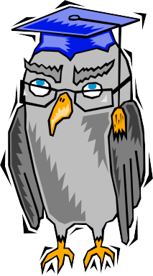
4² = four squared = 4x4 = 16
4

5² = five squared = 5x5 = 25
6² = six squared = 6x6 = 36
Now work out all the square numbers up to 12² Check your answers on your calculator please.

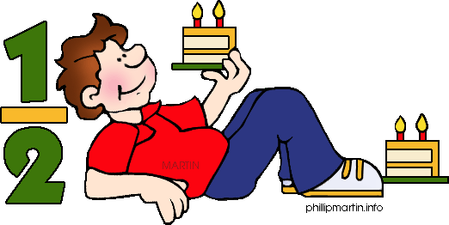
These questions are designed to get your mind whirring - so have a go. If you can’t do it first time then try, try again. It is important to persevere.

Justin divided twenty 1p coins between five small bags.
The way he has divided them up means he can pay any sum of money up to 20p without opening any of the bags.
How many 1p coins did Justin put in each bag?

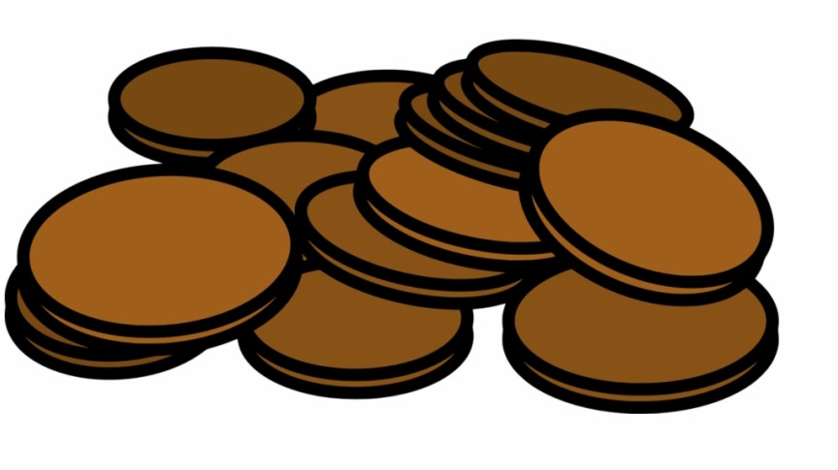




In these questions you will be given five options and you will be asked to choose the odd one out.
2. ODD ONE OUT / TYPE 2
All you need to do is identify similarities between four of the shapes that the fifth shape does not share.

What to look out for
The confusing aspect is that the four shapes may have differences as well as similarities; you should only focus on similarities. In the most difficult you will be asked to choose an option which may share some similarity but not as many as the other four share.

- Look closely at the shapes, how many sides do they have?
- Are there any noticeable size relationship issues with some elements being larger than others?
- Is there any shading or diagonal or horizontal lines within the shape(s)?
- If you believe they are all similar think again, one won’t be as similar.

Technique tips
These questions are often written in a way that it is difficult to spot the least similar shape and which is the odd one out.

- Focus on the number of sides shapes have
- The direction of diagonal or horizontal lines
- Any shading or bolding of lines
- Any pattern you can notice.
- Often you will be left with two similar options, but there will always be a distinguishing feature. Renew your focus on the detail of each shape and a solution will emerge.
- Remember it is better to do one question at a time, reach an answer (correct or not) then look through the explanation to improve your understanding. Following this process will lead to improvement.

In the case of the example question all shapes share an alternating pattern but only one starts with a dotted pattern rather than a black shape.
Example
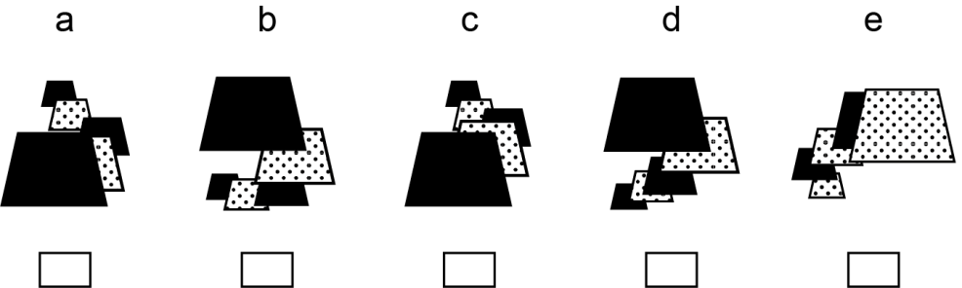

Answers A, B, C and D all start with a black shape on top then alternate between dotted and black. But E starts with a dotted shape then alternates between black and dotted.

Explanation


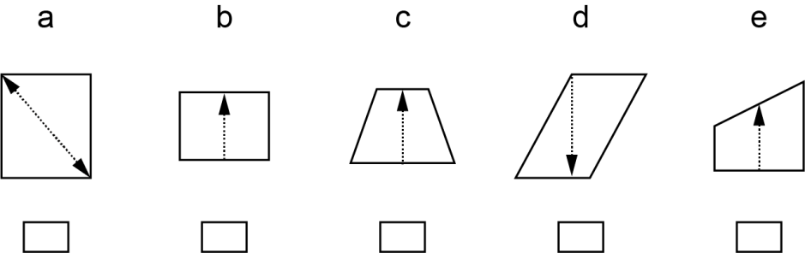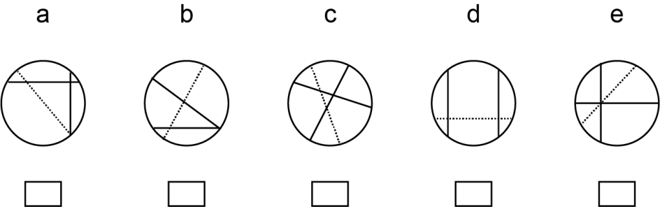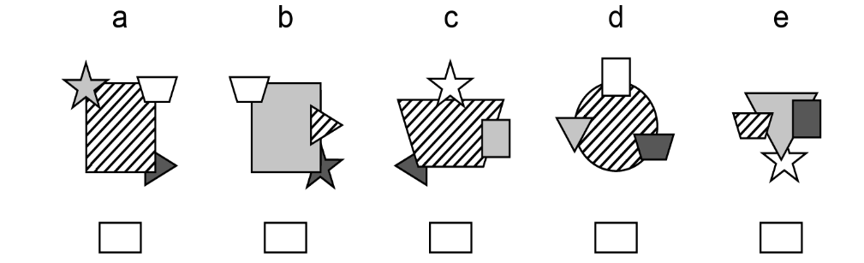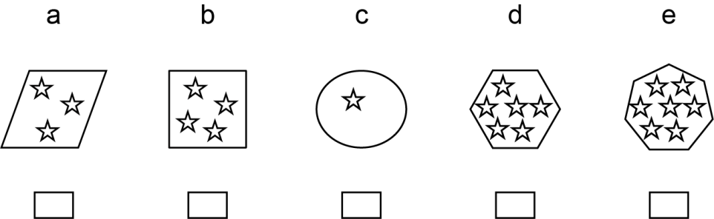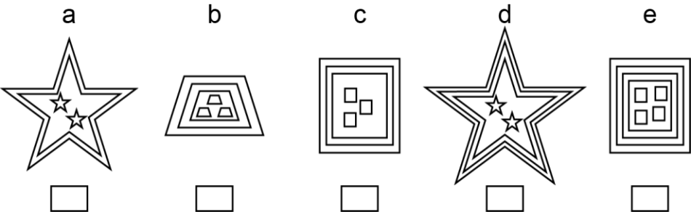
2. ODD ONE OUT / TYPE 2
1
2
3
4
5


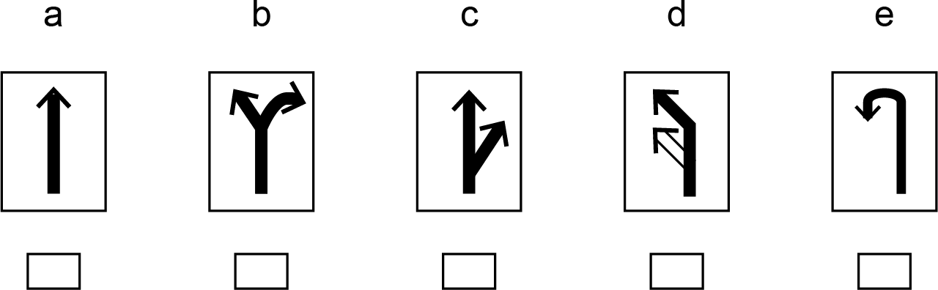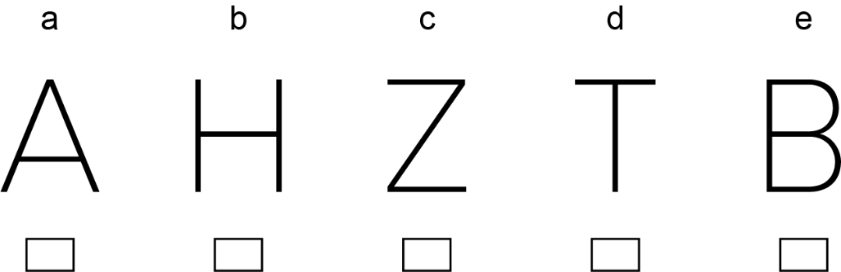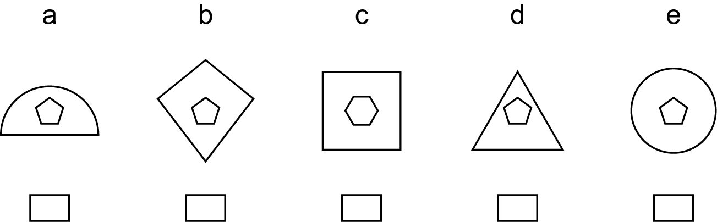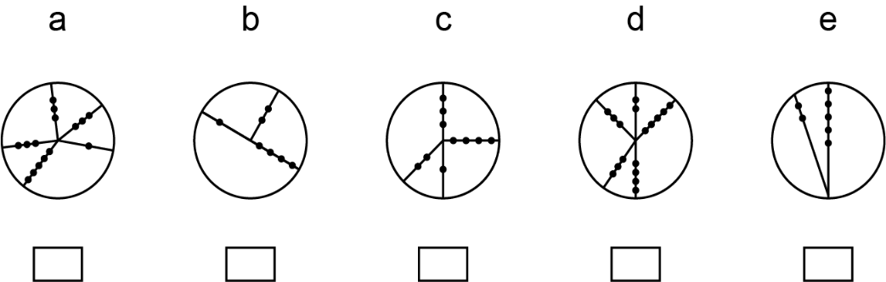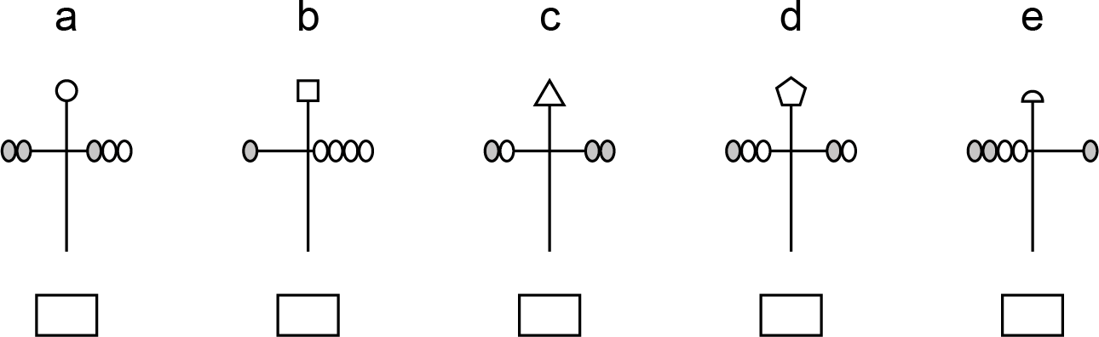
2. ODD ONE OUT / TYPE 2
6
7
8
9
10

