The words from past papers are difficult- use your personal words list to help you to learn them.
The Complete CEM 11+ Programme - Part 13
This time you have a very difficult stretch comprehension, this will help you should CEM make their texts more challenging.

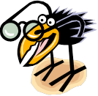
- Reading: Are you enjoying reading every day? There’s an old saying - ‘Those who read, succeed’. It’s as true today as it has always been. Please make sure you read for at least half an hour each day.

- Your Personal Words List: These sheets help give you a format to
note down words you haven’t quite learnt properly and new words you find.
Revise the sheets regularly and your vocabulary will grow.

- Synonyms 4: Your fourth batch of synonyms. This section includes words such as deficiency and diminutive. When you think you have really learnt the words please wait a couple of days and then test yourself again to make sure the words have really sunk in.

- Synonyms Match-Up Test: Only do this simple test a few days after you have learnt these words. Any mistakes or hesitancy will indicate they could be learnt more thoroughly.

- Commonly Misspelt Words: These are the top 150 commonly misspelt words. Say each word out loud five times and write it out five times. A few days later do the Look Cover Write Check test to further embed your ability to spell these words correctly.

- Words from Past Papers: If you are not sure then add the word to your
personal words list. This time words include candidate and wasteful.

- Homographs: Can you think of two meanings for the word hamper? Do the exercise to check your understanding of these words. Learn any you didn’t get.

- Essential Spelling: More words to learn from the essential spelling bank. Only do the tests when the words have been learnt properly.

- Apostrophes: This time two more sheets on contractions.

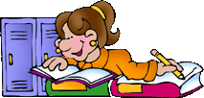

© Learning Street

- Find the Mistakes: How many mistakes can you find this week?

- Revision Puzzle - Anagrams: Can you find out which word impatientponds is an anagram of? Remember children will probably have to have several goes to get as many as they can; this process helps them to develop the tenacity they’ll need later on.

- Revision Puzzle - Crossword: This crossword puzzle revises the words you have learnt in this section of the course, work at it over several sittings please.

Verbal Reasoning

- Move a letter to make two new words

- Stretch Comprehension – The Secret Garden: CEM could start to use classic texts as they do elsewhere. If so, then comprehensions could be similar to this. Read the text and answer the questions, including the spot the mistakes bonus questions at the end.

Variety Test 3

Maths

- Revision Test: Complete please. Now with prime numbers.

- Decimals: Can you crack the decimal code to answer the trick question? This
will be fun, but only if you concentrate!

- Factors: Quick revision sheet.

Prime Numbers:
  - Revise prime numbers please.
  - Mystery picture. Colour or shade in ONLY the Prime Numbers to reveal the mystery object. What will it be?

- Shapes: The RHOMBUS. Learn the facts – you don’t win your badge until you do! Use the equilateral triangle you made last time and see how two of them together make a rhombus.

© Learning Street

Non-Verbal Reasoning:

- NVR Timed Test: With NVR it’s important to work both quickly and accurately. This short revision paper contains 12 questions and you have 9 minutes to complete it. Note that your time allowance is now reducing so please try to stick to it. Make sure you go over any mistakes in detail otherwise improvement will not happen.



  - Please sign below when you have completed everything.
    - Your helper may have to test you on some things.

Signed: (Parent/Teacher and Pupil)………………………………………………………

Please do lots of reading throughout this programme.
We hope you enjoyed this part of the course.

© Learning Street

My Personal Words List

Each week you will find new words or words you haven’t quite learnt yet.
Familiarisation and a wide vocabulary only develops with frequent exposure. Use
this sheet to identify new words, then revise them regularly.

New word (Write the new word here) | Meaning  (Write down its meaning in your own  words) | New word in sentence (Write a short sentence with your new word in it)

© Learning Street


FOLD

Harder Word |  | Easier Word
deficiency |  | shortage
demonstrate |  | show
denounce |  | condemn
deride |  | mock
desert |  | forsake
despise |  | scorn
detest |  | hate
difficult |  | hard
diminish |  | lessen
diminutive |  | small
disaster |  | calamity
disperse |  | scatter
drowsy |  | sleepy
dubious |  | doubtful
dusk |  | twilight
edible |  | eatable
elude |  | escape
eminent |  | famous
encircle |  | surround
endeavour |  | attempt



© Learning Street


Synonyms Match-up
Below you will see words from the synonyms you have just learnt. Match each word from the box below with its synonym in the list below.
deficiency demonstrate denounce deride
desert
despise detest difficult diminish
diminutive
disaster disperse drowsy dubious
dusk
edible elude eminent encircle
endeavour

attempt
calamity
condemn
doubtful
eatable
escape
famous
forsake
hard
hate
lessen
mock
scatter
scorn
shortage
show
sleepy
small
surround
twilight

© Learning Street

SMU/4



Say the word out loud, write it out five times while saying it aloud each time, then use the LOOK COVER WRITE CHECK method to learn them.
You MUST learn them.
There are 15 sheets altogether.

definite description
desperately

develop

diamond

difference

difficulty

disappear

disappearance

disappointed

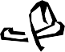

© Learning Street

I PROMISE

I know all these 10 words.

Signed:
……………………………
CMW/4

150 Commonly Misspelt Words

- Remember to check each word and tick it if it is correct. ✓
- You must do this as you go along, not at the end!
- Say the word out loud each time you write it.
- Write each word out 4 times, the more you write it out the better.

It’s really important to learn how to spell these words because mistakes are often made here. Challenge yourself to make a special effort to learn them thoroughly.

Look Cover Write Check

Look/Learn/Cover | Write/Check 1 | Write/Check 2 | Write/Check 3 | Write/Check 4
definite
description
desperately
develop
diamond
difference
difficulty
disappear
disappearance
disappointed

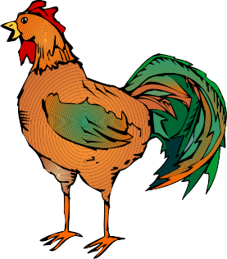LCWC/4
Try using any new words you have learnt in conversation, look out for them when you are reading.
© Learning Street

- These words have come up before in 11 Plus past papers and may come up again.
- Insert the right word into each sentence. Watch out because some words will fit more than one sentence but there is only one solution. Use your logic skills to re-adjust if you go wrong.
- If you don’t know any of the words then add them to your weekly vocabulary sheet.
sanitary
betray
candidate
liable
convey
deposit
arouse
decline
credit
caution
wasteful
expel
consent
absurd
oppose
- There are many residents who plans to build a new supermarket on the
street.
- It is particularly important to maintain a environment in a hospital.

- The company was to be sued if they didn’t follow the law correctly.

- The Head Teacher threatened to the naughty pupil.

- She was the perfect for the job.

- He found it absolutely that his flight was delayed by four hours.

- He was so full that he had to his host’s offer of another scoop of ice
cream.
- He could not accurately his feelings in writing.

- It was exceptionally to throw away so much food.

- She needed her parents’ to go on the school trip.

- She didn’t want to her friend’s trust.

- He was a to his school.

- They had to the money into the bank.

- The Police Officer issued a _ _ _ _ _ _ _ .

- They tried not to any suspicion.
Marks /15

© Learning Street

WFPP/7



Some words have more than one meaning. They are called homographs.

For example:
I will show you how it is done. They went to the theatre to see a show.
jar hamper jet lap jam keep hide hop iron lace
  - Write in the word from the list above to complete the meaning:
- She filled the with goodies .
She was sure the weather would them.

- They played and seek.
is tanned and made into leather goods.

- He tried to on one leg.
The flower of the plant is used to make beer.

- The shirt really did need an .
Eating spinach is a great way to boost your levels.

- He spread the on the bread. The traffic was 3 miles long.

- She dropped the jam .
She felt a when the car went over the pothole.

- The flew through the sky.
She used the wash to clean her car.

- She wanted to the necklace. The castle was built in 1594.

- She asked me to her shoes. The tablecloth was made of .

- The child sat on her father’s . One more and she was finished.

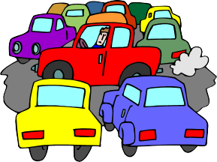

Jam

HG7 © Learning Street

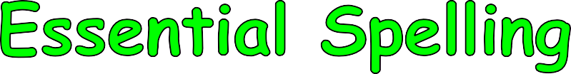

Learn these words. Test yourself using the look, learn, cover, write, check method.

Look/Learn/Cover | Write/Check 1 | Write/Check 2 | Write/Check 3
build
earth
heart
naughty
purpose
thought
busy
business
height
notice
quarter

Choose from the words you have just learnt and use each a maximum of once to fill in the sentences below.
(Some words may not be needed)

1/ Long ago people
the
was flat.

2/ The
indicated the
limit for vehicles.

3/ There were four of us so I got a cake.
of the shaped

4/ His kept him very .

5/ It was permission.
to
a house without getting planning

Fill in the gaps to find the word meaning the OPPOSITE of the word below.
idle | _ _ _ _ |  | depth | _ _ _ _ _ _
obedient | _ _ _ _ | _ _ _ | ignore | _ _ _ _ _ _

ES7 © Learning Street


Contractions using an apostrophe
Contractions
FOLD

1. we are |  | we’re
2. they are |  | they’re
3. I will |  | I’ll
4. he will |  | he’ll
5. she will |  | she’ll
6. you will |  | you’ll
7. who will |  | who’ll
8. they will |  | they’ll
9. all is |  | all’s
10. did not |  | didn’t
11. do not |  | don’t
12. has not |  | hasn’t
13. have not |  | haven’t
14. he would |  | he’d
15. I would |  | I’d
16. over |  | o’er
17. shall not |  | shan’t
18. that is |  | that’s
19. whatever |  | whate’er
20. wherever |  | where’er

SCORE 1st attempt 2nd attempt

© Learning Street

Apos/9



Write the passage, making contractions from the words
underlined.
We are going to have to go shopping today before lunch. I will have to make sure I write a list before I go so I do not forget anything. You will have to remind me to take it. Lucy said that they will get here around 1pm, but she said she will call us when they are about ten minutes away. They have not let me know if they have any allergies so I will have to be prepared. I would like to start cooking by 12pm or I shall not be ready in time. We need to decide who will set up the table as well because I would like to stay in the kitchen. So that is the plan.

© Learning Street

Apos/10

Find the Mistakes (time to get your red pen out!)

I. Ian Beck’s school work for marking

I think that football is a beautifull game. Watching a skillful passige of play by my team is a wonderfull site. It is thrilling to see an artfull player dribling the ball passed the opposing defenders and then beeting the gaolkeeper. Every team strives for success so that it can fullfil the exspectations of it’s supporters.
I also think it can be an ugly game. Some footballers are very aggresive and they break the rules willfully. This is anoying and wasteful. Dangerous tackles can cause painfull injuries and I hate seeing a player being carried of on a strecher. Especialy if he is one of my team!

How many mistakes in spelling or grammar did you spot?

© Learning Street

Revision Anagrams – Jumbled Letters

- This exercise uses words you have recently learnt.
- Use the clues to help you sort the letters out to find the answer.
- If you are not sure of a word (spelling or meaning) add it to your own personal vocabulary list.

Question | Clue | Answer
1. rested | To abandon someone or something.
2. idcufflit | When something is hard.
3. belied | The opposite of inedible.
4. finetide | Something that is absolutely certain.
5. predictions | To explain how something is.
6. eveplod | To improve something.
7. moandid | A sparkly precious stone often seen in jewellery.
8. rainysat | Relating to health or the protection of health.
9. upperso | Similar to function.
10. retruaq | Divide one by four.
11. impatientponds | When something does not meet your expectations.
12. niceled | No.
13. anythug | Bad behaviour.
14. hepram | A basket for a picnic.
15. drabus | Similar to bizarre.

© Learning Street

Anagrams/13


Crossword Revision Puzzle
You have recently learnt all these words. Use the clues to solve the puzzle. Please revise any you are not sure of.

 |  |  |  |  |  |  |  |  |  |  |  |  |  |  |  |  |  |  | 1
 |  |  |  |  |  |  |  |  |  |  |  |  |  | 2 |  |  |  |  | U
 |  |  |  |  |  |  |  |  |  |  |  |  |  | R |  |  |  |  | I
 |  |  |  |  |  |  |  |  |  |  |  | 3 |  |  |  |  |  |  | O
 |  |  |  |  |  |  |  |  | 4 |  |  | 5 |  | D |  |  | V | O |  | R
 |  |  |  |  |  |  |  |  | L |  |  |  |  | E
 |  |  |  |  |  |  |  |  |  |  |  |  |  |  |  |  | 6
 |  |  |  |  |  |  |  |  |  |  |  |  |  | 7 |  |  | I | N | U |  |  |  | E
 |  |  |  | 8 |  |  |  | 9 | E |  | E | S | T
 |  |  |  | E |  |  |  | I |  |  |  |  |  |  |  |  | A
 |  | 10 | U | S |  |  |  | S | S |  |  |  |  |  |  |  | P |  |  |  |  |  | 11
 |  |  |  |  |  |  |  |  |  |  |  |  |  |  |  |  |  |  |  |  |  |  | O
 |  |  |  |  |  |  | 12 | E | M |  |  |  |  | R |  | T | E
 |  |  |  |  |  |  |  | S |  |  |  | 13
 |  |  |  | T |  |  |  | 14 | M |  |  | E |  | T |  |  |  |  |  |  | 15 |  | K
 |  |  |  | E |  |  |  |  |  |  |  | F |  |  | 16 | A | N |  | I |  | A |  | E
 |  |  |  | L
 |  |  |  | Y |  | 17 | E | N |  |  |  | C | E |  |  |  | E
 |  |  |  |  | 18 | H |  | R |  |  |  | E |  |  |  |  |  |  |  |  | F
 |  |  |  |  |  |  |  |  |  |  |  |  |  |  |  |  |  |  |  |  | U
 |  |  |  |  |  |  |  |  |  |  |  | C |  |  |  |  |  |  |  |  | L
 |  |  |  |  |  |  | 19 D |  |  |  | S | Y
Clues across
5. To try to do something.
7. Very small.
- To dislike something or someone intensely.
- A commercial or industrial enterprise.
12. A synonym of show.
14. Famous and/or respected.
- A person who is seeking something, perhaps a job.
- To speak out against something. Similar to condemn.
- When there is not enough of something.
- Half asleep.
Clues down
- Open to doubt.
- To speak of someone or something with contempt.
- Similar to hate.
- Similar to escape.
6. The act of leaving secretly or without explanation.
- Undertaken as a last resort.
- To distribute something loosely.
11. To abandon something.
13. Lacking.
15. The act of using too much of something.
© Learning Street




These questions are a test of vocabulary and spelling. Students with a wider vocabulary will perform better. Don’t forget, as well as practising your technique you should also work to widen your vocabulary.

The question
Move one letter from the word on the left into the word on the right to make two new words.
drain iced
The answer
rain diced

Technique
Very often you will find you can get to the answer with a quick glance. If not, then you need to work methodically through.
The key point to remember is that when you remove a letter you still need the word on the left to make sense. DO NOT THINK ABOUT THE RIGHT HAND WORD UNTIL YOU ARE SURE WHICH LETTER YOU CAN TAKE FROM THE WORD ON THE LEFT.
So in this case:
drain – D = Rain – Possible drain – R = Dain – Possible drain – A = Drin – No drain – I = Dran – No drain – N = Drai – No
So the two options are D and R.
Next try and fit these into ‘ICED’ to make a new word.

© Learning Street




Trying ‘R’ the options are RICED, IRCED, ICRED, ICERD, ICEDR – None of which are
words. So the new word must be formed using ‘D’.
The options are DICED, IDCED, ICDED, ICEDD. DICED is the answer.
Where vocabulary is weak and pupils are unsure in this case, their two possibilities might be RICED and DICED.
In this case they will need to opt for one or the other but will do so having gone through a process to narrow their options.

© Learning Street




Now try these questions:
Move one letter from the word on the left and put it into the word on the right. Two new words should be created.
- cream pins

- shave oar

- pleat how

- spare trip

- slate barn

- aural mode

- reach band

- greed rein

- could sop

- close hill

© Learning Street

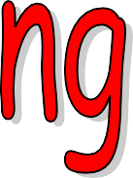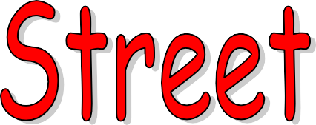

VERBAL REASONING
CEM STRETCH COMPREHENSION TEST

Name:
Date of Birth:
Today’s Date:

READ THESE INSTRUCTIONS CAREFULLY BEFORE STARTING.

  - This short test contains a reading comprehension exercise, followed by some additional questions on spelling and punctuation mistakes.
  - These are two of the question types that CEM uses in their multiple choice verbal reasoning tests.
  - Try to do the test in as close to exam conditions as possible.
  - The time allowance is 40 minutes. Try to spend approximately 30 minutes on the reading comprehension exercise, and 10 minutes on the spelling and punctuation mistakes.
  - Work as quickly as you can throughout the paper.
  - Do move on if you cannot do a question but mark it to come back to.
  - As this is multiple-choice make sure you have a go at every question. If you
don’t have a go, you can’t get a mark.

© Learning Street
www.learning-street.org © Learning Street 2016 © Learning Street 2016 © Learning Street 2016 © Learning Street 2016 © Learning Street 2016

THE SECRET GARDEN – Frances Hodgson Burnett

The extract is taken from a story about a girl called Mary who is orphaned and sent to live with her uncle in Yorkshire, having been living in India with her parents. Her uncle’s home is a huge old manor house with acres of land. Mary soon hears from the servants of the house about a secret garden somewhere in the grounds of the manor, and she eventually finds it for herself.

Mary skipped round all the gardens and round the orchard, resting every few minutes. At length she went to her own special walk and made up her mind to try if she could skip the whole length of it. It was a good long skip and she began slowly, but before she had gone half-way down the path she was so hot and breathless that she was obliged to stop. She did not mind much, because she had
5 already counted up to thirty. She stopped with a little laugh of pleasure, and there, lo and behold, was the robin swaying on a long branch of ivy. He had followed her and he greeted her with a chirp. As Mary had skipped toward him she felt something heavy in her pocket strike against her at each jump, and when she saw the robin she laughed again.

“You showed me where the key was yesterday,” she said. “You ought to show me the door today;
10 but I don’t believe you know!”

The robin flew from his swinging spray of ivy on to the top of the wall and he opened his beak and sang a loud, lovely trill, merely to show off. Nothing in the world is quite as adorably lovely as a robin when he shows off–and they are nearly always doing it.

Mary Lennox had heard a great deal about Magic in her Ayah’s stories, and she always said that
15 what happened almost at that moment was Magic.

One of the nice little gusts of wind rushed down the walk, and it was a stronger one than the rest. It was strong enough to wave the branches of the trees, and it was more than strong enough to sway the trailing sprays of untrimmed ivy hanging from the wall. Mary had stepped close to the robin, and suddenly the gust of wind swung aside some loose ivy trails, and more suddenly still she jumped
20 toward it and caught it in her hand. This she did because she had seen something under it–a round knob which had been covered by the leaves hanging over it. It was the knob of a door.

She put her hands under the leaves and began to pull and push them aside. Thick as the ivy hung, it nearly all was a loose and swinging curtain, though some had crept over wood and iron. Mary’s heart began to thump and her hands to shake a little in her delight and excitement. The robin kept
25 singing and twittering away and tilting his head on one side, as if he were as excited as she was. What was this under her hands which was square and made of iron and which her fingers found a hole in?

It was the lock of the door which had been closed ten years and she put her hand in her pocket, drew out the key and found it fitted the keyhole. She put the key in and turned it. It took two hands
30 to do it, but it did turn.

And then she took a long breath and looked behind her up the long walk to see if anyone was coming. No one was coming. No one ever did come, it seemed, and she took another long breath,
© Learning Street 1

because she could not help it, and she held back the swinging curtain of ivy and pushed back the door which opened slowly–slowly.

35 Then she slipped through it, and shut it behind her, and stood with her back against it, looking about her and breathing quite fast with excitement, and wonder, and delight.

She was standing inside the secret garden.

It was the sweetest, most mysterious-looking place any one could imagine. The high walls which shut it in were covered with the leafless stems of climbing roses which were so thick that they were
40 matted together. Mary Lennox knew they were roses because she had seen a great many roses in India. All the ground was covered with grass of a wintry brown and out of it grew clumps of bushes which were surely rose-bushes if they were alive. There were numbers of standard roses which had so spread their branches that they were like little trees. There were other trees in the garden, and one of the things which made the place look strangest and loveliest was that climbing roses had run
45 all over them and swung down long tendrils which made light swaying curtains, and here and there they had caught at each other or at a far-reaching branch and had crept from one tree to another and made lovely bridges of themselves. There were neither leaves nor roses on them now and Mary did not know whether they were dead or alive, but their thin grey or brown branches and sprays looked like a sort of hazy mantle spreading over everything, walls, and trees, and even brown grass,
50 where they had fallen from their fastenings and run along the ground. It was this hazy tangle from tree to tree which made it all look so mysterious. Mary had thought it must be different from other gardens which had not been left all by themselves so long; and indeed it was different from any other place she had ever seen in her life.

55
Please answer the questions on the following page

© Learning Street 2

Questions
Answer by circling the letter next to your chosen response.
- The robin guides Mary towards the door of the secret garden, but what did he lead her to find the day before? Choose the correct item:

  - The map to the garden
  - The key
  - A gold watch
  - The window of the garden

- What do you think Mary can feel in her pocket in lines 6-7? Choose one item:

  - Her mobile phone
  - The key to the garden
  - A pebble she found on a walk

- Choose which sentence explains how we know that Mary believes in magic:

  - Because the robin told her it was real
  - Because she has watched many programmes about magic
  - Because her father was a magician
  - Because her nanny in India told her stories about magic

- There is a strong wind outside before Mary discovers the secret garden. Choose what two things the wind was strong enough to do. Look at lines 16 – 18 for your answer:

  - It was strong enough to make Mary unsteady on her feet
  - It was strong enough to wave the branches of the trees
  - It was more than strong enough to sway the trailing sprays of untrimmed ivy hanging from the wall
  - It was more than strong enough to force the petals off the flowers

- The robin seems excited by Mary’s discovery. Which of the following does the robin do that suggests he is excited? Look around line 25 and choose one answer:

  - The robin kept flying around in circles
  - The robin kept singing and twittering away and tilting his head on one side
  - The robin was smiling at Mary

- The trailing ivy in front of the door to the secret garden is described as ‘a loose and swinging curtain.’ What technique is being used here? Choose one answer:

  - Metaphor
  - Repetition
  - Simile
  - Personification

© Learning Street 3

- Which part of the door to the secret garden does Mary spot first?

  - The letterbox
  - The door step
  - The door knob

- Read lines 22-26 and identify which of the following Mary does that tells us she is excited about finding the door:

  - Mary began to jump up and down excitedly
  - Mary’s heart began to thump and her hands to shake a little

- How long has the garden been left for? Choose the correct answer:

  - One hundred years
  - Twenty years
  - Ten years
  - Five years

- What three things does Mary feel when she finally enters the secret garden and leans against the door, breathing heavily? Choose the correct three words:

  - Fascination
  - Excitement
  - Wonder
  - Amazement
  - Delight

- Choose the correct answer: the secret garden is full of:

  - Daffodils
  - Roses
  - Hyacinths
  - Lilies

- Why does Mary recognise this particular flower? Choose the correct reason:

  - She had seen lots of them in India
  - They were her mother’s favourite flowers
  - She has a book on flowers and saw it in there
  - Her bedroom was painted with that pattern

© Learning Street 4

- Why do you think Mary finds the garden so mysterious? Choose the four correct statements:

  - The fact that the flowers and plants have grown wild and covered the whole garden
  - The fact that she has never seen a garden like this in her life
  - Because there are so many animals in the garden
  - It reminds her of India a little
  - It reminds her of a holiday she once went on
  - The fact that the garden is full of dead plants and bushes as well as living flowers and plants

- Identify which three of these adjectives are used in the final paragraph. Choose the correct answers:

  - Smallest
  - Sweetest
  - Tiniest
  - Prettiest
  - Loveliest
  - Strangest
  - Nicest

- What technique is being used in the following quotes from the final paragraph? Choose the correct answer:

“Climbing roses had run all over them” “Swung down long tendrils”
“They had caught at each other” “Crept from one tree to another” “Run along the ground”

  - Simile
  - Metaphor
  - Personification
  - Onomatopoeia

- What type of word is ‘obliged’?

  - pronoun
  - adjective
  - adverb
  - verb

- If you are ‘obliged’ to do something, what does this mean?

  - you want to do it
  - you are forced to do something
  - you are being paid to do something
  - you have a choice if you do it

© Learning Street 5

- Choose the two pronouns in this list:

  - He
  - Mary
  - She
  - What

- Which word from the title of the story, ‘The Secret Garden’, is an adjective?

  - The
  - Secret
  - Garden

- Synonyms for the word ‘suddenly’ include ‘immediately’ and ‘instantly’. But what type of words are these?

  - nouns
  - verbs
  - adjectives
  - adverbs

© Learning Street 6

Oliver Twist
In the following passage there are some spelling mistakes. On each numbered line there is either one mistake, two mistakes or no mistakes. Each line is divided into groups of words with a letter underneath. If there is a mistake, ring the correct letter(s). If there is no mistake ring X.



















- He had dimminished the distance between himself and London by full four miles

A | B | C |  | D X
22) more, before he | recolected how much | he must undergo |  | ere he could hope to
A | B | C |  | D | X
23) reach his place of | destination. As this | considaration forced |  | itself upon him, he
A | B | C |  | D | X
24) slackened his pace | a little, and meditated |  | upon his means of | getting there. He had
A | B |  | C | D X
25) a crust of bread, a | coarse shirt, and two |  | pairs of stockings, | in his bundle. He had
A | B |  | C | D X
26) a penny too—a | gift of Sowerberry's after |  | some funeral in which he had accquitted
A | B |  | C D |  | X
27) himself more than | ordenarily well—in his |  | pockit. 'A clean shirt,' thought Oliver,
A | B | C |  | D | X
28) 'is a very comfortable thing; and so are two pears of darned stockings; and so is a
A | B | C |  | D | X
29) penny; but they | are small helps to a | sixty-five miles' walk |  | in wintar time.'
A | B | C |  | D | X



















In the following sentences, there are either one or two mistakes in punctuation. Rewrite each sentence using the correct punctuation in the space provided.

- The two boy's rucksacks were found in the forest.

- I can see: only one thing the old farmhouse.

- My favourite books are: ‘Harry Potter’ and 'The Hunger Games'.

- The children’s’ books and pencil cases were put in their bag’s.

© Learning Street 7

VERBAL REASONING VARIETY TEST 3
- Inside the brackets write the letter which will end the first word and begin the second.
Marks

T O M ( …. ) R I B E .........
- Complete this analogy.
RED is to STOP as ......................... is to GO .........
- Underline the word which cannot be made from some or all of the letters of the word OPERATIONAL, using each letter not more than once.

PARTIAL TROOP PORTION PRONE REPORT .........
- Which letter of the alphabet is immediately after the fourth vowel? ……. .........
- Write one word to continue this series.
pan, panic son, sonic class, ........................ .........
- Write the next two letters in this series.
CX DW EV FU .............. .............. .........
- Underline the word which would come in the middle if these words were

arranged in alphabetical order.
purple pumpkin puma pullet purity
- Inside the brackets write the word of four letters which will complete all five words.
.........

. . . . some . . . .over . . . . shake . . . . stand . . . .bag ( . . . . ) .........
- Underline the two words below which are opposite in meaning.
slow strict stern shallow swift swerve .........

- In a certain code QRSTUV stands for GARDEN. What would DANGER be in the same code?
.........

( )
- Underline the word which does not fit in with the others.
colt stallion foal filly ewe mare .........
- Write the word which has both these meanings.

  - the field where cricket is played
  - a black tarry substance used to treat wood. ( )
.........

- If 4658912 means GRANITE, then 1256984 means ......................... .........

Marks
- Underline the word which is similar in meaning to the word in capitals.

FRAGILE: lively complicated supple delicate robust .........
- Inside the brackets, write the word which will finish the incomplete word.

A carp is someone who is skilled at woodwork. ( )
16 Write the word which can be made from some or all of the letters in the word COLLAPSE, using each letter not more than once.
.........

CAPSULE PLEASE SCALLOP POLICE PEOPLE (..................) .........
- In the sentence below, eight consecutive letters spell a word meaning ‘good-looking’. Write this word inside the brackets.
The meal consisted of raw fish and some stodgy rice (..................) ........
- Rearrange the letters of the word in capitals to form a word which corresponds to the given meaning.
EVER: To swerve, or to change direction. (..................) .........
- How many more consonants than vowels are there in the word AMBIDEXTOROUS
(..................) .........
- The same three letters are in all the words below. Make a word from them.
WRAPPING LAWNMOWER WANDER HAWKER WRANGLE
(..................) .........
- On the dotted line write the word which completes the sentence and which rhymes with the word in capitals
ROOM: In the church was the ............ of an ancient warrior .........
- Underline the two words which should change places in order that the sentence below should be correct.
When the player blew his whistle the referee kicked the ball. .........
- Notice how the second word of each pair is formed from the first, then write the missing word.
gamble, game current, curt minute, .................... .........
- In the space write the missing word, which is formed by rearranging the letters of the word underlined.

He claimed the cost of the hospital treatment on his ................... insurance.
- Make a word from the letters which remain after the words NAP and RENT have been taken out of the word PERMANENT.
.........

( )
.........



Look at number 3. Rule: What you do to the bottom you do to the top.
Go for 20

- Factors of 15. Start with 1.
11. 9 x 8 =
out of 20 this week

- Is 9 a PRIME number? Yes/No 12. 1
5
2
m = cm

- 4
=
5
? 100
13. 64 =

- 6.8 ÷ 10 = 14. 7.6 ÷ 100 =
8


5. 6.1
6.2

Find the PERIMETER

=
5

- Is 7 a PRIME number? =

6.
This is an angle
16. 1
6
of 36 + ¹
of 25 =

7. 1
3
5

Kg =
g 17. 9² =

8.
4.8 + 7.9 =
  - What is this shape called?


9.
12m Find the area
  - Is 5 a PRIME number? =

10.
10m =

5² - 2² =

  - c
a b
d

Is the line ab parallel to cd?

YES/NO


Marks this week:……………
© Learning Street



Prime numbers are special numbers because they can only be divided by itself and 1.
2 is the first Prime Number.

1 | 2 | 3 | 4 | 5 | 6 | 7 | 8 | 9 | 10
11 | 12 | 13 | 14 | 15 | 16 | 17 | 18 | 19 | 20
21 | 22 | 23 | 24 | 25 | 26 | 27 | 28 | 29 | 30
31 | 32 | 33 | 34 | 35 | 36 | 37 | 38 | 39 | 40
41 | 42 | 43 | 44 | 45 | 46 | 47 | 48 | 49 | 50
51 | 52 | 53 | 54 | 55 | 56 | 57 | 58 | 59 | 60
61 | 62 | 63 | 64 | 65 | 66 | 67 | 68 | 69 | 70
71 | 72 | 73 | 74 | 75 | 76 | 77 | 78 | 79 | 80
81 | 82 | 83 | 84 | 85 | 86 | 87 | 88 | 89 | 90
91 | 92 | 93 | 94 | 95 | 96 | 97 | 98 | 99 | 100

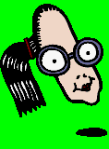
Have a good look at these Prime Numbers before you solve the puzzle by colouring in all the
Prime Numbers on the next sheet.
Try not to peep when you start!

© Learning Street

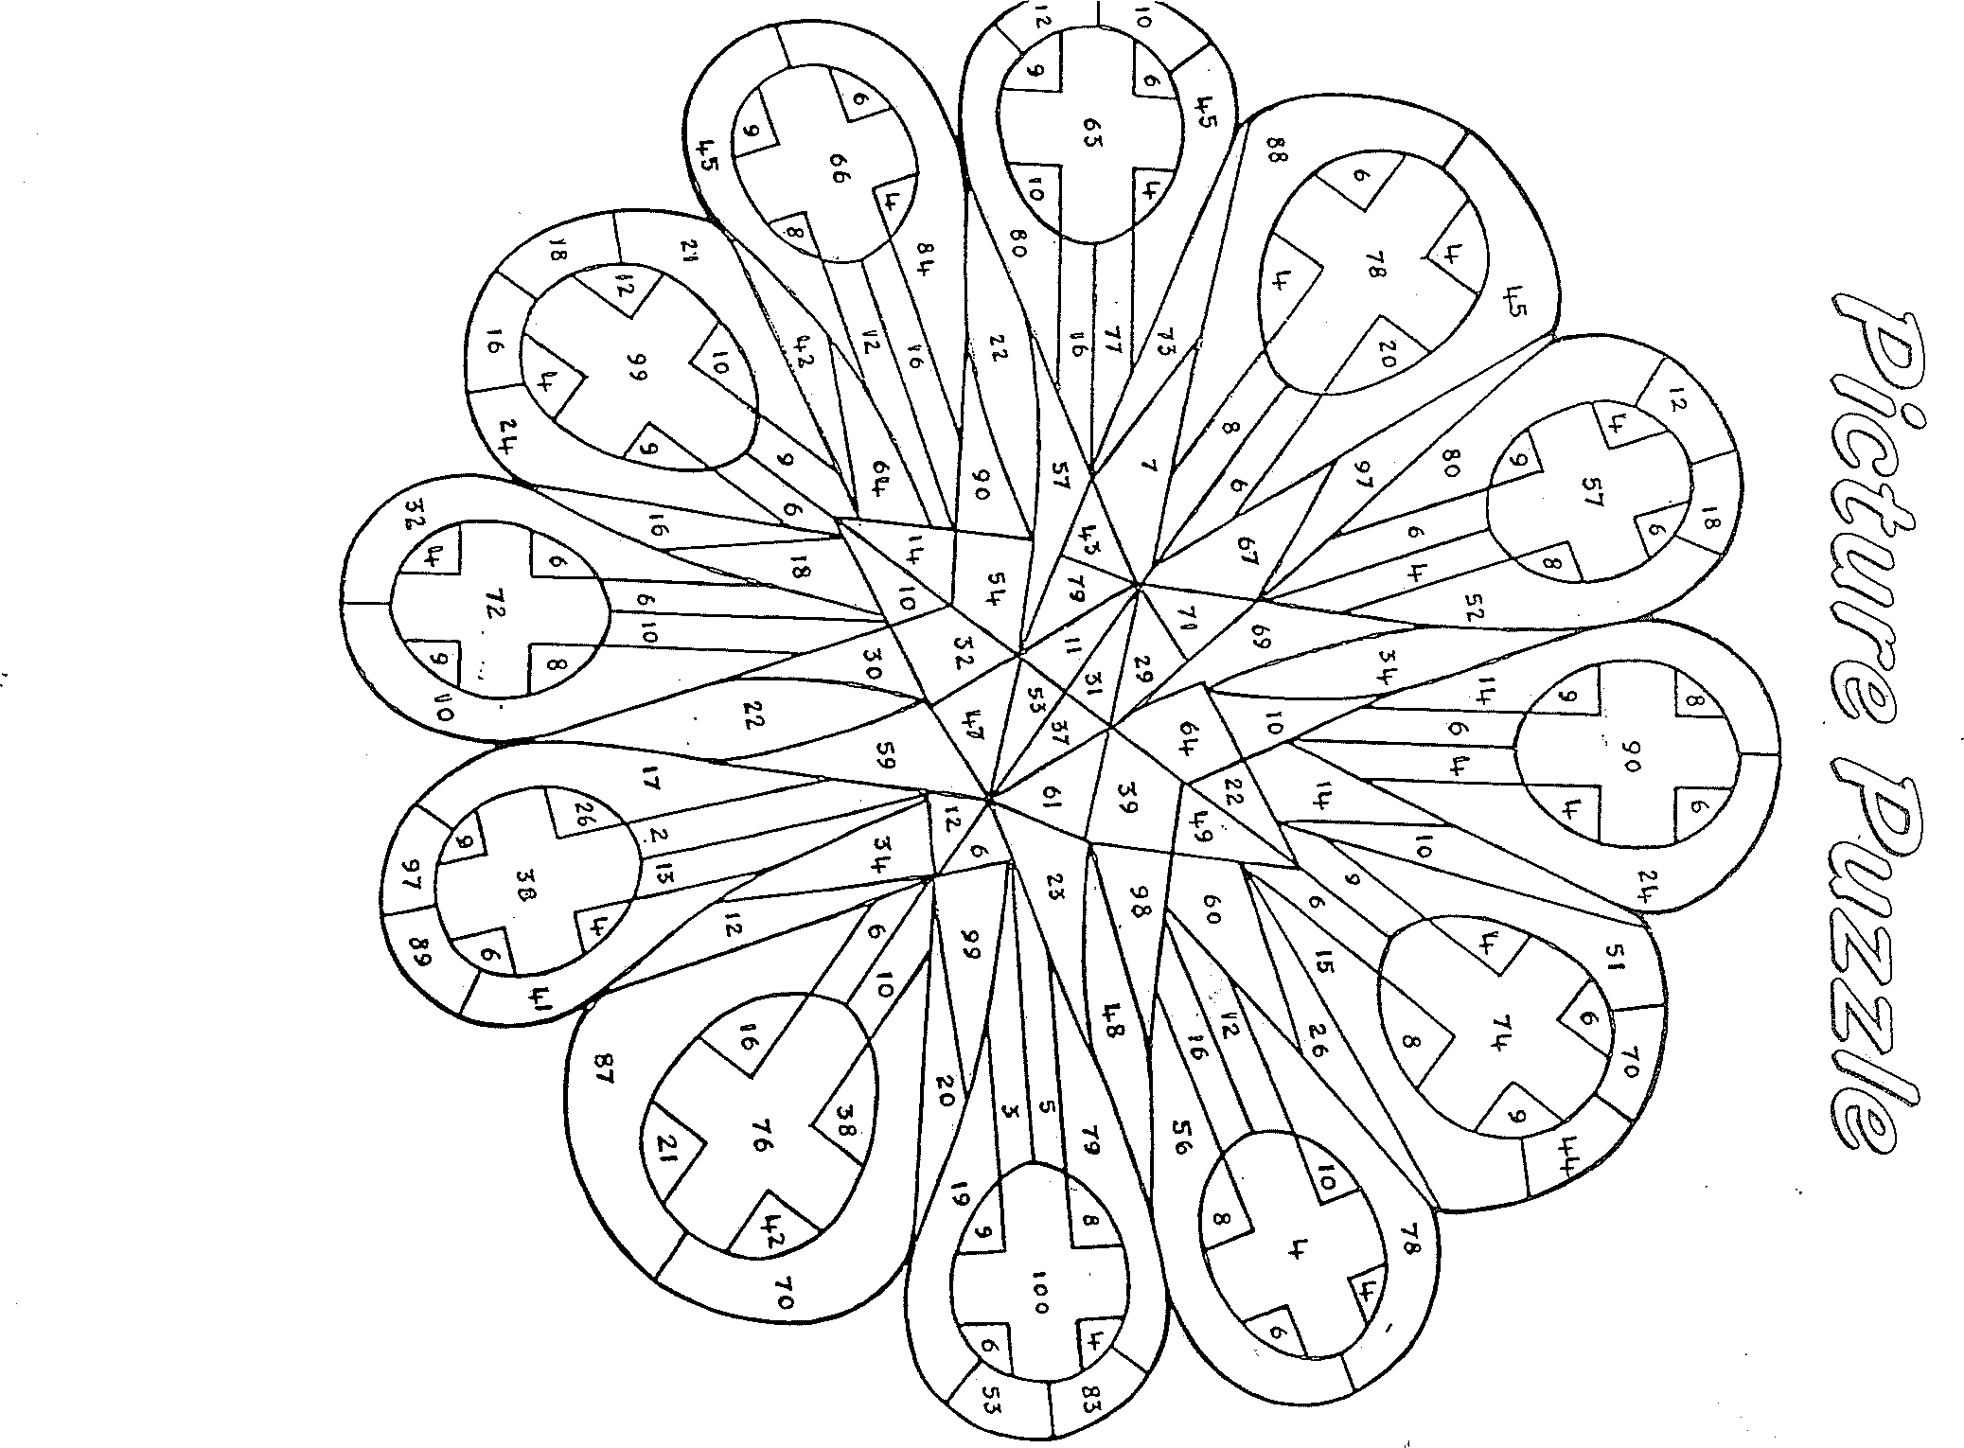



REVISION OF FACTORS
It is important to be good at factors.
Try these.

Remember to start with 1 and end with itself.

Find the factors of: | Answers – Cover up!
24 = | 1, 2, 3, 4, 6, 8, 12, 24
36 = | 1, 2, 3, 4, 6, 9, 12, 18, 36
12 = | 1, 2, 3, 4, 6, 12
14 = | 1, 2, 7, 14
9 = | 1, 3, 9
20 = | 1, 2, 4, 5, 10, 20
26 = | 1, 2, 13, 26
27 = | 1, 3, 9, 27
21 = | 1, 3, 7, 21
15 = | 1, 3, 5, 15

Marks: ……………………….

When we start Fractions you will find them easy now that you are cool on factors.

© Learning Street

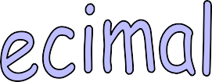

Trick question: What can eat as much as it wants and never grow fat?
Use this key to find the answer:

A | E | H | I | L | M | N | O | S | T | Y
78.24 | 27.6 | 6.095 | 18.375 | 6.95 | 6.102 | 69.5 | 78.42 | 79.79 | 27.675 | 76.144

- The difference between 128.1 and 49.86
What to do: Carefully work out each sum.
The answer will correspond to a letter above.

Put the letter in the appropriate box below to get the answer to the trick question!
- 7 thousandths greater than 6.095
- Twice 39.21
- The sum of 18.095 and 9.58
- 3.85 less than 9.945
- The difference between 35 and 16.625
- By how much is 37.255 greater than 9.58?
- 2 hundredths greater than 78.4
- 6.95 multiplied by 10
- 4 hundredths less than 6.99
- The sum of 15.8, 23.75 and 36.594
- Five – tenths less than 28.1
- 26.5 greater than 51.74
- Add 14.06 to 13.615
- The sum of 36.83 and 42.96
- Add five – thousandths to 6.09
- Multiply 7.842 by 10
- Add nine – tenths and five – hundredths to 6
- Multiply 0.276 by 100
- 0.21 less than 80

-
7.
6.
1.
2. | 3. | 4. | 5.

8. | 9. | 10. | 11.

12. | 13. | 14. | 15.


16. | 17. | 18. | 19. | 20.

© Learning Street

( Answer: A MOTH – IT ONLY EATS HOLES! )



Facts:

  - A rhombus is made from two equilateral triangles.
Draw two equilateral triangles joined together and you have made a rhombus.

  - An equilateral triangle has equal sides so a rhombus has equal sides. It is like a square that has been pushed over to one side.
Take note: A square and a rhombus are not the same because a square has right angles and a rhombus has acute and obtuse angles. This is important!

  - The opposite sides are parallel, like railway tracks. You can show parallel lines using arrows. Arrows denote a pair of parallel lines, and must go in the same direction.
See the arrows?

Look at the diagram. A rhombus has 2 pairs of parallel railway tracks. Remember - lines that go in the same direction are called parallel lines.

    - Copy this into your exercise book very neatly, using your own equilateral triangle. You constructed one last week. Write down all the important facts.

I have understood these important facts ✓ 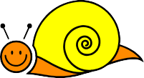

© Learning Street


Explanation
Example
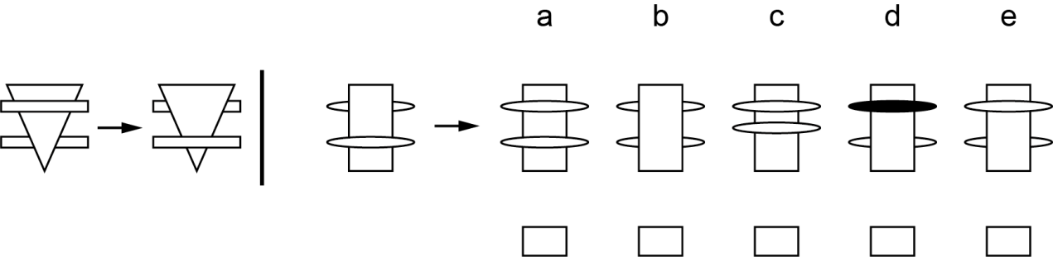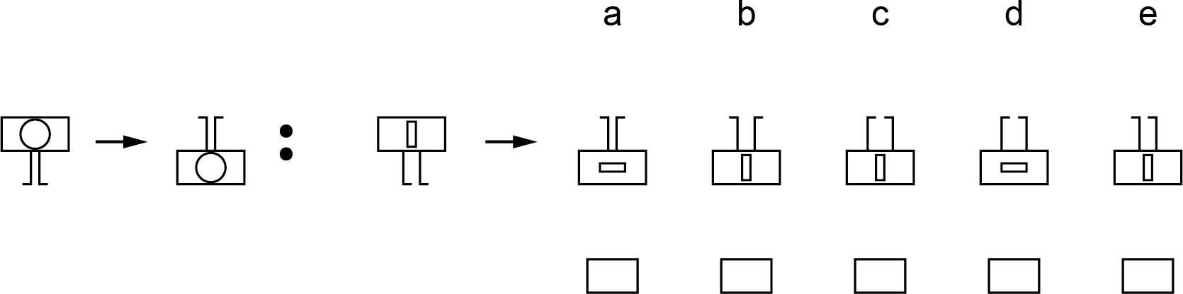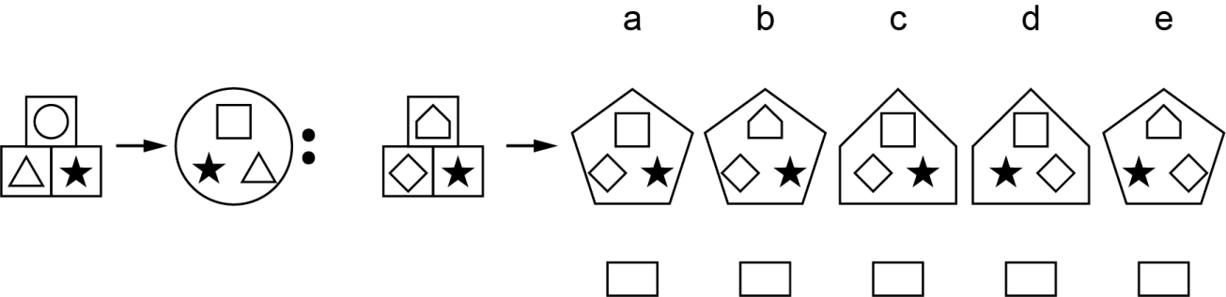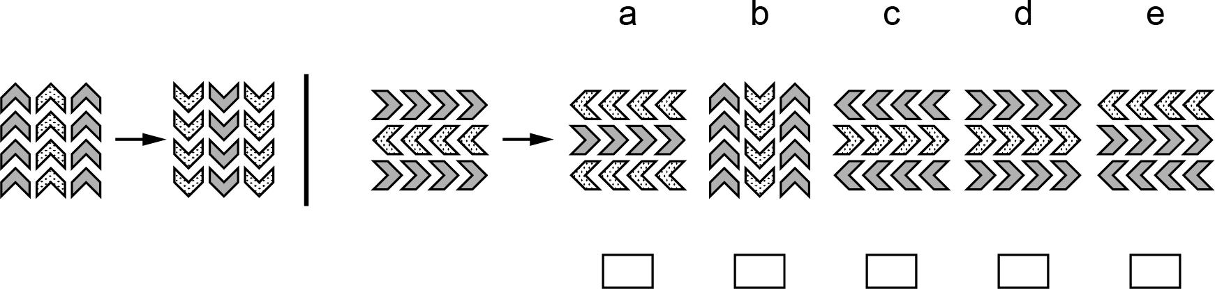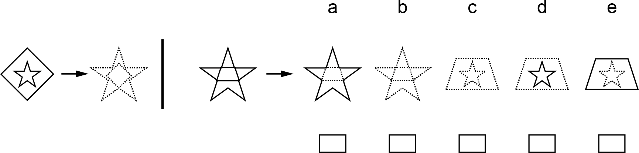
1. LIKE SHAPES / TYPE 1
There is no change in the large shape from the first set of shapes to the second. However the shape that is behind the larger moves to the front and the other shape that is in front moves behind.
1
2
3
4

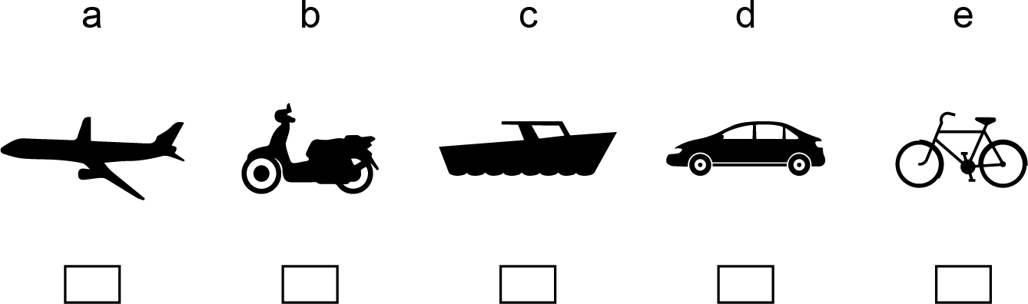
Example
Explanation
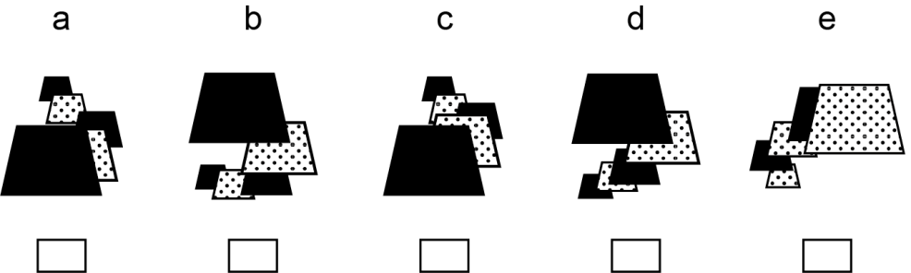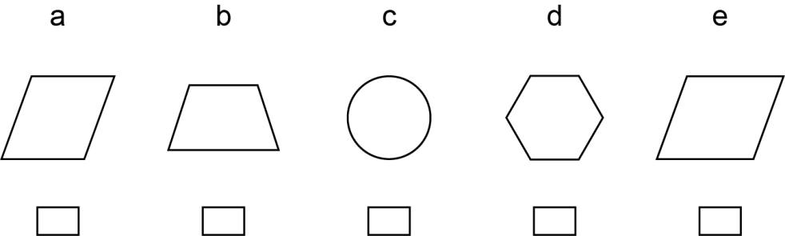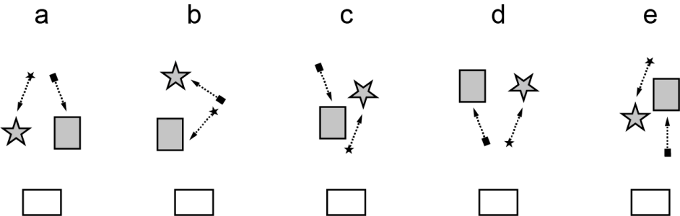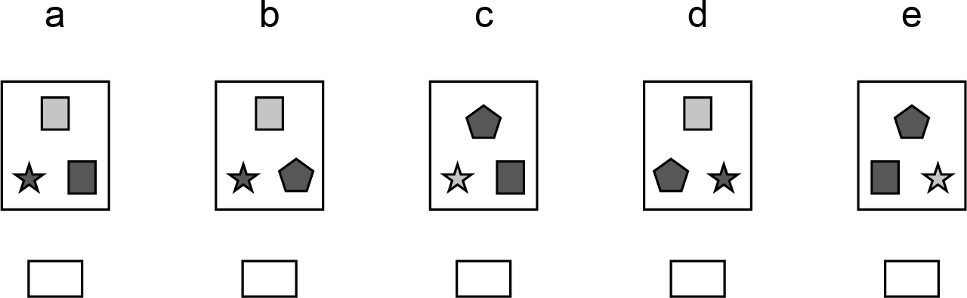
- ODD ONE OUT / TYPE 2
Answers A, B, C and D all start with a black shape on top then alternate between dotted and black. But E starts with a dotted shape then alternates between black and dotted.
1
2
3

4


Explanation
Example
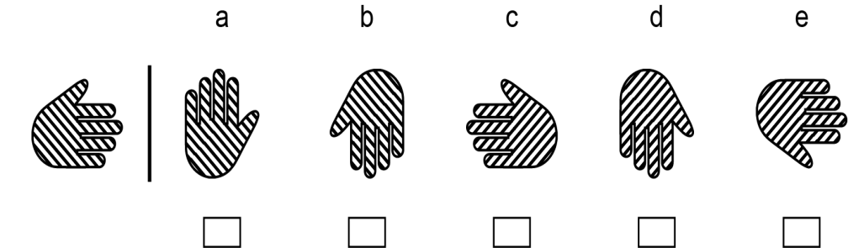
3. ROTATIONS / TYPE 3
Only one of the answers is a rotation of the original. D is the only possible answer as it is the only hand with the thumb still on the left hand side. The lines also go from the bottom left of the hand to the top right.

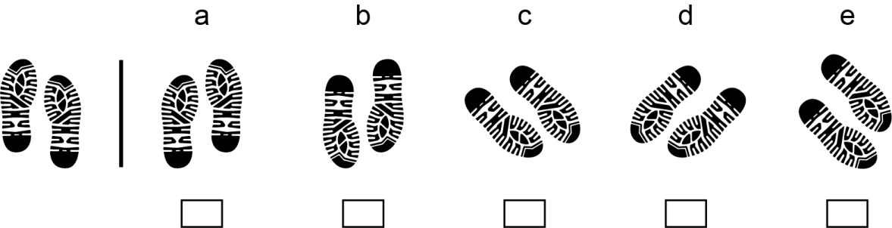
1

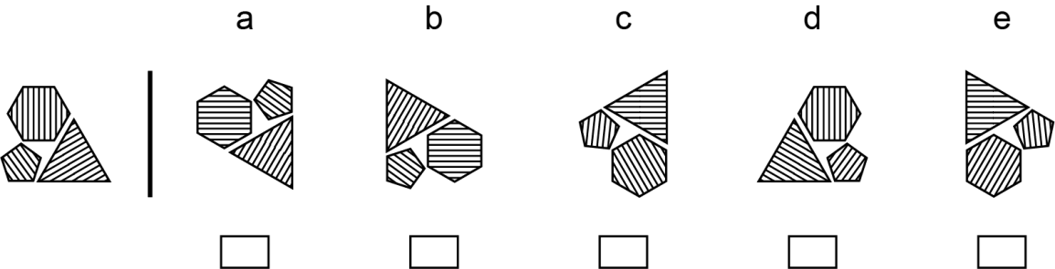
2
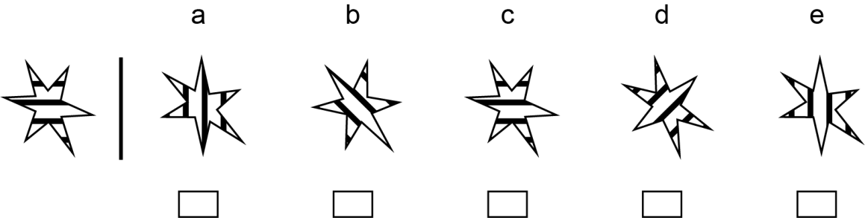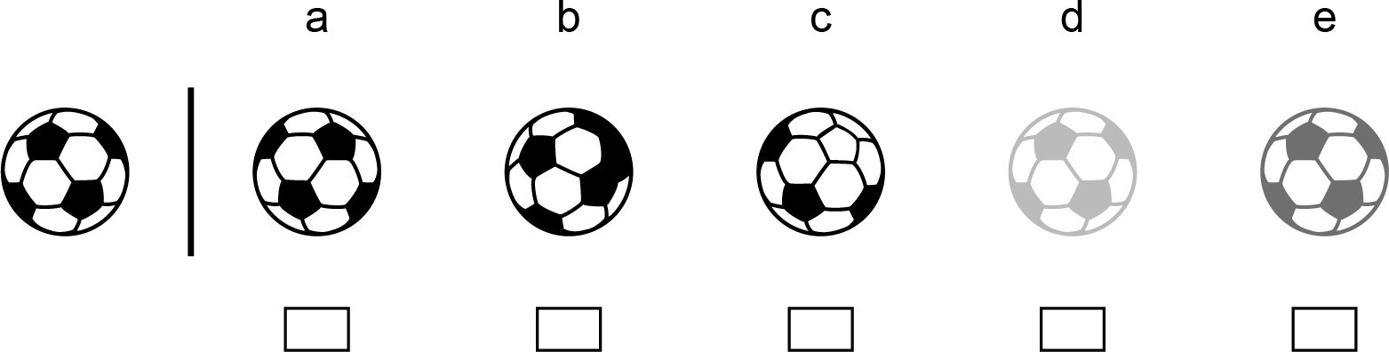
3
4

ANSWERS - COMPLETE VOCABULARY – PART 13

Synonyms Match-up
endeavour disaster denounce dubious edible elude eminent desert difficult detest diminish deride disperse dispise deficiency
demonstrate drowsy diminutive encircle dusk

Words from Past Papers
oppose sanitary liable expel candidate absurd decline convey wasteful consent betray credit deposit caution arouse

© Learning Street

Homographs
- hamper
- hide
- hop
- iron
- jam
- jar
- jet
- keep
- lace
- lap

Apostrophes
We’re I’ll don’t You’ll they’ll she’ll they’re haven’t I’ll
I’d shan’t who’ll I’d that’s

Revision Anagrams
- Desert
- Difficult
- Edible
- Definite
- Description
- Develop
- Diamond
- Sanitary
- Purpose
- Quarter
- Disappointment
- Decline
- Naughty
- Hamper
- Absurd

Crossword Revision Puzzle Down
- Dubious
- Deride
- Despise
- Elude
6. Disappearance
- Desperately
- Disperse
11. Forsake
13. Deficiency
15. Wasteful

Across
- Endeavour
7. Diminutive
- Detest
- Business
12. Demonstrate
14. Eminent
- Candidate
- Denounce
- Shortage
- Drowsy

ANSWERS - COMPLETE ENGLISH - PART 13

Essential Spelling

1/ Long ago people thought the Earth was flat.
2/ The notice indicated the height limit for vehicles.
3/ There were four of us so I got a quarter of the heart shaped cake. 4/ His business kept him very busy.
5/ It was naughty to build a house without planning permission.

busy height
naughty notice

Find the Mistakes - I
beautiful skilful
I think that football is a beautifull game. Watching a skillful passage wonderful sight
passige of play by my team is a wonderfull site. It is thrilling to artful dribbling past
see an artfull player dribling the ball passed the opposing
beating goalkeeper
defenders and then beeting the gaolkeeper. Every team strives
fulfil expectations its for success so that it can fullfil the exspectations of it’s

supporters.

I also think it can be an ugly game. Some footballers are very aggressive wilfully annoying aggresive and they break the rules willfully. This is anoying and
painful
wasteful. Dangerous tackles can cause painfull injuries and I hate
off stretcher. Especially
seeing a player being carried of on a strecher. Especialy if he is

one of my team!

© Learning Street

ANSWERS - VERBAL REASONING CEM - PART 29

Move a letter to make two new words
  - e. cram pines
  - s. have soar
  - l. peat howl
  - e. spar tripe
  - s. late barns
  - l. aura model
  - r. each brand
  - g. reed reign
  - u. cold soup
  - c. lose chill

Stretch Comprehension
    - b
    - b
    - d
    - b and c
    - b
    - a
    - c
    - b
    - c
    - b, c and e
    - b
    - a
    - a, b, d and f 14) b, e and f 15) c
- d
- b
- a and c 19) b
- d

Spelling mistake answers
- a
- b
- c
- x
- x
- d
- b and c
- c
- d

Punctuation mistake answers
- The two boys’ rucksacks were found in the forest. (The apostrophe should be at the end of the word as there are two boys)
- I can see only one thing: the old farmhouse. (The colon needs to be after the word ‘thing’ so that the phrase before the colon would make sense alone)
- My favourite books are, ‘Harry Potter’ and ‘The Hunger Games’. (A colon cannot be used as the phrase before it does not make

ANSWERS - VERBAL REASONING CEM - PART 13

- sense alone. A comma should be used instead.)
- The children’s books and pencil cases were put in their bags. (The books and pencil cases belong to the children, so only one apostrophe is needed. The bags are possessions, so an apostrophe is not needed)

Variety Test 3
- B
- green
- report
- P
- classic
- GT HS
- pumpkin
- hand
- slow swift
- TRVQUS
- ewe
- pitch
- TEARING
- delicate
- enter
- SCALLOP
- handsome
- veer
- 1
- RAW / WAR
- tomb
- player referee
- mine
- medical
- ME

ANSWERS - COMPLETE MATHS – PART 13

Maths Revision Sheet

1. 1,3,5,15.
  - No!
  - 80
  - 0.68
  - 24.6
  - acute
  - 3,200g
  - 12.7
  - 120m squared
  - 21
  - 72
  - 550 cm
  - 8
  - 0.076
  - Yes!
  - 11
  - 81
  - Parallelogram
  - Yes!
  - No!!

ANSWERS - COMPLETE NON-VERBAL REASONING – PART 13

Non-Verbal Reasoning Like Shapes
- E - (The first set of shapes is rotated 180 degrees to form the second set of shapes. While you could argue from the example that the second shape is a mirror of the first shape, none of the answers match this pattern so it must be rotated 180 degrees.)
- D - (The outer shape, the square, changes to be in an inner shape at the top of the 3 inner shapes. The top inner shape in the first set of shapes changes to be the outer shape in the second set. Finally the bottom two inner shapes swap sides.)
- A - (The arrows are rotated 180 degrees and the dotted shading changes to light shading and the light shading changes to dotted shading.)
- C - (The outer shape gets smaller and moves to become the inside shape and the inside shape becomes larger to become the outer shape. The outlines of both the shapes changes from solid to dotted.)

Odd One Out
- C - (The only shape without a straight edge is the circle which is C.)
- B - (In each answer there is an arrow pointing towards a large shape, and on the end of the arrow is a smaller version of the large shape. The odd one out is B as it has a small square pointing towards the star and a small star pointing towards the square.)
- A - (The only answer without 3 different shapes within the rectangle is A which has two rectangles and a star.)
- C - (All of the vehicles are pointing to the left except for the boat in C which is pointing to the right.)

Rotations
- C - (C is a rotation of around 135 degrees clockwise of the original.)
- E - (E is a rotation of around 225 degrees clockwise of the original.)
- C - (C is a rotation of either 0 degrees or 360 degrees of the original.)
- A - (A is a rotation of around 45 degrees anti clockwise of the original.)

© Learning Street

