Stages of sleep

Usually sleepers pass through five stages: 1, 2, 3, 4 and REM (rapid eye movement) sleep. These stages progress cyclically from 1 through REM then begin again with stage 1. One cycle lasts around 100 minutes.
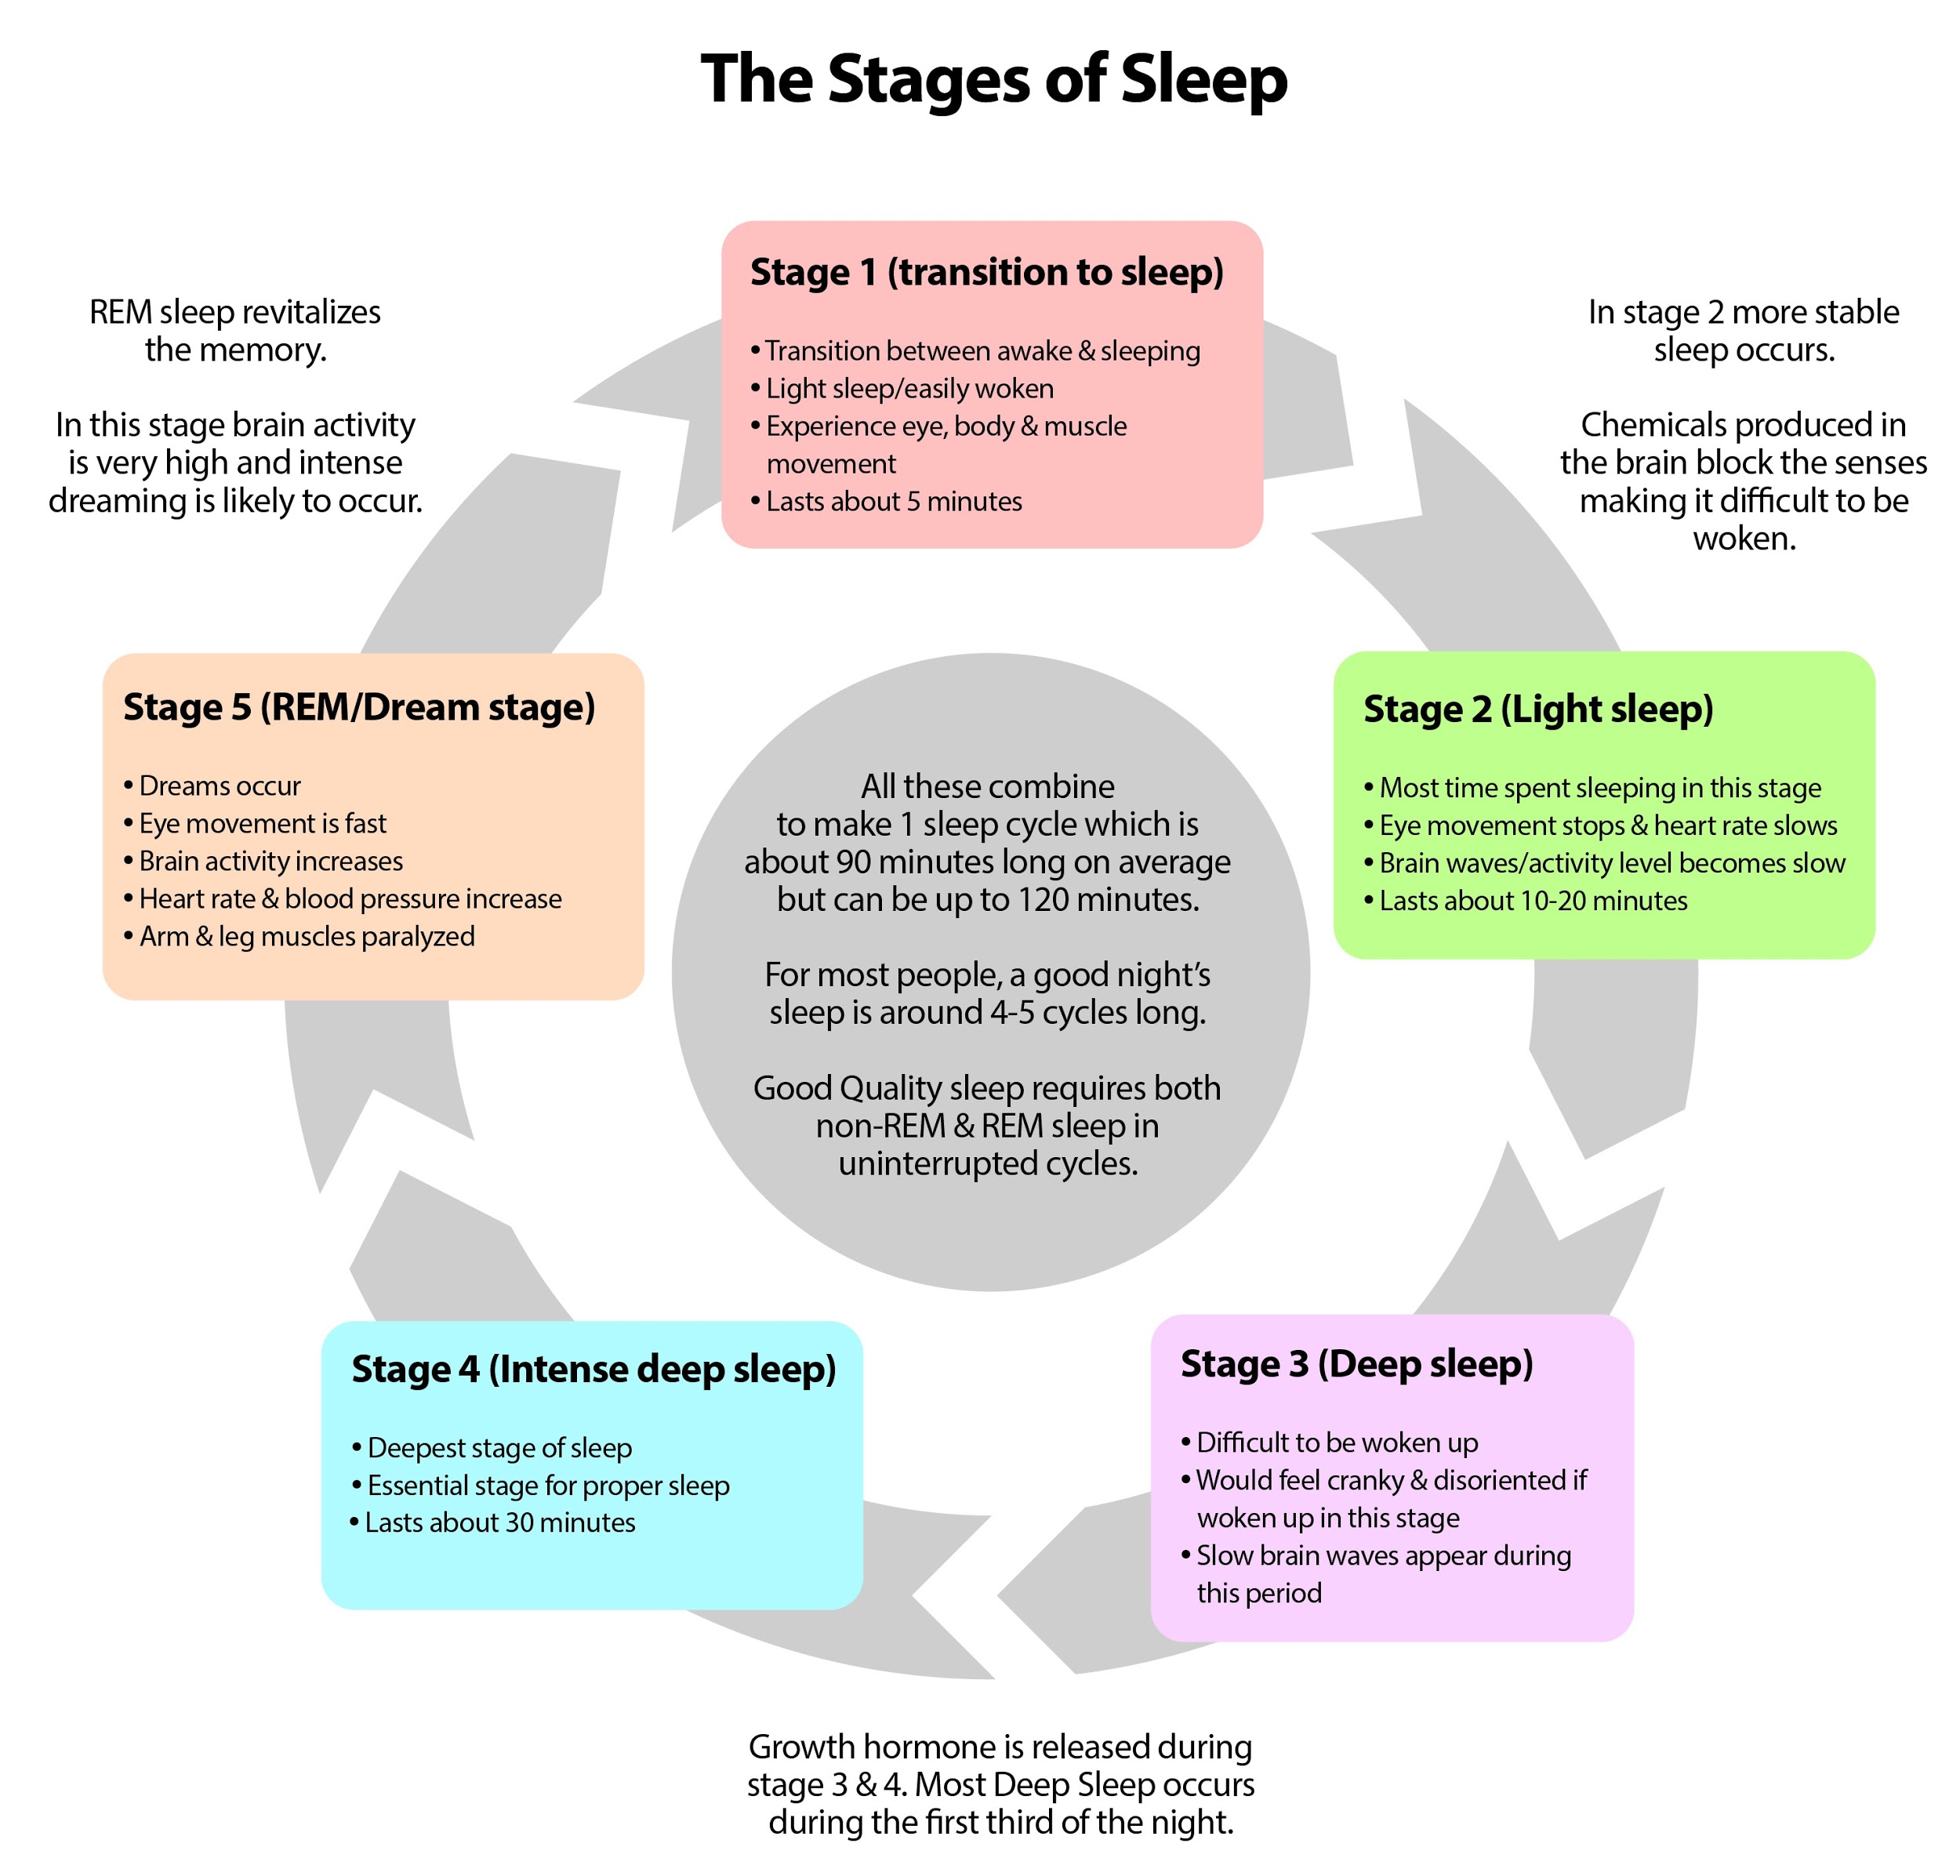

Stage 1 (falling asleep):
The stage between wakefulness and sleep, sometimes referred to as somnolence or drowsy sleep, in which the muscles are still quite active and the eyes roll around slowly and may open and close from time to time. In more scientific terms, stage 1 is the period of transition from relatively unsynchronized beta and gamma brain waves. breathing gradually becomes more regular and the heart rate begins to slow. Dreaming is relatively rare during this stage, but sudden twitches or hypnic (hypnagogic) state (sudden short micro-awakenings often accompanied by a falling sensation) are quite common, the last gasps of waking control before sleep takes over. 5 minutes approx.

Stage 2 (light sleep):
The first unequivocal stage of sleep, during which muscle activity decreases still further and conscious awareness of the outside world begins to fade completely. Brain waves are mainly in the theta wave range, but in addition stage 2 is also characterized by two distinguishing phenomena: sleep spindles and K-complexes, together, these serve to protect sleep and suppress response to outside stimuli, as well as to aid in sleep-based memory consolidation and information processing. Because sleepers pass through this stage several times during the night, more time is spent in stage 2 sleep than in any other single stage. 10-20 minutes approx.

Stage 3/4 (deep/ intense sleep):
It was know as separate stages but know is known as just one stage. Is also known as deep or delta or slow-wave sleep (SWS).
During this period the sleeper is even less responsive to the outside environment, essentially cut off from the world and unaware of any sounds or other stimuli. Stage 3 is characterized by delta brain waves, along with some sleep spindles, although much fewer than in stage 2. It last 30 minutes or more.
Essential stage for proper sleep.Between these and the REM sleep can occur night terrors, sleepwalking and first stage for dreaming.

R.E.M. Stage:
Rapid eye movement stage. Also referred to as paradoxical sleep.
This is the final stage of any standard sleep cycle. The first Rapid Eye Movement sleep usually happens after having been asleep at least 90 minutes. Dreaming, nightmares, sleep paralysis and sleepwalking can occur. Alpha, Bethany and desynchronous waves. This stage is also characterized by an increase of the heart and respiration rates, and their rhythms become irregular. Lasts around 10 minutes.

