


It is probable that the Romans used outcropping coal (‘outcropping’ means where the coal comes to the earth’s surface or appears in exposed rock faces) when working iron or burning lime for building purposes. There is no mention of coal mining in the Domesday Book of 1086 though lead and iron mines are recorded. In the 13th century there are records of coal excavations in Durham and Northumberland, Nottinghamshire and Derbyshire, Staffordshire, Lancashire, the Forest of Dean and North and South Wales. At this time coal was referred to as sea cole, a reference to coal found on the shore, washed up by the sea from cliffs or undersea outcrops in north east England. The early mines were shallow bell pits where coal was close to the surface. Shafts lined with tree trunks and branches have been found in Lancashire in workings dating from early 17th century. By 1750 brick lined shafts to 150 foot depth were common.

Industrial Revolution
Coal production increased dramatically in the 19th century as the Industrial Revolution gathered pace, as a fuel for steam engines such as the Newcomen engine, and later, the Watt steam engine. A key development was the invention, at Coalbrookdale, in the early 18th century, of coke which could be used to make pig iron in a blast furnace. The development of the steam locomotive early in the 19th century gave added impetus, and coal consumption grew rapidly as the railway network expanded through the Victorian period. Coal was widely used for domestic heating owing to its low cost and widespread availability. The manufacture of coke also provided coal gas, which could be used for heating and lighting.

Decline
By the 1960s, the coal industry was declining. In March 1968, the last pit in the Black Country closed and pit closures were a regular occurrence in many other areas. In the mid 1970s, 130 million tons of coal was being produced annually, but production started to fall below 100 million tons during the 1980s. Over the next twenty years numerous pit closures were announced as only the most economic could afford to stay in operation. By 1995 only 50 million tons of coal was produced. In January 2008 the last deep mine in South Wales closed when the coal was exhausted. Britain now has to import most of its coal.
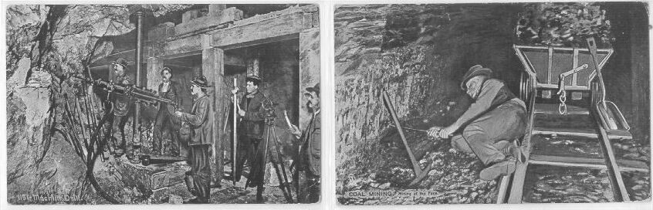

Answers
- What are we told that the Romans used coal for? Tick the correct answer:
  - Heating their bath water
  - Burning lime for building purposes
  - Building forts
  - Producing gas

- Which of these types of mines are recorded in the Domesday book?
  - Coal
  - Iron
  - Lead

- What did people call coal found in sea cliffs?

- What did miners use to line their mine shafts in the 1600s?
  - Wood
  - Bricks
  - Cement

- According to the text, in what century did the Industrial revolution ‘gather pace’?
  - 17th
  - 18th
  - 19th

In the article above, what do the following words mean? They are underlined in the text.

- Excavations: a. dwellings 7. Shallow: a. simple
- diggings b. not deep
- reports c. broad

- Dramatically: a. playfully 9. Impetus: a. drive
  - slowly b. importance
  - markedly c. danger

- Consumption: a. wastage 11. Expanded: a. enlarged
  - pollution b. shrank
  - use c. decreased

- Domestic: a. boiler 13. Manufacture: a. burning
  - for the home b. making
  - servant c. crushing

- Declining: a. spreading 15. Closures: a. buildings
  - rising b. strikes
  - dwindling c. closings

- Exhausted: a. finished 17. Import a. sell
  - tired b. buy from abroad
  - evaporated c. send

- What did Mr Newcomen and Mr Watt invent?

- What is a steam locomotive?

- Where was coke invented?

- What was coke used for?
  - taking gas out of coal
  - making pig iron in a blast furnace
  - domestic heating

- What, according to the text, did people use coal gas for?
  - cooking
  - lighting
  - heating
  - motor fuel

- When was the last deep mine closed, and why?
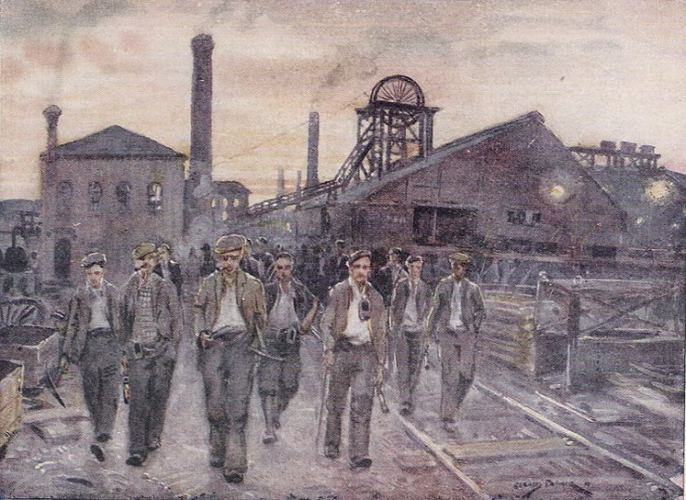

Answers

  - b
  - b and c
  - sea cole
  - a
  - c
  - b
  - b
  - c
  - a
  - c
  - a
  - b
  - b
  - c
  - c
  - a
  - b
  - Steam engines
  - A train driven by steam power.
  - Coalbrookdale
  - b
  - b and c
  - 2008, because the coal ran out

