

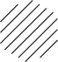 |  | 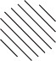

Section 1

To the left in the example below there are five squares arranged in order. One of these
squares has been left empty. One of the five squares on the right should take the place of the empty square and its letter has been marked on your answer sheet.
Example


A B C D E
Answer: B
As you move through the series, the dot acquires an extra ring around it, increasing the overall size of the circle each time. The central dot is present in each cell.

Now do the two practice questions below.
P1

A B C D E

This series has two rules: firstly, an arrow is added each time and, secondly, the direction of the arrows alternates, pointing downwards then upwards etc. Therefore, the missing square should have five arrows pointing downwards, as in answer option C.

P2

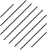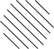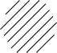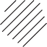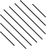
A B C D E

In this series, the image changes across every other square so the pattern for 1, 3 and 5 is independent from squares 2 and 4. We can see that the pattern for 2 and 4 remains the same: the five-sided shape doesn’t change. The pattern for 1, 3 and 5 shows that the six-sided shape is always positioned the same way but the direction of the diagonal lines alternates. In square 5 they will be slanting right, as in answer option A.

1

 |  |  |  | 

A B C D E

2

A B C D E

3

A B C D E

4

A B C D E

5
A B C D E






































6

A B C D E

7

 |  | 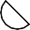 | 
A B C D E

8

A B C D E

9

A B C D E

10
 |  |  |  | 
A B C D E

Answers:

Section 1
1. A
2. E
3. B
4. E
5. D
6. A
7. C
8. D
9. E
10. C

