

GCSE GEOGRAPHY Name:
The Challenge of Natural Hazards
Complete the questions by typing in the answer boxes, which will expand as necessary.
Then fill in the self-assessment form as fully as you can to help you reflect on your work.

Tectonic Hazards
1 Study the diagram below, showing two different plate margins.
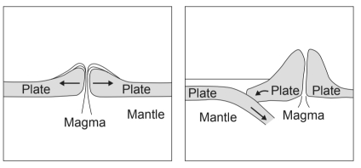
(a) What is a plate margin?

(2)
(b) Describe the difference(s) between destructive and constructive plate margins.

(3)
(Total 5 marks)
2 Describe the characteristics of oceanic crust.

(Total 3 marks)
3 Study the world map below showing plate margins and active volcanoes.
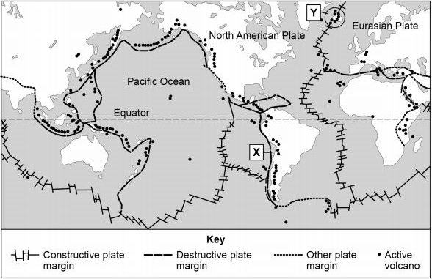
(a) Using the map above which one of the following statements is true?
Put an X in one box only.
A | All active volcanoes occur in lines along  plate margins.
B | There are more active volcanoes along  constructive margins than destructive margins
C | There are many active volcanoes around  the edge of the Pacific Ocean.
D | Active volcanoes are found along the eastern  side of North and South America.
(1)
(b) Describe the movement of plates along plate margin X.

(1)
(Total 2 marks)
Tropical Storms
4 Describe the conditions that lead to the formation of tropical revolving storms.

(Total 3 marks)
5 Study the map showing the track of Hurricane Irma in September 2017.
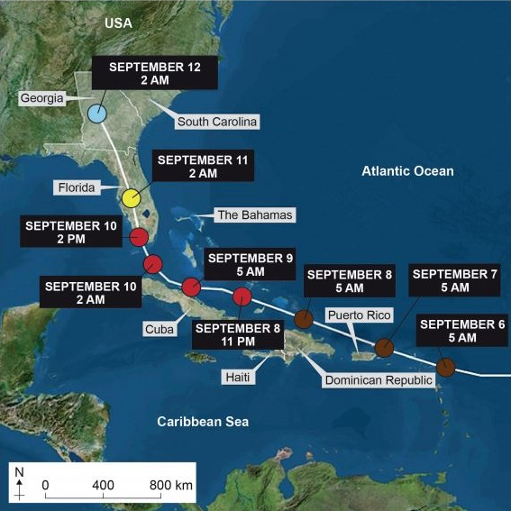
Saffir-Simpson Hurricane Wind Scale
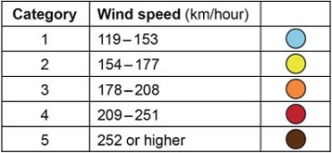
(a) Using the map above, describe the track of Hurricane Irma between 6 September 2017 and 12 September 2017.

(2)
(b) Using the map above, what happened to the wind speed of Hurricane Irma between 8 and 12 September 2017?

(1)
(Total 3 marks)
6 Study the photograph showing the effects of Hurricane Matthew in south western Haiti.
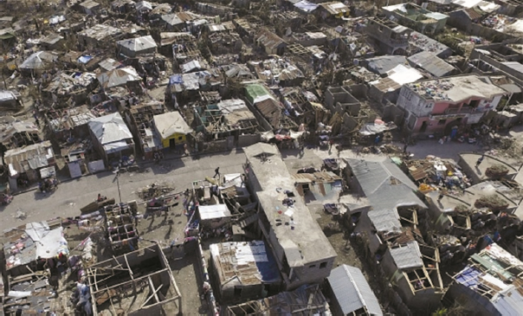
Using the photograph, state two primary effects of Hurricane Matthew.
1
2
(Total 2 marks)
Climate Change
7 What is ‘global climate change’?

(Total 2 marks)
8 Study the diagram showing the process of global warming, a cause of climatic change.
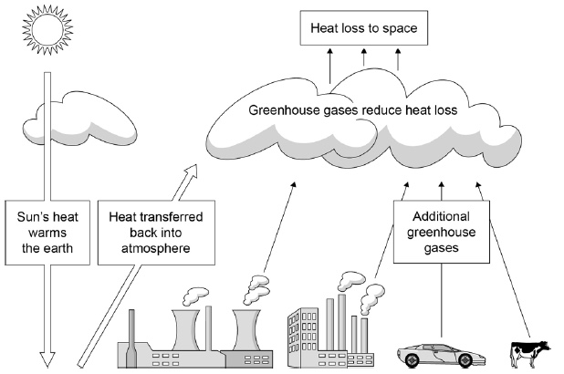
Identify two sources of greenhouse gases suggested by the diagram.
1
2
(Total 2 marks)
9 Study the figure, a graph showing changes in the amount of carbon dioxide (CO₂) in the atmosphere.
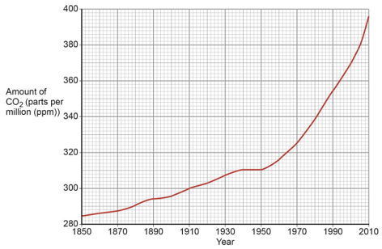
(a) Describe the change in the amount of carbon dioxide in the atmosphere shown
in the graph.

(2)
(b) Outline one reason why the concentration of carbon dioxide in the atmosphere has changed over time.

(2)
(Total 4 marks)
10 Explain how volcanic activity and orbital changes may cause long-term climate change.

(Total 4 marks)

Feedback Form Instructions
When you have answered as many questions as you can, complete the form on the last page to help you reflect on your work.

How to fill in the form
1 Put your confidence score in Column C. This is not about the number of marks you achieved but how sure you felt while you were answering the question.
Confidence | Definition
0 | I didn’t answer this one
1 | I guessed the answer
2 | I needed help with the answer
3 | I understood the question but wasn’t sure about my answer
4 | I was fairly confident I would get most of the marks
5 | I was sure my answer was correct and I would get full marks
2 Use the mark scheme to check your answers.
Put the mark you think you achieved in Column Mark.
3 Write an overall comment about how you felt each question went.
- If you got help, make a note in the comment box specifying the source: internet,
friend, book, parent or tutor.
4 Complete ‘I can…’ and ‘I need to…’ sentences.
- ‘I can…’ sentences might include the questions you found easiest to answer, got the most marks for or felt the most confident about.
- ‘I need to…’ sentences might include areas you need to revise, questions you want to ask your teacher or the next topic or skill you want to work on.
5 Return the form to your teacher.

The Challenge of Natural Hazards
Feedback form Name

Qu | Total marks | Self-assessment
 |  | C | Mark | Comment
1 | 5
2 | 3
3 | 2
4 | 3
5 | 3
6 | 2
7 | 2
8 | 2
9 | 4
10 | 4
Overall
I can ……

I need to …….

Qu | Total marks | Teacher review
 |  | Mark | Comment
1 | 5
2 | 3
3 | 2
4 | 3
5 | 3
6 | 2
7 | 2
8 | 2
9 | 4
10 | 4
Overall
You can ……

You need to …….

